Service Summary
 | The EarlyWatch Alert service has detected severe problems that may cause you to lose business.  Please evaluate the recommendations.

Alerts Decisive For Red Report
SAP HANA database: Number of Records exceeds critical limit.

Alert Overview
ABAP number ranges are almost exhausted.
SAP HANA database: The duration of the blocking savepoint phase is extraordinary long.
SAP HANA database: No consistency checks are scheduled.
SAP HANA network settings for System Replication is insecure.
SAP HANA database: User SYSTEM is active and valid.
Users with critical authorizations, which allow to do anything in client 000
Users with critical authorizations, which allow to do anything in other client(s) than 000
Users with critical authorizations, which should not be used in production in other client(s) than 000
8 inconsistent material document header inconsistencies needs to be fixed in your system
There are aborted postings (errors in UPDATE). Reprocess them to ensure consistent data.
We found more than 30 ABAP dumps in your system.
SAP HANA database: Parameters are not set in accordance with the recommendation.
SAP HANA database: Memory consumption of tables exceeds 50% of usable memory.
SAP HANA database: Number of Records of partitioned tables reaches critical limit.
SAP HANA database: Row Store shows fragmentation
Missing index causes expensive SQL statement.
Configuration issue causes expensive SQL statement.
Secure password policy is not sufficiently enforced.
Gateway Access Control List reg_info is not effective.
Protection of Passwords in Database Connections
SAP HANA database: Users with critical privilege DATA ADMIN.
SAP Software on this system is about to be outdated. Support with SAP Security Notes is endangered.
RFC Gateway default security behaviour is not activated. System may be at risk, when ACLs secinfo or reginfo are missing.
User SAP* does not exists in client 000, potentially allowing critical logon in the future
User SAP* does not exists in other client(s) than 000, potentially allowing critical logon in the future

Note: This report can be viewed in "SAP for Me". One of the benefits using SAP EarlyWatch Alert Workspace is proactive alerts calculated in the workspace. Do not miss any important findings: subscribe to notifications with just a few clicks on Notification Activation. For detailed configuration options, read this Best Practices blog.
How to get access to the SAP EarlyWatch Alert apps is explained in SAP Note 2520319. The following link to the SAP EarlyWatch Alert Reports app always opens up the latest report for this system. Similarly, this link to the SAP EarlyWatch Alert Dashboard shows you the analytical dashboard for this system. Specific links to analytical detail pages in SAP EarlyWatch Alert Workspace are included in the respective sections in this report.
The EWA Status App is your entry point for analysis if you are missing the current data in EarlyWatch Alert apps.
Based on these findings, it is recommended that you perform the following Guided Self-Services.
Guided Self Service | FAQ SAP Note
Security Optimization Service | 1484124

For more information about Guided Self-Services, see SAP Enterprise Support Academy. Academy -
Check Overview
Topic Rating | Topic | Subtopic Rating | Subtopic
 | Software Configuration for PRD
 |  |  | SAP Application Release - Maintenance Phases
 |  |  | Security Risk Due to Outdated Support Packages
 |  |  | Database - Maintenance Phases
 |  |  | Operating System(s) - Maintenance Phases
 |  |  | SAP Kernel Release
 | Performance Overview PRD
 | Workload Distribution PRD
 |  |  | Workload by Application Module
 |  |  | DB Load Profile
 | SAP System Operating PRD
 |  |  | Availability based on Collector Protocols
 |  |  | Program Errors (ABAP Dumps)
 |  |  | Update Errors
 |  |  | Table Reorganization
 |  |  | Critical Number Ranges
 |  |  | Number Range Trace
 |  |  | Exhausted Number Range Buffers
 |  |  | DDLOG Sequence Exhaustion may cause unplanned downtime*
 | Hardware Capacity
 | Security
 |  |  | Maintenance Status of current SAP HANA Database Revision *
 |  |  | SAP HANA System Privilege DATA ADMIN
 |  |  | SAP HANA Password Policy *
 |  |  | SAP HANA Audit Trail*
 |  |  | SAP HANA SQL Trace Level*
 |  |  | SAP HANA Network Settings for Internal Services *
 |  |  | SAP HANA Network Settings for System Replication Communication (listeninterface)
 |  |  | Activation Status and Validity of User SYSTEM
 |  |  | Age of Support Packages
 |  |  | Default Passwords of Standard Users
 |  |  | Control of the Automatic Login User SAP**
 |  |  | Protection of Passwords in Database Connections
 |  |  | ABAP Password Policy
 |  |  | RFC Gateway Security
 |  |  | Message Server Security *
 |  |  | Critical authorizations, which allow to do anything
 |  |  | Critical authorizations, which should not be used in production
 |  |  | Critical authorizations, which should only see very limited use in production
 | Software Change and Transport Management of PRD
 |  |  | Emergency Changes
 |  |  | Failed Changes
 | SAP HANA Database PRD
 |  |  | SAP HANA Stability and Alerts
 |  |  | SAP HANA Database Configuration
 |  |  | SAP HANA Resource Consumption
 |  |  | SAP HANA Workload and Performance
 |  |  | Size and Growth
 |  |  | Administration
 | SAP NetWeaver Gateway
 |  |  | MetaData Cache Activation
 |  |  | Logging Configuration
 |  |  | Gateway Error Logs*
 |  |  | Important Periodic Jobs
 | Fiori Checks for PRD
 |  |  | Maintenance and Update Strategy for SAP Fiori Front-End Server
 |  |  | SAPUI5 Version
 |  |  | SAP Fiori Cache Buster Activation
 |  |  | HTTP/2 Support
 |  |  | Activated but unused ICF services in UI5 apps*

*Remark: The check overview includes checks executed with a green result, which do not appear in the report.
Note: All recommendations in this report are based on our general experience. Test them before using them in your production system. Note that EarlyWatch Alert is an automatic service.
Note: If you have any questions about the accuracy of the checks in this report or the correct configuration of the SAP Solution Manager EarlyWatch Alert service, create a customer case under component SV-SMG-SER-EWA.
Note: If you require assistance to resolve concerns about the performance of the system, or if you require a technical analysis of other aspects of your system as highlighted in this report, please contact your customer or Customer Interaction Center. To contact the Customer Interaction Center, please refer to the contact methods provided in SAP Note 560499. For details of how to set the appropriate priority level, see SAP Note 67739.

Performance Indicators for PRD
The following table shows the relevant performance indicators in various system areas.
Area | Indicators | Value
System Performance | Active Users (>400 steps) | 10411
System Performance | Fiori Users | 0
System Performance | Avg. Availability per Week | 89 %
System Performance | Avg. Response Time in Dialog Task | 1136 ms
System Performance | Max. Dialog Steps per Hour | 290562
System Performance | Avg. Response Time at Peak Dialog Hour | 1142 ms
System Performance | Avg. Response Time in RFC Task | 487 ms
System Performance | Max. Number of RFCs per Hour | 729071
System Performance | Avg. RFC Response Time at Peak Hour | 498 ms
Hardware Capacity | Max. CPU Utilization on DB Server | 44 %
Hardware Capacity | Max. CPU Utilization on Appl. Server | 44 %
Database Performance | Avg. DB Request Time in Dialog Task | 502 ms
Database Performance | Avg. DB Request Time for RFC | 86 ms
Database Performance | Avg. DB Request Time in Update Task | 84 ms
Database Space Management | DB Size | 7068.35 GB
Database Space Management | DB Growth Last Month | 126.20- GB

Landscape

Products and Components in current Landscape
Product
System | SAP Product | Product Version
PRD~ABAP | SAP S/4HANA | 2021

Main Instances
Related System | Main Instance
PRD~ABAP | SAP S/4HANA Server

Databases
Related System | Database System | Database Version | DB ID
PRD~ABAP | SAP HANA Database | 2.00.059.04 | PRD

Servers in current Landscape
SAP Application Servers
System | Host | Instance Name | Logical Host | ABAP | JAVA
PRD~ABAP | sapapp38 | sapapp38_PRD_38 | sapapp38
PRD~ABAP | sapapp20 | sapapp20_PRD_20 | sapapp20
PRD~ABAP | sapapp40 | sapapp40_PRD_40 | sapapp40
PRD~ABAP | sapapp37 | sapapp37_PRD_37 | sapapp37
PRD~ABAP | sapapp23 | sapapp23_PRD_23 | sapapp23
PRD~ABAP | sapapp41 | sapapp41_PRD_41 | sapapp41
PRD~ABAP | sapapp19 | sapapp19_PRD_19 | sapapp19
PRD~ABAP | sapapp33 | sapapp33_PRD_33 | sapapp33
PRD~ABAP | sapapp27 | sapapp27_PRD_27 | sapapp27
PRD~ABAP | sapapp18 | sapapp18_PRD_18 | sapapp18
PRD~ABAP | sapapp21 | sapapp21_PRD_21 | sapapp21
PRD~ABAP | sapapp35 | sapapp35_PRD_35 | sapapp35
PRD~ABAP | sapapp32 | sapapp32_PRD_32 | sapapp32
PRD~ABAP | sapapp31 | sapapp31_PRD_22 | sapapp31
PRD~ABAP | sapapp30 | sapapp30_PRD_30 | sapapp30
PRD~ABAP | sapapp36 | sapapp36_PRD_36 | sapapp36
PRD~ABAP | sapapp28 | sapapp28_PRD_28 | sapapp28
PRD~ABAP | sapapp31-ha | sapapp31-ha_PRD_22 | sapapp31-ha
PRD~ABAP | sapapp29 | sapapp29_PRD_29 | sapapp29
PRD~ABAP | sapapp39 | sapapp39_PRD_39 | sapapp39
PRD~ABAP | sapapp34 | sapapp34_PRD_34 | sapapp34
PRD~ABAP | sapapp15 | sapapp15_PRD_15 | sapapp15
PRD~ABAP | sapapp26 | sapapp26_PRD_26 | sapapp26
PRD~ABAP | sapapp42 | sapapp42_PRD_42 | sapapp42
PRD~ABAP | sapapp43 | sapapp43_PRD_43 | sapapp43

DB Servers
Related System | Host | Logical Host (SAPDBHOST)
PRD~ABAP | tsls4proddbh | dbcls-tta-prd

Components
Related System | Component | Host | Instance Name | Logical Host
PRD~ABAP | ABAP SCS | sapapp22 | sapapp22_PRD_00 | sapapp22

Hardware Configuration
Host Overview
Host | Hardware Manufacturer | Model | CPU Type | CPU MHz | Operating System | CPUs | Cores | Memory in MB
sapapp15
sapapp18
sapapp19
sapapp20
sapapp21
sapapp22
sapapp23
sapapp26
sapapp27
sapapp28
sapapp29
sapapp30
sapapp31
sapapp31-ha
sapapp32
sapapp33
sapapp34
sapapp35
sapapp36
sapapp37
sapapp38
sapapp39
sapapp40
sapapp41
sapapp42
sapapp43
tsls4proddbh | Lenovo | Think SR950 -[7X13CTO1WW]- | Xeon Platinum 8280L | 3150 | SUSE Linux Enterprise Server 15 (x86_64) | 448 | 224 | 12385750

Service Data Quality and Service Readiness
 | The SAP S/4HANA system PRD is not fully prepared for delivery of future remote services.

Rating | Check Performed
 | Sending EarlyWatch Alert of PRD to SAP Backbone
 | Configuring PRD for SAP Note Assistant
 | Service Data Quality
 | Service Preparation of PRD

Sending EarlyWatch Alert of PRD to SAP Backbone
System PRD is prepared for SAP Support Backbone update sending EWA data on HTTPS through SAP Focused Run 3.0 KPD

All connections to SAP Support Backbone use https protocol only. For a how to, refer to Connectivity to SAP.
The following table shows the latest data transmissions for system PRD:
Latest Service Data for System PRD Sent to SAP
Date (collected) | System | Sends EWA? | Kernel | Kernel | ST-PI | ST-PI | Destination | User | Ready for 2020 | Date (received) | Dest. Functional?
10.10.2025 | SAP Focused Run 3.0 KPD | yes | 777_REL 500 |  | 740 24 |  | HTTPS -> SAP | technical communication user |  | 11.10.2025
29.10.2025 | SAP Focused Run 3.0 KPD | yes | 777_REL 500 |  | 740 24 |  | HTTPS -> SAP | technical communication user |  | 30.10.2025
11.10.2025 | Solution Manager 7.2 SOL | n/a | 753_REL 923 |  | n/a |  | n/a | n/a

Configuring PRD for SAP Note Assistant
Configuration and Usage of Digitally Signed SAP Notes
Type | Finding | Further Information
 | A non-signed SAP Note was downloaded last time on 14.05.2025 | SAP Note 2537133
 | SNOTE is configured to connect with HTTPS to SAP using destination SAP-SUPPORT_PORTAL to SAP's Service market place and destination SAP-SUPPORT_NOTE_DOWNLOAD to SAP's File content management system | Guided Answer 'Options for Downloading Digitally Signed SAP Notes'

Service Preparation of PRD
Rating | Check Performed
 | Service Preparation Check (RTCCTOOL)
 | Service Data Control Center of PRD
 | Hardware Utilization Data

In preparation for SAP services, ensure that connections, collectors, and service tools are up to date. These functionalities are explained in SAP Notes 91488 and 2253047.

Service Preparation Check (RTCCTOOL)
Before we can ship any services, the latest version of the SAP Service tools must be implemented in your system.
Report RTCCTOOL was last run on 11.10.2025. During the check, the tool detected issues for which a RED rating was set.
Overall Status | SAP Note | Topic | Tool Status | Manual Status
 | 69455 | ST-A/PI 01V_731 Support Package 3
 | 2485075 | SAP Note 2485075 for DVM [Serv. Exec]
 | 69455 | Addon ST-A/PI 01V_731
 | 69455 | Proc. after addon impl.
 | 69455 | Switch on digital content verification
 | 69455 | Allow Online data collectors
 | 539977 | Addon ST-PI 740
 | 539977 | ST-PI 740 Support Package 24
 | 1985402 | Note 1985402 datacoll. for HANA
 | 12103 | Collectors and TCOLL
 | 207223 | EWAlert setup

Recommendation:
ST-A/PI 01V_731 Support Package 3
Addon supportpackage level 3 for ST-A/PI 01V_731 for NetWeaver as of 7.31 [your current version is more than two levels lower than the latest available]
From http://support.sap.com/supporttools ->ST-A/PI->Support packages-> ST-A/PI 01V_731 download patches up to SAPKITABC6. Use the Maintenance optimizer to release the download. Upload from frontend to transaction SPAM, define a queue and import.
SAP Note 2485075 for DVM [Serv. Exec]
Table deletion from Analysis not working
Please implement coding correction from note 2485075 using SNOTE.

SDCC Destination Table
The table below summarizes the destinations configured in Service Data Control Center.
Finding | Details | Rating
There are conflicting multiple destinations to SAP Support Backbone defined. | 2 destinations exist. Delete the superfluous destination(s).
A Solution Manager ('BACK') destination exists.
There is one Source System for Service Definitions defined. | The Solution Manager is defined as Source System for Service Definitions. Find information about the Source System for Service Definitions flag in SAP Note SAP Note 1075827.

Recommendation: Resolve the issue reported in the table.

Performance DB (ST03 / ST06)
Analysis of ST06 and history data indicate some problems with SAPOSCOL. Check SAPOSCOL and see SAP Note 1309499.

Hardware Utilization Data
Host | Operating System | Performance Data
sapapp15 | OS not detected | OK
sapapp18 | OS not detected | OK
sapapp19 | OS not detected | OK
sapapp20 | OS not detected | OK
sapapp21 | OS not detected | OK
sapapp22 | OS not detected | --
sapapp23 | OS not detected | --
sapapp26 | OS not detected | OK
sapapp27 | OS not detected | OK
sapapp28 | OS not detected | OK
sapapp29 | OS not detected | OK
sapapp30 | OS not detected | OK
sapapp31 | OS not detected | OK
sapapp31-ha | OS not detected | OK
sapapp32 | OS not detected | OK
sapapp33 | OS not detected | OK
sapapp34 | OS not detected | OK
sapapp35 | OS not detected | OK
sapapp36 | OS not detected | OK
sapapp37 | OS not detected | OK
sapapp38 | OS not detected | OK
sapapp39 | OS not detected | OK
sapapp40 | OS not detected | OK
sapapp41 | OS not detected | OK
sapapp42 | OS not detected | OK
sapapp43 | OS not detected | OK
tsls4proddbh | SUSE Linux Enterprise Server 15 (x86_64) | --

Hardware capacity checks could not be run successfully due to missing data. See SAP Note 1309499.

Software Configuration for PRD
 | We have listed recommendations concerning the current software configuration on your system.

Your system's software versions are checked. If known issues with the software versions installed are identified, they are highlighted.

SAP Application Release - Maintenance Phases
SAP Product Version | End of Mainstream Maintenance | Status
SAP S/4HANA 2021 | 31.12.2026

Rating Legend
Rating | Description
 | Mainstream / Extended maintenance offered by SAP is available for the next 18 months or longer.
 | Mainstream / Extended maintenance offered by SAP will end in 6 to 18 months.
 | Mainstream / Extended maintenance offered by SAP has expired or will expire in the next 6 months.

Your main product version runs under SAP mainstream maintenance until 31.12.2026.
Please refer to the SAP Enterprise Support Reporting Cockpit for further information about the maintenance status of any additional Add-On product version on your system.

Security Risk Due to Outdated Support Packages
The chapter Security provides the following ratings regarding the maintenance status of implemented Support Packages:
Rating | Check | System ID
 | Maintenance Status of current SAP HANA Database Revision | PRD
 | Age of Support Packages | PRD

The Support Package level of key software components on your system threatens to run out of security maintenance. For more information, see chapter Security.

Support Package Maintenance - ABAP
The following table shows an overview of currently installed software components.
Support Packages
Software Component | Version | Patch Level | Latest Avail. Patch Level | Support Package | Component Description
BLACKLIN | S2205 | 0 |  |  | BlackLine Connector Extractor For SAP S4 2005
BLG | C2205 | 0
DMIS_CNT | 2011_1_731 | 3 | 25 | SAPK-11603INDMISCNT | TDMS Application Content
EA-DFPS | 806 | 2 | 5 | SAPK-80602INEADFPS | EA-Defense Forces & Public Security
EA-HR | 608 | 105 | 126 | SAPK-608A5INEAHR | SAP R/3 Enterprise Human Resource & Travel Extension
EA-PS | 806 | 2 | 5 | SAPK-80602INEAPS | SAP R/3 Enterprise Public Services
FI-CAX | 806 | 2 | 5 | SAPK-80602INFICAX | FI-CAX: Extended FI-CA
GBX01HR | 600 | 19 | 19 | SAPK-60019INGBX01HR | GBX01HR 600 (oData Base, HCM Fiori)
GBX01HR5 | 605 | 21 | 27 | SAPK-60521INGBX01HR5 | GBX01HR5
GRCPIERP | V1200_S4 | 8 | 10 | SAPK-V1208INGRCPIERP | SAP GRC PlugIn for ERP
GRCPINW | V1200_750 | 12 | 22 | SAPK-V1212INGRCPINW | SAP GRC Plug-in for NW
INSURANCE | 806 | 2 | 5 | SAPK-80602ININSURANC | INSURANCE SAP Insurance
IS-OIL | 806 | 2 | 5 | SAPK-80602INISOIL | SAP for Oil & Gas
IS-PRA | 806 | 2 | 5 | SAPK-80602INISPRA | IS-PRA
IS-PS-CA | 806 | 2 | 5 | SAPK-80602INISPSCA | IS-Public Sector Contract Accounting
IS-UT | 806 | 2 | 5 | SAPK-80602INISUT | IS-UT
MDG_APPL | 806 | 2 | 5 | SAPK-80602INMDGAPPL | MDG Applications
MDG_FND | 806 | 2 | 5 | SAPK-80602INMDGFND | MDG Foundation
NMI_CONT | 2006_1_700 | 21 | 21 | SAPK-61721INNMICONT | New GL Migration Implementation CONTENT
OTBCBAS | 0700_006 | 4 | 6 | SAPK-00604INOTBCBAS | Business Center Base by OpenText
OTBCRM | 0700_006 | 1 | 1 | SAPK-00601INOTBCRM | OpenText Business Center xECM Integration
OTBCS4 | 1610_106 | 4 | 6 | SAPK-10604INOTBCS4 | Otbcs4
OTBCS4OC | 1610_106 | 1 | 3 | SAPK-10601INOTBCS4OC | Opentext Vim S/4 Order To Cash
OTBCS4PP | 1610_106 | 1 | 3 | SAPK-10601INOTBCS4PP | Opentext Vim S/4 P2p
OTBCSL00 | 0700_006 | 4 | 6 | SAPK-00604INOTBCSL00 | OpenText OTBCSL00
OTBCSL08 | 81610_106 | 0 | 1 |  | OpenText OTBCSL08
OTBCSL30 | 81610_106 | 4 | 6 | SAPK-10604INOTBCSL30 | OTBCSL
OTBCSL38 | 80700_006 | 0 |  |  | Otbcsl38
OTBCSLOC | 0700_006 | 1 | 3 | SAPK-00601INOTBCSLOC | Opentext Vim Order To Cash
OTBCSLPP | 0700_006 | 1 | 3 | SAPK-00601INOTBCSLPP | Opentext Vim Procure To Pay
OTBCWUI | 0740_006 | 2 | 6 | SAPK-00602INOTBCWUI | OT Business Center Web Ui
OTEXBAS | 2140_700 | 0 |  |  | Opentext Basis Add On
OTEXERP | 2140_700 | 0 |  |  | DOCU LINK ERP
OTEXRL | 2140_700 | 0 |  |  | Otexrl
OTEXVIM | 81610_106 | 4 | 6 | SAPK-10604INOTEXVIM | Vendor Invoice Management
S4CEXT | 106 | 2 | 5 | SAPK-10602INS4CEXT | S4cext
S4CORE | 106 | 2 | 5 | SAPK-10602INS4CORE | S4core
S4COREOP | 106 | 2 | 5 | SAPK-10602INS4COREOP | S/4HANA, On-Premise only parts.
S4CRM | 206 | 2 | 5 | SAPK-20602INS4CRM | SAP S/4HANA for customer management
S4DEPREC | 106 | 2 | 5 | SAPK-10602INS4DEPREC | S/4HANA, deprecation parts.
S4FND | 106 | 2 | 5 | SAPK-10602INS4FND | S/4HANA Foundation, common parts.
SAP_ABA | 75G | 2 | 5 | SAPK-75G02INSAPABA | SAP Anwendungsbasis
SAP_BASIS | 756 | 2 | 5 | SAPK-75602INSAPBASIS | SAP Basis component
SAP_BW | 756 | 2 | 5 | SAPK-75602INSAPBW | SAP Business Warehouse
SAP_GWFND | 756 | 2 | 5 | SAPK-75602INSAPGWFND | SAP NetWeaver Gateway Foundation
SAP_HR | 608 | 105 | 126 | SAPKE608A5 | SAP HR
SAP_UI | 756 | 4 | 8 | SAPK-75604INSAPUI | User Interface Technology
ST-A/PI | 01V_731 | 0 | 3 |  | ST-A/PI Service Tools for Applications Plug-In
ST-PI | 740 | 22 | 24 | SAPK-74022INSTPI | Solution Tools Plugin
UIHR001 | 100 | 5 | 18 | SAPK-10005INUIHR001 | UI for ERP Human capital management
V4CORE | 2020V2 | 0 |  |  | Vistex V4 Hana Core
V4DMP | 2020V2 | 0 |  |  | Vistex V4Hana Data Maintanence Pricing
V4IA | 2020V2 | 0 |  |  | Vistex V/4 HANA Incentives Administration

Database - Maintenance Phases
Database Version | End of Standard Vendor Support* | Comment | Status | SAP Note
SAP HANA Database 2.0 |  | Follows Application |  | 2378962

* Maintenance phases and duration for the DB version are defined by the vendor. Naming of the phases and required additional support contracts differ depending on the vendor. Support can be restricted to specific patch levels by the vendor or by SAP. Check in the referenced SAP Note(s) whether your SAP system requires a specific patch release to guarantee support for your database version.

Operating System(s) - Maintenance Phases
Host | Operating System | End of Standard Vendor Support* | End of Extended Vendor Support* | Comment | Status | SAP Note
26 Hosts
tsls4proddbh | SUSE Linux Enterprise Server 15 (x86_64) | 31.07.2028 | 31.07.2031 | Limited (LTSS) |  | 936887

* Maintenance phases and duration for the operating system version are defined by the vendor. Naming of the phases and required additional support contracts differ depending on the vendor. Support can be restricted to specific patch levels by the vendor or by SAP. Check in the referenced SAP Note(s) whether your SAP system requires a specific patch release to guarantee support for your operating system version.
The automatic determination of the used operating system version(s) of system PRD did not work correctly for at least one host. For more information and possible reasons, refer to the section 'Service Preparation and Data Quality of PRD'.

HANA Database Version for PRD
The following table shows your current/planned SAP HANA database version.
HANA Database Version
SID | SPS Stack | SP Revision | Maintenance Revision | In Maintenance ? | SAP Notes | Upgrade Information
PRD | 2.00 SP 05 | 2.00.059.004 | yes |  | 2378962

SAP HANA: SQLDBC Version

SAP HANA: Installed SQLDBC Version
The following table shows your currently installed SAP HANA database client component version.
Instance Name | SQLDBC Version | Rating
25 Instances | 2.12.025

SAP Note | Description
1906576 | HANA client and server cross-version compatibility
2339267 | The SAP HANA client version and installation manifest file doesn't match currently available SAP HANA server version information

SAP HANA: Installed DBSL Version
The following table shows the DBSL version currently installed.
Instance | Current DBSL Release | Current DBSL Patch | Recommended DBSL Release | Recommended DBSL Patch | Rating
sapapp18_PRD_18 | 789 | 100 | 789 | 0
sapapp27_PRD_27 | 789 | 100 | 789 | 0
sapapp38_PRD_38 | 789 | 100 | 789 | 0
sapapp20_PRD_20 | 789 | 100 | 789 | 0
sapapp40_PRD_40 | 789 | 100 | 789 | 0
sapapp37_PRD_37 | 789 | 100 | 789 | 0
sapapp23_PRD_23 | 789 | 100 | 789 | 0
sapapp41_PRD_41 | 789 | 100 | 789 | 0
sapapp19_PRD_19 | 789 | 100 | 789 | 0
sapapp33_PRD_33 | 789 | 100 | 789 | 0
sapapp21_PRD_21 | 789 | 100 | 789 | 0
sapapp35_PRD_35 | 789 | 100 | 789 | 0
sapapp32_PRD_32 | 789 | 100 | 789 | 0
sapapp31_PRD_22 | 789 | 100 | 789 | 0
sapapp30_PRD_30 | 789 | 100 | 789 | 0
sapapp36_PRD_36 | 789 | 100 | 789 | 0
sapapp28_PRD_28 | 789 | 100 | 789 | 0
sapapp31-ha_PRD_22 | 789 | 100 | 789 | 0
sapapp29_PRD_29 | 789 | 100 | 789 | 0
sapapp39_PRD_39 | 789 | 100 | 789 | 0
sapapp34_PRD_34 | 789 | 100 | 789 | 0
sapapp15_PRD_15 | 789 | 100 | 789 | 0
sapapp26_PRD_26 | 789 | 100 | 789 | 0
sapapp42_PRD_42 | 789 | 100 | 789 | 0
sapapp43_PRD_43 | 789 | 100 | 789 | 0

Your installed SAP HANA DBSL meets the recommended requirement to access the SAP HANA database.

SAP Kernel Release
Your system is running an SAP kernel that is up to date. This means that you have the latest available improvements and error corrections offered by SAP to its customers.
Instance(s) | SAP Kernel Release | Patch Level | Age in Months | OS Family
25 instances | 789 | 129 | 5

Additional Remarks
SAP releases Support Package stacks (including SAP kernel patches) on a regular basis for most products (generally 2–4 times a year). We recommend that you base your software maintenance strategy on these stacks.
You should only consider using a more recent SAP kernel patch than that shipped with the latest Support Package Stack for your product if specific errors occur.
For more information, see SAP Service Marketplace at https://support.sap.com/software/patches/stacks.html (SAP Support Package Stack information) and https://me.sap.com/softwarecenter/support/index (Support Packages & patch information).
For each patch there is an SAP Note in which all known regressions for this level are listed. Find it using the keyword KRNL789PL129 in the SAP Note search. For detailed information, see SAP Note 1802333 - Finding information about regressions in the SAP kernel.

Missing Side Effect Solving Notes for Finance
For all implemented SAP Notes in Finance causing side effects, the solution is implemented too.

Missing Side Effect Solving Notes for Materials Management
For all implemented SAP Notes in SAP Materials Management causing side effects, the solution is implemented too.

Missing Side Effect Solving Notes for Payroll
For all implemented SAP Notes in SAP Payroll causing side effects, the solution is implemented too.

Important SAP Notes for IBM Cloud
The table below lists important SAP Notes for your current hyperscaler environment.
SAP Notes for IBM Cloud
Description | SAP Note
General Support Statement for Virtual Environments | 1492000
SAP Support in IaaS Environments | 1380654
Key Monitoring Metrics for SAP on IaaS Infrastructure | 2469354
SAP on IBM Cloud: Support Prerequisites | 2414820
SAP Applications on IBM Cloud: Supported DB/OS and IBM Cloud Bare Metal Server Types | 2414097
SAP Applications on IBM Cloud Virtual Private Cloud (VPC) Infrastructure environment | 2927211

Hardware Capacity
 | We have checked your system for potential CPU or memory bottlenecks and found that the hardware of your servers is sufficient for the current workload.

Note: Hardware capacity evaluation is based on hosts for which data is at least partially available.

Overview System PRD
General
This analysis focuses on the workload during the peak working hours (9-11, 13) and is based on the hourly averages collected by SAPOSCOL. For information about the definition of peak working hours, see SAP Note 1251291.
CPU
If the average CPU load exceeds 75%, temporary CPU bottlenecks are likely to occur. An average CPU load of more than 90% is a strong indicator of a CPU bottleneck.
Memory
If your hardware cannot handle the maximum memory consumption, this causes a memory bottleneck in your SAP system that can impair performance. The paging rating depends on the ratio of paging activity to physical memory. A ratio exceeding 25% indicates high memory usage (if Java has been detected 0%) and values above 50% (Java 10%) demonstrate a main memory bottleneck.
Server | Max. CPU load [%] | Date | Rating | RAM [MB] | Max. Paging [% of RAM] | Date | Rating
sapapp21 | 34 | 05.10.2025
sapapp18 | 33 | 06.10.2025
sapapp27 | 26 | 10.10.2025
sapapp33 | 27 | 07.10.2025
sapapp19 | 30 | 07.10.2025
sapapp41 | 25 | 07.10.2025
sapapp37 | 36 | 07.10.2025
sapapp40 | 28 | 05.10.2025
sapapp20 | 42 | 10.10.2025
sapapp38 | 24 | 08.10.2025
sapapp35 | 34 | 06.10.2025
sapapp32 | 29 | 08.10.2025
sapapp31 | 2 | 05.10.2025
sapapp30 | 37 | 06.10.2025
sapapp36 | 27 | 07.10.2025
sapapp28 | 29 | 07.10.2025
sapapp31-ha | 7 | 05.10.2025
sapapp29 | 29 | 07.10.2025
sapapp39 | 16 | 06.10.2025
sapapp34 | 29 | 08.10.2025
sapapp15 | 42 | 08.10.2025
sapapp26 | 43 | 08.10.2025
sapapp42 | 44 | 08.10.2025
sapapp43 | 2 | 05.10.2025

Note: For virtualization or IaaS scenarios (for example, IBM PowerVM, VMware, Amazon AWS, ...) it is possible that the CPU rating for some hosts is YELLOW or RED, even though the utilization value is quite low. In this case, the relevant host could not use maximum usable capacity due to a resource shortage within the virtualized infrastructure (for example, IBM PowerVM: Shared Pool CPU utilization).

Enhanced Hardware Monitoring in Cloud Environments
Enhanced hardware monitoring for virtualized environments is not working for some of the current hosts:
Enhanced Monitoring Settings
Host | Enhanced Monitoring Access | Status Message | Rating
sapapp15 | FALSE | Check Host data access. Refer to SAP Note 1606643.
sapapp18 | FALSE | Check Host data access. Refer to SAP Note 1606643.
sapapp19 | FALSE | Check Host data access. Refer to SAP Note 1606643.
sapapp20 | FALSE | Check Host data access. Refer to SAP Note 1606643.
sapapp21 | FALSE | Check Host data access. Refer to SAP Note 1606643.
sapapp22 | n/a | n/a
sapapp23 | FALSE | Check Host data access. Refer to SAP Note 1606643.
sapapp26 | FALSE | Check Host data access. Refer to SAP Note 1606643.
sapapp27 | FALSE | Check Host data access. Refer to SAP Note 1606643.
sapapp28 | FALSE | Check Host data access. Refer to SAP Note 1606643.
sapapp29 | FALSE | Check Host data access. Refer to SAP Note 1606643.
sapapp30 | FALSE | Check Host data access. Refer to SAP Note 1606643.
sapapp31 | FALSE | Check Host data access. Refer to SAP Note 1606643.
sapapp31-ha | FALSE | Check Host data access. Refer to SAP Note 1606643.
sapapp32 | FALSE | Check Host data access. Refer to SAP Note 1606643.
sapapp33 | FALSE | Check Host data access. Refer to SAP Note 1606643.
sapapp34 | FALSE | Check Host data access. Refer to SAP Note 1606643.
sapapp35 | FALSE | Check Host data access. Refer to SAP Note 1606643.
sapapp36 | FALSE | Check Host data access. Refer to SAP Note 1606643.
sapapp37 | FALSE | Check Host data access. Refer to SAP Note 1606643.
sapapp38 | FALSE | Check Host data access. Refer to SAP Note 1606643.
sapapp39 | FALSE | Check Host data access. Refer to SAP Note 1606643.
sapapp40 | FALSE | Check Host data access. Refer to SAP Note 1606643.
sapapp41 | FALSE | Check Host data access. Refer to SAP Note 1606643.
sapapp42 | FALSE | Check Host data access. Refer to SAP Note 1606643.
sapapp43 | FALSE | Check Host data access. Refer to SAP Note 1606643.
tsls4proddbh | n/a | n/a

Recommendation:
For full SAP support, we recommend enabling built-in monitors on your SAP system and on the underlying infrastructure to retrieve enhanced information about configuration and resource utilization.
SAP Note 2469354 provides an overview of key metrics by IaaS platform that will get available once the enhanced monitoring is active.
See SAP Notes https://service.sap.com/sap/support/notes/ 2414820[2414820] and https://service.sap.com/sap/support/notes/ 2923984[2923984] for details on how to enable the enhanced hardware monitoring on IBM Cloud Infrastructure and SAP.

Business Key Figures
System errors or business exceptions can be a reason for open, overdue, or unprocessed business documents or long-lasting processes. SAP Business Process Analysis, Stabilization and Improvement offerings focus on helping you to find these documents (as it may directly or indirectly negatively impact business).
This section provides an example of indicators, and its findings are a basis of further SAP offerings. In the example below, the backlog of business documents is compared to daily or weekly throughput or set in relation to absolute threshold numbers.
It provides business information to discuss possible technical or core business improvement process potential.
SAP tools and methods can help to monitor and analyze business processes in more detail.
Find more information, see here.
NOTE: Overdue or exceptional business documents are often caused by system errors, such as user handling issues, configuration or master data issues, or open documents on inactive organizational units or document types that can be included in the measurements. These documents are rarely processed further by the business departments and often do not have a direct impact on customer satisfaction, revenue stream, or working capital. Nevertheless, these documents can have negative impacts on other areas such as supply chain planning accuracy, performance (of other transactions, reports, or processes), and reporting quality.
For more information about this section, see here. See "Which optional content can be activated in SAP EarlyWatch Alert?".
Rating | Step | Description
 | CONFIGURATION IN SAP EWA MANAGEMENT | SYSTEM IS NOT ACTIVE FOR SPECIAL CONTENT (SEE SAP NOTE 1257308).
 | DATA COLLECTION IN MANAGED SYSTEM | NO DATA HAS BEEN TRANSFERED FROM MANAGED SYSTEM.
 | KEY FIGURES SHOWN IN SESSION | NO KEY FIGURE WAS YET PROCESSED.

SAP Business Process Analytics
With SAP Business Process Analytics in SAP Solution Manager, you can continuously analyze the above key figures and more than 750 additional out-of-the-box key figures for continuous improvement potential in your SAP business processes.
With SAP Business Process Analytics, you can perform the following functions:
(1) Internal business process benchmarking (across organizational units, document types, customers, materials, and so on) for a number of exceptional business documents and/or for the cumulated monetary value of these documents.
(2) Age analysis to measure how many open documents you have from the previous years or months.
(3) Trend analysis for these business documents over a certain time period.
(4) Create a detailed list for all of these exceptional business documents in the managed system, enabling a root cause analysis to find reasons why these documents are open, overdue, or erroneous.
SAP Business Process Analytics can help you to achieve the following main goals:
- Gain global transparency of business-relevant exceptions to control template adherence
- Improve process efficiency and reduce process costs by reducing system issues and eliminating waste (for example, user handling, configuration issues, and master data issues)
- Improve working capital (increase revenue, reduce liabilities and inventory levels)
- Ensure process compliance (support internal auditing)
- Improve supply chain planning (better planning results and fewer planning exceptions)
- Improve closing (fewer exceptions and less postprocessing during period-end closing)
SAP also provides business process improvement methodology to help you identify and analyze improvement potential within your business processes using Business Process Analytics in SAP Solution Manager and visualize it for your senior management.
For more information, navigate to the following link: here.
In general, SAP Active Global Support provides several self-assessments or guided services to encourage customers to benefit from an SAP Business Process Stabilization and/or Business Process Improvement project.

Workload of System PRD
This chart displays the main task types and indicates how their workload is distributed in the system. The table below lists the detailed KPIs.
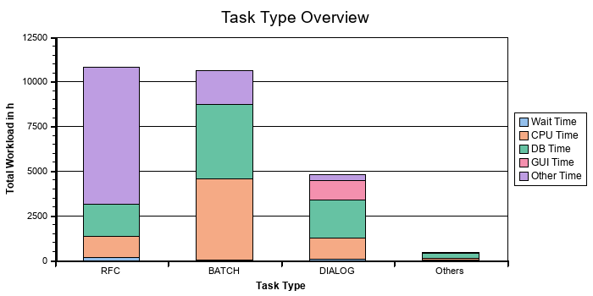
Response Time Components In Hours
Task Type | Response Time | Wait Time | CPU Time | DB Time | GUI Time
RFC | 10.811,0 | 173,9 | 1.193,0 | 1.786,5 | 0,0
BATCH | 10.615,9 | 0,7 | 4.562,0 | 4.172,2 | 0,0
DIALOG | 4.802,1 | 69,8 | 1.194,8 | 2.123,7 | 1.068,4
Others | 445,3 | 22,0 | 105,6 | 257,5 | 0,0

Workload By Users
User activity is measured in the workload monitor. Only users of at least medium activity are counted as 'active users'.
Users | Low Activity | Medium Activity | High Activity | Total Users
dialog steps per week | 1 to 399 | 400 to 4799 | 4800 or more
measured in system | 19395 | 9430 | 981 | 29806

Workload Distribution PRD
The performance of your system was analyzed with respect to the workload distribution. We did not detect any major problems that could affect the performance of your SAP system.

Workload Distribution across ABAP Application Servers
To prevent a workload imbalance on one or more servers, we have analyzed the workload statistics for each SAP instance in your SAP production system.
If your total hardware capacity is sufficient to handle your peak workload, an overload on one or more servers can increase response times for all users logged on to those servers. If the affected servers are running updates or a database instance, all users can be affected.
The following diagrams show the system workload distribution across all instances. We strongly recommend that you distribute the workload equally across all application servers.
The following aspects of the workload are evaluated below:
- The total number of transaction steps performed on the different servers
- The percentage of CPU time consumed by SAP applications running on the different servers
If the workload is distributed equally, the distribution of CPU time should be proportional to the number of CPUs on the different servers.
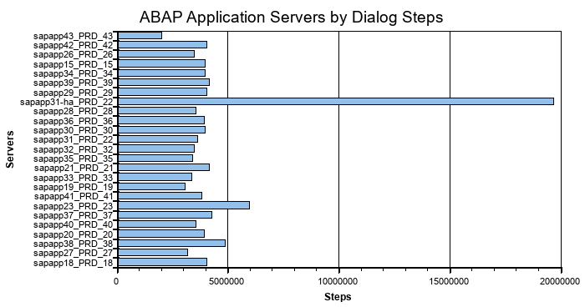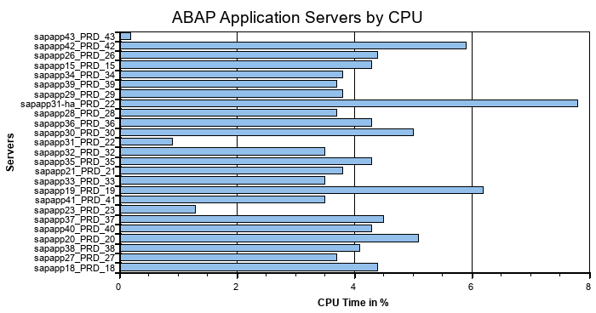
Note that your database capacity is limited by the database server hardware available. This is important, since your database is a central resource for all system activities. In contrast, application servers are not a central resource and affect only the users on that particular server. CPU shortages can be solved by improving the workload distribution or by adding a new application server. For information about automatic load balancing, refer to SAP Note 26317.

Workload by Application Module
The following diagrams show how each application module contributes to the total system workload. Two workload aspects are shown:
- CPU time: total CPU load on all servers in the system
- Database time: total database load generated by the application
All programs that are not classified in the Application Hierarchy are summarized in the "Unassigned" category. Customer programs, industry solutions, and third-party add-on developments may fall into this category.
The Application Hierarchy can be found in the Repository Browser (transaction SE80): in the "Object Category" selection field choose "Application Hierarchy".
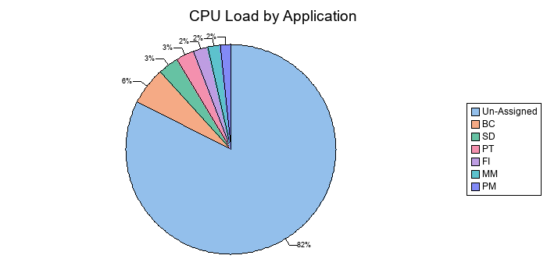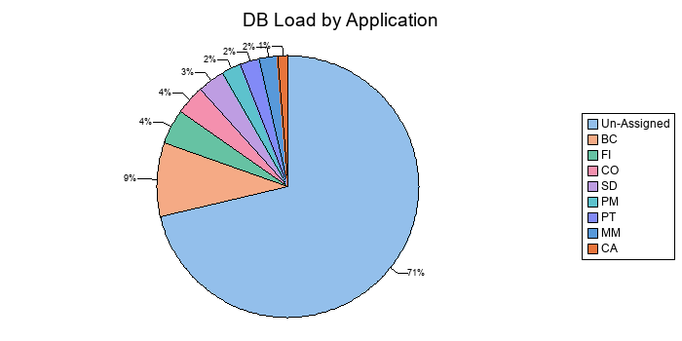

DB Load Profile
The number of work processes creating database load in parallel is not significantly high.

The following diagram shows the DB load caused by dialog, RFC, HTTP(S), and background tasks, over different time frames.
The data provided in the diagram represents the average number of database processes occupied by each task type in the database during the specified time frames.
These statistics are calculated as a weekly average, the average values over six working days with a unit of one hour. Periods between 00:00-06:00 and 21:00-24:00 contain an average value per hour, as these are not core business hours.
You can enable 24-hour monitoring by implementing SAP Note 910897. With 24-hour monitoring, the time profile returns the workload of the system or application server on an hourly basis rather than returning an average value per hour for the periods 00:00–06:00 and 21:00–24:00.
By comparing the load profiles for dialog and background activity, you can get an overview of the volume of background activity during online working hours.
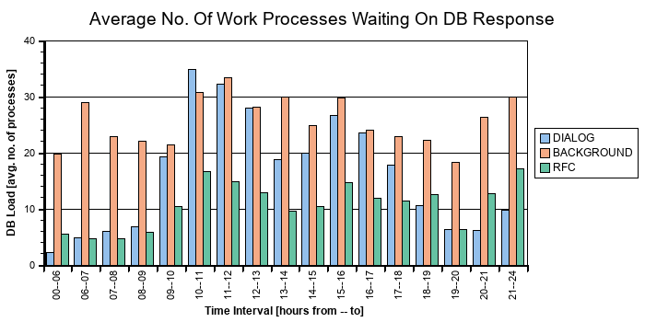

Performance Overview PRD
 | The performance of your system was analyzed with respect to the average response times and total workload. We did not detect any major problems that could affect the performance of your system.

Note: To access the response time statistics in SAP EarlyWatch Alert Workspace, click system response time
The following table shows the average response times for various task types:
Averages of Response Time Components in ms
Task type | Dialog Steps | Response Time | CPU Time | Wait Time | Load Time | DB Time | GUI Time
DIALOG | 15.220.527 | 1.135,8 | 282,6 | 16,5 | 3,0 | 502,3 | 252,7
RFC | 71.940.058 | 541,0 | 59,7 | 8,7 | 1,0 | 89,4 | 0,0
UPDATE | 7.260.789 | 130,4 | 36,8 | 1,1 | 2,9 | 84,3 | 0,0
UPDATE2 | 2.104.504 | 90,7 | 12,6 | 3,7 | 1,2 | 71,5 | 0,0
BATCH | 4.853.064 | 7.874,8 | 3.384,1 | 0,5 | 27,8 | 3.094,9 | 0,0
SPOOL | 374.913 | 528,9 | 28,5 | 29,4 | 0,5 | 145,0 | 0,0
HTTP | 993.997 | 75,8 | 10,6 | 39,7 | 1,4 | 13,4 | 0,0
HTTPS | 264.561 | 196,8 | 45,0 | 16,4 | 2,3 | 81,5 | 0,0
WS-HTTP | 469.732 | 296,0 | 113,2 | 17,9 | 4,6 | 159,9 | 0,0

44% of the total response time is database time. If the dialog response time lies outside the acceptable boundaries and you are unhappy with overall system performance, investigate the reason for the high database times.
More than 200 ms of the dialog response time is caused by GUI time. High GUI time can be caused by poor network performance.
Perform a LAN Ping check via ST06 with a package size of 4096 bytes. The reference response times are:
- In a local area network (LAN: < 20 milliseconds
- In a Wide Area Network (WAN): < 50 milliseconds
- With a modern connection (for example, 56 KB): < 250 milliseconds
- There should be no loss of data package.
For further analysis, use NIPING as per SAP Note 500235 – Network Diagnosis with NIPING. If necessary, contact your network partner to improve the network throughput.
Other optimization options:
Low-Speed Connection
In WAN (wide area network) environments, switch the network communication between the GUI and the application level to Low Speed Connection.
This will reduce the volume of data transferred per dialog step (see SAP Note 164102). You can activate the low-speed connection in the SAP logon window by selecting the entry for an SAP system and selecting the "Low Speed Connection" option in the Properties Advanced menu option.
SAP Easy Access Menu
1) Restrict the number of transactions in a user role (ideally 1,000 or fewer).
2) Avoid widely used background images in SAP Easy Access menu (which should be no larger than 20 KB).
Please refer to SAP Note 2428353 for details on how to analysis high GUI times on SAP systems.

Performance Evaluation
The measured times are compared against reference times to provide a rating.
- If the number of dialog steps in an hour is less than 1000, this hour is not considered.
- If the total number of transaction steps is less than 20000, the rating for the task is not performed (indicated by a gray icon in the table).
- RED if at least three time ranges are rated RED.
- YELLOW if two time ranges are rated RED or at least three time ranges are rated YELLOW.
The table below shows that no problem is expected on the application or database servers.
Task | Steps | Application Server Performance | Database Server Performance
Dia | 15.187.268
Upd | 7.260.789
HTTP | 993.997
HTTPS | 264.561

Rating | Task Type | Time | Dialog Steps | Response Time | CPU Time | DB Time
 | Dia | 10-11 | 1.386.897,0 | 1.379,0 | 323,0 | 632,0
 | Dia | 13-14 | 880.913,0 | 1.211,0 | 355,0 | 536,0

The ratings in the table above are determined by comparisons against the reference table below.
If the dialog response times are very poor, it will cause a RED rating for the entire check.
Task | Reference for Avg. Response Time (ms) Yellow Rating | Reference for Avg. Response Time (ms) Red Rating | Reference for Avg. DB time (ms) Yellow Rating | Reference for Avg. DB time (ms) Red Rating
Dia | 1.200 | 3.600 | 600 | 1.800
Upd | 2.400 | 3.600 | 1.200 | 1.800
HTTP | 1.200 | 3.600 | 600 | 1.800
HTTPS | 1.200 | 3.600 | 600 | 1.800

Transaction Profile Check
The following tables show the response times and the number of dialog steps for the transactions that cause the heaviest workload in your system.

Transactions by Total Workload
To access the transaction response time in SAP EarlyWatch Alert Workspace, click here.
The following tables list the activities with the highest contribution to the total workload.
Workload by Transaction (Dialog/HTTP(S)/WS-HTTP )
Transaction | Type | Dialog Steps | Total Resp. Time in % | Avg. Resp. Time in ms | Avg. CPU Time in ms | Avg. DB Time in ms | Avg. GUI Time in ms
/OPT/VIM_WP | DIA | 874.368 | 2,9 | 1.920,9 | 444,6 | 999,4 | 341,1
ZSSNEW | DIA | 169.525 | 1,6 | 5.297,8 | 2.109,0 | 2.671,6 | 897,3
SESSION_MANAGER | DIA | 673.546 | 0,8 | 670,3 | 39,5 | 108,1 | 411,0
VA02 | DIA | 317.672 | 0,7 | 1.197,9 | 181,4 | 479,9 | 113,0
FBL3N | DIA | 65.271 | 0,5 | 4.818,1 | 1.578,7 | 3.265,3 | 420,8
VA01 | DIA | 373.529 | 0,5 | 793,5 | 115,6 | 586,3 | 82,1
ZLOGSHEET1 | DIA | 4.210 | 0,5 | 68.621,6 | 43.060,7 | 26.466,3 | 0,0
ME23N | DIA | 382.539 | 0,5 | 702,0 | 100,2 | 182,3 | 357,2
YSTOCKN | DIA | 17.261 | 0,4 | 14.596,3 | 4.582,4 | 9.149,1 | 899,5
WCTL | DIA | 309.693 | 0,4 | 808,2 | 169,6 | 367,3 | 212,5

2.5% of the total response time in the above table is caused by customer transactions.
Workload by Transaction (Batch)
Transaction | Dialog Steps | Total Resp. Time in % | Total Resp. Time in s | Total CPU Time in s | Total DB Time in s
ZMFAR_FBL3N_GRIR_TEST | 389 | 2,3 | 1.311.331,0 | 1.195.921,0 | 126.849,3
YMPIR_MODIFY_YMPIT_MRO_ORDTRK | 271 | 2,2 | 1.274.974,0 | 622.906,0 | 720.093,1
RPTIME00 | 1.049 | 2,1 | 1.212.642,0 | 628.071,0 | 618.096,3
ZQEVAI30 | 4.394 | 2,0 | 1.158.150,0 | 411.450,0 | 1.010.876,5
YMFAR_COLLECTION_PENDINGSETOFF | 34 | 1,8 | 1.029.908,0 | 1.012.082,0 | 19.956,5
YBASR_AUTH_DISPLAY | 66 | 1,8 | 1.027.907,0 | 1.003.962,0 | 13.107,8
ZCRMB_STOCK | 386 | 1,4 | 823.578,0 | 494.840,0 | 371.016,2
YMPCI_FPC_GR_POST | 37.480 | 1,4 | 818.804,0 | 67.063,0 | 184.237,9
YMQMR_TC_FAILURE_BATCHES | 54 | 1,3 | 720.119,0 | 185.341,0 | 655.943,6
EDOC_BACKGROUND | 77.416 | 1,3 | 716.767,0 | 29.328,0 | 81.646,5

14.2% of the total response time in the above table is caused by customer transactions.
Workload by Web Services
Service | Calls | Total Resp. Time in % | Avg. Resp. Time in ms | Avg. CPU Time in ms | Avg. DB Time in ms | Type
Total | 658.562 | 100,0 | 706,6 | 127,0 | 250,2
YMSDP_100082_II_STOCKYARDDTLS | 3.008 | 28,0 | 43.316,4 | 125,4 | 335,7 | asynchronous
YMSDI_100092_II_PO_RELEASE | 294 | 13,9 | 219.461,4 | 1.377,7 | 4.001,9 | asynchronous
YMPII_100024_CD_II_SI_IS_CONTR | 100.183 | 11,4 | 528,9 | 233,3 | 464,6 | synchronous
YOMSI_100002_II_SI_IA_ORDER_RE | 60.791 | 4,6 | 349,8 | 93,1 | 243,7 | asynchronous
YMSD_100012_CAPL_II_SI_IA_AUTO | 147 | 4,2 | 132.366,1 | 18.942,6 | 116.024,4 | asynchronous
YMCRM_100037II_CR2HR_TDC_CRMIS | 1.735 | 3,3 | 8.930,9 | 1.779,1 | 4.093,0 | asynchronous
YMPII_100039_II_SI_IS_TAX_BRE1 | 20.855 | 2,5 | 547,0 | 366,9 | 132,3 | synchronous
YMCRMI_10037_II_TDC_PO_CRIMIS | 1.709 | 2,0 | 5.520,5 | 1.175,4 | 2.693,0 | asynchronous
YMSDI_100008_II_ORDER_CREATION | 2.660 | 2,0 | 3.428,5 | 310,0 | 3.113,5 | synchronous
YIUSC1_100017II_SI_IA_SERVICE | 58 | 1,6 | 128.419,8 | 3.116,4 | 10.435,8 | asynchronous

Transactions by DB Load
The following transaction profiles list the transactions that have the greatest share in the database load, sorted by percentage of total database access times.
Database Load by Transactions (Dialog/HTTP(S) )
Transaction | Type | Dialog Steps | Total DB Time in % | Avg. DB Time in ms
/OPT/VIM_WP | DIA | 874.368 | 3,7 | 999,4
ZSSNEW | DIA | 169.525 | 1,9 | 2.671,6
VA01 | DIA | 373.529 | 0,9 | 586,3
FBL3N | DIA | 65.271 | 0,9 | 3.265,3
YSTOCKN | DIA | 17.261 | 0,7 | 9.149,1
VA02 | DIA | 317.672 | 0,6 | 479,9
YHRPD022 | DIA | 2.109 | 0,6 | 70.733,5
YMSTB | DIA | 20.915 | 0,6 | 6.780,9
ZVSOSTATUS | DIA | 51.967 | 0,6 | 2.721,2
YSTOCKN_V2 | DIA | 36.479 | 0,6 | 3.767,0

5.0% of the total database time in the above table is caused by customer transactions.
If average database times are outside acceptable boundaries and you are unhappy with the performance of a transaction, contact your in-house developers about possible optimization potential and open a message under component SV-PERF if required.
Database Load by Transactions (Batch)
Transaction | Dialog Steps | Total DB Time in % | Total DB Time in s
ZQEVAI30 | 4.394 | 4,3 | 1.010.876,0
YMPIR_MODIFY_YMPIT_MRO_ORDTRK | 271 | 3,1 | 720.093,0
YMQMR_TC_FAILURE_BATCHES | 54 | 2,8 | 655.944,0
RPTIME00 | 1.049 | 2,6 | 618.096,0
ZPPNV_WIP_KPHNEW | 30 | 2,3 | 542.734,0
RFITEMGL | 440 | 1,7 | 408.306,0
YMPCR_STOCK_REPORT_HANA_V2 | 874 | 1,6 | 375.700,0
ZCRMB_STOCK | 386 | 1,6 | 371.016,0
YMPCI_FPC_ACT_GI_POST | 17.276 | 1,4 | 329.270,0
YCTDI_SD_DATA_TRANSFER | 9.207 | 1,3 | 301.751,0

18.4% of the total database time in the above table is caused by customer transactions.

RFC Load by Initiating Action
The load in task type RFC is shown. In the workload monitor, this information is shown as 'Load from External Systems'. The calling system can be an application server of the system itself or any external system using the RFC interface. The 'Initial Action' is the calling program initiating the RFC. The total response time for each initial action is shown as an absolute value and as a percentage compared to the total RFC load considered in this table. The average times (per dialog step) are shown in milliseconds [ms].
Calls from external systems are shown if they account for at least 8h or 5% of the total RFC load. Local calls are shown if they account for at least 24h or 20% of the total RFC load.
Load Overview
Initial System | Load [s] | Load %
Local system PRD | 22.025.795 | 59,87
Sum of external systems | 14.762.852 | 40,13
SLT Load (Part of Sum of external systems) | 9.893.723 | 26,89
n/a (not available) | 322 | 0,00
RFC load (sum of above) | 36.788.969 | 100,00
RFC load in Performance Overview | 38.922.419 | 105,80
Load of all task types in Performance Overview | 122.323.588 | 332,50

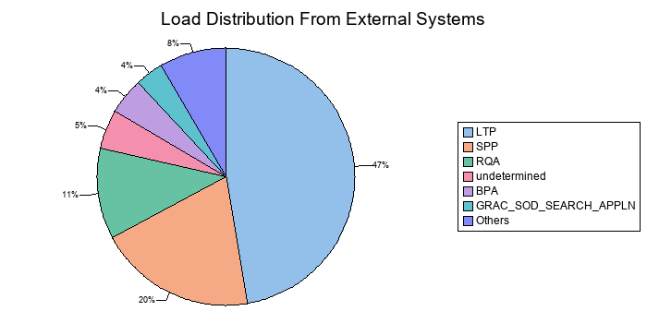
Top 20 RFC Calls From External Systems - Average Times [ms]
Initial System | Initial Action | Total Resp. Time in s | % of RFC Load | Avg. Response Time | Avg. CPU Time | Avg. DB Time | Avg. Roll Wait Time
LTP | /1LT/IUC_LOAD_MT_01K_001 | 1.492.862 | 4,06 | 588,0 | 99,7 | 106,1 | 0,2
LTP | /1LT/IUC_LOAD_MT_002_001 | 711.155 | 1,93 | 444,6 | 20,6 | 40,1 | 0,2
LTP | /1LT/IUC_LOAD_MT_009_001 | 627.469 | 1,71 | 399,6 | 20,6 | 37,0 | 0,2
SPP | /1LT/IUC_LOAD_MT_009_001 | 601.717 | 1,64 | 813,3 | 35,1 | 52,2 | 0,1
undetermined | undetermined_startup_0 | 594.638 | 1,62 | 270,2 | 38,0 | 118,2 | 12,1
LTP | /1LT/IUC_LOAD_MT_001_001 | 530.582 | 1,44 | 614,2 | 15,7 | 37,5 | 0,4
SPP | /1LT/IUC_LOAD_MT_003_001 | 504.176 | 1,37 | 967,6 | 9,5 | 20,2 | 0,2
SPP | /1LT/IUC_LOAD_MT_00A_001 | 480.369 | 1,31 | 904,8 | 23,9 | 40,9 | 0,2
SPP | /1LT/IUC_LOAD_MT_002_001 | 471.156 | 1,28 | 1.037,2 | 16,7 | 82,1 | 0,2
SPP | /1LT/IUC_LOAD_MT_005_001 | 420.967 | 1,14 | 1.022,1 | 16,9 | 79,5 | 0,2
LTP | /1LT/IUC_LOAD_MT_01F_001 | 381.320 | 1,04 | 1.294,7 | 312,4 | 143,9 | 0,9
RQA | 5CF3FCEB1CD81ED880977295CE7A0785 | 378.869 | 1,03 | 573,8 | 22,7 | 50,1 | 0,4
LTP | /1LT/IUC_LOAD_MT_009_002 | 326.106 | 0,89 | 401,8 | 20,6 | 37,7 | 0,2
RQA | GRAC_REP_OBJ_SYNC_ECC | 249.746 | 0,68 | 83.891,7 | 13.442,3 | 67.701,6 | 536,9
RQA | GRAC_ACTION_USAGE_SYNC | 246.439 | 0,67 | 68.684,3 | 10.819,2 | 70,2 | 0,7
RQA | GRAC_ACTION_USAGE_ECC | 242.865 | 0,66 | 61.687,8 | 9.811,6 | 43,2 | 0,5
LTP | /1LT/IUC_LOAD_MT_01H_001 | 199.029 | 0,54 | 1.193,8 | 266,3 | 89,0 | 1,5
LTP | /1LT/IUC_LOAD_MT_01K_002 | 197.802 | 0,54 | 601,4 | 106,0 | 108,5 | 0,2
LTP | /1LT/IUC_LOAD_MT_01D_001 | 191.179 | 0,52 | 369,6 | 6,8 | 13,4 | 0,7
GRAC_SOD_SEARCH_APPLN | 005056ADFC181EDD8CA4680F10EBFCC6 | 188.212 | 0,51 | 666,2 | 75,9 | 79,3 | 5,2

Top 20 RFC Calls From Local System - Average Times [ms]
Initial System | Initial Action | Total Resp. Time in s | % of RFC Load | Avg. Response Time | Avg. CPU Time | Avg. DB Time | Avg. Roll Wait Time
PRD | SAPMSSY1 | 5.423.004 | 14,74 | 4.516,6 | 1.382,4 | 634,3 | 248,4
PRD | /OPT/VIM_WP | 3.391.005 | 9,22 | 501,1 | 18,6 | 78,3 | 1,0
PRD | /SDF/MON_SCHEDULER | 785.946 | 2,14 | 4.569.451,2 | 10.187,7 | 220.375,5 | 1.763,0
PRD | RSARFCEX | 753.394 | 2,05 | 67,7 | 8,1 | 7,0 | 0,3
PRD | /SDF/SMON_SCHEDULER | 669.686 | 1,82 | 4.650.599,6 | 15.905,8 | 323.723,9 | 4.961,4
PRD | SECM_LOG_2_ESP | 513.528 | 1,40 | 808,6 | 205,5 | 19,7 | 1,5
PRD | YSTD | 426.740 | 1,16 | 1.689,5 | 17,4 | 31,0 | 0,2
PRD | YEPA_SCO_CREATE_KPO | 412.727 | 1,12 | 4.782,8 | 32,1 | 66,6 | 0,4
PRD | YMPIR_IBSC_STARS_INTERFACE | 345.852 | 0,94 | 653,3 | 29,5 | 67,6 | 0,1
PRD | TUBE_STO_CLOSE | 334.177 | 0,91 | 40.599,8 | 23,4 | 33,9 | 0,2
PRD | VIM_BC_INBOUND_PROCESSING | 275.961 | 0,75 | 677,0 | 157,4 | 178,0 | 0,2
PRD | YMT_EPA_SCO_CREATE | 256.696 | 0,70 | 3.309,5 | 31,4 | 60,7 | 0,2
PRD | YMPIR_SD_AUTO_IV_POST | 219.499 | 0,60 | 3.653,4 | 24,4 | 41,6 | 0,7
PRD | YMPIR_MM_MRP_INSURANCE_BG | 204.065 | 0,55 | 194,7 | 10,9 | 17,3 | 0,3
PRD | YMPIR_CREATE_SES_EBUY | 201.989 | 0,55 | 249,1 | 29,1 | 53,4 | 0,2
PRD | FPGR_POST_116_SLAB_A | 175.445 | 0,48 | 354,2 | 9,9 | 24,1 | 0,2
PRD | YMSDR_EPA_SCOCRT_TUBES | 171.799 | 0,47 | 4.222,5 | 31,0 | 55,8 | 0,3
PRD | TSBAN_MO_SETTLEMENT_IRON MAKING | 154.739 | 0,42 | 4.411,8 | 212,7 | 3.496,6 | 111,2
PRD | TSBAN_MO_SETTLEMENT_MILLS | 147.260 | 0,40 | 4.245,2 | 192,6 | 3.398,8 | 84,9
PRD | SAP_COLLECTOR_PERFMON_SWNCCOLL | 145.875 | 0,40 | 3.078,0 | 2.414,4 | 296,3 | 0,8

SAP System Operating PRD
 | We analyzed the daily operation of your system and detected severe problems that may have a serious financial impact on your business.

Rating | Check
 | Availability based on Collector Protocols
 | Program Errors (ABAP Dumps)
 | Update Errors
 | Table Reorganization
 | Critical Number Ranges
 | Number Range Trace
 | Exhausted Number Range Buffers
 | DDLOG Sequence Exhaustion may cause unplanned downtime

Availability based on Collector Protocols
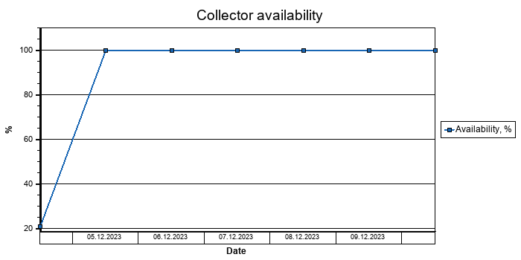
A value of 100% means that the collector was available all day. "Available" in the context of this report means that at least one SAP instance was running. If the SAP collector was not running correctly, the values in the table and graphics may be incorrect.
To check these logs, call transaction ST03N (expert mode) and choose "Collector and Performance DB -> Performance Monitor Collector -> Log".
This check is based on the logs for job COLLECTOR_FOR_PERFORMANCEMONITOR that runs every hour.
The job does NOT check availability; it carries out only general system tasks such as collecting and aggregating SAP performance data for all servers/instances. The log does not contain any direct information about availability; it contains only information about the status of the hourly statistical data collection.
As of SAP Basis 6.40, system availability information is available in the CCMS (Computing Center Management System) of an SAP System, in Service Level Reporting of SAP Solution Manager.
This function is provided by the relevant Solution Manager Support Packages as an advanced development. For more information, refer to SAP Note 944496, which also lists the prerequisites that must be fulfilled before implementation can take place."

Update Errors
In a system running under normal conditions, only a small number of update errors should occur. To set the rating for this check, the number of active users is also taken into consideration. The following table contains the number of update errors detected.
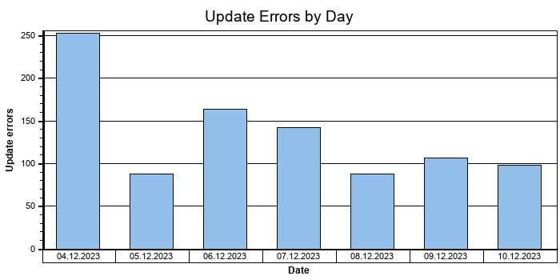
We have detected 939 update errors.
Recommendation: Check the update errors periodically with the corresponding application teams according to SAP Note 1510367. This is in order to determine whether an update record can be updated again, depending on what action has already been taken by the affected users.
Implementation: Problems during the processing of update requests can be checked in the syslog and the database log files; refer to the relevant SAP Notes.
Note: To select the update errors in transaction SM13, enter the following values:
- Client = *
- User = *
- From date back = one year

Table Reorganization
When analyzing your database, we detected large or rapidly growing tables or indexes.
Recommendation: Implement the SAP Notes listed below to reduce the size of some of these tables or indexes.
Background: For more information about SAP Data Volume Management, see SAP DVM wiki.
Table / Index Name | Size of Table / Index [MByte] | Recommended SAP Note
ACCTCR | 123.504,0 | 178476, 48009
APQD | 20.762,0 | 36781, 18307
ARFCSDATA | 9.723,0 | 375566
TST03 | 94.710,0 | 48400, 130978, 16083

Program Errors (ABAP Dumps)
26070 ABAP dumps have been recorded in your system in the period 04.10.2025 to 11.10.2025. ABAP dumps are generally deleted after 7 days by default. To view the ABAP dumps in your system, call transaction ST22 and choose Selection. Then select a timeframe.
Date | Number of Dumps
04.10.2025 | 1.411
05.10.2025 | 4.747
06.10.2025 | 4.891
07.10.2025 | 4.363
08.10.2025 | 3.774
09.10.2025 | 3.290
10.10.2025 | 3.048
11.10.2025 | 546

Name of Runtime Error | Dumps | Server (e.g.) | Date (e.g.) | Time (e.g.)
CONNE_IMPORT_WRONG_COMP_TYPE | 1 | sapapp28_PRD_28 | 04.10.2025 | 02:16:27
DBIF_RSQL_SQL_ERROR | 3 | sapapp43_PRD_43 | 04.10.2025 | 23:52:13
DBIF_RTAB_SQL_ERROR | 3 | sapapp18_PRD_18 | 04.10.2025 | 23:55:28
FIND_INFINITE_LOOP | 1 | sapapp37_PRD_37 | 05.10.2025 | 09:42:11
SAPSQL_NO_ROLL | 1 | sapapp26_PRD_26 | 05.10.2025 | 10:01:37
CALL_DIALOG_CONTAINER_MISSING | 1 | sapapp40_PRD_40 | 05.10.2025 | 11:47:31
TSV_BTR_PAGE_ALLOC_FAILED | 2 | sapapp32_PRD_32 | 05.10.2025 | 12:06:25
SAPSQL_IN_ITAB_ILLEGAL_SIGN | 2 | sapapp27_PRD_27 | 05.10.2025 | 18:47:33
OPEN_DATASET_NO_AUTHORITY | 1 | sapapp30_PRD_30 | 06.10.2025 | 10:21:23
CATCH_ILLEGAL_STATE | 1 | sapapp33_PRD_33 | 06.10.2025 | 15:02:50
PERFORM_PARAMETER_MISSING | 1 | sapapp38_PRD_38 | 06.10.2025 | 15:20:47
RFCGUI_UNEXPECTED_DATA | 1 | sapapp20_PRD_20 | 06.10.2025 | 21:23:58
COMMIT_IN_POSTING | 61 | sapapp20_PRD_20 | 07.10.2025 | 10:16:27
PERFORM_NOT_FOUND | 4 | sapapp31-ha_PRD_22 | 07.10.2025 | 11:45:01
ITAB_DUPLICATE_KEY | 3 | sapapp26_PRD_26 | 07.10.2025 | 12:37:42
ASSERTION_FAILED | 23 | sapapp21_PRD_21 | 07.10.2025 | 13:05:50
TYPELOAD_NEW_VERSION | 248 | sapapp41_PRD_41 | 07.10.2025 | 14:58:22
TSV_ILLEGAL_REFERENCE | 1 | sapapp41_PRD_41 | 07.10.2025 | 16:05:41
TSV_LIN_ALLOC_FAILED | 7 | sapapp42_PRD_42 | 07.10.2025 | 16:16:17
REFS_NOT_SUPPORTED_YET | 2 | sapapp18_PRD_18 | 07.10.2025 | 19:32:45
TSV_TNEW_BLOCKS_NO_ROLL_MEMORY | 7 | sapapp39_PRD_39 | 07.10.2025 | 22:02:12
OBJECTS_NOT_CHARLIKE | 5 | sapapp21_PRD_21 | 07.10.2025 | 22:24:44
OBJECTS_OBJREF_NOT_ASSIGNED_NO | 5 | sapapp34_PRD_34 | 07.10.2025 | 22:50:54
STRING_OFFSET_TOO_LARGE | 2 | sapapp21_PRD_21 | 08.10.2025 | 10:10:24
DBSQL_NO_MORE_CONNECTION | 50 | sapapp41_PRD_41 | 08.10.2025 | 10:39:31
CALL_FUNCTION_REMOTE_ERROR | 3 | sapapp15_PRD_15 | 08.10.2025 | 14:07:24
TABLE_LINE_NOT_EXISTING | 1 | sapapp30_PRD_30 | 08.10.2025 | 14:41:35
SYSTEM_ABAP_ACCESS_DENIED | 6 | sapapp41_PRD_41 | 08.10.2025 | 15:46:31
DBIF_DSQL2_OBJ_UNKNOWN | 35 | sapapp29_PRD_29 | 08.10.2025 | 15:53:44
DYNPRO_SEND_IN_BACKGROUND | 148 | sapapp15_PRD_15 | 08.10.2025 | 15:58:28
SYSTEM_ON_COMMIT_INTERRUPTED | 8 | sapapp34_PRD_34 | 08.10.2025 | 16:09:52
PERFORM_CONFLICT_TYPE | 5 | sapapp38_PRD_38 | 08.10.2025 | 16:11:59
CONV_EXIT_FIELD_TOO_SHORT | 8 | sapapp31_PRD_22 | 08.10.2025 | 16:42:16
TABLE_INVALID_INDEX | 9 | sapapp31-ha_PRD_22 | 08.10.2025 | 18:27:24
COMPUTE_BCD_OVERFLOW | 18 | sapapp15_PRD_15 | 08.10.2025 | 19:32:11
EXSORT_FWRITE_FAILED | 1 | sapapp41_PRD_41 | 08.10.2025 | 19:41:10
COLLECT_OVERFLOW_TYPE_P | 5 | sapapp15_PRD_15 | 08.10.2025 | 19:45:31
DYNPRO_NOT_FOUND | 9 | sapapp36_PRD_36 | 09.10.2025 | 03:02:42
SYSTEM_NO_MEMORY | 1 | sapapp27_PRD_27 | 09.10.2025 | 10:05:24
SAPSQL_DATA_LOSS | 33 | sapapp41_PRD_41 | 09.10.2025 | 10:28:55
OBJECTS_OBJREF_NOT_ASSIGNED | 12 | sapapp37_PRD_37 | 09.10.2025 | 10:46:18
DBSQL_SQL_DEADLOCK_DETECTED | 13 | sapapp34_PRD_34 | 09.10.2025 | 12:00:12
DYNP_TOO_MANY_RADIOBUTTONS_ON | 5 | sapapp30_PRD_30 | 09.10.2025 | 12:05:21
LOAD_PROGRAM_TABLE_MISMATCH | 1 | sapapp34_PRD_34 | 09.10.2025 | 14:59:35
GETWA_NO_MEM | 1 | sapapp38_PRD_38 | 09.10.2025 | 15:21:47
SAPSQL_STMNT_TOO_LARGE | 19 | sapapp26_PRD_26 | 09.10.2025 | 16:39:36
DBSQL_SQL_ERROR | 51 | sapapp18_PRD_18 | 09.10.2025 | 16:53:38
LOAD_NO_SPACE_FOR_TABLE | 5 | sapapp34_PRD_34 | 09.10.2025 | 17:24:26
TCHK_MOVE_CORRESPONDING | 4 | sapapp34_PRD_34 | 09.10.2025 | 17:38:45
SYSTEM_CORE_DUMPED | 10 | sapapp15_PRD_15 | 09.10.2025 | 20:16:28
DBSQL_STMNT_TOO_LARGE | 55 | sapapp28_PRD_28 | 09.10.2025 | 20:40:25
BCD_FIELD_OVERFLOW | 64 | sapapp15_PRD_15 | 09.10.2025 | 21:29:13
DBIF_DSQL2_SQL_ERROR | 7 | sapapp30_PRD_30 | 10.10.2025 | 06:30:07
CALL_FUNCTION_NOT_FOUND | 74 | sapapp34_PRD_34 | 10.10.2025 | 10:50:58
MESSAGE_TYPE_UNKNOWN | 3 | sapapp34_PRD_34 | 10.10.2025 | 11:49:27
CALL_FUNCTION_CONFLICT_TYPE | 12 | sapapp41_PRD_41 | 10.10.2025 | 12:20:20
RABAX_CALLING_RABAX | 2 | sapapp21_PRD_21 | 10.10.2025 | 13:24:19
MEMORY_NO_MORE_PAGING | 37 | sapapp18_PRD_18 | 10.10.2025 | 13:37:29
CONVT_OVERFLOW | 57 | sapapp27_PRD_27 | 10.10.2025 | 14:29:30
CALL_TRANSACTION_NOT_FOUND | 19 | sapapp34_PRD_34 | 10.10.2025 | 15:55:04
LOAD_PROGRAM_NOT_FOUND | 41 | sapapp18_PRD_18 | 10.10.2025 | 16:33:34
SYNTAX_ERROR | 19 | sapapp37_PRD_37 | 10.10.2025 | 17:11:15
DYNPRO_MSG_IN_HELP | 34 | sapapp28_PRD_28 | 10.10.2025 | 18:00:56
LIST_TOO_MANY_LPROS | 128 | sapapp36_PRD_36 | 10.10.2025 | 18:21:27
DATA_OFFSET_TOO_LARGE | 22 | sapapp37_PRD_37 | 10.10.2025 | 18:23:24
TABLE_ILLEGAL_STATEMENT | 20 | sapapp37_PRD_37 | 10.10.2025 | 18:50:08
IMPORT_WRONG_END_POS | 3 | sapapp26_PRD_26 | 10.10.2025 | 19:10:38
SAPSQL_PARSE_ERROR | 14 | sapapp31-ha_PRD_22 | 10.10.2025 | 19:20:02
CALL_FUNCTION_PARM_MISSING | 78 | sapapp20_PRD_20 | 10.10.2025 | 19:22:24
UNCAUGHT_EXCEPTION | 314 | sapapp26_PRD_26 | 10.10.2025 | 19:40:04
CALL_TRANSACTION_NO_AUTH | 82 | sapapp18_PRD_18 | 10.10.2025 | 19:45:27
MESSAGE_TYPE_X | 163 | sapapp38_PRD_38 | 10.10.2025 | 21:46:50
GETWA_NOT_ASSIGNED | 51 | sapapp15_PRD_15 | 10.10.2025 | 22:22:03
DBSQL_DUPLICATE_KEY_ERROR | 377 | sapapp20_PRD_20 | 10.10.2025 | 23:51:03
DATA_OFFSET_NEGATIVE | 43 | sapapp20_PRD_20 | 10.10.2025 | 23:51:36
DBSQL_ILLEGAL_CLIENT_SPECIFIED | 117 | sapapp33_PRD_33 | 11.10.2025 | 00:01:02
SYSTEM_NO_ROLL | 237 | sapapp31-ha_PRD_22 | 11.10.2025 | 00:04:54
TSV_TABH_POOL_NO_ROLL_MEMORY | 78 | sapapp31-ha_PRD_22 | 11.10.2025 | 00:11:17
SESSIONMEM_QUOTA_WARNING | 841 | sapapp31-ha_PRD_22 | 11.10.2025 | 00:15:32
TSV_TNEW_OCCURS_NO_ROLL_MEMORY | 128 | sapapp31-ha_PRD_22 | 11.10.2025 | 00:16:03
CALL_FUNCTION_SEND_ERROR | 3.425 | sapapp31-ha_PRD_22 | 11.10.2025 | 00:33:44
TIME_OUT | 538 | sapapp33_PRD_33 | 11.10.2025 | 01:01:33
BCD_ZERODIVIDE | 10 | sapapp36_PRD_36 | 11.10.2025 | 02:00:19
CONVT_NO_NUMBER | 338 | sapapp36_PRD_36 | 11.10.2025 | 03:30:37
CONNE_IMPORT_WRONG_COMP_LENG | 15 | sapapp27_PRD_27 | 11.10.2025 | 03:52:36
RAISE_EXCEPTION | 260 | sapapp39_PRD_39 | 11.10.2025 | 04:57:46
ITAB_LINE_NOT_FOUND | 2.585 | sapapp15_PRD_15 | 11.10.2025 | 05:20:47
RFC_NO_AUTHORITY | 4.499 | sapapp31_PRD_22 | 11.10.2025 | 05:30:06
TSV_TNEW_PAGE_ALLOC_FAILED | 4.704 | sapapp39_PRD_39 | 11.10.2025 | 05:42:09
SQL_CAUGHT_RABAX | 3.852 | sapapp39_PRD_39 | 11.10.2025 | 05:42:11
DYNPRO_FIELD_CONVERSION | 1.877 | sapapp37_PRD_37 | 11.10.2025 | 05:44:50

It is important that you monitor ABAP dumps using transaction ST22 on a regular basis. If ABAP dumps occur, you should determine the cause as soon as possible.
Based on our analysis, we found several ABAP dumps that need your attention. Evaluate and resolve the above dumps. If you cannot find a solution, send a customer message to SAP to request support.

Critical Number Ranges
We have checked the usage of ABAP number ranges and found some that have already been used 90% or more.
The object names in column "Object" are provided with a direct link into the analysis of number ranges in the EarlyWatch Alert Workspace. There you can view the time series of the number range and a predicted worst-case date when the number range may be exhausted, provided that enough data is already available.
Rating | Client | % Used | % Warning | Object | Short text | Subobject | Interval | To Year | Length | Remaining Numbers | Rolling (Yes/No) | # per Week
 | 600 | 93,13 | 90,00 | BU_PARTNER | Business partner |  | CP |  | 1.000.000 | 68.690 | No | 0
 | 600 | 99,32 | 95,00 | RV_BELEG | SD Documents |  | TB |  | 100.000 | 684 | Yes | 0
 | 600 | 98,96 | 95,00 | RV_BELEG | SD Documents |  | 76 |  | 199.999 | 2.081 | Yes | 0
 | 500 | 97,17 | 99,00 | ZLCNRANGE | No. range for LCN |  | 09 |  | 99.999 | 2.827 | No | 0
 | 600 | 92,84 | 90,00 | ZBATCH_TGS | ZBATCH_TGS | 019 | 01 |  | 9.999 | 716 | Yes | 0
 | 600 | 92,17 | 99,00 | ZLCNRANGE | No. range for LCN |  | 2M |  | 99.999 | 7.833 | No | 0
 | 600 | 90,15 | 99,00 | ZLCNRANGE | No. range for LCN |  | 2A |  | 99.999 | 9.850 | No | 0
 | 600 | 87,52 | 99,00 | ZLCNRANGE | No. range for LCN |  | SI |  | 99.999 | 12.481 | No | 0
 | 600 | 84,11 | 99,00 | ZLCNRANGE | No. range for LCN |  | SP |  | 99.999 | 15.885 | No | 0
 | 600 | 83,07 | 99,00 | ZLCNRANGE | No. range for LCN |  | DL |  | 100.000 | 16.929 | No | 0
 | 600 | 25,08 | 10,00 | ALE_CP | Change pointer |  | 01 |  | 9.999.999.999 | 7.491.627.407 | Yes | 0

This table shows our findings. Please note that the following number ranges are not considered:
- Number ranges that have never been used (where the level is equal to the "from" value)
- External number ranges
- Number ranges below a certain level
- Number ranges of the client 000 except SPO_NUM, AENDBELEG
- Rolling number ranges that have rolled successfully in the past
- After three successful EarlyWatch Alert sessions, number ranges that do not change in their level are removed from the check. These are still visible in the EarlyWatch Alert Workspace -> "Critical Number Ranges Card"
The column "Length" indicates the total number of numbers in the number range. The column "% Warning" is a predefined threshold for the used percentage of a given number range object. If this limit is reached, the business user receives a warning. Unlike previous versions of this check, the rating of a number range now uses this warning threshold instead of an artificially chosen fixed value. This is to be closer to real-world usage of number ranges.
The column "Weeks" may contain a figure that indicates in how many weeks a number range might fill completely if it is used in the same rate like in the last two weeks.
In contrary to the prediction of the date when a number range may fill completely that is available in the EarlyWatch Alert Workspace this prediction is not calculated by means of machine learning but by simple linear extrapolation of up to three last known values. Take them with a grain of salt.
All empty columns will be hidden to improve the readability of the table.
When there are too many number range objects to report, up to 8 of each object per client are listed above.
This table lists those superfluous number range objects. Please use the links in the table for further analysis of these number ranges.
If a number range is exhausted, then the following may happen:
Non-rolling Number Range
- The process gets no new number and receives an error message.
Rolling Number Range
- The next number drawn after the last one will again be the one defined by the “from” value. There is no warning.
- There might be old objects with keys that are now drawn again from the number range. Depending on the business process, either existing objects will be overwritten, or they cannot be saved because of conflicting unique keys. The former might happen undetected and usually this is not what you want.
Recommendation: Check the number ranges that are critical to your business and make sure that you have enough numbers available. Depending on the business process and application area, the number range can be extended:
- By adapting the interval parameters "from number", "to number", and "level"
- By providing a new interval. This might happen automatically for some applications.
In case of rolling number ranges, make sure that old objects are reorganized, deleted, or archived in time before the number range reaches its limit.
Regarding specific number ranges, further information may be found in SAP Notes or Knowledge Base articles. Use the number range object name as a search criterium.
If you think that the rating is too harsh, that is, there are plenty of numbers still available, then check the warning level of that number range object in transaction SNRO or SNUM. Enter the number range object name and choose Display. Then check the value of % Warning. For example, a value of 10.0 % means "warn me if there are only 10 % of the possible numbers left", while here in this check, the respective fill level is displayed. In this example it would be 90 %. The warning level should nevertheless be set according to business requirements.
See also SAP Note 2292041 and SAP Help Portal Number range objects

Number Range Trace
The following table shows the findings regarding the number range trace. Please follow the recommendations below the table.
An active number range trace severely affects the performance of number assignment. It is meant as a means to track down specific issues for a short period of time.
For general information about the number range trace, please read SAP Note 2611178.
Number Range Trace Information
Remark | Client | NR Object | Subobject | NR Number | To Year | Trace Active | Orphaned Trace Records | No. of Trace Records
3 | 600 | RF_BELEG | 1000 | 65 | 2025 |  |  | 1

Recommendation: Depending on the figure in the column Remark, we recommend:
(1) For this number range object, the trace is active. Please check whether this is necessary. The number range trace can cause performance degradations and thus should only be used to track down a specific issue. When this has been finished, the trace should be switched off.
(2) For this number range object, the trace is not active but there are still trace records available. See column No. of Trace Records. These should be deleted once they are not needed any more.
(3) There are trace records of a number range trace that has been deleted. These should be deleted once they are not needed any more.
The Number Range Trace is managed using program NK_SET_SYSLOG_PARMS. Trace records can be viewed and/or deleted using program NK_DISPLAY_TRACE. See also SAP Note 2611178.
The configuration of number range traces and the display of trace records with NK_DISPLAY_TRACE is not cross-client. You must log on to the respective client to follow the recommendations. See the client field in the table above.

Exhausted Number Range Buffers
We found number range buffers that are already exhausted.
Many exhausted number range buffers in the number range shadow table (NRIVSHADOW) can degrade the performance of number range assignment. This in turn directly affects the throughput of the respective business process.
Please read SAP KBA 2787435 for criteria for deletion (reorganization) of exhausted, that is, fully used up buffers.
Exhausted Local Number Range Buffers
Client | Number of Exhausted Buffers
400 | 4.061
500 | 1.576
600 | 40
700 | 3.405

Recommendation: Use program NK_REORGANIZE according to SAP KBA 2787435 to delete used buffers.
This means that ranges that have already been used up will be removed from the table NRIVSHADOW. That is where the number range level is greater than or equal to the buffer's upper limit.

Security
 | Critical security issues were found in your system.  See the information in the following sections.

Rating | Check
 | Maintenance Status of current SAP HANA Database Revision
 | SAP HANA System Privilege DATA ADMIN
 | SAP HANA Password Policy
 | SAP HANA Audit Trail
 | SAP HANA SQL Trace Level
 | SAP HANA Network Settings for Internal Services
 | SAP HANA Network Settings for System Replication Communication (listeninterface)
 | Activation Status and Validity of User SYSTEM
 | Age of Support Packages
 | Default Passwords of Standard Users
 | Control of the Automatic Login User SAP*
 | Protection of Passwords in Database Connections
 | ABAP Password Policy
 | RFC Gateway Security
 | Message Server Security
 | Critical authorizations, which allow to do anything
 | Critical authorizations, which should not be used in production
 | Critical authorizations, which should only see very limited use in production

SAP HANA Database PRD

SAP HANA System Privilege DATA ADMIN

Users with DATA ADMIN Privilege
Users in your SAP HANA database have the DATA ADMIN system privilege.
The count considers direct grants to the users as well as indirect grants using roles. Users are counted as activated if the validity time range matches the time of the evaluation and the user is not deactivated.
The SYSTEM and _SYS_REPO users are not considered, because these users have the DATA ADMIN privilege by design and the privilege cannot be revoked from these users.
Number of Additional Users with DATA ADMIN Privilege | 2

DATA ADMIN provides the authorization to modify and delete every object in every schema.
Recommendation: Remove the DATA ADMIN privilege from all user accounts except the SYSTEM und _SYS_REPO users.

SAP HANA Network Settings for System Replication Communication (listeninterface)
Rating | File Name | Section | Key | Current Value | Comment
 | global.ini | system_replication_communication | enable_ssl | off | TLS encrypted communication expected (when listeninterface = .global)
 | global.ini | system_replication_communication | listeninterface | .global | TLS encrypted communication expected (when listeninterface = .global)
 | global.ini | system_replication_hostname_resolution | 10.170.64.50 | tsls4proddbdr
 | global.ini | system_replication_hostname_resolution | 10.207.61.113 | tsls4proddbh
 | global.ini | system_replication_hostname_resolution | 10.207.61.123 | tsls4proddb

With current parameter settings, the default (public) network route is used for system replication communication or the system replication communication is not strictly restricted to the hosts of your scenario. This can be used to attack your SAP HANA system.
Recommendation: Immediate action is recommended. Implement one of the best practices outlined below:
Enable TLS encryption for system replication communication to ensure that all communication is limited to hosts having the same system PKI. As of SAP HANA 1.0 SPS 10, a system PKI is automatically set up as part of the installation. It is ready for use without further configuration:
1. Set parameter enable_ssl to value 'on'. The parameter is in file global.ini, section system_replication_communication.
2. Encrypt the Internal Communication of SAP HANA by changing parameter ssl to value 'systempki'. This parameter is in file global.ini, section [communication].
Both parameters are not case sensitive and must be set on all sites of your replication scenario. After making the change, you must restart your SAP HANA system.
This is the simplest approach to secure system replication communication. It is recommended for all current SAP HANA revisions: SAP HANA 1.0 revision 122.15 (January 2018) or later and SAP HANA 2.0 revision 12.4 (February 2018) or 24 (March 2018) or 30 (April 2018) or any later revision of the respective Support Package).
If your system is already configured with separate networks for public, internal, and system replication communication, you can also choose an alternative approach. With such a network topology, you can ensure that hosts listen to system replication communication only on the dedicated ports of the separate network and reject incoming requests on other interfaces:
1. Set parameter listeninterface in section system_replication_communication to '.internal'.
2. In the system_replication_hostname_resolution section of the global.ini file, configure parameters that define a correct mapping of IP address to hostname for each host of your SR scenario. Select the appropriate name / value pairs based on your documentation of your network topology. Entries for hosts of neighboring sites must be included as a minimum.
Note that some SAP HANA scenarios do not support the parameter setting listeninterface = .internal. If you choose this option, refer to the SAP HANA Security Guide on SAP Help Portal.

Activation Status and Validity of User SYSTEM
The activation status and validity dates (VALID FROM and VALID TO) of user SYSTEM have been checked in system table USERS.
Rating | Check
 | User SYSTEM is currently active and valid.

Active standard users are an easy and widely used target for hacking attacks since they are available in every system. Furthermore, the user SYSTEM is like a super user with very powerful user authorizations that cannot be revoked.
Recommendation: Review the current usage of user SYSTEM and set up and test a user and role concept, so that the use of user SYSTEM becomes obsolete.
Deactivate the user account with the SQL statement:
ALTER USER SYSTEM DEACTIVATE USER NOW.
To prevent misuse of user SYSTEM, activate related audit policies in your SAP HANA system as described in the SAP HANA Administration Guide.

ABAP Stack of PRD

Age of Support Packages
The following table shows the current status, the final assembly date at SAP, and the implementation date of selected key software components that are installed in the system.
Software Component | Release | Support Package | Final assembly date | Age of final assembly date in months | Support Package import date | Age of SP import date in months | Rating
S4CORE | 106 | 2 | 30.04.2022 | 20 | 14.08.2025 | 4
SAP_ABA | 75G | 2 | 26.03.2022 | 21 | 14.08.2025 | 4
SAP_BASIS | 756 | 2 | 21.04.2022 | 20 | 14.08.2025 | 4
SAP_GWFND | 756 | 2 | 26.03.2022 | 21 | 14.08.2025 | 4

SAP provides SAP Security Notes with high or very high priority for Support Packages shipped within the last 24 months.
We identified key software components on your system that are about to leave this timeframe within the next 6 months.
In the case of SAP Solution Manager, the software component BBPCRM is not separately checked because the update is covered via software component ST.
For more information as well as exceptions, see https://support.sap.com/securitynotes --> “SAP Security Patch Day”.
Recommendation: Run support package updates at least once a year. In addition, evaluate SAP Security Notes once a month at the time of the monthly SAP Security Patch Day. SAP strongly recommends always performing support package updates for the complete support package stack and not just for the software components listed above. See https://support.sap.com/en/my-support/software-downloads/support-package-stacks.html for further information.

Default Passwords of Standard Users
Standard users have default passwords.
Recommendation: Run report RSUSR003 to check for standard users having default passwords in some clients.
Ensure that user SAP* exists in all clients and has a non-default password even if profile parameter login/no_automatic_user_sapstar is set to 1.
Ensure that user SAPCPIC has a non-default password in all clients.
User EARLYWATCH was used in client 066 only. This client should no longer exist, and therefore, this user should not exist either in any client.
SAP Note 1749142 describes how to remove an obsolete client 066.
Make sure that user TMSADM exists only in client 000 and that the standard password has been changed. SAP Note 1414256 describes a support tool for changing the password of user TMSADM in all systems of the transport domain.
For more information, see "Protecting Special Users" either on SAP Help Portal or in the SAP NetWeaver AS ABAP Security Guide.

Protection of Passwords in Database Connections
Database user passwords of connected systems can be found in table DBCON.
Recommendation: Execute the valid manual postprocessing step described in SAP Security Note 1823566.
Note: This Note is valid for all ABAP installations that use database connections, including when the text focuses on SAP Solution Manager. The Note refers to SAP Solution Manager because typically, many DB connections are maintained.
If this recommendation is displayed, there are DB connections with passwords on the analyzed system. Although transaction DBCO (which you use to maintain such DB connections) does not show the passwords, you can find the obfuscated passwords using transaction SE16 for table DBCON with the field value PASSWORD <> space.

ABAP Password Policy
If password login is allowed for specific instances only, the password policy is checked only for these instances.

Password Complexity
Parameter: login/min_password_lng
Rating | Instance | Current Value(s) | Recommended Value
 | All instances | 6 | 8

The current system settings allow a password length of fewer than 8 characters.
This allows weak passwords. Attackers may successfully recover these passwords and gain unauthorized access to the system.
Recommendation: Assign a minimum value of 8 to the profile parameter login/min_password_lng.
In addition, SAP provides options to enforce complex passwords. Find the current settings of the corresponding profile parameters in the following table.
Parameter | Instance | Current Value(s)
login/min_password_digits | All instances | 1
login/min_password_letters | All instances | 1
login/min_password_lowercase | All instances | 1
login/min_password_uppercase | All instances | 1
login/min_password_specials | All instances | 1

Recommendation: Enforce a minimum of 3 independent character categories using the corresponding profile parameters. For more information, see SAP Note 862989 and the section Profile Parameters for Logon and Password (Login Parameters) either on SAP Help Portal or in the SAP NetWeaver AS ABAP Security Guide.

RFC Gateway Security

Enabling an Initial Security Environment
Parameter: gw/acl_mode
Rating | Instance | Current Value | Recommended Value
 | All instances | 0 | 1

Profile parameter gw/acl_mode is not set to 1.
Recommendation: Profile parameter gw/acl_mode should be set to 1 to activate a more secure default behavior if either of the access control lists defined by profile parameters gw/sec_info and gw/reg_info does not exist.
SAP recommends setting profile parameter gw/acl_mode to 1 to establish an additional line of defense should any of the access control lists be missing. For more information, see SAP Note 1480644.

RFC Gateway Access Control Lists
Parameters: gw/sec_info gw/reg_info
Rating | Instance | Error Condition
 | All instances | gw/reg_info and gw/sec_info are defined

reg_info
Rating | Instance | Error Condition | File does not exist (default)
 | All instances | P TP=*

sec_info
Rating | Instance | Error Condition | File does not exist (default)
 | All instances

Parameter: gw/sim_mode
Rating | Instance | Current Value | Recommended Value
 | All instances | 0 | 0

At least one of the following critical conditions is true:
- Profile parameters gw/reg_info is not set
- File reginfo does not exist
- File reginfo contains at least one trivial entry
Recommendation: The profile parameters gw/sec_info and gw/reg_info provide the file names of the corresponding access control lists. These access control lists are critical to controlling RFC access to your system, including connections to RFC servers. You should create and maintain both access control lists, which you can do using transaction SMGW.
The files secinfo and reginfo, which are referenced by these profile parameters, should exist and should not contain trivial entries.
The profile parameter gw/acl_mode should be set to 1 to enable secure default rules if any of these files do not exist.
The profile parameter gw/sim_mode should be set to 0 to disable the simulation mode which would accept any connections.
SAP recommends defining and properly maintaining these access control lists to prevent rogue servers from accessing the system. For more information, see the following SAP Notes:
SAP Note 1305851 - Overview note: "reg_info" and "sec_info"
SAP Note 1408081 - Basic settings for reg_info and sec_info
For more information, see "Configuring Connections between SAP Gateway and External Programs Securely" on SAP Help Portal and the SAP Gateway wiki on the SAP Community Network.
See also the white paper on SAP Security Recommendations: Securing Remote Function Calls (RFC) available at https://support.sap.com/content/dam/support/en_us/library/ssp/security-whitepapers/securing_remote-function-calls.pdf.

Users with Critical Authorizations
For more information about the following check results, see SAP Note 863362.
Note that 25 firefighter accounts have been identified in your system. These firefighter accounts are not considered in the subsequent checks for critical authorizations.
Recommendation: Depending on your environment, review your authorization concept and use the Profile Generator (transaction PFCG) to correct roles and authorizations. You can use the User Information System (transaction SUIM) to check the results. For each check, you can review the roles or profiles that include the authorization objects listed in the corresponding section.

Critical authorizations, which allow to do anything

Super User Accounts
Users with authorization profile SAP_ALL have full access to the system. There should be a minimum of such users. The number of users with this authorization profile is stated for each client.
Client | No. of Users Having This Authorization | No. of Valid Users | Rating
000 | 1 | 11
001 | 1 | 1
400 | 3 | 124
500 | 6 | 737
600 | 11 | 89.390
700 | 4 | 285
800 | 3 | 53

Authorization profile:
SAP_ALL

Users Authorized to Debug / Replace
This authorization provides access to data and functions, since any authorization check that is built in ABAP can be bypassed. In addition, you can change data during processing, which may lead to inconsistent results. The specified number of users for each client have the checked authorization.
Client | No. of Users Having This Authorization | No. of Valid Users | Rating
000 | 2 | 11
001 | 1 | 1
400 | 7 | 124
500 | 32 | 737
600 | 70 | 89.390
700 | 9 | 285
800 | 14 | 53

Authorization objects:
Object 1: S_DEVELOPwith ACTVT=02 (change) and OBJTYPE=DEBUG
Note: If you do not want to disable development in your system, you have to exclude the authorization for OBJTYPE=DEBUG with ACTVT=02 from roles and only allow any other object type for S_DEVELOP. This means that development and debugging with visualization is still possible.
You can achieve this by adding two authorizations to the object S_DEVELOP: one with all object types except for DEBUG and all activities, and another for the object type DEBUG only and all activities except for 02.

Critical authorizations, which should not be used in production

Users Authorized to Change or Display all Tables
Unauthorized access to sensitive data is possible if too many users have this authorization. The specified number of users for each client have the checked authorization.
Client | No. of Users Having This Authorization | No. of Valid Users | Rating
000 | 3 | 11
001 | 1 | 1
400 | 31 | 124
500 | 44 | 737
600 | 4.644 | 89.390
700 | 49 | 285
800 | 20 | 53

Authorization objects:
Object 1: S_TCODE with TCD=SE16, TCD=SE16N, TCD=SE17, TCD=SM30, or TCD=SM31
Object 2: S_TABU_DIS with ACTVT = 03 or 02 and DICBERCLS = *

Critical authorizations, which should only see very limited use in production

Users Authorized to Start all Reports
This authorization allows critical functions and reports that do not contain their own authorization checks to be executed. The specified number of users for each client have the checked authorization.
Client | No. of Users Having This Authorization | No. of Valid Users | Rating
000 | 2 | 11
001 | 1 | 1
400 | 11 | 124
500 | 20 | 737
600 | 44 | 89.390
700 | 12 | 285
800 | 13 | 53

AUTHORIZATION OBJECTS:
Object 1: S_TCODE with TCD=SA38
Object 2: S_PROGRAM with P_ACTION=SUBMIT P_GROUP=*
or
Object 1: S_TCODE with TCD=SE38
Object 2: S_DEVELOP with OBJTYPE=PROG OBJNAME=* ACTVT=16

Users Authorized to Reset/Change User Passwords
The following users are allowed to change and reset the passwords of users. This is very risky because any of these users could change the password and log on themselves with another user. The only consequence is that the "real user" would no longer be able to log on because the password would have been changed. However, this normally results in the password being reset, because there is a chance that the "real user" might have forgotten the correct password.
Client | No. of Users Having This Authorization | No. of Valid Users | Rating
000 | 3 | 11
001 | 1 | 1
400 | 11 | 124
500 | 33 | 737
600 | 98 | 89.390
700 | 40 | 285
800 | 22 | 53

Authorization objects:
Object 1: S_TCODE with TCD=SU01 or TCD=OIBB or TCD=OOUS or TCD=OPF0 or TCD=OPJ0 or TCD=OVZ5
Object 2: S_USER_GRP with ACTVT=05

Software Change and Transport Management of PRD
 | Software change management issues were found in your system.  See the information in the following sections.

SAP Netweaver Application Server ABAP of PRD
Rating | Check Performed
 | Emergency Changes
 | Failed Changes

Number of Transport Requests
The following diagram contains information about the number of transport requests per day that were imported into the SAP system in the last week.
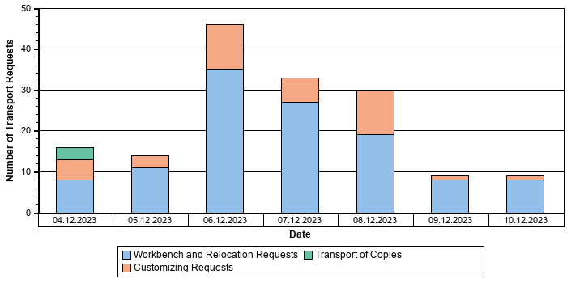
Date | Workbench and Relocation Requests | Customizing Requests | Transport of Copies
04.10.2025 | 8 | 5 | 3
05.10.2025 | 11 | 3 | 0
06.10.2025 | 35 | 11 | 0
07.10.2025 | 27 | 6 | 0
08.10.2025 | 19 | 11 | 0
09.10.2025 | 8 | 1 | 0
10.10.2025 | 8 | 1 | 0

Number of Transported Objects
The following diagram contains information about the number of objects per day that was imported into the SAP system in the last week.
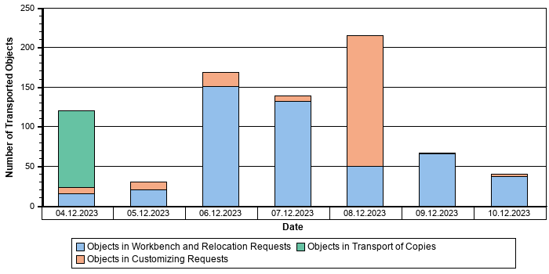
Date | Objects in Workbench and Relocation Requests | Objects in Customizing Requests | Objects in Transport of Copies
04.10.2025 | 15 | 8 | 97
05.10.2025 | 20 | 10 | 0
06.10.2025 | 151 | 17 | 0
07.10.2025 | 132 | 7 | 0
08.10.2025 | 50 | 165 | 0
09.10.2025 | 66 | 1 | 0
10.10.2025 | 37 | 3 | 0

Emergency Changes
We analyzed the number of emergency changes in system PRD in the last week.
Rating | Item | Value | Explanation
 | Transport requests created in production | 0 | Number of transport requests; created or released in production.
 | Transport requests with short transition time | 104 | The duration between the export from the development system and the import into the production system was shorter than one day.
 | Total number of transport requests | 153 | Total number of transport requests in production.

Transport Requests with a short Transition Time
Request | Export from DEV | Import in PRD
QS4K9U06JF | 07.10.2025 12:07:08 | 07.10.2025 15:45:57
QS4K9U06JX | 07.10.2025 12:21:55 | 07.10.2025 15:59:45
QS4K9U09FX | 07.10.2025 16:40:48 | 07.10.2025 17:22:52
QS4K9U0F71 | 06.10.2025 18:49:14 | 07.10.2025 12:45:30
QS4K9U0F74 | 06.10.2025 18:49:19 | 07.10.2025 12:45:35
...

Recommendation: Transport requests with a short transition time of less than one day have occurred in the last week. These transports may not have been tested sufficiently.
Make sure that they did not cause problems in production.

Failed Changes
In this check, we analyzed the number of failed changes in system PRD during the last week.
Rating | Item | Value | Explanation
 | Transport requests with import errors | 1 | Number of transport requests with import errors that were not resolved within one hour.
 | Overtakers and bypassed transport requests | 0 | If an old object version overwrites a newer one we count this as a transport sequence error. We count both the overtaker transport and the bypassed transport. Each transport is only counted once.
 | Total number of transport requests | 153 | Total number of transport requests that were imported or released in production within the last week.

Import Errors
Request | Import Date in PRD | Return Code | Import Step | Number of Failed Objects | Number of Objects in Request
QS4K9U0L7O | 10.10.2025 | 0008 | Generation | 1 | 4

Recommendation: Import errors occurred in the last week. This means that transported objects or dependent objects could not be activated correctly. Make sure that these errors have been fixed in production.
Import errors should already be detected during imports into the QA environment and fixed by a correction transport. Both transports must then be imported into the production system together.

Financial Data Quality
 | After execution of the “quick” consistency checks and execution of the main reconciliation report, NO issues were identified that require your attention.  Please note that, due to a technical limitation in automatic data collection, we can only identify high-level indicators, which are a general sign of further inconsistencies in financial data.

The current Financial Data Quality chapter contains essential information about the quality and consistency of your financial data.
This chapter is structured with three subchapters: “Financial Data Integrity”, “Financial Data Management”, “Reconciliation for S/4HANA”. The first two chapters are based on “quick” checks of different financial modules. The latter chapter displays the status and results of the main reconciliation checks.
It is important to understand that, due to the technical limitation of the automated data collection, we can cover only a limited result list in your system using the “quick” consistency checks. The reconciliation checks are the main sources of data for our financial data quality analysis and should be executed. These checks ensure full transparency at the consistency level of your financial data.

Financial Data Integrity
Our “quick” checks identified no inconsistencies in the area of Financial Data Integrity that require your attention.

Financial Data Management
Our “quick” checks identified no inconsistencies in the area of Financial Data Management that require your attention.

Reconciliation for S/4HANA
This section displays data from the reconciliation checks in the area of Finance.

Reconciliation of S4 System
The data displayed in this chapter is a result of execution of the FINS_REC transaction. This transaction reconciles the General Ledger. Identified inconsistencies might have a negative impact on your daily business. Please note that, when estimating the resolution effort of the identified inconsistencies, you should refer to the number of different error types, but not the total number of errors.
Refer to SAP Note 2714344 for more information about the identified error types.
In your case, this transaction had not been executed or not fully executed. Please make sure to fully scan your system for possible further inconsistencies in your financial data.

Data Volume Management (DVM)
Data relevant for Data Volume Management was collected on system PRD and stored in the SDCCN download. If you gave your consent, this data has been sent to SAP for further analysis. After the analysis has finished, you can find the analysis result in SAP Support Launchpad via the link shown in the "Link to SAP Support Launchpad" column in the table below.
Note:
For more information about DVM cloud-based service delivery, see Knowledge Base Article 2716655.
Link to SAP Support Launchpad
https://launchpad.support.sap.com/#/dataoverview/

Materials Management - Inventory Management Checks
Checks for Materials Management - Inventory Management-related inconsistencies were performed in your system. Below is the summary of the checks. For checks where your action is needed, the recommendations are provided.
Rating | Check
 | Inconsistent Material Document Header

MM-IM - Material Document Header Inconsistencies
8 material document header related inconsistencies were found in your system.
Recommendation: All entries in table MSEG must refer to a single entry in table MKPF. If you have entries in the MSEG table which are missing corresponding entries in the table MKPF, such entries should be fixed . These inconsistencies will also have an impact if you plan to migrate your system to S/4HANA.
Check if these entries are still needed. If yes, then correct the inconsistencies. You may choose to recover missing entries from an archive or a backup. Otherwise, the orphan entries should be deleted. To check the issue in detail, run the report 'MMIM_S4SIC_CHECKS' delivered with SAP Note 3268840 - MM-IM proactive consistency check (SI check) report. SAP Note 3212869 - Proactive Analysis of MM-IM consistency is a prerequisite to run this report.
For more details, refer to SAP Note 2197392 - Resolve findings of core ERP MM-IM S/4HANA pre checks -> section MKPF and MSEG consistency -> topic: ALL_MKPF_EXIST.
The table below shows the first 10 entries with material document header related inconsistencies in your system.
Client | Material Document Year | Material Document
600 | 2009 | 4905828677
600 | 2009 | 4905828703
600 | 2017 | 4905796105
600 | 2017 | 4905796771
600 | 2017 | 4907533902
600 | 2017 | 4907533911

SAP HANA Database PRD
 | We have checked your SAP HANA environment and found some issues that might have a negative impact on your overall system stability. Review the report carefully and implement our recommendations.

Rating | Check
 | SAP HANA Stability and Alerts
 | SAP HANA Database Configuration
 | SAP HANA Resource Consumption
 | SAP HANA Workload and Performance
 | Size and Growth
 | Administration

Overview
The tables below provide an overview of your current SAP HANA database configuration.
DB Version / Start Time
Current SAP HANA DB Version | Build Branch | Start Time
2.00.059.04 | fa/hana2sp05 | 15.10.2025 08:03:55

Technical Instances
Host | Database Name | System ID | Instance | Active | Daemon | Start Time | Time Zone | Nameserver Role | Indexserver Role
tsls4proddbh | PRD | PRD | 00 | yes | yes | 2025-10-15 08:03:49.411 | IST | MASTER | MASTER

Hardware Settings - General Data
Host | Physical Hostname | Manufacturer | Model
tsls4proddbh | tsls4proddbh | Lenovo | ThinkSystem SR950 -[7X13CTO1WW]-

Hardware Settings - CPU and Memory Data
Host | CPU Type | CPU Frequency | CPU Cores | Threads | Sockets | NUMA Nodes | Physical Memory [GB] | Allocation Limit [GB] | Swap Space [GB]
tsls4proddbh | Intel(R) Xeon(R) Platinum 8280L CPU @ 2.70GHz | 3.156 | 224 | 448 | 8 | 8 | 12.095,5 | 9.500,0 | 0,0

Operating System Details
Host | Operating System PPMS Name | Operating System Version | Operating System Kernel | NOFILES Limit | OPEN_FILE Limit
tsls4proddbh | LINUX_X86_64 | SUSE Linux Enterprise Server 15 SP2 | 5.3.18-150200.24.154-default | 1.048.576 | 20.000.000

HANA Feature Usage
Usage | Installed / used | Additional data | SAP Note
Multitenant Database Containers (MDC) | Yes | System ID: PRD | 2101244
Dynamic Tiering | No |  | 2140959
Enterprise Performance Management Add-On (EPM MDS) | No |  | 2456225
Embedded liveCache | No |  | 2593571
Streaming Server | No
Advanced Function Libraries | No
XS Advanced | No
Embedded Statisticsserver active | Yes |  | 2147247
System Replication | Yes |  | 1999880
Smart Data Access (SDA) | No |  | 2180119
Smart Data Integration (SDI) | No |  | 2400022
Smart Data Streaming (SDS) | No |  | 2367236
Persistent Memory | No |  | 2700084
Fast Restart Option | No |  | 2700084
Data Aging | No |  | 2416490
Extension Node | No |  | 2741690
Workload Classes | Yes |  | 2222250
Native Storage Extension (NSE) | Yes |  | 2775588
Multi Dimensional Expressions (MDX) | No
Multi Dimensional Services (MDS) | No |  | 2670064

System Replication Overview
Host | Site Name | Secondary Host | Secondary Site Name | Replication Mode | Full Sync | Operation Mode
tsls4proddbh | NODEB | tsls4proddb | NODEA | SYNC | DISABLED | logreplay
tsls4proddb | NODEA | tsls4proddbdr | NODEC | ASYNC | DISABLED | logreplay

HANA Update Information
Date | Version
08.07.2020 | 1.00.122.13.1507793622
09.07.2020 | 1.00.122.18.1531375173
12.07.2020 | 1.00.122.30.1582793455
20.06.2021 | 2.00.055.00.1615413201
15.09.2022 | 2.00.059.04.1655794895

SAP HANA Stability and Alerts

SAP HANA Alerts
SAP HANA alerts have been issued for the monitored timeframe.

SAP HANA collects system information periodically and issues alerts of different priority levels according to predefined thresholds. These alerts can be used to monitor the performance and stability of the SAP HANA database. Possible alert priorities are:
1 – Information
2 – Low
3 – Medium
4 – High
5 – Statistics Server Alert
The following "Alerts" table shows SAP HANA alerts that reached at least medium priority during the monitored timeframe. It also shows how often an alert was created and the highest priority for this particular alert.
The "Recommendations" table lists recommendations for the alerts found and refers to SAP KBA Notes if available. Further details and recommendations for SAP HANA alerts are available in the relevant sections of the report.
Alerts
Alert ID | Alert | No. of Occurrences | Highest Rating
49 | Identifies long-running blocking situations. | 1.056 | 4
48 | Identifies long-running uncommitted write transactions. | 268 | 4
42 | Identifies long-idling cursors. | 37 | 4
78 | Identifies closed connections between the primary system and a secondary system. If connections are closed, the primary system is no longer being replicated. | 23 | 4
36 | Determines whether or not the most recent data backup was successful. | 10 | 4
20 | Determines the growth rate of non-partitioned columns tables. | 4 | 4
131 | Determines the number of session requests waiting in the admission control queue. This can indicate an issue with the response time of the request. | 3 | 4
30 | Determines whether or not the disks to which data and log files are written are full. A disk-full event causes your database to stop and must be resolved. | 1 | 4
27 | Determines the number of records in the partitions of column-store tables. A table partition cannot contain more than 2,147,483,648 (2 billion) rows. | 174 | 3
94 | System Replication secondary site has a higher log replay backlog than expected. | 5 | 3
39 | Identifies long-running SQL statements. | 3 | 3
59 | Determines the percentage of transactions that are blocked. | 1 | 3
5 | Determines the percentage CPU idle time on the host and therefore whether or not CPU resources are running low. | 1 | 3
46 | Identifies new runtime dump files (*rtedump*) have been generated in the trace directory of the system. These contain information about, for example, build, loaded modules, running threads, CPU, and so on. | 1 | 3
104 | System Replication secondary site has a higher log shipping backlog than expected. | 1 | 3

Recommendations
Alert ID | General Recommendation | KBA
5 | Investigate CPU usage. For details please refer to the chapter "SAP HANA Resource Consumption". | 1909670
20 | Consider partitioning the table. For details please refer to the chapter "Size and Growth". | 1910140
27 | Consider repartitioning the table. For details please refer to the chapter "Size and Growth". | 1910188
30 | Resolve the disk-full event as follows: In the Administration Editor on the Overview tab, choose the "Disk Full Events" link and mark the event as handled. Alternatively, execute the SQL statements ALTER SYSTEM SET EVENT ACKNOWLEDGED '<host>:<port>' <id> and ALTER SYSTEM SET EVENT HANDLED '<host>:<port>' <id>. | 1870858
36 | Investigate why the last data backup failed, resolve the problem, and perform a new data backup as soon as possible. For details please refer to the chapter "Administration". | 1900795
39 | Investigate the statement. For more information, see the table _SYS_STATISTICS.HOST_LONG_RUNNING_STATEMENTS. | 1849392
42 | Close the cursor in the application, or kill the connection by executing the SQL statement ALTER SYSTEM DISCONNECT SESSION <LOGICAL_CONNECTION_ID>. For more information, see the table HOST_LONG_IDLE_CURSOR (_SYS_STATISTICS). | 1849392, 1900261
46 | Check the contents of the dump files. For details please refer to the chapter "SAP HANA Stability and Alerts". | 1977099
48 | Close the uncommitted transaction in the application or kill the connection by executing the SQL statement ALTER SYSTEM DISCONNECT SESSION <LOGICAL_CONNECTION_ID>. For more information, see the table HOST_UNCOMMITTED_WRITE_TRANSACTION (_SYS_STATISTICS). | 1849392
49 | Investigate the blocking and blocked transactions and if appropriate cancel one of them. | 1849392
59 | Investigate blocking and blocked transactions and if appropriate cancel some of them.
78 | Investigate why connections are closed (for example, network problem) and resolve the issue.
94 | Investigate on secondary site, why log replay backlog is increased
104 | Investigate on primary and secondary site, why log shipping backlog is increased
131 | Investigate why the session requests newly queued by admission control. Refer to M_ADMISSION_CONTROL_EVENTS for more information.

Recommendation: Monitor SAP HANA alerts in the system closely to get an overview of the SAP HANA system status. React to warnings and problems visible in the alerts in due time. If you require support, open a message on component HAN-DB*.
For details, refer to the SAP HANA Administration Guide and to the SAP Note 2445867 How-To: Interpreting and Resolving SAP HANA Alerts.

SAP HANA Dumps
SAP HANA dumps were detected during the time period analyzed.

SAP HANA dumps indicate critical situations during SAP HANA system operation.
Date | Crash Dumps | OOM Dumps | Emergency Dumps | Cleanup OOM Dumps | Composite OOM Dumps | Page Dumps | Operating System OOM Dumps | Process Allocation Limit OOM Dumps
04.10.2025 | 0 | 0 | 0 | 0 | 0 | 0 | 0 | 0
05.10.2025 | 0 | 0 | 0 | 0 | 0 | 0 | 0 | 0
06.10.2025 | 0 | 0 | 0 | 0 | 1 | 0 | 0 | 0
08.10.2025 | 0 | 0 | 0 | 0 | 0 | 0 | 0 | 0

We observed a number of dumps in your SAP HANA system. Depending on the type of dump, different actions have to be performed:
Out-of-memory dumps:
There are different reasons for out-of-memory dumps.
- "OOM Dump": Insufficient memory for normal operation.
- "Composite OOM Dump": Expensive SQL statements in SAP HANA consume too much memory and exceed the statement limit.
- "Cleanup OOM dump": This is an automatic dump to document the memory state after cleanup of an OOM situation.
- "Operating System OOM Dump": This type is raised if a certain memory request cannot be fulfilled by the operating system. The root cause has to be evaluated by analyzing the related OOM diagnosis file. Open a customer incident on component HAN-DB*, if necessary.
- "Process Allocation Limit OOM Dump": This type is raised if a certain memory request cannot be fulfilled by the corresponding process (e.g. indexserver or nameserver). The root cause has to be evaluated by analyzing the related OOM diagnosis file and is mostly caused by a too low limit set with parameter <global.ini|nameserver.ini|indexserver.ini> -> [memorymanager] -> allocationlimit. Open a customer incident on component HAN-DB*, if necessary.
All other dumps:
In the event of emergency dumps or crash dumps, the call stack has to be evaluated. Open a customer incident on component HAN-DB*, if necessary.
Type of Dump | SAP Note
Out-Of-Memory Dump | 1999997
Composite Out-Of-Memory Dump | 1999997
Crash Dump | 2177064
Page Dump | 1977242
Operating System Out-Of-Memory Dump | 2800138

To access the long-term history of memory consumption in SAP EarlyWatch Alert Workspace, click here.

SAP HANA Service Restarts
No critical issues with SAP HANA service restarts were detected.

We did not find critical issues with SAP HANA service restarts.

SAP HANA DB Availability
The SAP HANA DB availability was based on the availability of the index server as logged in the daemon trace file.
No critical problems occurred regarding the availability of SAP HANA services.

SAP HANA Database Configuration

Parameter Recommendation
Check parameter settings

Some parameters are not set as recommended, or there are parameters deviating from default values.
This table highlights the parameters that were checked with regard to their impact on system performance and stability.
Important SAP HANA Parameters
Location | Parameter | Layername | Current Value | Recommended Value | Rating | SAP Note
global.ini [communication] | tcp_backlog | DATABASE | 2048 | <restore default> |  | 2382421
global.ini [memorymanager] | gc_unused_memory_threshold_abs | DEFAULT | 0 | 2432000 |  | 2169283
global.ini [memorymanager] | gc_unused_memory_threshold_rel | DEFAULT | -1 | 25 |  | 2169283
global.ini [persistence] | internal_caching_for_main | SYSTEM | false | <restore default> |  | 2403124
global.ini [resource_tracking] | service_thread_sampling_monitor_enabled | DATABASE | true | <restore default> |  | 2114710
global.ini [resource_tracking] | service_thread_sampling_monitor_thread_detail_enabled | DATABASE | true | <restore default> |  | 2114710
indexserver.ini [memorymanager] | proactive_gc_interval | SYSTEM | 10 | <restore default> |  | 2953186
indexserver.ini [search] | qo_top_1_optimization | DATABASE | false | <restore default> |  | 2238679
indexserver.ini [table_consistency_check] | columncheck_parallel_threshold |  |  | 4000000000 |  | 2116157
indexserver.ini [threads] | default_stack_size_kb |  |  | 2048 |  | 1999997
indexserver.ini [threads] | worker_stack_size_kb |  |  | 2048 |  | 1999997

Recommendation: Set the SAP HANA parameters to the recommended value in the table.
Note: The recommendation "<restore default>" is assigned if a custom parameter value is equal to the SAP HANA default and therefore not explicitly required. In that case the default should be restored. Use the SQL command "ALTER SYSTEM ALTER CONFIGURATION ( '<filename>', '<layername>' ) UNSET ( '<section>', '<parameter name>' )". See SAP Note 2186744 for details.
Be aware that for a proper tenant DB parameter setting, the parameters configured on the system DB side must also be double-checked. Otherwise, critical parameters can be set in the system DB that appear as default values on the tenant side. Default values are only reported by the parameter check if an explicit recommendation exists, therefore, critical settings can be missed by focusing only on the tenant DB parameter check.
The table "SAP HANA Parameters deviating from default" lists parameters deviating from default. These parameters do not belong to the set of recommended parameters, they represent parameters that are not set to DEFAULT value.
In the list below, there might be parameters that needed to be changed, but also parameters that were supposed to be set back to their default values (as for special settings only in certain SAP HANA revisions) but were forgotten. The purpose of this output is only to report those parameters to bring them to your attention so you can check them.
SAP HANA Parameters deviating from default
Location | Parameter | Layername | Current Value
global.ini [backup] | log_backup_buffer_size | SYSTEM | 512
global.ini [memorymanager] | enable_sharing_allocator_for_implicit | DATABASE | true
global.ini [memorymanager] | global_allocation_limit | SYSTEM | 9728000
global.ini [persistence] | non_trans_cch_block_size | SYSTEM | 134217728
global.ini [system_replication] | logshipping_timeout | SYSTEM | 3600
indexserver.ini [communication] | maxchannels | SYSTEM | 40000
indexserver.ini [communication] | maxendpoints | SYSTEM | 40000
indexserver.ini [mds] | use_sql_procedure_for_analytics | SYSTEM | TRUE
indexserver.ini [persistence] | disposition_lob_read | SYSTEM | 1
indexserver.ini [persistence] | disposition_lob_read_small | SYSTEM | 1
indexserver.ini [persistence] | disposition_lob_write | SYSTEM | 1
indexserver.ini [persistence] | disposition_lob_write_small | SYSTEM | 1
indexserver.ini [sql] | hex_enable_remote_table_access | SYSTEM | false
scriptserver.ini [communication] | maxchannels | SYSTEM | 4000
scriptserver.ini [communication] | maxendpoints | SYSTEM | 4000

SAP HANA Workload Management
SAP HANA workload parameters are set in the recommended range.

Workload management in SAP HANA allows you to balance and manage all workload types for optimal throughput and response times. The available workload management parameters limit resource consumption (e.g. CPU, threads, memory) for certain operations. The recommended values depend on available memory resources and on the number of CPU threads of the database server (also referred to as number of logical CPUs). For general information, refer to SAP Note 2222250 (FAQ: SAP HANA Workload Management).

Disk Configuration
There are no disk configuration issues.

Disk ID | Device ID | File system | Host | Path | Usage
2 | 192790 | xfs | tsls4proddbh | /usr/sap/PRD/HDB00/backup/data/ | DATA_BACKUP
3 | 56296 | xfs | tsls4proddbh | /sapmnt/log/PRD/ | LOG
4 | 192790 | xfs | tsls4proddbh | /usr/sap/PRD/HDB00/backup/log/ | LOG_BACKUP+CATALOG_BACKUP
5 | 192790 | xfs | tsls4proddbh | /usr/sap/PRD/HDB00/tsls4proddbh/ | TRACE
1 | 250990 | xfs | tsls4proddbh | /sapmnt/data/PRD/ | DATA

There are no disk configuration issues. Data and log data is stored on separate physical devices.

Size and Growth
Monitoring the size and growth of the HANA database is crucial for system stability and performance. In terms of stability, the growth on disk is shown. In terms of performance, the size of row and column tables as well as the size of delta areas in column tables are analyzed.

Disk Usage
Percentage of free disk space > 20%

The table below shows the disk occupancy with respect to the partitions and their usage types. If the percentage of free disk space falls below 10%, an intermediate action has to be performed. Otherwise, there is a risk of standstill in the SAP HANA database.
Disk Space
Host | Available Disk Space [GB] | Used Disk Space [GB] | Percentage of free Disk Space | Usage Types | File system | Rating
tsls4proddbh | 13.279,63 | 9.992,55 | 24,8 | DATA | xfs
tsls4proddbh | 543,21 | 62,57 | 88,5 | LOG | xfs
tsls4proddbh | 1.023,50 | 155,46 | 84,8 | CATALOG_BACKUP+DATA_BACKUP+LOG_BACKUP+TRACE | xfs

The graph shows the history of disk space usage.
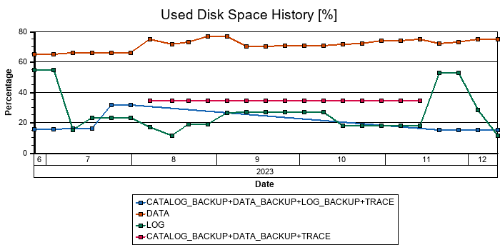

Database Growth
The graph shows the database size and growth based on the size of data volumes.
Total Size: Amount of data allocated by SAP HANA database on data volumes.
Used Size: Amount of used data by SAP HANA database on data volumes.
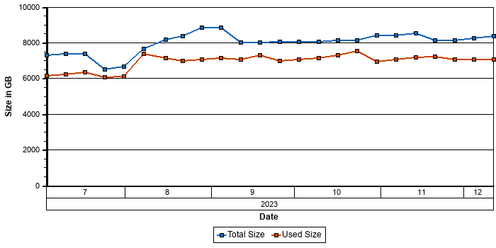
To access the database growth chart in SAP EarlyWatch Alert Workspace, click here.

Tables and Indexes
The table below displays the number of column and row tables together with their indexes.
Tables and Indexes
Objects | Number
Column Tables | 166.057
Indexes of Column Tables | 173.584
Row Tables | 23.846
Indexes of Row Tables | 917

For some use cases in SAP CRM / ERP / SCM on SAP HANA, it can still be beneficial to use secondary indexes. This is especially true for highly selective queries on non-primary key fields. For more information, see SAP Note 1794297 (Secondary Indexes for the Business Suite on SAP HANA). This Note has three reports (ZHDB_INDEX_ANALYZE, ZHDB_INDEX_CREATE, and ZHDB_INDEX_CHECK) to analyze and create the necessary indexes.

Size of Database Schemas
The following table lists the size of schemas in the SAP HANA database.
Size of HANA schemas
Host | Schema name | Size in MB | Store type
tsls4proddbh | SAPPRD | 5.182.950 | Column store
tsls4proddbh | _SYS_STATISTICS | 7.193 | Column store
tsls4proddbh | _SYS_REPO | 553 | Column store
tsls4proddbh | _SYS_AUDIT | 197 | Column store
tsls4proddbh | _SYS_BI | 13 | Column store
tsls4proddbh | _SYS_RT | 1 | Column store
tsls4proddbh | _SYS_XS | 1 | Column store
tsls4proddbh | SAPPRD | 68.759 | Row store
tsls4proddbh | SYS | 2.242 | Row store
tsls4proddbh | SAPTMF_RT_3012#DI | 7 | Row store
tsls4proddbh | _SYS_STATISTICS | 4 | Row store
tsls4proddbh | SAPS4H_RT_9019#DI | 2 | Row store

SAP HANA Row Store

Row Store Size
The allocated row store size is below the technical limit.

The table below shows the size of the SAP HANA row store. The row store contains mainly SAP Basis and application statistics tables. The rating indicates whether the technical size limit will be reached in the near future.
The size of the row store generally has a direct impact on the start-up time of the SAP HANA database. This is relevant for system start-up and for recovery. We recommend that you keep the row store at an optimum size by performing housekeeping for large Basis tables (SAP Note 2388483) and, where feasible, moving large application tables from row store to column store.
Row Store Size
Host | Port | Total Size (GB) | Rating
tsls4proddbh | 30046 | 154,33

Row Store Fragmentation
The row store is fragmented.

The following table shows the allocated size and free page ratio (fragmentation) of the row store. The term 'fragmentation' refers to unused space in the SAP HANA row store that cannot be used for technical reasons. High fragmentation can cause performance issues and longer backup times. Row store reorganization is generally recommended if the allocated row store size is larger than 10 GB and the free page ratio is greater than 30%.
Row Store Size and Fragmentation
Host | Port | Allocated Size [MB] | Free Size [MB] | Free Page Ratio [%] | Row Store Reorganization Recommended
tsls4proddbh | 30046 | 127.360 | 43.543 | 34 | Yes

The row store shows high fragmentation. It should be reorganized to regain unused space and avoid performance issues.
There are two ways to implement row store reorganization.
Restart time row store reorganization
Row store reorganization can be performed at restart time. Since there are no active update transactions during the restart time, this reorganization achieves the maximum compression ratio.
Online row store reorganization
Row store reorganization can be performed at runtime. To minimize the interference of other transactions, the relevant tables are locked exclusively and update transactions cannot be carried out on those tables. The list of affected tables is determined on the fly depending on the memory usage. As it is executed at runtime, some uncompressed row store memory may remain.
Recommendation: See SAP Note 1813245 for details and carefully follow the instructions for performing a row store reorganization.

Largest Row Store Tables
The table lists the largest tables according to total disk size. The size of the memory and the number and type of LoBs are also shown. The LOBs are marked with either "H" (Hybrid) or "M" (Memory) and the number of the existing LoB columns.
Schema Name | Table Name | Total Disk Size (MB) | Size in Memory (MB) | Max Size in Memory (MB) | Nr. of Records | LOB Size (MB) | LOB Details
SAPPRD | TST03 | 94.710 | 575 | 637 | 8.179.637 | 94.071 | H1
SAPPRD | SXMSCLUR | 82.215 | 4.308 | 4.952 | 10.166.560 | 77.262 | H1
SAPPRD | SXMSCLUP | 37.264 | 778 | 964 | 7.991.691 | 36.300 | H1
SAPPRD | APQD | 20.762 | 15.041 | 17.509 | 59.303.411 | 1.715 | H1
SAPPRD | ODQDATA | 18.883 | 351 | 416 | 2.951.948 | 18.467 | H1
SAPPRD | ODQDATA_F | 15.845 | 2 | 2 | 17.611 | 15.843 | H1
SAPPRD | SWNCMONI | 15.575 | 14.036 | 15.575 | 4.973.907 | 0 | 0
SAPPRD | ARFCSDATA | 9.723 | 8.788 | 9.723 | 4.917.928 | 0 | 0
SAPPRD | VBDATA | 5.213 | 372 | 447 | 1.533.348 | 4.760 | H1
SAPPRD | QRFC_I_SDATA | 4.981 | 4.183 | 4.979 | 4.901.515 | 2 | H1

For large SAP Basis tables, remove obsolete data regularly according to SAP Note 2388483.

SAP HANA Column Store

Largest Column Tables (Size)
The table lists the largest tables according to total disk size. The size of the memory and the number and type of LoBs are also shown. The LOBs are marked with either "H" (Hybrid) or "M" (Memory) and the number of the existing LoB columns.
Schema Name | Table Name | Nr. of Partitions | Total Disk Size (MB) | Size in Memory (MB) | Max. Size in Memory (MB) | LOB Size (MB) | LOB Details
SAPPRD | CDPOS | 5 | 519.599 | 527.802 | 527.802 | 0 | 0
SAPPRD | ACDOCA | 9 | 454.635 | 518.233 | 518.121 | 0 | 0
SAPPRD | DBTABLOG | 1 | 357.652 | 24.933 | 24.933 | 333.203 | H1
SAPPRD | SOFFCONT1 | 1 | 308.295 | 551 | 552 | 307.741 | H1
SAPPRD | PRCD_ELEMENTS | 5 | 253.506 | 262.541 | 262.250 | 0 | 0
SAPPRD | PCL4 | 1 | 224.481 | 226.334 | 226.334 | 0 | 0
SAPPRD | SOC3N | 1 | 160.556 | 438 | 438 | 160.109 | H4
SAPPRD | DMS_CONT1_CD1 | 1 | 147.693 | 340 | 341 | 147.338 | H1
SAPPRD | EDOCUMENTFILE | 1 | 125.881 | 16.243 | 16.243 | 109.787 | H2
SAPPRD | ACCTCR | 2 | 123.504 | 128.319 | 128.319 | 0 | 0

For large SAP Basis tables, remove obsolete data regularly according to SAP Note 2388483.

Largest Non-partitioned Column Tables (Records)
The number of records in column-based table partitions may become critical very soon.

The table below shows the largest non-partitioned column tables in terms of the number of records.
Largest Non-partitioned Column Tables According To Records
Schema Name | Table Name | Records (Total) | Rating | 2 Billion Records App
SAPPRD | YBAST_AUDIT_INFO | 1.830.733.473 |  | Prediction
SAPPRD | BSEG | 1.548.828.547 |  | Prediction
SAPPRD | J_1I_INDX | 1.516.072.791 |  | Prediction
SAPPRD | FAGL_SPLINFO_VAL | 1.511.145.150 |  | Prediction
SAPPRD | BDCP2 | 1.222.533.501 |  | Prediction
SAPPRD | JCDS | 1.218.710.053 |  | Prediction
SAPPRD | YKPI_VALUE | 1.050.465.834 |  | Prediction
SAPPRD | PPOIX | 990.563.363
SAPPRD | CFIN_ACCCR | 932.193.670
SAPPRD | /IRM/IPCRPTR | 901.629.987

At least one of the tables listed above has a very high number of records and may reach the technical limit for SAP HANA (two billion records per table) in the near future.
Tables with more than 300 million records are not yet critical with regard to the technical limit but table partitioning should be considered if these tables are expected to grow rapidly in the future.
Recommendation: Consider partitioning for tables that are expected to grow rapidly in order to ensure parallelization and adequate performance. We recommend that you re-partition tables before inserting mass data or while they are still small.
For more information, see SAP Note 1650394 or refer to the SAP HANA Administration Guide.
Note: The link to the 2 Billion Records app is only valid if you send SAP EarlyWatch Alert data to SAP. See this blog for details.

Largest Column Table Partitions (Records)
The number of records in column-based table partitions may become critical.

The table below lists the largest column table partitions in the productive schema in terms of number of entries.
Largest Partitioned Column Tables According To Records
Schema Name | Table Name | Partition ID | Records (Total) | Rating | 2 Billion Records App
SAPPRD | ACCTCR | 2 | 1.579.771.554 |  | Prediction
SAPPRD | ACCTCR | 1 | 1.579.758.051 |  | Prediction
SAPPRD | CDPOS | 5 | 1.430.092.281
SAPPRD | CDPOS | 1 | 1.430.077.663
SAPPRD | CDPOS | 2 | 1.430.040.062
SAPPRD | CDPOS | 4 | 1.430.023.580
SAPPRD | CDPOS | 3 | 1.430.022.928
SAPPRD | PRCD_ELEMENTS | 4 | 1.144.562.288
SAPPRD | PRCD_ELEMENTS | 5 | 1.144.541.540
SAPPRD | PRCD_ELEMENTS | 1 | 1.144.520.369

At least one of the table partitions listed above has a high number of records and will reach the technical limit for SAP HANA (two billion records per table or partition) in the near future.
Recommendation: Consider re-partitioning tables that are expected to grow. We recommend that you re-partition tables before inserting mass data or while they are still small.
For more information, see SAP Note 1650394 or refer to the SAP HANA Administration Guide (http://help.sap.com/hana/SAP_HANA_Administration_Guide_en.pdf).
Note: The link to the 2 Billion Records app is only valid if you send SAP EarlyWatch Alert data to SAP. See this blog for details.

Native Storage Extension
The table below lists tables for which Native Storage Extension or Data Archiving is configured. It also lists on which layer (table, partition, column) the page loadable is defined.
If the loadable page is enabled on column level, the corresponding column names are listed. In case a table is listed multiple times, the configuration was done on multiple layers (e.g. column and partition).
Schema Name | Table Name | Partitions | Column | Definition of Loadable Page
SAPPRD | /AIF/STRUC_CA_DD | 0 |  | TABLE
SAPPRD | AAB_ID_PROPT | 0 |  | TABLE
SAPPRD | ACDOCD | 0 |  | TABLE
SAPPRD | ACLPERMIS | 0 |  | TABLE
SAPPRD | ACMDCLSRC | 0 |  | TABLE
SAPPRD | ACMDCLSRCT | 0 |  | TABLE
SAPPRD | APJ_W_JCE_GR_T | 0 |  | TABLE
SAPPRD | APJ_W_JCE_PAR | 0 |  | TABLE
SAPPRD | APJ_W_JCE_RO_T | 0 |  | TABLE
SAPPRD | APJ_W_JCE_SCT_T | 0 |  | TABLE
SAPPRD | APJ_W_JT_RO_T | 0 |  | TABLE
SAPPRD | ARS_W_API | 0 |  | TABLE
SAPPRD | ARS_W_API_SCCSSR | 0 |  | TABLE
SAPPRD | ARS_W_API_STATE | 0 |  | TABLE
SAPPRD | BADIIMPL_ENH | 0 |  | TABLE
SAPPRD | BADI_CHAR_COND | 0 |  | TABLE
SAPPRD | BADI_IMPL | 0 |  | TABLE
SAPPRD | BADI_MAIN | 0 |  | TABLE
SAPPRD | BADI_SPOT | 0 |  | TABLE
SAPPRD | CFD_W_BUS_CTXT_T | 0 |  | TABLE
 | The output is cut off because of too many entries.

The largest tables according to the disk size of the loadable page are shown in the table below.
It lists the total number of partitions, the number of partitions for NSE, the total memory size (memory size in DRAM and persistent memory), the total memory size in DRAM (heap also including the loadable size of the table), the persistent memory size, the loadable size in memory, and the loadable size on disk of the tables.
Schema Name | Table Name | Total Number of Partitions | Number Partitions in NSE | Total Memory Size (MB) | Total Memory Size in DRAM (MB) | Memory Size in Persistent Memory (MB) | Memory Size of Loadable Page (MB) | Disk Size of Loadable Page (MB)
SAPPRD | DOKTL | 1 | 1 | 1.532 | 1.532 | 0 | 1.418 | 1.420,71
SAPPRD | D010TAB | 1 | 1 | 1.327 | 1.327 | 0 | 1.296 | 1.297,63
SAPPRD | DD03L | 1 | 1 | 1.391 | 1.391 | 0 | 1.289 | 1.296,64
SAPPRD | D010INC | 1 | 1 | 727 | 727 | 0 | 710 | 709,63
SAPPRD | DYNPSOURCE | 1 | 1 | 225 | 225 | 0 | 222 | 222,39
SAPPRD | COV_GENDATA | 1 | 1 | 181 | 181 | 0 | 177 | 177,51
SAPPRD | SPROXDAT | 1 | 1 | 135 | 135 | 0 | 131 | 141,33
SAPPRD | TADIR | 1 | 1 | 156 | 156 | 0 | 127 | 131,77
SAPPRD | DOKHL | 1 | 1 | 140 | 140 | 0 | 125 | 128,46
SAPPRD | DD04T | 1 | 1 | 124 | 124 | 0 | 114 | 115,48
SAPPRD | DDFIELDANNO | 1 | 1 | 0 | 0 | 0 | 0 | 109,71
SAPPRD | DD03ND | 1 | 1 | 110 | 110 | 0 | 101 | 108,02
SAPPRD | DD05S | 1 | 1 | 124 | 124 | 0 | 103 | 104,95
SAPPRD | DD27S | 1 | 1 | 123 | 123 | 0 | 100 | 104,14
SAPPRD | DOKIL | 1 | 1 | 108 | 108 | 0 | 93 | 94,95
SAPPRD | SMIMCONT1 | 1 | 1 | 83 | 83 | 0 | 80 | 93,15
SAPPRD | DDCDS_CONDITION | 1 | 1 | 31 | 31 | 0 | 25 | 80,13
SAPPRD | DD02T | 1 | 1 | 82 | 82 | 0 | 75 | 75,54
SAPPRD | D021T | 1 | 1 | 75 | 75 | 0 | 68 | 68,90
SAPPRD | DDHEADANNO | 1 | 1 | 76 | 76 | 0 | 66 | 67,13
 | The output is cut off because of too many entries.

SAP HANA NSE Buffer Cache
The table below lists information regarding the SAP HANA NSE Buffer Cache.
Host | Port | Cache Name | State | Replacement Policy | Max. Size (GB) | Used Size (GB) | Hit Ratio (%)
tsls4proddbh | 30046 | CS | ENABLED | IMPROVED LRU | 950,00 | 7,49 | 99,99

The table below shows the page behavior of the Buffer Cache.
Host | Port | Cache Name | State | Replacement Policy | Page Size (kB) | Total Size (GB) | Hot Page Size (GB) | Out of Buffer Page Size (GB)
tsls4proddbh | 30046 | CS | ENABLED | IMPROVED LRU | 4 | 7,79 | 0,03 | 0,00
 |  |  |  |  | 16 | 9,00 | 0,02 | 0,00
 |  |  |  |  | 64 | 9,37 | 0,18 | 0,00
 |  |  |  |  | 256 | 75,74 | 16,09 | 0,00
 |  |  |  |  | 1.024 | 75,93 | 20,90 | 0,00

SAP HANA Resource Consumption
The following table shows an overview of the resource consumption of the SAP HANA instances in the monitored timeframe.
HANA Instances Overview
HANA Instance | Role | CPU Usage | Memory Usage of HANA server | Memory Usage of SAP HANA Instance | Memory Allocation of Tables | Memory Consumption Indexserver
tsls4proddbh_PRD_00 | MASTER

Some of the SAP HANA hardware resources are not sufficient for the current workload. This may lead to performance and stability issues. Details of resource consumption issues are listed in the sections below.

Memory Utilization Overview for SAP HANA Instances
The following table shows the memory usage of the SAP HANA database. The table displays weekly average values for the SAP HANA memory areas:
'Memory usage of the HANA database' corresponds to the memory used by the entire SAP HANA database (comparable to 'DB used memory' in SAP HANA studio).
'Global allocation limit' is the limit for the overall memory usage of the SAP HANA instance defined by the global_allocation_limit parameter.
'Row store size' shows the average size of row store tables in SAP HANA memory.
'Column store size' shows the average size of column store tables in SAP HANA memory.
The main SAP HANA workload is handled by the SAP HANA index server. The weekly average of the hourly maximum values of the 'Memory usage of the index server' and the 'Effective allocation limit' of the index server are listed.
More detailed information about memory shortage on an SAP HANA instance is provided in the sections below.
Avg. memory usage by SAP HANA Instances
HANA instance | Memory usage of SAP HANA [GB] | Global allocation limit [GB] | Row store size [GB] | Column store size [GB] | Memory usage of indexserver [GB] | Effective allocation limit of indexserver [GB]
tsls4proddbh_PRD_00 | 6.826 | 9.500 | 136 | 5.179 | 6.354 | 8.944

SAP HANA Instance tsls4proddbh_PRD_00

CPU Usage of SAP HANA Server
No CPU bottlenecks were detected.

To access the CPU usage charts in SAP EarlyWatch Alert Workspace, click here.
The graphics below show the average and maximum CPU consumption per hour.
The data is obtained from the statistics tables of the SAP HANA database.
If the average CPU consumption exceeds 75%, a YELLOW rating is assigned. If it exceeds the threshold of 90%, a RED rating is assigned.
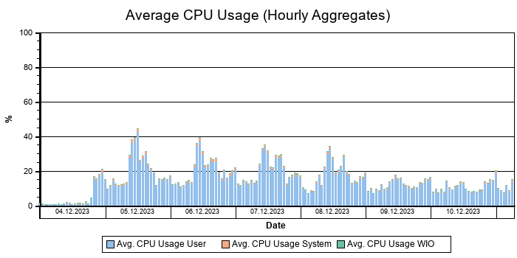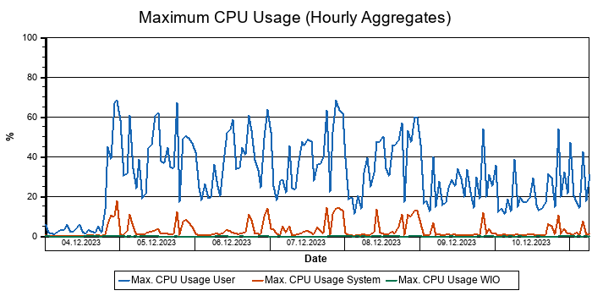
We did not find any critical issues in this area.

Memory Usage of SAP HANA Server
No memory bottlenecks were detected.

To access the memory usage chart in SAP EarlyWatch Alert Workspace, click here.
The following graph shows the physical memory usage during the monitored timeframe. The average and maximum memory used by SAP HANA (and possibly other processes) is compared with the available physical memory of the SAP HANA server.
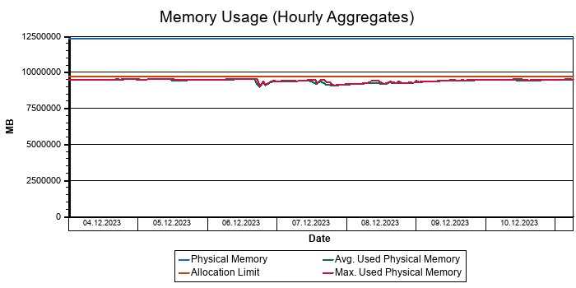
No critical issues were detected in this area.

Memory Usage of SAP HANA Instance
The memory consumption of the SAP HANA instance is not critical.

To access the memory usage chart in SAP EarlyWatch Alert Workspace, click here.
The following graph shows the memory usage of the SAP HANA database instance during the monitored timeframe. The memory used by SAP HANA on the SAP HANA host is compared with the global allocation limit of the SAP HANA instance.
If the "Used SAP HANA Instance Memory" approaches the "Global Allocation Limit", data has to be unloaded from SAP HANA memory. This may affect the overall performance and stability of the SAP HANA database.
The SAP HANA memory usage should not exceed 90% of the "Global Allocation Limit".
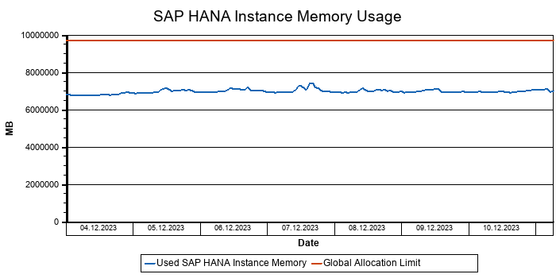
The memory consumption of the SAP HANA instance is not critical.

Memory Allocation of Tables
The memory usage of tables exceeds 50% of the global allocation limit of the SAP HANA instance.

This graphic shows the average memory consumption for storing row and column tables, and the memory available for temporary calculations and other operations.
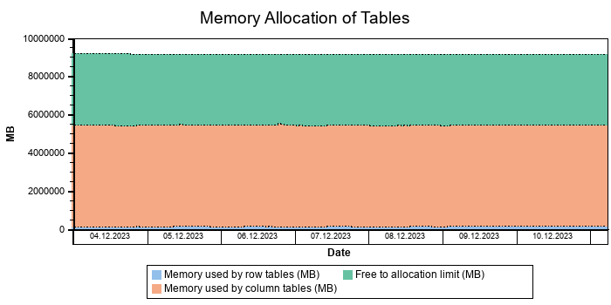
From a SAP HANA sizing perspective, it is recommended that the memory usage for SAP HANA tables remains below 50% of the global allocation limit.
If the memory usage for SAP HANA tables reaches 70% of the global allocation limit, the remaining memory resources for temporary calculations may be too small.
The memory remaining for working operations may become critical.
Recommendation: Monitor the SAP HANA memory consumption closely. For more information about SAP HANA memory consumption and monitoring, see the SAP HANA Administration Guide, chapter "Monitoring SAP HANA systems" at http://help.sap.com/hana/SAP_HANA_Administration_Guide_en.pdf .

Memory Consumption of Indexserver
The memory consumption of the index server is critical.

To access the memory usage chart in SAP EarlyWatch Alert Workspace, click here.
The index server is the most critical component with regard to SAP HANA memory consumption and must be monitored regularly. If the memory consumption of the index server approaches the effective allocation limit, table unloads or even out-of-memory dumps may occur.
The following graph shows the memory consumption of the index server in relation to its effective allocation limit.
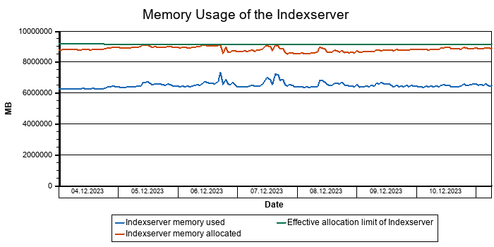
The memory consumption of the index server was high.
This is due either to the large amount/size of loaded tables or to query processing in the SAP HANA database consuming too much memory.
Recommendation: Analyze the reason for high memory consumption of the index server and plan measures to reduce the memory consumption of the SAP HANA database.

SAP HANA Heap Consumption
In the table below, the largest heap allocators are shown for the two periods with highest memory consumption during the previous week. The heap allocator sizes are average values per hour.
Date | Time | Category | Component | Size (MB)
06.10.2025 | 17 | Pool/ColumnStore/Main/Dictionary/RoDict | Column Store Tables | 1687457
06.10.2025 | 17 | Pool/ColumnStore/Main/Uncompressed | Column Store Tables | 874136
06.10.2025 | 17 | Pool/ColumnStore/Main/Index/Single | Column Store Tables | 789781
06.10.2025 | 17 | Pool/ColumnStore/Main/Compressed/Indirect | Column Store Tables | 636003
06.10.2025 | 17 | Pool/ColumnStore/Main/Rowid | Column Store Tables | 391196
06.10.2025 | 17 | Pool/JoinEvaluator/JERequestedAttributes/Results | Statement Execution & Intermediate Results | 237117
06.10.2025 | 17 | Pool/ColumnStore/Main/Dictionary/ValueDict | Column Store Tables | 197800

We observed a memory bottleneck in the previous week, which might be caused by temporary large heap allocators belonging to different memory areas. SAP Note 1999997 describes an overview of the heap allocators, as well as possible actions.

Main Memory Areas of SAP HANA
The following graph shows the top 5 consumers of SAP HANA memory. Additional allocators are summed up in the "Others" category. Refer to SAP Note 1999997 - FAQ: SAP HANA Memory for a more detailed explanation of SAP HANA memory allocation.
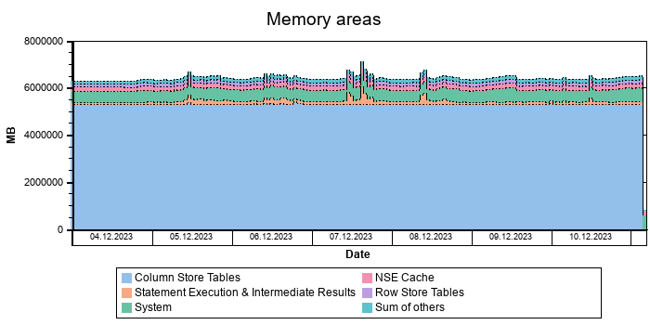
To access the memory usage chart in SAP EarlyWatch Alert Workspace, click here.

SAP HANA Workload and Performance

SAP HANA Workload
The table shows the number of SQL requests executed per second and per node (maximum 23 nodes) in your SAP HANA system in the monitored timeframe.
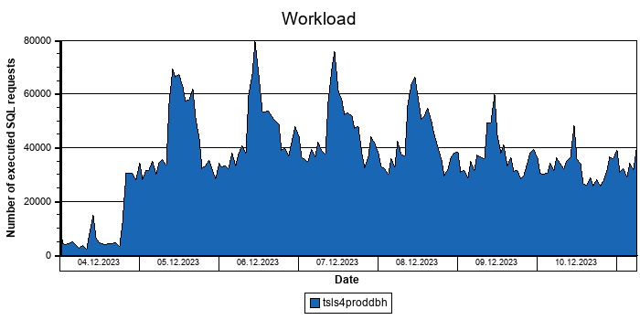

SAP HANA Response Times
The following graph shows the execution times of the SAP HANA system in the monitored timeframe aggregated from all SAP HANA nodes. The displayed "Execution Time" is the hourly average execution time obtained by the historized SQL Plan Cache.
Since the "Execution Time" in the SQL Plan Cache does not contain all response time parts, we also show in the graph below the "Sum Execution Time", which is the sum of the "Execution Time" plus preparation time and table load time. For more information, see SAP Note 2000002 .
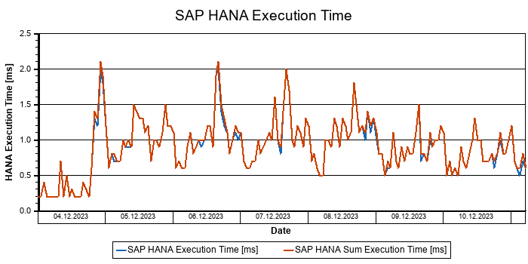
The following graph shows the response time distribution of the SAP HANA system. The data is collected from the history data of the SQL Plan Cache.
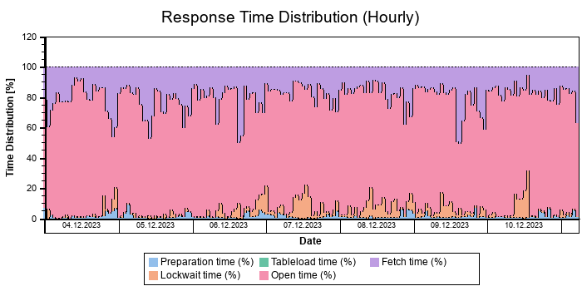
Explanation of the SAP HANA response time shares:
- Preparation time – time share for plan preparation
- Open time – time share for cursor open and select
- Fetch time – time share for cursor fetch
- Lock wait time - lock wait time share for the plan
- Table load time – time share for loading tables during plan preparation (available as of SAP HANA rev. 50)

Delta Merges

Column Tables with Largest Delta Stores
No problems with the delta size of column store tables were detected.

The separation into main and delta storage allows high compression and high write performance at the same time. Write operations are performed on the delta store and changes are transferred from the delta store to the main store asynchronously during delta merge.
The column store automatically performs a delta merge according to several technical limits that are defined by parameters.
If applications require more direct control over the merge process, the smart merge function can be used for certain tables (for example, BW prevents delta merges during data loading for performance reasons).
Largest Column Tables in terms of Delta size
Schema Name | Table Name | Partition ID | Memorysize in Main Store [MB] | Memorysize in Delta Store [MB] | Records in Delta Store | Sum of Records | Days since last Merge | Auto Merge On
SAPPRD | CDPOS | 3 | 106.514,8 | 1.187,0 | 3.363.055 | 1.429.978.792 | 5 | TRUE
SAPPRD | BSEG | 0 | 111.982,1 | 1.148,2 | 2.341.937 | 1.548.808.660 | 5 | TRUE
SAPPRD | CFIN_ACCCR | 0 | 32.297,7 | 1.112,9 | 6.137.634 | 932.090.952 | 4 | TRUE
SAPPRD | CDPOS | 4 | 106.568,4 | 1.085,3 | 3.185.844 | 1.429.980.025 | 4 | TRUE
SAPPRD | PCL4 | 0 | 225.254,0 | 1.079,1 | 1.036.291 | 338.766.027 | 5 | TRUE
SAPPRD | QAMV | 0 | 43.718,5 | 1.066,3 | 3.343.093 | 512.230.628 | 6 | TRUE
SAPPRD | ACCTCR | 1 | 63.289,6 | 881,9 | 3.897.820 | 1.579.713.617 | 6 | TRUE
SAPPRD | ACCTCR | 2 | 63.314,2 | 830,2 | 3.931.693 | 1.579.727.240 | 6 | TRUE
SAPPRD | FAGL_SPLINFO_VAL | 0 | 40.333,0 | 821,2 | 3.928.400 | 1.511.133.090 | 6 | TRUE
SAPPRD | BDCP2 | 0 | 57.912,7 | 816,3 | 3.714.732 | 1.222.531.914 | 7 | TRUE

Delta Merge Statistics
The SAP HANA database column store uses efficient compression algorithms to keep relevant application data in memory. Write operations on the compressed data are costly since they require the storage structure to be reorganized and the compression to be recalculated. Therefore, write operations in the column store do not directly modify the compressed data structure in the "main storage".
Instead, all changes are first written into a separate data structure called "delta storage" and synchronized with the main storage at a later point in time. This synchronization operation is called a delta merge.
Performance issues may occur in SAP HANA if there is a large amount of data in the delta storage, because read times from delta storage are considerably slower than reads from main storage.
In addition, the merge operation on a large data volume may cause bottleneck situations, since the data to be merged is held in memory twice during the merge operation.
The following graph shows the number of successful and failed delta merges in the monitored timeframe.
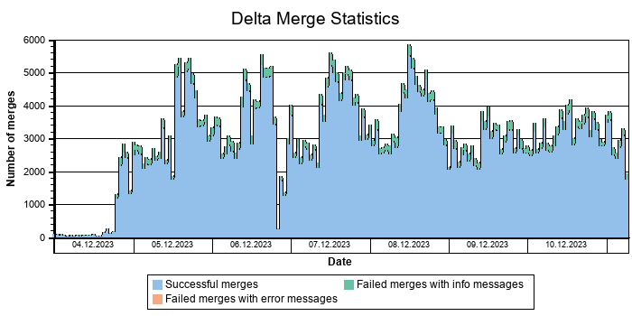
The following graph shows the delta merge volume from all merge types and the average delta merge time per record in the monitored timeframe:
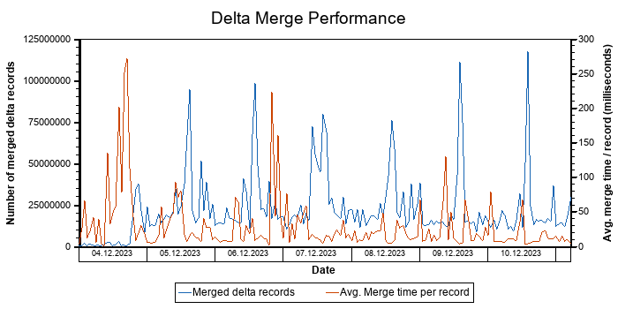
Note: High merge duration can be a result of a high number of records to be merged or of a high-load situation in the system.

Delta Merge Errors
The following table provides an overview of the delta merge errors that occurred in the monitored timeframe. The column "Message Type" shows the level of importance of the entry.
Delta Merge Errors
Date | Host | Port | Error code | Error range | Merge type | Number of errors | Message Type
10.10.2025 | tsls4proddbh | 30046 | 2486 | 2048 | MERGE ( AUTO ) | 5171 | Information
11.10.2025 | tsls4proddbh | 30046 | 2482 | 2048 | MERGE ( AUTO ) | 1 | Information
11.10.2025 | tsls4proddbh | 30046 | 2486 | 2048 | MERGE ( AUTO ) | 1486 | Information

The following table lists descriptions and general recommendations for delta merge errors. Additional support for error handling can be requested via a customer message on component HAN-DB if necessary.
Errors only for Information
Error | Description | Recommended action
2482 | The delta storage is empty or the evaluation of the smart merge costfunction indicated that a merge is not necessary. | See the detailed recommendation below.
2486 | All rows in delta were not optimizable | Check why merge operation was started although no row can be processed.

Recommendation for error 2482: No further action is required if this occurs occasionally.
If it occurs frequently: Check M_DELTA_MERGE_STATISTICS and review the smart merge cost function with SAP experts (smart_merge_decision_func parameter).

SAP HANA I/O Performance Counters

Duration of Blocking Savepoint Phase
The duration of blocking savepoint phase is too high.

The majority of the savepoint is performed online without holding a lock, but the finalization of the savepoint requires a lock. This step is called the "blocking savepoint phase".
The graph shows the hourly average for the duration of the "blocking savepoint phase" in the monitored timeframe.
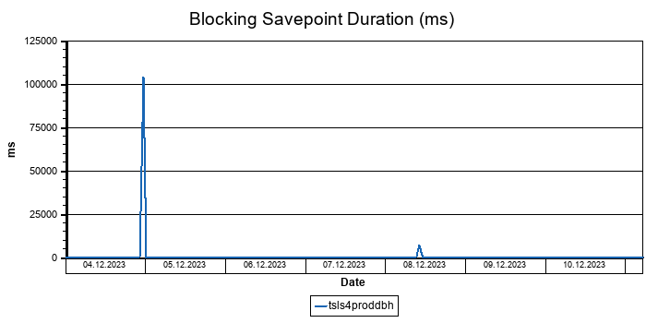
The hourly average duration of blocking savepoint phases exceeded 10 seconds during some periods of last week. While the blocking savepoint phase is running, DML operations such as INSERT, UPDATE and DELETE, and DDL operations are blocked with a ConsistentChangeLock (see SAP Note 1999998). High duration of blocking savepoint phases can be caused by I/O performance issues. For further investigation, check SAP Note 2100009 and consider opening an incident message on component HAN-DB.

Administration

Diagnosis Files
The trace directory contains a high number of diagnosis files or the files occupy a lot of disk space.

During operation, the SAP HANA database service writes messages and information to log files in its trace directory. The system administrator should check these files regularly and react to error messages accordingly. A large number of files may be generated, which can take up a lot of disk space and impair performance. The following table shows the number of files contained in the trace directory.
Diagnosis Files
Server | Measured Time Period | Type | Number of Files | Total Size in MB
tsls4proddbh | Weekly | Log | 2 | 1.397,56
tsls4proddbh | Weekly | Trace | 33 | 319,04
tsls4proddbh | Weekly | Dump | 7 | 90,58
tsls4proddbh | Unlimited | TOTAL | 169 | 3.707,74

We recommend that you check the content of the trace folder in the SAP HANA database installation directory on a regular basis and delete any files that are no longer required.

Backup and Recovery
Some issues for operating or administration in terms of backup/recovery have been detected.

Log Backup
Date | Weekday | Successful Log Backups | Unsuccessful Log Backups
04.10.2025 | Monday | 1.065 | 0
05.10.2025 | Tuesday | 1.055 | 0
06.10.2025 | Wednesday | 1.037 | 0
07.10.2025 | Thursday | 1.132 | 0
08.10.2025 | Friday | 1.096 | 0
09.10.2025 | Saturday | 998 | 0
10.10.2025 | Sunday | 1.004 | 0

Data Backup
Date | Weekday | Successful Data Backups | Unsuccessful Data Backups
04.10.2025 | Monday | 3 | 1
05.10.2025 | Tuesday | 1 | 1
06.10.2025 | Wednesday | 2 | 0
07.10.2025 | Thursday | 1 | 0
08.10.2025 | Friday | 0 | 0
09.10.2025 | Saturday | 2 | 0
10.10.2025 | Sunday | 0 | 0

Number of Log Segments
This graph shows the number of log segments residing on your log volume.
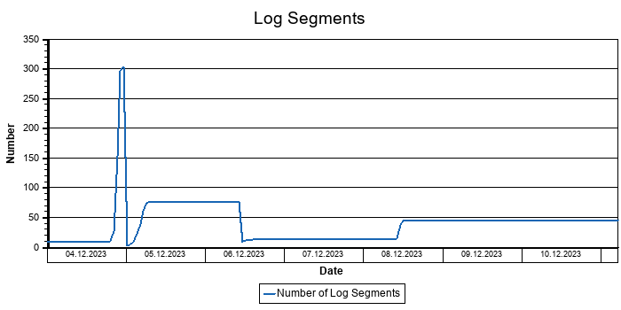
We found situations where the number of log segments increased significantly. A high number of free log segments is usually a consequence of an issue in the past (for example, failing log backup or savepoint delays). Therefore, SAP HANA created additional log segments and subsequently reuses them until they are manually reclaimed. A high number of non-reusable log segments results in increased log volume consumption on disk and, in the worst case, to disk full situations.
Recommendation: Check whether log backup operation and performance are appropriate.
Execute the following command in order to reclaim free log segments:
ALTER SYSTEM RECLAIM LOG

Global Consistency Check Run
The scheduling of the consistency check runs is not in agreement with SAP's recommendations.

The tables below show your setup of the consistency check runs. We differentiate between consistency check runs executed on all levels (CHECK_TABLE_CONSISTENCY(CHECK,'NULL','NULL')) and consistency check runs executed on table level (CHECK_TABLE_CONSISTENCY(CHECK,<SCHEMA_NAME>,<TABLE_NAME>)) or executed by the statistics server.
Consistency Check Runs on all Levels with Action 'CHECK'
Number of successful Executions | Last Start Date
0

Consistency Check Runs on Table Level with Action 'CHECK'
Number of checked Tables | Number of not verified Tables | Last Start Date
0 | 51203

Table Consistency Check by Statisticsserver
Action | Time since last Run
check_delta_log, check_variable_part_sanity, check_data_container, check_variable_part_double_reference_global, check_partitioning, check_replication, check_table_container_no_load | 220 Days, 6 Hours

No global consistency check and no consistency check scheduled by the statistics server was observed during the last 32 days, or a global consistency check on table level was running for less than 50% of the tables.
Recommendation: SAP strongly recommends performing a global consistency check once in the backup cycle (at least once per month). Further information can be found in SAP Note 2116157 and in the SAP HANA Admin Guide -> Managing Tables -> Table and Catalog Consistency Check. Please note that the consistency check should be performed at times when there is a low load on your system. The consistency should be checked by calling the procedure 'CHECK_TABLE_CONSISTENCY('CHECK', NULL, NULL)'. Alternatively you can schedule the check 'CHECK_TABLE_CONSISTENCY('CHECK', <SCHEMA_NAME>, <TABLE_NAME>)' with a calculated list of tables.

License Information
Your license is permanent and valid.

The following table shows information about the validity of your license. The license should be permanent and valid.
License Information
System ID | Installation Number | Expiration Date | Permanent | Valid | Product Name | Product Limit
PRD | 7120052684 |  | TRUE | TRUE | SAP-HANA | 9500

Statisticsserver and Monitoring
No issues with the statistics server were detected.

The table below shows KPIs relevant for monitoring stability with the embedded statistics server.
KPI | Current value | Rating
Status of the embedded Statisticsserver | Okay
Alerts in the Statisticsserver are not scheduled in the expected timeframe. | 0
Number of tables not located on the master server | 0
Number of disabled alert collectors | 0
Number of disabled statistic collectors | 0
Collector_Global_Table_Persistence_Statistics idle | Idle
Number of collectors with retention times < 42 days | 0
High number of unprocessed e-Mails | 28
Status of Collector HOST_CS_UNLOADS | Inactive
Number of relevant inactive actions | 0
Number of actions with unknown state | 0
Number of Statisticsserver worker threads | 5
Historic thread samples save interval (s) | 600
History of M_RECORD_LOCKS collected | no

Important SAP Notes for SAP HANA
Important information is available in the SAP Notes below.

The following tables list important SAP Notes for SAP HANA.
SAP Notes for SAP HANA
SAP Note | Description
1514967 | SAP HANA: Central Note
2380229 | SAP HANA Platform 2.0 - Central Note
2091951 | Best Practice: SAP HANA Database Backup & Restore
2021789 | SAP HANA Revision and Maintenance Strategy
2000003 | FAQ: SAP HANA
2600030 | Parameter Recommendations in SAP HANA Environments
1911180 | HANA EarlyWatch Alerts (EWA) Issues
1592925 | SAP HANA Database service connections
1642148 | FAQ: SAP HANA Database Backup & Recovery
1664432 | DBA Cockpit: SAP HANA database as remote database
1681092 | Multiple SAP HANA databases on one appliance
1661202 | Support for multiple applications on SAP HANA
1650394 | SAP HANA DB: Partitioning and Distribution of Large Tables
1953429 | SAP HANA and SAP NetWeaver AS ABAP on one Server
1761546 | SAP ERP powered by SAP HANA - Optimizations
1872170 | Suite on HANA and S/4 HANA sizing report
1794297 | Secondary Indexes for the business suite on HANA

SAP Notes for operating system
SAP Note | Description
2684254 | SAP HANA DB: Recommended OS settings for SLES 15 / SLES for SAP Applications 15

Problematic SQL Statements in PRD
 | At least one SQL statement causes unnecessary high load on the system.

In the following table(s), SQL statement(s) are shown for which a recommendation is provided in the next section. Details can be found in the section listed.
Missing index causes expensive SQL statement
Statement String | Statement Hash | Section | Rating
SELECT "VBELV" , "POSNV" , "VBELN" , "POSNN" FROM "VBFA" ... | 26c09a7ce6c5ef9e6cad9845f229670b | Statements on Top Scanned Table/SQL Statement 26c09a7ce6c5ef9e6cad9845f229670b/Thread Distribution/High Number of Scanned Records
SELECT "VBELV" , "POSNV" FROM "VBFA" WHERE "MANDT" = ? A ... | ada23372ea59c0abd82cc2ffe5bbd714 | Statements on Top Scanned Table/SQL Statement ada23372ea59c0abd82cc2ffe5bbd714/Thread Distribution/High Number of Scanned Records
SELECT "VBELV" , "POSNV" FROM "VBFA" WHERE "MANDT" = ? A ... | c68c04a41b33a9f31691287ed2b77388 | Statements on Top Scanned Table/SQL Statement c68c04a41b33a9f31691287ed2b77388/Thread Distribution/High Number of Scanned Records
SELECT "VBELV" , "VBELN" , "VBTYP_V" , "POSNN" FROM "VBF ... | da0cae818c8fca6b540d1d5f8357432a | Top Statements (CPU Peak Hour)/SQL Statement da0cae818c8fca6b540d1d5f8357432a/Thread Distribution/High Number of Scanned Records

Configuration issue causes expensive SQL statement
Statement String | Statement Hash | Section | Rating
SELECT /* Buffer Loading */ "MANDT" , "KAPPL" , "KSCHL" ... | 54a9566c2195e1ab2540c7f5d0ac6ff4 | Top Statements (Thread Samples)/SQL Statement 54a9566c2195e1ab2540c7f5d0ac6ff4/Statement used for Buffer Loading
SELECT /* Buffer Loading */ "MANDT" , "KAPPL" , "KSCHL" ... | 77658c84db4c1afd41fa26aff7df5464 | Top Statements (Total Memory)/SQL Statement 77658c84db4c1afd41fa26aff7df5464/Statement used for Buffer Loading

SAP HANA SQL Statements in PRD
This section provides an overview of the "most expensive SQL statements". When possible, a recommendation is provided.
A more detailed analysis of the SQL statements (including the possibility to choose different time windows) is supported by the "Self-Service SQL Statement Tuning" (see SAP Note 1601951). For general information on dealing with expensive SQL statements in SAP HANA, see SAP Note 2000002.

Data Quality
A download-based SQL statement analysis can be performed.
The following table provides information about the data in the SDCC download. For details, see SAP Note 2344673.
Observation | Comment | Rating
Version of ST-PI function module: 38 | Check SAP Note 2344673 for possible reasons. Some improvements on top of the current support package are available with the most recent version of SAP Note 2344673.

Top Statements (Elapsed Time)
This section shows the top non-internal statements according to "Total Elapsed Time". The "Total Elapsed Time" is the sum of the "Total Execution Time" and the "Total Preparation Time" from the SQL PLAN CACHE. It has a direct impact on the response time of the application calling the statement.
See the following table for details of the selection:
Database Start | 15.10.2025 -- 08:03:55
Data Collection | 11.10.2025 -- 06:41:29
Analysis Type | Analysis of Plan Cache
Data Source | HOST_SQL_PLAN_CACHE
Begin of Time Interval | 03.10.2025 -- 23:48:58
End of Time Interval | 11.10.2025 -- 00:55:39

The selected statements - identified by their "Statement Hash" - are listed in the following table. Further details of these statements can be found in the subsections.
Statement Hash | Total Elapsed Time [s] | Number of Executions | Time / Execution [us] | Records / Execution | Time / Record [us]
938619e1d06635b2b252709b7ccd58af | 865.286,4 | 42.194 | 20.507.332,4 | 1,0 | 20.424.557,6
b1ee826430a30c5a298aa2631ce552c9 | 370.854,2 | 125.617 | 2.952.261,1 | 684,2 | 4.314,9
e83bedba7efbf579dcddfc21eabc1b91 | 313.291,7 | 3.550.842 | 88.230,3 | 1,0 | 88.242,1
7d6c514686df80e386680d0a8a249452 | 245.466,1 | 113.652 | 2.159.804,5 | 63,1 | 34.230,6
ac0fbdccfb4fc58deff85309166b95c0 | 191.741,8 | 437.896.093 | 437,9 | 70,7 | 6,2

SQL Statement 938619e1d06635b2b252709b7ccd58af
SELECT DISTINCT
"A" . "REF_DOC" , "A" . "REF_DOC_YEAR" , "B" . "BUDAT_MKPF"
FROM
"/OPT/VIM_1ITEM" "A" INNER JOIN /* Redirected table: MSEG */ "NSDM_V_MSEG" "B" ON "A" . "MANDT" = "B" . "MANDT" AND "A"
. "REF_DOC" = "B" . "LFBNR" AND "A" . "REF_DOC_YEAR" = "B" . "MJAHR"
WHERE
"A" . "MANDT" = ? AND "A" . "DOCID" = ? WITH RANGE_RESTRICTION('CURRENT')
Statement Impact
Indicator | Value
Contribution to Total CPU Load [%] | 3,59
Contribution to Total Execution Time [%] | 9,76
Maximal CPU Consumption per Hour [%] ( 05.10.2025 between 12:00 and 13:00 ) | 4,49

Note: The statement as identified by its statement hash can also be found in other sections of this report:
Other Sections Dealing with this Statement
SAP HANA SQL Statements in PRD -> Top Statements (CPU Peak Hour)
SAP HANA SQL Statements in PRD -> Top MATDOC Statements (Elapsed Time)
SAP HANA SQL Statements in PRD -> Top Statements (Thread Samples)
SAP HANA SQL Statements in PRD -> Top Statements (Total Memory)

Analysis of Where Clause
Table | Field | Operator | Supported by Single Column Index | Compression | Distinct Values | SCANNED RECORD COUNT | INDEX LOOKUP COUNT
/OPT/VIM_1ITEM | DOCID | = |  | DEFAULT | 10.594.120 | 119.414.604 | 816.740
/OPT/VIM_1ITEM | MANDT | = |  | RLE | 1 | 3.879 | 2

Time Consumption
The following table gives an overview of the time consumption of the analyzed SQL statement.
Activity | Total Time [s] | Average Time [us] | Minimal Time [us] | Maximal Time [us]
TOTAL EXECUTION | 865.285 | 20.507.309 | 198 | 316.055.039
PREPARATION | 1 | 23
LOCK DURATION | 0 | 0

Statement History (Thread Sample 'Running')
The following graph shows the number of observed thread samples (in state "running") related to this SQL statement together with the contribution of those samples to all thread samples (in state "running") active in the system.
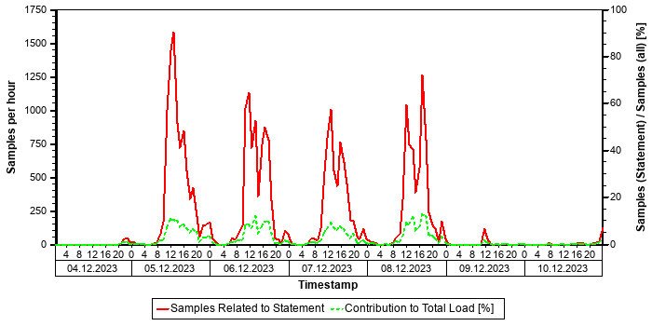

Correlation with Index Server Resource Consumption
The distribution of thread samples with the status "Running" correlates strongly with the overall CPU or memory consumption of the system. Such a correlation indicates that this statement might be responsible for peaks in the memory or CPU consumption.
Distiribution | Correlation Coefficient | Comment
CPU consumption index server(s) - Threads (running) from this SQL statement | 0,81 | strong correlation
Memory consumption index server(s) - Threads (running) from this SQL Statement | 0,62 | strong correlation

Tables
In the following, the tables involved in the SQL statement are listed (maximum of 20), sorted by the number of records.
Table Name | Schema Name | Table Type | Partition Type | Number of Records | Host
MATDOC | SAPPRD | COLUMN | Table not partitioned | 565.077.043 | tsls4proddbh
/OPT/VIM_1ITEM | SAPPRD | COLUMN | Table not partitioned | 30.153.698 | tsls4proddbh

Compatibility View Access
SAP S/4HANA Supply Chain (MM - Inventory Management) offers a simplified data model. Several tables have become obsolete and are removed. To allow existing coding to continue to work, these tables are replaced by views with the same name, known as "Compatibility Views". As a result, read access to these objects is still possible; however, performance is affected since it is now an access to a view instead of a simple table. For some general background information, see https://launchpad.support.sap.com/#/notes/2206980 [SAP Note 2206980].
For performance-critical coding parts, we strongly recommend the code adjustments suggested in Section 2 of the SAP Note. For non-critical parts, these adjustments are optional in the short term but recommended in the long term.

Origin of SQL Statement
The following table shows details of the applications responsible for the statement. This information is based on the information provided by SAP HANA in the "application source" connected to the statement in the "thread samples" or the list of "prepared" or "active" statements, and is not necessarily complete.
SID | Transaction / Jobaname | Report | Line | Last Changed on: | SAP Coding
PRD | /OPT/DR_BR_WAIT | LZOPT_VIM_1U07 | 29 | 25.09.2019
PRD | /OPT/VIM_ANALYTICS | LZOPT_VIM_1U07 | 29 | 25.09.2019
PRD | /OPT/VIM_ANALYTICS_750 | LZOPT_VIM_1U07 | 29 | 25.09.2019
PRD | /OPT/VIM_RULERUN | LZOPT_VIM_1U07 | 29 | 25.09.2019
PRD | /OPT/VIM_VA2 | LZOPT_VIM_1U07 | 29 | 25.09.2019
PRD | /OPT/VIM_WP | LZOPT_VIM_1U07 | 29 | 25.09.2019
PRD | RSWIWILS | LZOPT_VIM_1U07 | 29 | 25.09.2019
PRD | SBWP | LZOPT_VIM_1U07 | 29 | 25.09.2019
PRD | SWIA | LZOPT_VIM_1U07 | 29 | 25.09.2019
PRD | VIM_BC_INBOUND_PROCESSING | LZOPT_VIM_1U07 | 29 | 25.09.2019
PRD | YP2P_DASH | LZOPT_VIM_1U07 | 29 | 25.09.2019

SQL Statement b1ee826430a30c5a298aa2631ce552c9
SELECT
"MANDT" , "MATBF" , "WERKS" , "LGORT_SID" , "CHARG_SID" , "BUDAT" , "DISUB_OWNER_CID" , "MAT_KDAUF" , "MAT_KDPOS" , "CHARG_CID" , "LBBSA_SID" , "UNRESTRICTEDSTOCK" , "QUALITYINSSTOCK" , "RESTSTOCK" , "BLOCKSTOCK" , "BLOCKSTOCKRETURN" , "MEINS" , "STOCK_QTY" , "JARHPER" , "BWTAR" , "UPTO30DAYS" , "BT31TO90DAYS" , "BT90TO180DAYS" , "ABOVE180DAYS"
FROM
/* Entity name: YMPC_WRAPPER_MATDOC */ "YMPCWRAPMD" ( "P_WERKS" => ? , "P_BUDAT" => ? ) "YMPC_WRAPPER_MATDOC"
WHERE
"MANDT" = ? AND ( ( "MATBF" = ? AND "CHARG_SID" = ? ) OR ( "MATBF" = ? AND "CHARG_SID" = ? ) OR ( "MATBF" = ? AND "CHARG_SID" = ? ) OR ( "MATBF" = ? AND "CHARG_SID" = ? ) OR ( "MATBF" = ? AND "CHARG_SID" = ? ) OR ( "MATBF" = ? AND "CHARG_SID" = ? ) OR ( "MATBF" = ? AND "CHARG_SID" = ? ) OR ( "MATBF" = ? AND "CHARG_SID" = ? ) OR ( "MATBF" = ? AND "CHARG_SID"= ? ) OR ( "MATBF" = ? AND "CHARG_SID" = ? ) OR ( "MATBF" = ? AND "CHARG_SID" = ? ) OR ( "MATBF" = ? AND "CHARG_SID" = ? ) OR ( "MATBF" = ? AND "CHARG_SID" = ? ) OR ( "MATBF" = ? AND "CHARG_SID" = ? ) OR ( "MATBF" = ? AND "CHARG_SID" = ? )OR ( "MATBF" = ? AND "CHARG_SID" = ? ) OR ( "MATBF" = ? AND "CHARG_SID" = ? ) OR ( "MATBF" = ? AND "CHARG_SID" = ? ) OR( "MATBF" = ? AND "CHARG_SID" = ? ) OR ( "MATBF" = ? AND "CHARG_SID" = ? ) OR ( "MATBF" = ? AND "CHARG_SID" = ? ) OR ( "MATBF" = ? AND "CHARG_SID" = ? ) OR ( "MATBF" = ? AND "CHARG_SID" = ? ) OR ( "MATBF" = ? AND "CHARG_SID" = ? ) OR ( "MATBF" = ? AND "CHARG_SID" = ? ) OR ( "MATBF" = ? AND "CHARG_SID" = ? ) OR ( "MATBF" = ? AND "CHARG_SID" = ? ) OR ( "MATBF" = ? AND "CHARG_SID" = ? ) OR ( "MATBF" = ? AND "CHARG_SID" = ? ) OR ( "MATBF" = ? AND "CHARG_SID" = ? ) OR ( "MATBF" =? AND "CHARG_SID" = ? ) OR ( "MATBF" = ? AND "CHARG_SID" = ? ) OR ( "MATBF" = ? AND "CHARG_SID" = ? ) OR ( "MATBF" = ? AND "CHARG_SID" = ? ) OR ( "MATBF" = ? AND "CHARG_SID" = ? ) OR ( "MATBF" = ? AND "CHARG_SID" = ? ) OR ( "MATBF" = ? AND"CHARG_SID" = ? ) OR ( "MATBF" = ? AND "CHARG_SID" = ? ) OR ( "MATBF" = ? AND "CHARG_SID" = ? ) OR ( "MATBF" = ? AND "CHARG_SID" = ? ) OR ( "MATBF" = ? AND "CHARG_SID" = ? ) OR ( "MATBF" = ? AND "CHARG_SID" = ? ) OR ( "MATBF" = ? AND "CHARG_SID" = ? ) OR ( "MATBF" = ? AND "CHARG_SID" = ? ) OR ( "MATBF" = ? AND "CHARG_SID" = ? ) OR ( "MATBF" = ? AND "CHARG_SID" = ? ) OR ( "MATBF" = ? AND "CHARG_SID" = ? ) OR ( "MATBF" = ? AND "CHARG_SID" = ? ) OR ( "MATBF" = ? AND "CHARG_SID"= ? ) OR ( "MATBF" = ? AND "CHARG_SID" = ? ) ) WITH RANGE_RESTRICTION('CURRENT')
Statement Impact
Indicator | Value
Contribution to Total CPU Load [%] | 1,18
Contribution to Total Execution Time [%] | 4,18
Maximal CPU Consumption per Hour [%] ( 05.10.2025 between 00:00 and 01:00 ) | 1,55

Note: The statement as identified by its statement hash can also be found in other sections of this report:
Other Sections Dealing with this Statement
SAP HANA SQL Statements in PRD -> Top MATDOC Statements (Elapsed Time)

Analysis of Where Clause
Table | Field | Operator | SCANNED RECORD COUNT | INDEX LOOKUP COUNT
MATDOC | CHARG_SID | = | 333.954.108.842.427 | 972.081
MATDOC | MANDT | = | 548.707.335.241 | 0
MATDOC | MATBF | = | 185.327.222.403.864 | 4.974.459

Time Consumption
The following table gives an overview of the time consumption of the analyzed SQL statement.
Activity | Total Time [s] | Average Time [us] | Minimal Time [us] | Maximal Time [us]
TOTAL EXECUTION | 370.834 | 2.952.103 | 1.410 | 113.465.225
PREPARATION | 20 | 158
LOCK DURATION | 0 | 0

Statement History (Thread Sample 'Running')
The following graph shows the number of observed thread samples (in state "running") related to this SQL statement together with the contribution of those samples to all thread samples (in state "running") active in the system.
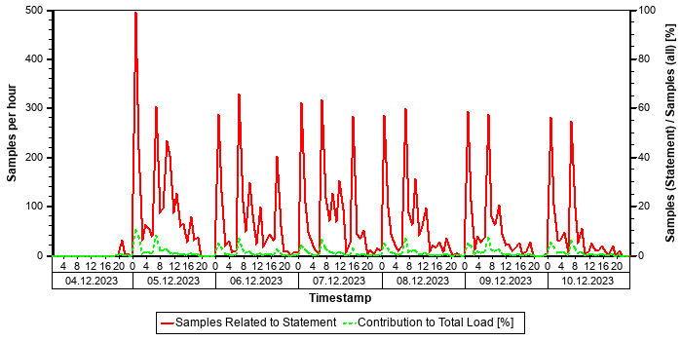

Tables
In the following, the tables involved in the SQL statement are listed (maximum of 20), sorted by the number of records.
Table Name | Schema Name | Table Type | Partition Type | Number of Records | Host
MATDOC | SAPPRD | COLUMN | Table not partitioned | 565.077.043 | tsls4proddbh

Origin of SQL Statement
The following table shows details of the applications responsible for the statement. This information is based on the information provided by SAP HANA in the "application source" connected to the statement in the "thread samples" or the list of "prepared" or "active" statements, and is not necessarily complete.
SID | Transaction / Jobaname | Report | Line | Last Changed on: | SAP Coding
PRD | FP_STOCK_BARA | YMPCR_STOCK_REPORT_HANA | 4.602 | 16.11.2025
PRD | FP_STOCK_CRM | YMPCR_STOCK_REPORT_HANA | 4.602 | 16.11.2025
PRD | FP_STOCK_LD2 | YMPCR_STOCK_REPORT_HANA | 4.602 | 16.11.2025
PRD | YMPCR_STOCK_REPORT_HANA | YMPCR_STOCK_REPORT_HANA | 4.602 | 16.11.2025
PRD | YSTOCKN | YMPCR_STOCK_REPORT_HANA | 4.602 | 16.11.2025
PRD | YSTOCKN_BE_SY | YMPCR_STOCK_REPORT_HANA | 4.602 | 16.11.2025
PRD | YSTOCKN_D_5 | YMPCR_STOCK_REPORT_HANA | 4.602 | 16.11.2025

SQL Statement e83bedba7efbf579dcddfc21eabc1b91
SELECT
"DATA"
FROM
"REPOTEXT"
WHERE
"PROGNAME" = ? AND "R3STATE" = ? AND "LANGUAGE" = ? WITH RANGE_RESTRICTION('CURRENT')
Statement Impact
Indicator | Value
Contribution to Total CPU Load [%] | 0,01
Contribution to Total Execution Time [%] | 3,53
Maximal CPU Consumption per Hour [%] ( 09.10.2025 between 09:00 and 10:00 ) | 0,01

Analysis of Where Clause
Table | Field | Operator | SCANNED RECORD COUNT | INDEX LOOKUP COUNT
REPOTEXT | LANGUAGE | = | 0 | 0
REPOTEXT | PROGNAME | = | 0 | 6.314.052
REPOTEXT | R3STATE | = | 0 | 0

Time Consumption
The following table gives an overview of the time consumption of the analyzed SQL statement.
Activity | Total Time [s] | Average Time [us] | Minimal Time [us] | Maximal Time [us]
TOTAL EXECUTION | 313.291 | 88.230 | 70 | 52.616.447
PREPARATION | 1 | 0
LOCK DURATION | 0 | 0

Statement History (Thread Sample 'Running')
The following graph shows the number of observed thread samples (in state "running") related to this SQL statement together with the contribution of those samples to all thread samples (in state "running") active in the system.
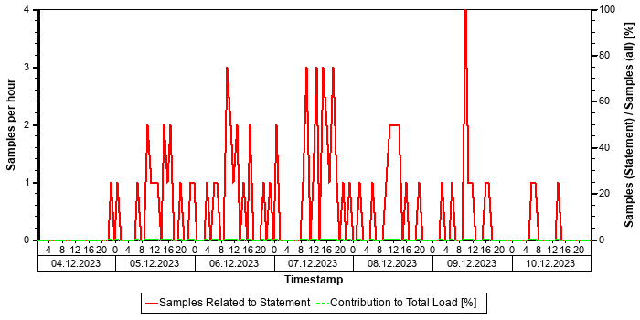

Correlation with Index Server Resource Consumption
The distribution of thread samples with the status "Running" correlates strongly with the overall CPU or memory consumption of the system. Such a correlation indicates that this statement might be responsible for peaks in the memory or CPU consumption.
Distiribution | Correlation Coefficient | Comment
CPU consumption index server(s) - Threads (running) from this SQL statement | 0,52 | strong correlation
Memory consumption index server(s) - Threads (running) from this SQL Statement | 0,39 | medium correlation

Tables
In the following, the tables involved in the SQL statement are listed (maximum of 20), sorted by the number of records.
Table Name | Schema Name | Table Type | Partition Type | Number of Records | Host
REPOTEXT | SAPPRD | COLUMN | Table not partitioned | 1.032.675 | tsls4proddbh

Origin of SQL Statement
The following table shows details of the applications responsible for the statement. This information is based on the information provided by SAP HANA in the "application source" connected to the statement in the "thread samples" or the list of "prepared" or "active" statements, and is not necessarily complete.
SID | Transaction / Jobaname | Report | Line | Last Changed on: | SAP Coding | Application Component | Description
PRD | ME52N | CL_SAL_READ_FILES=============CM003 | 5 | 01.06.2015 |  | BC-SEC-SAL | Security Audit Log

SQL Statement 7d6c514686df80e386680d0a8a249452
SELECT
"MANDANT" , "OBJECTCLAS" , "OBJECTID" , "CHANGENR" , "TABNAME" , "TABKEY" , "FNAME" , "CHNGIND" , "TEXT_CASE" , "UNIT_OLD" , "UNIT_NEW" , "CUKY_OLD" , "CUKY_NEW" , "VALUE_NEW" , "VALUE_OLD" , "_DATAAGING"
FROM
"CDPOS"
WHERE
"MANDANT" = ? AND "OBJECTID" IN ( ? , ? , ? , ? , ? , ? , ? , ? , ? , ? , ? , ? , ? , ? , ? , ? , ? , ? , ? , ? , ? , ?, ? , ? , ? , ? , ? , ? , ? , ? , ? , ? , ? , ? , ? , ? , ? , ? , ? , ? , ? , ? , ? , ? , ? , ? , ? , ? , ? , ? , ? , ?, ? , ? , ? , ? , ? , ? , ? , ? , ? , ? , ? , ? , ? , ? , ? , ? , ? , ? , ? , ? , ? , ? , ? , ? , ? , ? , ? , ? , ? , ?, ? , ? , ? , ? , ? , ? , ? , ? , ? , ? , ? , ? , ? , ? , ? , ? , ? , ? ) AND "TABNAME" IN ( N'LIKP' , N'VBAK' , N'LIPS' , N'VBAP' ) AND "OBJECTCLAS" IN ( N'LIEFERUNG' , N'VERKBELEG' ) AND "CHNGIND" = N'D' WITH RANGE_RESTRICTION('CURRENT')
Statement Impact
Indicator | Value
Contribution to Total CPU Load [%] | 0,72
Contribution to Total Execution Time [%] | 2,77
Maximal CPU Consumption per Hour [%] ( 09.10.2025 between 23:00 and 24:00 ) | 0,22

Analysis of Where Clause
Table | Field | Operator | SCANNED RECORD COUNT | INDEX LOOKUP COUNT
CDPOS | CHNGIND | = | 579 | 0
CDPOS | MANDANT | = | 61.527.983 | 30
CDPOS | OBJECTCLAS | IN | 8.997.435 | 71
CDPOS | OBJECTID | IN | 1.277.616.497.678.994 | 3.297.086
CDPOS | TABNAME | IN | 58.493.754.973 | 269.413

Time Consumption
The following table gives an overview of the time consumption of the analyzed SQL statement.
Activity | Total Time [s] | Average Time [us] | Minimal Time [us] | Maximal Time [us]
TOTAL EXECUTION | 245.436 | 2.159.540 | 5.060 | 22.527.203
PREPARATION | 30 | 265
LOCK DURATION | 0 | 0

Statement History (Thread Sample 'Running')
The following graph shows the number of observed thread samples (in state "running") related to this SQL statement together with the contribution of those samples to all thread samples (in state "running") active in the system.
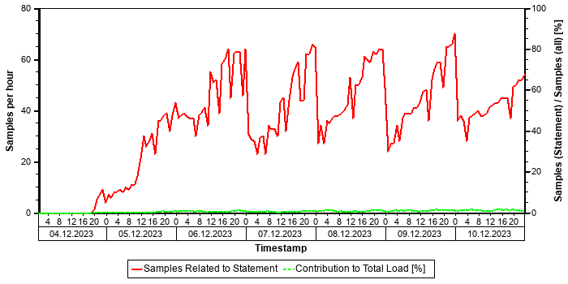

Correlation with Index Server Resource Consumption
The distribution of thread samples with the status "Running" correlates strongly with the overall CPU or memory consumption of the system. Such a correlation indicates that this statement might be responsible for peaks in the memory or CPU consumption.
Distiribution | Correlation Coefficient | Comment
CPU consumption index server(s) - Threads (running) from this SQL statement | 0,43 | medium correlation
Memory consumption index server(s) - Threads (running) from this SQL Statement | 0,52 | strong correlation

Tables
In the following, the tables involved in the SQL statement are listed (maximum of 20), sorted by the number of records.
Table Name | Schema Name | Table Type | Partition Type | Number of Records | Host
CDPOS | SAPPRD | COLUMN | HASH | 7.150.225.343 | tsls4proddbh

Origin of SQL Statement
The following table shows details of the applications responsible for the statement. This information is based on the information provided by SAP HANA in the "application source" connected to the statement in the "thread samples" or the list of "prepared" or "active" statements, and is not necessarily complete.
SID | Transaction / Jobaname | Report | Line | Last Changed on: | SAP Coding | Application Component | Description
PRD | DEL_DOC_INCR_TRANSFER | YCTDI_SD_DATA_TRANSFER | 5.546 | 13.04.2025 |  | BC-DWB | ABAP Workbench, Java IDE and Infrastructure
PRD | DEL_DOC_INCR_TRANSFER_500 | YCTDI_SD_DATA_TRANSFER | 5.546 | 13.04.2025 |  | BC-DWB | ABAP Workbench, Java IDE and Infrastructure

SQL Statement ac0fbdccfb4fc58deff85309166b95c0
SELECT
"CTYP" , "VORLNR" , "VERSION" , "MKMNR"
FROM
"QCVM"
WHERE
"MANDANT" = ? AND ( ( "VORLNR" = ? AND "CTYP" = ? AND "VERSION" = ? AND NOT "MKMNR" IN ( N'ISI_LOGO' , N'NB_LSA' , N'MO_LSA' , N'TI_LSA' , N'V_LSA' , N'B_LSA' , N'CR_LSA' , N'NI_LSA' , N'CU_LSA' ) ) OR ( "VORLNR" = ? AND "CTYP" = ? AND "VERSION" = ? AND NOT "MKMNR" IN ( N'ISI_LOGO' , N'NB_LSA' , N'MO_LSA' , N'TI_LSA' , N'V_LSA' , N'B_LSA' , N'CR_LSA' , N'NI_LSA' , N'CU_LSA' ) ) OR ( "VORLNR" = ? AND "CTYP" = ? AND "VERSION" = ? AND NOT "MKMNR" IN ( N'ISI_LOGO' , N'NB_LSA' , N'MO_LSA' , N'TI_LSA' , N'V_LSA' , N'B_LSA' , N'CR_LSA' , N'NI_LSA' , N'CU_LSA' ) ) OR ( "VORLNR" = ? AND "CTYP" = ? AND"VERSION" = ? AND NOT "MKMNR" IN ( N'ISI_LOGO' , N'NB_LSA' , N'MO_LSA' , N'TI_LSA' , N'V_LSA' , N'B_LSA' , N'CR_LSA' , N'NI_LSA' , N'CU_LSA' ) ) OR ( "VORLNR" = ? AND "CTYP" = ? AND "VERSION" = ? AND NOT "MKMNR" IN ( N'ISI_LOGO' , N'NB_LSA' , N'MO_LSA' , N'TI_LSA' , N'V_LSA' , N'B_LSA' , N'CR_LSA' , N'NI_LSA' , N'CU_LSA' ) ) OR ( "VORLNR" = ? AND "CTYP" = ?AND "VERSION" = ? AND NOT "MKMNR" IN ( N'ISI_LOGO' , N'NB_LSA' , N'MO_LSA' , N'TI_LSA' , N'V_LSA' , N'B_LSA' , N'CR_LSA' , N'NI_LSA' , N'CU_LSA' ) ) OR ( "VORLNR" = ? AND "CTYP" = ? AND "VERSION" = ? AND NOT "MKMNR" IN ( N'ISI_LOGO' , N'NB_LSA' , N'MO_LSA' , N'TI_LSA' , N'V_LSA' , N'B_LSA' , N'CR_LSA' , N'NI_LSA' , N'CU_LSA' ) ) OR ( "VORLNR" = ? AND "CTYP"= ? AND "VERSION" = ? AND NOT "MKMNR" IN ( N'ISI_LOGO' , N'NB_LSA' , N'MO_LSA' , N'TI_LSA' , N'V_LSA' , N'B_LSA' , N'CR_LSA' , N'NI_LSA' , N'CU_LSA' ) ) OR ( "VORLNR" = ? AND "CTYP" = ? AND "VERSION" = ? AND NOT "MKMNR" IN ( N'ISI_LOGO' , N'NB_LSA' , N'MO_LSA' , N'TI_LSA' , N'V_LSA' , N'B_LSA' , N'CR_LSA' , N'NI_LSA' , N'CU_LSA' ) ) OR ( "VORLNR" = ? AND "CTYP" = ? AND "VERSION" = ? AND NOT "MKMNR" IN ( N'ISI_LOGO' , N'NB_LSA' , N'MO_LSA' , N'TI_LSA' , N'V_LSA' , N'B_LSA' , N'CR_LSA' , N'NI_LSA' , N'CU_LSA' ) ) OR ( "VORLNR" = ? AND "CTYP" = ? AND "VERSION" = ? AND NOT "MKMNR" IN ( N'ISI_LOGO' , N'NB_LSA' , N'MO_LSA' , N'TI_LSA' , N'V_LSA' , N'B_LSA' , N'CR_LSA' , N'NI_LSA' , N'CU_LSA' ) ) OR ( "VORLNR" = ? AND "CTYP" = ? AND "VERSION" = ? AND NOT "MKMNR" IN ( N'ISI_LOGO' , N'NB_LSA' , N'MO_LSA' , N'TI_LSA' , N'V_LSA' , N'B_LSA' , N'CR_LSA' , N'NI_LSA' , N'CU_LSA' ) ) OR ( "VORLNR" = ? AND "CTYP" = ? AND "VERSION" = ? AND NOT "MKMNR" IN ( N'ISI_LOGO' , N'NB_LSA' , N'MO_LSA' , N'TI_LSA' , N'V_LSA' , N'B_LSA' , N'CR_LSA' , N'NI_LSA' , N'CU_LSA' ) ) OR ( "VORLNR" = ? AND "CTYP" = ? AND "VERSION" = ? AND NOT "MKMNR" IN ( N'ISI_LOGO' , N'NB_LSA' , N'MO_LSA' , N'TI_LSA' , N'V_LSA' , N'B_LSA' , N'CR_LSA' , N'NI_LSA' , N'CU_LSA' ) ) OR ( "VORLNR" = ? AND "CTYP" = ? AND "VERSION" = ? AND NOT "MKMNR" IN ( N'ISI_LOGO' , N'NB_LSA' , N'MO_LSA' , N'TI_LSA' , N'V_LSA' , N'B_LSA' , N'CR_LSA' , N'NI_LSA' , N'CU_LSA' ) ) OR ( "VORLNR" = ? AND "CTYP" = ? AND "VERSION" = ? AND NOT "MKMNR" IN ( N'ISI_LOGO' , N'NB_LSA' , N'MO_LSA' , N'TI_LSA' , N'V_LSA' ,N'B_LSA' , N'CR_LSA' , N'NI_LSA' , N'CU_LSA' ) ) OR ( "VORLNR" = ? AND "CTYP" = ? AND "VERSION" = ? AND NOT "MKMNR" IN ( N'ISI_LOGO' , N'NB_LSA' , N'MO_LSA' , N'TI_LSA' , N'V_LSA' , N'B_LSA' , N'CR_LSA' , N'NI_LSA' , N'CU_LSA' ) ) OR ( "VORLNR" = ? AND "CTYP" = ? AND "VERSION" = ? AND NOT "MKMNR" IN ( N'ISI_LOGO' , N'NB_LSA' , N'MO_LSA' , N'TI_LSA' , N'V_LSA' , N'B_LSA' , N'CR_LSA' , N'NI_LSA' , N'CU_LSA' ) ) OR ( "VORLNR" = ? AND "CTYP" = ? AND "VERSION" = ? AND NOT "MKMNR"IN ( N'ISI_LOGO' , N'NB_LSA' , N'MO_LSA' , N'TI_LSA' , N'V_LSA' , N'B_LSA' , N'CR_LSA' , N'NI_LSA' , N'CU_LSA' ) ) OR ("VORLNR" = ? AND "CTYP" = ? AND "VERSION" = ? AND NOT "MKMNR" IN ( N'ISI_LOGO' , N'NB_LSA' , N'MO_LSA' , N'TI_LSA' , N'V_LSA' , N'B_LSA' , N'CR_LSA' , N'NI_LSA' , N'CU_LSA' ) ) OR ( "VORLNR" = ? AND "CTYP" = ? AND "VERSION" = ? AND NOT "MKMNR" IN ( N'ISI_LOGO' , N'NB_LSA' , N'MO_LSA' , N'TI_LSA' , N'V_LSA' , N'B_LSA' , N'CR_LSA' , N'NI_LSA' , N'CU_LSA' ) ) OR ( "VORLNR" = ? AND "CTYP" = ? AND "VERSION" = ? AND NOT "MKMNR" IN ( N'ISI_LOGO' , N'NB_LSA' , N'MO_LSA' , N'TI_LSA' , N'V_LSA' , N'B_LSA' , N'CR_LSA' , N'NI_LSA' , N'CU_LSA' ) ) OR ( "VORLNR" = ? AND "CTYP" = ? AND "VERSION" = ? AND NOT"MKMNR" IN ( N'ISI_LOGO' , N'NB_LSA' , N'MO_LSA' , N'TI_LSA' , N'V_LSA' , N'B_LSA' , N'CR_LSA' , N'NI_LSA' , N'CU_LSA' ) ) OR ( "VORLNR" = ? AND "CTYP" = ? AND "VERSION" = ? AND NOT "MKMNR" IN ( N'ISI_LOGO' , N'NB_LSA' , N'MO_LSA' , N'TI_LSA' , N'V_LSA' , N'B_LSA' , N'CR_LSA' , N'NI_LSA' , N'CU_LSA' ) ) OR ( "VORLNR" = ? AND "CTYP" = ? AND "VERSION" = ? ANDNOT "MKMNR" IN ( N'ISI_LOGO' , N'NB_LSA' , N'MO_LSA' , N'TI_LSA' , N'V_LSA' , N'B_LSA' , N'CR_LSA' , N'NI_LSA' , N'CU_LSA' ) ) OR ( "VORLNR" = ? AND "CTYP" = ? AND "VERSION" = ? AND NOT "MKMNR" IN ( N'ISI_LOGO' , N'NB_LSA' , N'MO_LSA' , N'TI_LSA' , N'V_LSA' , N'B_LSA' , N'CR_LSA' , N'NI_LSA' , N'CU_LSA' ) ) OR ( "VORLNR" = ? AND "CTYP" = ? AND "VERSION" = ?AND NOT "MKMNR" IN ( N'ISI_LOGO' , N'NB_LSA' , N'MO_LSA' , N'TI_LSA' , N'V_LSA' , N'B_LSA' , N'CR_LSA' , N'NI_LSA' , N'CU_LSA' ) ) OR (
...
Statement Impact
Indicator | Value
Contribution to Total CPU Load [%] | 0,90
Contribution to Total Execution Time [%] | 2,16
Maximal CPU Consumption per Hour [%] ( 07.10.2025 between 21:00 and 22:00 ) | 0,25

Analysis of Where Clause
Table | Field | Operator | SCANNED RECORD COUNT | INDEX LOOKUP COUNT
QCVM | CTYP | = | 0 | 0
QCVM | MANDANT | = | 1.084 | 0
QCVM | MKMNR | IN | 170.387.610.688 | 389.738
QCVM | VERSION | = | 615 | 0
QCVM | VORLNR | = | 0 | 102.102

Time Consumption
The following table gives an overview of the time consumption of the analyzed SQL statement.
Activity | Total Time [s] | Average Time [us] | Minimal Time [us] | Maximal Time [us]
TOTAL EXECUTION | 191.712 | 438 | 140 | 703.863
PREPARATION | 30 | 0
LOCK DURATION | 0 | 0

Statement History (Thread Sample 'Running')
The following graph shows the number of observed thread samples (in state "running") related to this SQL statement together with the contribution of those samples to all thread samples (in state "running") active in the system.
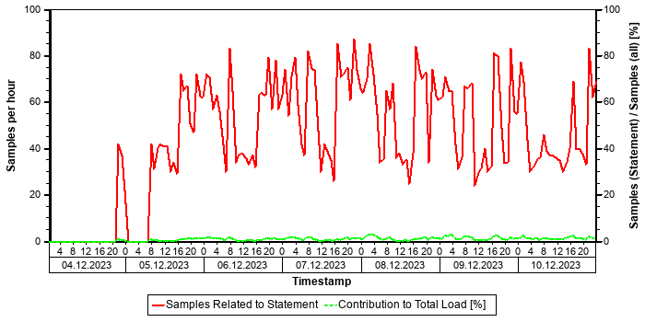

Correlation with Index Server Resource Consumption
The distribution of thread samples with the status "Running" correlates with the overall CPU or memory consumption of the system. Such a correlation indicates that this statement might be responsible for peaks in the memory or CPU consumption.
Distiribution | Correlation Coefficient | Comment
CPU consumption index server(s) - Threads (running) from this SQL statement | 0,33 | medium correlation
Memory consumption index server(s) - Threads (running) from this SQL Statement | 0,36 | medium correlation

Tables
In the following, the tables involved in the SQL statement are listed (maximum of 20), sorted by the number of records.
Table Name | Schema Name | Table Type | Partition Type | Number of Records | Host
QCVM | SAPPRD | COLUMN | Table not partitioned | 103.141 | tsls4proddbh

Origin of SQL Statement
The following table shows details of the applications responsible for the statement. This information is based on the information provided by SAP HANA in the "application source" connected to the statement in the "thread samples" or the list of "prepared" or "active" statements, and is not necessarily complete.
SID | Transaction / Jobaname | Report | Line | Last Changed on: | SAP Coding
PRD | YMQMR_TC_FAILURE_BATCHES_CR | LYMQMF_TC_FAILUREU01 | 80 | 09.05.2018
PRD | YMQMR_TC_FAILURE_BATCHES_HR | LYMQMF_TC_FAILUREU01 | 80 | 09.05.2018
PRD | YMQMR_TC_FAILURE_BATCHES_STK | LYMQMF_TC_FAILUREU01 | 80 | 09.05.2018

Top ACDOCA Statements (Elapsed Time)
This section shows the top non-internal statements according to "Total Elapsed Time". The "Total Elapsed Time" is the sum of the "Total Execution Time" and the "Total Preparation Time" from the SQL PLAN CACHE. It has a direct impact on the response time of the application calling the statement.
Only statements accessing table ACDOCA are shown.
See the following table for details of the selection:
Database Start | 15.10.2025 -- 08:03:55
Data Collection | 11.10.2025 -- 06:41:29
Analysis Type | Analysis of Plan Cache
Data Source | HOST_SQL_PLAN_CACHE
Begin of Time Interval | 03.10.2025 -- 23:48:58
End of Time Interval | 11.10.2025 -- 00:55:39

The selected statements - identified by their "Statement Hash" - are listed in the following table. Further details of these statements can be found in the subsections.
Statement Hash | Total Elapsed Time [s] | Number of Executions | Time / Execution [us] | Records / Execution | Time / Record [us]
d0ada142d46046fe6eb866bc45bf8a3f | 97.374,4 | 492 | 197.915.427,7 | 37,7 | 5.254.391,9
2d891796478663aecce2b831bcbb9b21 | 31.543,2 | 590.242 | 53.441,2 | 1,0 | 53.441,2
1cb2dc345d6d694335f129c231f1e82e | 29.231,9 | 79.068 | 369.705,2 | 4.739,0 | 78,0
9c45856babfcb16e26d2fe198664c22f | 24.446,1 | 993.044 | 24.617,4 | 1,0 | 24.777,0
69346611f70f086df2afb2a455766503 | 22.374,4 | 169.666 | 131.873,4 | 5,2 | 25.368,9

SQL Statement d0ada142d46046fe6eb866bc45bf8a3f
SELECT
"LFGJA" , "LFMON" , "VERPR" , "MATNR" , "BWTAR"
FROM
/* Redirected table: MBEWH */ "MBVMBEWH" "MBEWH"
WHERE
"MANDT" = ? AND ( ( "MATNR" = ? AND "LFMON" = ? AND "LFGJA" = ? AND "BWTAR" = ? AND "BWKEY" = ? ) OR ( "MATNR" = ? AND "LFMON" = ? AND "LFGJA" = ? AND "BWTAR" = ? AND "BWKEY" = ? ) OR ( "MATNR" = ? AND "LFMON" = ? AND "LFGJA" = ? AND "BWTAR" = ? AND "BWKEY" = ? ) OR ( "MATNR" = ? AND "LFMON" = ? AND "LFGJA" = ? AND "BWTAR" = ? AND "BWKEY" = ? ) OR ( "MATNR"= ? AND "LFMON" = ? AND "LFGJA" = ? AND "BWTAR" = ? AND "BWKEY" = ? ) OR ( "MATNR" = ? AND "LFMON" = ? AND "LFGJA" = ? AND "BWTAR" = ? AND "BWKEY" = ? ) OR ( "MATNR" = ? AND "LFMON" = ? AND "LFGJA" = ? AND "BWTAR" = ? AND "BWKEY" = ? ) OR ( "MATNR" = ? AND "LFMON" = ? AND "LFGJA" = ? AND "BWTAR" = ? AND "BWKEY" = ? ) OR ( "MATNR" = ? AND "LFMON" = ? AND "LFGJA" = ? AND "BWTAR" = ? AND "BWKEY" = ? ) OR ( "MATNR" = ? AND "LFMON" = ? AND "LFGJA" = ? AND "BWTAR" = ? AND "BWKEY" = ? ) OR ( "MATNR" = ? AND "LFMON" = ? AND "LFGJA" = ? AND "BWTAR" = ? AND "BWKEY" = ? ) OR ( "MATNR" = ? AND "LFMON" = ? AND "LFGJA" = ? AND "BWTAR" = ? AND "BWKEY" = ? ) OR ( "MATNR" = ? AND "LFMON" = ? AND "LFGJA" = ? AND "BWTAR" = ? AND"BWKEY" = ? ) OR ( "MATNR" = ? AND "LFMON" = ? AND "LFGJA" = ? AND "BWTAR" = ? AND "BWKEY" = ? ) OR ( "MATNR" = ? AND "LFMON" = ? AND "LFGJA" = ? AND "BWTAR" = ? AND "BWKEY" = ? ) OR ( "MATNR" = ? AND "LFMON" = ? AND "LFGJA" = ? AND "BWTAR" = ? AND "BWKEY" = ? ) OR ( "MATNR" = ? AND "LFMON" = ? AND "LFGJA" = ? AND "BWTAR" = ? AND "BWKEY" = ? ) OR ( "MATNR" = ? AND "LFMON" = ? AND "LFGJA" = ? AND "BWTAR" = ? AND "BWKEY" = ? ) OR ( "MATNR" = ? AND "LFMON" = ? AND "LFGJA" = ? AND "BWTAR" = ? AND "BWKEY" = ? ) OR ( "MATNR" = ? AND "LFMON" = ? AND "LFGJA" = ? AND "BWTAR" = ? AND "BWKEY" = ? ) OR ("MATNR" = ? AND "LFMON" = ? AND "LFGJA" = ? AND "BWTAR" = ? AND "BWKEY" = ? ) OR ( "MATNR" = ? AND "LFMON" = ? AND "LFGJA" = ? AND "BWTAR" = ? AND "BWKEY" = ? ) OR ( "MATNR" = ? AND "LFMON" = ? AND "LFGJA" = ? AND "BWTAR" = ? AND "BWKEY" =? ) OR ( "MATNR" = ? AND "LFMON" = ? AND "LFGJA" = ? AND "BWTAR" = ? AND "BWKEY" = ? ) OR ( "MATNR" = ? AND "LFMON" = ?AND "LFGJA" = ? AND "BWTAR" = ? AND "BWKEY" = ? ) OR ( "MATNR" = ? AND "LFMON" = ? AND "LFGJA" = ? AND "BWTAR" = ? AND "BWKEY" = ? ) OR ( "MATNR" = ? AND "LFMON" = ? AND "LFGJA" = ? AND "BWTAR" = ? AND "BWKEY" = ? ) OR ( "MATNR" = ? AND "LFMON" = ? AND "LFGJA" = ? AND "BWTAR" = ? AND "BWKEY" = ? ) OR ( "MATNR" = ? AND "LFMON" = ? AND "LFGJA" = ? AND "BWTAR"= ? AND "BWKEY" = ? ) OR ( "MATNR" = ? AND "LFMON" = ? AND "LFGJA" = ? AND "BWTAR" = ? AND "BWKEY" = ? ) OR ( "MATNR" =? AND "LFMON" = ? AND "LFGJA" = ? AND "BWTAR" = ? AND "BWKEY" = ? ) OR ( "MATNR" = ? AND "LFMON" = ? AND "LFGJA" = ? AND "BWTAR" = ? AND "BWKEY" = ? ) OR ( "MATNR" = ? AND "LFMON" = ? AND "LFGJA" = ? AND "BWTAR" = ? AND "BWKEY" = ? ) OR ( "MATNR" = ? AND "LFMON" = ? AND "LFGJA" = ? AND "BWTAR" = ? AND "BWKEY" = ? ) OR ( "MATNR" = ? AND "LFMON" = ? AND "LFGJA" = ? AND "BWTAR" = ? AND "BWKEY" = ? ) OR ( "MATNR" = ? AND "LFMON" = ? AND "LFGJA" = ? AND "BWTAR" = ? AND "BWKEY" = ? ) OR ( "MATNR" = ? AND "LFMON" = ? AND "LFGJA" = ? AND "BWTAR" = ? AND "BWKEY" = ? ) OR ( "MATNR" = ? AND "LFMON" = ? AND "LFGJA" = ? AND "BWTAR" = ? AND "BWKEY" = ? ) OR ( "MATNR" = ? AND "LFMON" = ? AND "LFGJA" = ? AND "BWTAR" = ? AND "BWKEY" = ? ) OR ( "MATNR" = ? AND "LFMON" = ? AND "LFGJA" = ? AND "BWTAR" = ? AND "BWKEY" = ? ) OR ( "MATNR" = ? AND "LFMON" = ? AND "LFGJA" = ? AND "BWTAR" = ? AND "BWKEY" = ? ) OR ( "MATNR" = ? AND "LFMON" = ? AND "LFGJA" = ? AND "BWTAR" = ? AND "BWKEY" = ? ) OR ( "MATNR" = ? AND "LFMON" = ? AND "LFGJA" = ? AND "BWTAR" = ? AND "BWKEY" = ? ) OR ( "MATNR" = ? AND "LFMON" = ? AND "LFGJA" = ? AND "BWTAR" = ? AND "BWKEY" = ? ) OR ( "MATNR" = ? AND "LFMON" = ? AND "LFGJA" = ? AND"BWTAR" = ? AND "BWKEY" = ? ) OR ( "MATNR" = ? AND "LFMON" = ? AND "LFGJA" = ? AND "BWTAR" = ? AND "BWKEY" = ? ) OR ( "MATNR" = ? AND "LFMON" = ? AND "LFGJA" = ? AND "BWTAR" = ? AND "BWKEY" = ? ) OR ( "MATNR" = ? AND "LFMON" = ? AND "LFGJA" = ? AND "BWTAR" = ? AND "BWKEY" = ? ) OR ( "MATNR" = ? AND "LFMON" = ? AND "LFGJA" = ? AND "BWTAR" = ? AND "BWKEY" = ?) OR ( "MATNR" = ? AND "LFMON" = ? AND "LFGJA" = ? AND "BWTAR" = ? AND "BWKEY" = ? ) ) WITH RANGE_RESTRICTION('CURRENT')
Statement Impact
Indicator | Value
Contribution to Total CPU Load [%] | 0,71
Contribution to Total Execution Time [%] | 1,10
Maximal CPU Consumption per Hour [%] ( 07.10.2025 between 15:00 and 16:00 ) | 2,55

Note: The statement as identified by its statement hash can also be found in other sections of this report:
Other Sections Dealing with this Statement
SAP HANA SQL Statements in PRD -> Top Statements (Total Memory)

Analysis of Where Clause
Table | Field | Operator
? | BWKEY | =
? | BWTAR | =
? | LFGJA | =
? | LFMON | =
? | MANDT | =
? | MATNR | =

Time Consumption
The following table gives an overview of the time consumption of the analyzed SQL statement.
Activity | Total Time [s] | Average Time [us] | Minimal Time [us] | Maximal Time [us]
TOTAL EXECUTION | 97.373 | 197.912.591 | 119.457.067 | 374.958.438
PREPARATION | 1 | 2.837
LOCK DURATION | 0 | 0

Statement History (Thread Sample 'Running')
The following graph shows the number of observed thread samples (in state "running") related to this SQL statement together with the contribution of those samples to all thread samples (in state "running") active in the system.
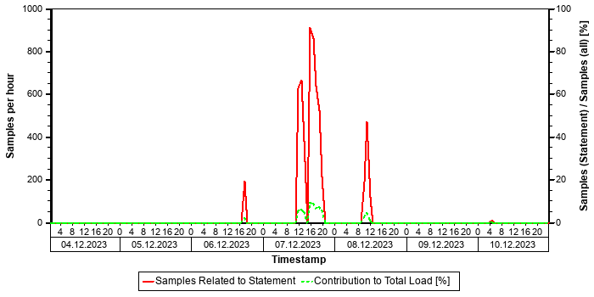

Correlation with Index Server Resource Consumption
The distribution of thread samples with the status "Running" correlates strongly with the overall CPU or memory consumption of the system. Such a correlation indicates that this statement might be responsible for peaks in the memory or CPU consumption.
Distiribution | Correlation Coefficient | Comment
CPU consumption index server(s) - Threads (running) from this SQL statement | 0,36 | medium correlation
Memory consumption index server(s) - Threads (running) from this SQL Statement | 0,67 | strong correlation

Tables
In the following, the tables involved in the SQL statement are listed (maximum of 20), sorted by the number of records.
Table Name | Schema Name | Table Type | Partition Type | Number of Records | Host
CKMLCR | SAPPRD | COLUMN | Table not partitioned | 796.619.304 | tsls4proddbh
MBEWH | SAPPRD | COLUMN | Table not partitioned | 145.755.805 | tsls4proddbh
MBEW | SAPPRD | COLUMN | Table not partitioned | 21.021.143 | tsls4proddbh
ACDOCA_M_EXTRACT | SAPPRD | COLUMN | Table not partitioned | 16.159.656 | tsls4proddbh
FMLT_CURTP_ML | SAPPRD | COLUMN | Table not partitioned | 22 | tsls4proddbh
DUMMY | SYS | ROW | Table not partitioned | 1 | tsls4proddbh
FMLT_PRICE | SAPPRD | COLUMN | Table not partitioned | 0 | tsls4proddbh

Origin of SQL Statement
The following table shows details of the applications responsible for the statement. This information is based on the information provided by SAP HANA in the "application source" connected to the statement in the "thread samples" or the list of "prepared" or "active" statements, and is not necessarily complete.
SID | Transaction / Jobaname | Report | Line | Last Changed on: | SAP Coding
PRD | YMPCR_STOCK_REPORT_SUM | YMPCR_STOCK_REPORT_SUM | 4.670 | 16.10.2025
PRD | YSTOCKDTLS | YMPCR_STOCK_REPORT_SUM | 4.670 | 16.10.2025

SQL Statement 2d891796478663aecce2b831bcbb9b21
SELECT
COUNT(*)
FROM
"FAAV_LINEITEMS"
WHERE
"MANDT" = ? AND "AWTYP" = ? AND "AWREF" = ? AND "AWORG" = ? AND "AWSYS" = ? AND "ANLN1" <> N'' WITH RANGE_RESTRICTION('CURRENT')
Statement Impact
Indicator | Value
Contribution to Total CPU Load [%] | 0,14
Maximal CPU Consumption per Hour [%] ( 08.10.2025 between 21:00 and 22:00 ) | 0,29

Analysis of Where Clause
Table | Field | Operator
? | ANLN1 | <>
? | AWORG | =
? | AWREF | =
? | AWSYS | =
? | AWTYP | =
? | MANDT | =

Time Consumption
The following table gives an overview of the time consumption of the analyzed SQL statement.
Activity | Total Time [s] | Average Time [us] | Minimal Time [us] | Maximal Time [us]
TOTAL EXECUTION | 31.537 | 53.431 | 23.987 | 14.146.345
PREPARATION | 6 | 10
LOCK DURATION | 0 | 0

Statement History (Thread Sample 'Running')
The following graph shows the number of observed thread samples (in state "running") related to this SQL statement together with the contribution of those samples to all thread samples (in state "running") active in the system.
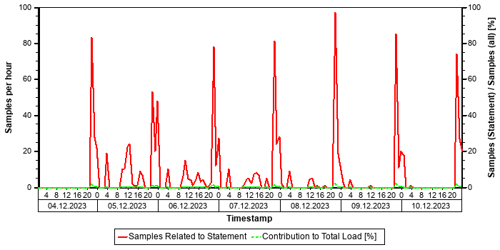

Tables
In the following, the tables involved in the SQL statement are listed (maximum of 20), sorted by the number of records.
Table Name | Schema Name | Table Type | Partition Type | Number of Records | Host
ACDOCA | SAPPRD | COLUMN | HASH | 3.570.094.832 | tsls4proddbh
BKPF | SAPPRD | COLUMN | Table not partitioned | 452.194.147 | tsls4proddbh
FAAT_DOC_IT | SAPPRD | COLUMN | Table not partitioned | 5.490.804 | tsls4proddbh
T093 | SAPPRD | COLUMN | Table not partitioned | 1.948 | tsls4proddbh
T093A | SAPPRD | COLUMN | Table not partitioned | 1.789 | tsls4proddbh
T030B | SAPPRD | COLUMN | Table not partitioned | 1.473 | tsls4proddbh
T093B | SAPPRD | COLUMN | Table not partitioned | 545 | tsls4proddbh
T001 | SAPPRD | COLUMN | Table not partitioned | 358 | tsls4proddbh
FINSC_LD_CMP | SAPPRD | COLUMN | Table not partitioned | 322 | tsls4proddbh
FAGL_TLDGRP_MAP | SAPPRD | COLUMN | Table not partitioned | 70 | tsls4proddbh
... (further 8 tables)... | ... | ... | ... |  | ...

Origin of SQL Statement
The following table shows details of the applications responsible for the statement. This information is based on the information provided by SAP HANA in the "application source" connected to the statement in the "thread samples" or the list of "prepared" or "active" statements, and is not necessarily complete.
SID | Transaction / Jobaname | Report | Line | Last Changed on: | SAP Coding | Application Component | Description
PRD | /OPT/VIM_VA2 | MF05LFO0 | 2.388 | 08.08.2025 |  | FI | Financial Accounting
PRD | ACC. DOCUMENT NO. UPDATE FOR DG | MF05LFO0 | 2.388 | 08.08.2025 |  | FI | Financial Accounting
PRD | FB02 | MF05LFO0 | 2.388 | 08.08.2025 |  | FI | Financial Accounting
PRD | FB03 | MF05LFO0 | 2.388 | 08.08.2025 |  | FI | Financial Accounting
PRD | FB1D | MF05LFO0 | 2.388 | 08.08.2025 |  | FI | Financial Accounting
PRD | FBL1N | MF05LFO0 | 2.388 | 08.08.2025 |  | FI | Financial Accounting
PRD | FBL3N | MF05LFO0 | 2.388 | 08.08.2025 |  | FI | Financial Accounting
PRD | FBS1 | MF05LFO0 | 2.388 | 08.08.2025 |  | FI | Financial Accounting
PRD | ME23N | MF05LFO0 | 2.388 | 08.08.2025 |  | FI | Financial Accounting
PRD | MIR4 | MF05LFO0 | 2.388 | 08.08.2025 |  | FI | Financial Accounting
PRD | MIRO | MF05LFO0 | 2.388 | 08.08.2025 |  | FI | Financial Accounting
PRD | RFITEMAP | MF05LFO0 | 2.388 | 08.08.2025 |  | FI | Financial Accounting
PRD | ZGST1 | MF05LFO0 | 2.388 | 08.08.2025 |  | FI | Financial Accounting

SQL Statement 1cb2dc345d6d694335f129c231f1e82e
SELECT DISTINCT
"MANDT" , "KOKRS" , "BELNR" , "BUZEI" , "PERIO" , "WTGBTR" , "WOGBTR" , "WKGBTR" , "WKFBTR" , "PAGBTR" , "PAFBTR" , "MEGBTR" , "MEFBTR" , "MBGBTR" , "MBFBTR" , "LEDNR" , "OBJNR" , "GJAHR" , "WRTTP" , "VERSN" , "KSTAR" , "HRKFT" , "VRGNG" , "PAROB" , "PAROB1" , "USPOB" , "VBUND" , "PARGB" , "BEKNZ" , "TWAER" , "OWAER" , "MEINH" , "MEINB" , "MVFLG" , "SGTXT", "REFBZ" , "ZLENR" , "BW_REFBZ" , "GKONT" , "GKOAR" , "WERKS" , "MATNR" , "RBEST" , "EBELN" , "EBELP" , "ZEKKN" , "ERLKZ" , "PERNR" , "BTRKL" , "OBJNR_N1" , "OBJNR_N2" , "OBJNR_N3" , "PAOBJNR" , "BELTP" , "BUKRS" , "GSBER" , "FKBER" , "SCOPE" , "LOGSYSO" , "PKSTAR" , "PBUKRS" , "PFKBER" , "PSCOPE" , "LOGSYSP" , "DABRZ" , "BWSTRAT" , "OBJNR_HK" , "TIMESTMP", "QMNUM" , "GEBER" , "PGEBER" , "GRANT_NBR" , "PGRANT_NBR" , "REFBZ_FI" , "SEGMENT" , "PSEGMENT" , "POSNR" , "PRCTR" ,"PPRCT" , "BUDGET_PD" , "PBUDGET_PD" , "PRODPER" , "AWTYP" , "AWKEY" , "AWSYS" , "KWAER" , "ACCAS" , "ACCASTY" , "KOSTL" , "LSTAR" , "AUFNR" , "AUTYP" , "PSPNR" , "PSPID" , "VBELN" , "VBPOSNR" , "CE4KEY" , "ERKRS" , "PACCAS" , "PACCASTY" ,"PKOSTL" , "PLSTAR" , "PAUFNR" , "PAUTYP" , "PPSPNR" , "PPSPID" , "PVBELN" , "PVBPOSNR" , "PCE4KEY" , "QUANT1" , "QUANT2" , "QUANT3" , "QUNIT1" , "QUNIT2" , "QUNIT3"
FROM
/* Redirected table: COEP */ "V_COEP" "COEP"
WHERE
"MANDT" = ? AND "KOKRS" = ? AND "BELNR" IN ( ? , ? , ? , ? , ? , ? , ? , ? , ? , ? , ? , ? , ? , ? , ? , ? , ? , ? , ? , ? , ? , ? , ? , ? , ? , ? , ? , ? , ? , ? , ? , ? , ? , ? , ? , ? , ? , ? , ? , ? , ? , ? , ? , ? , ? , ? , ? , ? , ? , ? , ? , ? , ? , ? , ? , ? , ? , ? , ? , ? , ? , ? , ? , ? , ? , ? , ? , ? , ? , ? , ? , ? , ? , ? , ? , ? , ? , ? , ? , ? , ? , ? , ? , ? , ? , ? , ? , ? , ? , ? , ? , ? , ? , ? , ? , ? , ? , ? , ? , ? ) WITH RANGE_RESTRICTION('CURRENT')
Statement Impact
Indicator | Value
Contribution to Total CPU Load [%] | 0,24
Maximal CPU Consumption per Hour [%] ( 09.10.2025 between 04:00 and 05:00 ) | 0,57

Analysis of Where Clause
Table | Field | Operator
? | BELNR | IN
? | KOKRS | =
? | MANDT | =

Time Consumption
The following table gives an overview of the time consumption of the analyzed SQL statement.
Activity | Total Time [s] | Average Time [us] | Minimal Time [us] | Maximal Time [us]
TOTAL EXECUTION | 29.162 | 368.821 | 9.009 | 2.717.493
PREPARATION | 70 | 884
LOCK DURATION | 0 | 0

Statement History (Thread Sample 'Running')
The following graph shows the number of observed thread samples (in state "running") related to this SQL statement together with the contribution of those samples to all thread samples (in state "running") active in the system.
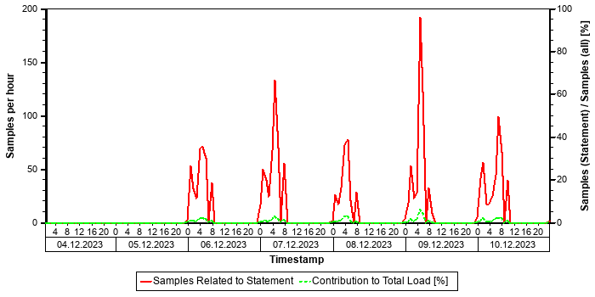

Tables
In the following, the tables involved in the SQL statement are listed (maximum of 20), sorted by the number of records.
Table Name | Schema Name | Table Type | Partition Type | Number of Records | Host
ACDOCA | SAPPRD | COLUMN | HASH | 3.570.094.832 | tsls4proddbh
COEP | SAPPRD | COLUMN | Table not partitioned | 688.922.099 | tsls4proddbh
PRPS | SAPPRD | COLUMN | Table not partitioned | 94.047 | tsls4proddbh
TKA01 | SAPPRD | COLUMN | Table not partitioned | 168 | tsls4proddbh
FINSC_CMP_VERSND | SAPPRD | COLUMN | Table not partitioned | 132 | tsls4proddbh

Origin of SQL Statement
The following table shows details of the applications responsible for the statement. This information is based on the information provided by SAP HANA in the "application source" connected to the statement in the "thread samples" or the list of "prepared" or "active" statements, and is not necessarily complete.
SID | Transaction / Jobaname | Report | Line | Last Changed on: | SAP Coding | Application Component | Description
PRD | CJ30 | LBPFCFD1 | 5.226 | 08.08.2025 |  | FI-FM | Funds Management
PRD | RBPFCPN1 | LBPFCFD1 | 5.226 | 08.08.2025 |  | FI-FM | Funds Management

SQL Statement 9c45856babfcb16e26d2fe198664c22f
SELECT
"MANDT" , "MATNR" , "BWKEY" , "BWTAR" , "LVORM" , "LBKUM" , "SALK3" , "VPRSV" , "VERPR" , "STPRS" , "PEINH" , "BKLAS" ,"SALKV" , "VMKUM" , "VMSAL" , "VMVPR" , "VMVER" , "VMSTP" , "VMPEI" , "VMBKL" , "VMSAV" , "VJKUM" , "VJSAL" , "VJVPR" ,"VJVER" , "VJSTP" , "VJPEI" , "VJBKL" , "VJSAV" , "LFGJA" , "LFMON" , "BWTTY" , "STPRV" , "LAEPR" , "ZKPRS" , "ZKDAT" ,"TIMESTAMP" , "BWPRS" , "BWPRH" , "VJBWS" , "VJBWH" , "VVJSL" , "VVJLB" , "VVMLB" , "VVSAL" , "ZPLPR" , "ZPLP1" , "ZPLP2" , "ZPLP3" , "ZPLD1" , "ZPLD2" , "ZPLD3" , "PPERZ" , "PPERL" , "PPERV" , "KALKZ" , "KALKL" , "KALKV" , "KALSC" , "XLIFO" , "MYPOL" , "BWPH1" , "BWPS1" , "ABWKZ" , "PSTAT" , "KALN1" , "KALNR" , "BWVA1" , "BWVA2" , "BWVA3" , "VERS1" , "VERS2" , "VERS3" , "HRKFT" , "KOSGR" , "PPRDZ" , "PPRDL" , "PPRDV" , "PDATZ" , "PDATL" , "PDATV" , "EKALR" , "VPLPR" , "MLMAA" , "MLAST" , "LPLPR" , "VKSAL" , "HKMAT" , "SPERW" , "KZIWL" , "WLINL" , "ABCIW" , "BWSPA" , "LPLPX" , "VPLPX" , "FPLPX" , "LBWST" , "VBWST" , "FBWST" , "EKLAS" , "QKLAS" , "MTUSE" , "MTORG" , "OWNPR" , "XBEWM" , "BWPEI" , "MBRUE" , "OKLAS" , "DUMMY_VAL_INCL_EEW_PS" , "OIPPINV"
FROM
/* Redirected table: MBEW */ "MBVMBEW" "MBEW"
WHERE
"MANDT" = ? AND "MATNR" = ? AND "BWKEY" = ? AND "BWTAR" = N'' AND "STPRS" > CAST( 0 AS DECIMAL(11,2) ) WITH RANGE_RESTRICTION('CURRENT')
Statement Impact
Indicator | Value
Contribution to Total CPU Load [%] | 0,09
Maximal CPU Consumption per Hour [%] ( 09.10.2025 between 16:00 and 17:00 ) | 0,05

Analysis of Where Clause
Table | Field | Operator
? | BWKEY | =
? | BWTAR | =
? | MANDT | =
? | MATNR | =
? | STPRS | >

Time Consumption
The following table gives an overview of the time consumption of the analyzed SQL statement.
Activity | Total Time [s] | Average Time [us] | Minimal Time [us] | Maximal Time [us]
TOTAL EXECUTION | 24.441 | 24.612 | 235 | 1.985.706
PREPARATION | 6 | 6
LOCK DURATION | 0 | 0

Statement History (Thread Sample 'Running')
The following graph shows the number of observed thread samples (in state "running") related to this SQL statement together with the contribution of those samples to all thread samples (in state "running") active in the system.
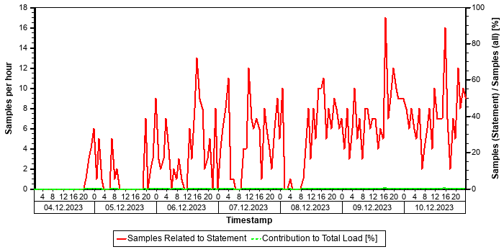

Tables
In the following, the tables involved in the SQL statement are listed (maximum of 20), sorted by the number of records.
Table Name | Schema Name | Table Type | Partition Type | Number of Records | Host
CKMLCR | SAPPRD | COLUMN | Table not partitioned | 796.619.304 | tsls4proddbh
MBEW | SAPPRD | COLUMN | Table not partitioned | 21.021.143 | tsls4proddbh
ACDOCA_M_EXTRACT | SAPPRD | COLUMN | Table not partitioned | 16.159.656 | tsls4proddbh
FMLT_CURTP_ML | SAPPRD | COLUMN | Table not partitioned | 22 | tsls4proddbh
DUMMY | SYS | ROW | Table not partitioned | 1 | tsls4proddbh
FMLT_PRICE | SAPPRD | COLUMN | Table not partitioned | 0 | tsls4proddbh

Origin of SQL Statement
The following table shows details of the applications responsible for the statement. This information is based on the information provided by SAP HANA in the "application source" connected to the statement in the "thread samples" or the list of "prepared" or "active" statements, and is not necessarily complete.
SID | Transaction / Jobaname | Report | Line | Last Changed on: | SAP Coding
PRD | CRM_POST_041_A | YMPCI_CRMIS_GR_POST | 1.943 | 17.10.2025
PRD | CRM_POST_127_A | YMPCI_CRMIS_GR_POST | 1.943 | 17.10.2025

SQL Statement 69346611f70f086df2afb2a455766503
SELECT
"LEDNR" , "OBJNR" , "GJAHR" , "VERSN" , "WRTTP" , "KSTAR" , "HRKFT" , "VRGNG" , "PAROB" , "USPOB" , "VBUND" , "PARGB" ,"BEKNZ" , "TWAER" , "MEINH" , "BEMOT" , "BELTP" , "WTGBTR" , "WTGPER" , "WOGBTR" , "WOGPER" , "WKGBTR" , "WKGPER" , "WKFBTR" , "WKFPER" , "PAGBTR" , "PAGPER" , "PAFBTR" , "PAFPER" , "MEGBTR" , "MEGPER" , "MEFBTR" , "MEFPER" , "MUVBTR" , "MUVPER"
FROM
/* Entity name: FCO_ABR_BEL_04 */ "FCOV_ABR_BEL04" ( "AKPERIO" => ? , "AKGJAHR" => ? ) "FCO_ABR_BEL_04"
WHERE
"MANDT" = ? AND "OBJNR" IN ( ? , ? , ? , ? , ? , ? , ? , ? , ? , ? , ? , ? , ? , ? , ? , ? , ? , ? , ? , ? ) AND "GJAHR" = ? AND "VERSN" IN ( ? , ? ) AND "WRTTP" = N'04' AND "BEKNZ" <> N'A' WITH RANGE_RESTRICTION('CURRENT')
Statement Impact
Indicator | Value
Contribution to Total CPU Load [%] | 0,20
Maximal CPU Consumption per Hour [%] ( 10.10.2025 between 17:00 and 18:00 ) | 0,97

Analysis of Where Clause
Table | Field | Operator
? | BEKNZ | <>
? | GJAHR | =
? | MANDT | =
? | OBJNR | IN
? | VERSN | IN
? | WRTTP | =

Time Consumption
The following table gives an overview of the time consumption of the analyzed SQL statement.
Activity | Total Time [s] | Average Time [us] | Minimal Time [us] | Maximal Time [us]
TOTAL EXECUTION | 19.717 | 116.212 | 6.364 | 3.232.516
PREPARATION | 2.657 | 15.662
LOCK DURATION | 0 | 0

Statement History (Thread Sample 'Running')
The following graph shows the number of observed thread samples (in state "running") related to this SQL statement together with the contribution of those samples to all thread samples (in state "running") active in the system.
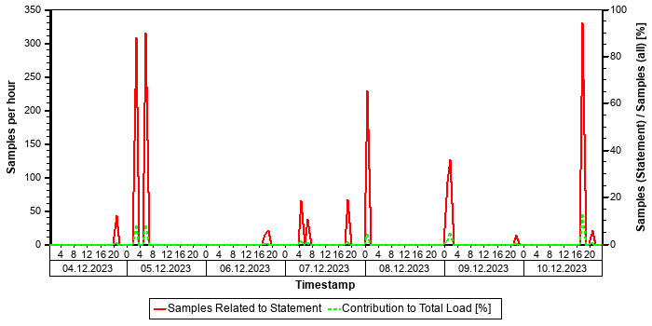

Tables
In the following, the tables involved in the SQL statement are listed (maximum of 20), sorted by the number of records.
Table Name | Schema Name | Table Type | Partition Type | Number of Records | Host
ACDOCA | SAPPRD | COLUMN | HASH | 3.570.094.832 | tsls4proddbh
TKA01 | SAPPRD | COLUMN | Table not partitioned | 168 | tsls4proddbh
FINSC_CMP_VERSNC | SAPPRD | COLUMN | Table not partitioned | 132 | tsls4proddbh
T000 | SAPPRD | COLUMN | Table not partitioned | 8 | tsls4proddbh

Origin of SQL Statement
The following table shows details of the applications responsible for the statement. This information is based on the information provided by SAP HANA in the "application source" connected to the statement in the "thread samples" or the list of "prepared" or "active" statements, and is not necessarily complete.
SID | Transaction / Jobaname | Report | Line | Last Changed on: | SAP Coding | Application Component | Description
PRD | PHASE0_PM_SETTL_LD1_2D | CL_FCO_ABR_BEL_PRE_READ_LAZY==CM00A | 6 | 06.04.2021 |  | CO-OM-OPA | Overhead Cost Orders
PRD | PHASE2_PM_SETTL_SSS_W | CL_FCO_ABR_BEL_PRE_READ_LAZY==CM00A | 6 | 06.04.2021 |  | CO-OM-OPA | Overhead Cost Orders
PRD | TSBAN_MO_SETTLEMENT_SHARED SERV | CL_FCO_ABR_BEL_PRE_READ_LAZY==CM00A | 6 | 06.04.2021 |  | CO-OM-OPA | Overhead Cost Orders

Top MATDOC Statements (Elapsed Time)
This section shows the top non-internal statements according to "Total Elapsed Time". The "Total Elapsed Time" is the sum of the "Total Execution Time" and the "Total Preparation Time" from the SQL PLAN CACHE. It has a direct impact on the response time of the application calling the statement.
Only statements accessing table MATDOC are shown.
See the following table for details of the selection:
Database Start | 15.10.2025 -- 08:03:55
Data Collection | 11.10.2025 -- 06:41:29
Analysis Type | Analysis of Plan Cache
Data Source | HOST_SQL_PLAN_CACHE
Begin of Time Interval | 03.10.2025 -- 23:48:58
End of Time Interval | 11.10.2025 -- 00:55:39

The selected statements - identified by their "Statement Hash" - are listed in the following table. Further details of these statements can be found in the subsections.
Statement Hash | Total Elapsed Time [s] | Number of Executions | Time / Execution [us] | Records / Execution | Time / Record [us]
938619e1d06635b2b252709b7ccd58af | 865.286,4 | 42.194 | 20.507.332,4 | 1,0 | 20.424.557,6
b1ee826430a30c5a298aa2631ce552c9 | 370.854,2 | 125.617 | 2.952.261,1 | 684,2 | 4.314,9
ca3a58d95faa0511223f7e57c57e3285 | 167.848,4 | 255.390 | 657.224,0 | 157,7 | 4.167,3
a3591253752496fbb5b23fd934e0a799 | 121.764,2 | 860.286 | 141.539,2 | 0,1 | 2.450.772,4
8081d474ada325a2ff0b41aacc964b66 | 81.238,1 | 6.116.248 | 13.282,3 | 5.422,0 | 2,4

SQL Statement 938619e1d06635b2b252709b7ccd58af
SELECT DISTINCT
"A" . "REF_DOC" , "A" . "REF_DOC_YEAR" , "B" . "BUDAT_MKPF"
FROM
"/OPT/VIM_1ITEM" "A" INNER JOIN /* Redirected table: MSEG */ "NSDM_V_MSEG" "B" ON "A" . "MANDT" = "B" . "MANDT" AND "A"
. "REF_DOC" = "B" . "LFBNR" AND "A" . "REF_DOC_YEAR" = "B" . "MJAHR"
WHERE
"A" . "MANDT" = ? AND "A" . "DOCID" = ? WITH RANGE_RESTRICTION('CURRENT')
Statement Impact
Indicator | Value
Contribution to Total CPU Load [%] | 3,59
Contribution to Total Execution Time [%] | 9,76
Maximal CPU Consumption per Hour [%] ( 05.10.2025 between 12:00 and 13:00 ) | 4,49

Note: The statement as identified by its statement hash can also be found in other sections of this report:
Other Sections Dealing with this Statement
SAP HANA SQL Statements in PRD -> Top Statements (CPU Peak Hour)
SAP HANA SQL Statements in PRD -> Top Statements (Elapsed Time)
SAP HANA SQL Statements in PRD -> Top Statements (Thread Samples)
SAP HANA SQL Statements in PRD -> Top Statements (Total Memory)

Analysis of Where Clause
Table | Field | Operator | Supported by Single Column Index | Compression | Distinct Values | SCANNED RECORD COUNT | INDEX LOOKUP COUNT
/OPT/VIM_1ITEM | DOCID | = |  | DEFAULT | 10.594.120 | 119.414.604 | 816.740
/OPT/VIM_1ITEM | MANDT | = |  | RLE | 1 | 3.879 | 2

Time Consumption
The following table gives an overview of the time consumption of the analyzed SQL statement.
Activity | Total Time [s] | Average Time [us] | Minimal Time [us] | Maximal Time [us]
TOTAL EXECUTION | 865.285 | 20.507.309 | 198 | 316.055.039
PREPARATION | 1 | 23
LOCK DURATION | 0 | 0

Statement History (Thread Sample 'Running')
The following graph shows the number of observed thread samples (in state "running") related to this SQL statement together with the contribution of those samples to all thread samples (in state "running") active in the system.


Correlation with Index Server Resource Consumption
The distribution of thread samples with the status "Running" correlates strongly with the overall CPU or memory consumption of the system. Such a correlation indicates that this statement might be responsible for peaks in the memory or CPU consumption.
Distiribution | Correlation Coefficient | Comment
CPU consumption index server(s) - Threads (running) from this SQL statement | 0,81 | strong correlation
Memory consumption index server(s) - Threads (running) from this SQL Statement | 0,62 | strong correlation

Tables
In the following, the tables involved in the SQL statement are listed (maximum of 20), sorted by the number of records.
Table Name | Schema Name | Table Type | Partition Type | Number of Records | Host
MATDOC | SAPPRD | COLUMN | Table not partitioned | 565.077.043 | tsls4proddbh
/OPT/VIM_1ITEM | SAPPRD | COLUMN | Table not partitioned | 30.153.698 | tsls4proddbh

Compatibility View Access
SAP S/4HANA Supply Chain (MM - Inventory Management) offers a simplified data model. Several tables have become obsolete and are removed. To allow existing coding to continue to work, these tables are replaced by views with the same name, known as "Compatibility Views". As a result, read access to these objects is still possible; however, performance is affected since it is now an access to a view instead of a simple table. For some general background information, see https://launchpad.support.sap.com/#/notes/2206980 [SAP Note 2206980].
For performance-critical coding parts, we strongly recommend the code adjustments suggested in Section 2 of the SAP Note. For non-critical parts, these adjustments are optional in the short term but recommended in the long term.

Origin of SQL Statement
The following table shows details of the applications responsible for the statement. This information is based on the information provided by SAP HANA in the "application source" connected to the statement in the "thread samples" or the list of "prepared" or "active" statements, and is not necessarily complete.
SID | Transaction / Jobaname | Report | Line | Last Changed on: | SAP Coding
PRD | /OPT/DR_BR_WAIT | LZOPT_VIM_1U07 | 29 | 25.09.2019
PRD | /OPT/VIM_ANALYTICS | LZOPT_VIM_1U07 | 29 | 25.09.2019
PRD | /OPT/VIM_ANALYTICS_750 | LZOPT_VIM_1U07 | 29 | 25.09.2019
PRD | /OPT/VIM_RULERUN | LZOPT_VIM_1U07 | 29 | 25.09.2019
PRD | /OPT/VIM_VA2 | LZOPT_VIM_1U07 | 29 | 25.09.2019
PRD | /OPT/VIM_WP | LZOPT_VIM_1U07 | 29 | 25.09.2019
PRD | RSWIWILS | LZOPT_VIM_1U07 | 29 | 25.09.2019
PRD | SBWP | LZOPT_VIM_1U07 | 29 | 25.09.2019
PRD | SWIA | LZOPT_VIM_1U07 | 29 | 25.09.2019
PRD | VIM_BC_INBOUND_PROCESSING | LZOPT_VIM_1U07 | 29 | 25.09.2019
PRD | YP2P_DASH | LZOPT_VIM_1U07 | 29 | 25.09.2019

SQL Statement b1ee826430a30c5a298aa2631ce552c9
SELECT
"MANDT" , "MATBF" , "WERKS" , "LGORT_SID" , "CHARG_SID" , "BUDAT" , "DISUB_OWNER_CID" , "MAT_KDAUF" , "MAT_KDPOS" , "CHARG_CID" , "LBBSA_SID" , "UNRESTRICTEDSTOCK" , "QUALITYINSSTOCK" , "RESTSTOCK" , "BLOCKSTOCK" , "BLOCKSTOCKRETURN" , "MEINS" , "STOCK_QTY" , "JARHPER" , "BWTAR" , "UPTO30DAYS" , "BT31TO90DAYS" , "BT90TO180DAYS" , "ABOVE180DAYS"
FROM
/* Entity name: YMPC_WRAPPER_MATDOC */ "YMPCWRAPMD" ( "P_WERKS" => ? , "P_BUDAT" => ? ) "YMPC_WRAPPER_MATDOC"
WHERE
"MANDT" = ? AND ( ( "MATBF" = ? AND "CHARG_SID" = ? ) OR ( "MATBF" = ? AND "CHARG_SID" = ? ) OR ( "MATBF" = ? AND "CHARG_SID" = ? ) OR ( "MATBF" = ? AND "CHARG_SID" = ? ) OR ( "MATBF" = ? AND "CHARG_SID" = ? ) OR ( "MATBF" = ? AND "CHARG_SID" = ? ) OR ( "MATBF" = ? AND "CHARG_SID" = ? ) OR ( "MATBF" = ? AND "CHARG_SID" = ? ) OR ( "MATBF" = ? AND "CHARG_SID"= ? ) OR ( "MATBF" = ? AND "CHARG_SID" = ? ) OR ( "MATBF" = ? AND "CHARG_SID" = ? ) OR ( "MATBF" = ? AND "CHARG_SID" = ? ) OR ( "MATBF" = ? AND "CHARG_SID" = ? ) OR ( "MATBF" = ? AND "CHARG_SID" = ? ) OR ( "MATBF" = ? AND "CHARG_SID" = ? )OR ( "MATBF" = ? AND "CHARG_SID" = ? ) OR ( "MATBF" = ? AND "CHARG_SID" = ? ) OR ( "MATBF" = ? AND "CHARG_SID" = ? ) OR( "MATBF" = ? AND "CHARG_SID" = ? ) OR ( "MATBF" = ? AND "CHARG_SID" = ? ) OR ( "MATBF" = ? AND "CHARG_SID" = ? ) OR ( "MATBF" = ? AND "CHARG_SID" = ? ) OR ( "MATBF" = ? AND "CHARG_SID" = ? ) OR ( "MATBF" = ? AND "CHARG_SID" = ? ) OR ( "MATBF" = ? AND "CHARG_SID" = ? ) OR ( "MATBF" = ? AND "CHARG_SID" = ? ) OR ( "MATBF" = ? AND "CHARG_SID" = ? ) OR ( "MATBF" = ? AND "CHARG_SID" = ? ) OR ( "MATBF" = ? AND "CHARG_SID" = ? ) OR ( "MATBF" = ? AND "CHARG_SID" = ? ) OR ( "MATBF" =? AND "CHARG_SID" = ? ) OR ( "MATBF" = ? AND "CHARG_SID" = ? ) OR ( "MATBF" = ? AND "CHARG_SID" = ? ) OR ( "MATBF" = ? AND "CHARG_SID" = ? ) OR ( "MATBF" = ? AND "CHARG_SID" = ? ) OR ( "MATBF" = ? AND "CHARG_SID" = ? ) OR ( "MATBF" = ? AND"CHARG_SID" = ? ) OR ( "MATBF" = ? AND "CHARG_SID" = ? ) OR ( "MATBF" = ? AND "CHARG_SID" = ? ) OR ( "MATBF" = ? AND "CHARG_SID" = ? ) OR ( "MATBF" = ? AND "CHARG_SID" = ? ) OR ( "MATBF" = ? AND "CHARG_SID" = ? ) OR ( "MATBF" = ? AND "CHARG_SID" = ? ) OR ( "MATBF" = ? AND "CHARG_SID" = ? ) OR ( "MATBF" = ? AND "CHARG_SID" = ? ) OR ( "MATBF" = ? AND "CHARG_SID" = ? ) OR ( "MATBF" = ? AND "CHARG_SID" = ? ) OR ( "MATBF" = ? AND "CHARG_SID" = ? ) OR ( "MATBF" = ? AND "CHARG_SID"= ? ) OR ( "MATBF" = ? AND "CHARG_SID" = ? ) ) WITH RANGE_RESTRICTION('CURRENT')
Statement Impact
Indicator | Value
Contribution to Total CPU Load [%] | 1,18
Contribution to Total Execution Time [%] | 4,18
Maximal CPU Consumption per Hour [%] ( 05.10.2025 between 00:00 and 01:00 ) | 1,55

Note: The statement as identified by its statement hash can also be found in other sections of this report:
Other Sections Dealing with this Statement
SAP HANA SQL Statements in PRD -> Top Statements (Elapsed Time)

Analysis of Where Clause
Table | Field | Operator | SCANNED RECORD COUNT | INDEX LOOKUP COUNT
MATDOC | CHARG_SID | = | 333.954.108.842.427 | 972.081
MATDOC | MANDT | = | 548.707.335.241 | 0
MATDOC | MATBF | = | 185.327.222.403.864 | 4.974.459

Time Consumption
The following table gives an overview of the time consumption of the analyzed SQL statement.
Activity | Total Time [s] | Average Time [us] | Minimal Time [us] | Maximal Time [us]
TOTAL EXECUTION | 370.834 | 2.952.103 | 1.410 | 113.465.225
PREPARATION | 20 | 158
LOCK DURATION | 0 | 0

Statement History (Thread Sample 'Running')
The following graph shows the number of observed thread samples (in state "running") related to this SQL statement together with the contribution of those samples to all thread samples (in state "running") active in the system.


Tables
In the following, the tables involved in the SQL statement are listed (maximum of 20), sorted by the number of records.
Table Name | Schema Name | Table Type | Partition Type | Number of Records | Host
MATDOC | SAPPRD | COLUMN | Table not partitioned | 565.077.043 | tsls4proddbh

Origin of SQL Statement
The following table shows details of the applications responsible for the statement. This information is based on the information provided by SAP HANA in the "application source" connected to the statement in the "thread samples" or the list of "prepared" or "active" statements, and is not necessarily complete.
SID | Transaction / Jobaname | Report | Line | Last Changed on: | SAP Coding
PRD | FP_STOCK_BARA | YMPCR_STOCK_REPORT_HANA | 4.602 | 16.11.2025
PRD | FP_STOCK_CRM | YMPCR_STOCK_REPORT_HANA | 4.602 | 16.11.2025
PRD | FP_STOCK_LD2 | YMPCR_STOCK_REPORT_HANA | 4.602 | 16.11.2025
PRD | YMPCR_STOCK_REPORT_HANA | YMPCR_STOCK_REPORT_HANA | 4.602 | 16.11.2025
PRD | YSTOCKN | YMPCR_STOCK_REPORT_HANA | 4.602 | 16.11.2025
PRD | YSTOCKN_BE_SY | YMPCR_STOCK_REPORT_HANA | 4.602 | 16.11.2025
PRD | YSTOCKN_D_5 | YMPCR_STOCK_REPORT_HANA | 4.602 | 16.11.2025

SQL Statement ca3a58d95faa0511223f7e57c57e3285
SELECT
"MANDT" , "MATBF" , "WERKS" , "LGORT_SID" , "CHARG_SID" , "BUDAT" , "DISUB_OWNER_CID" , "MAT_KDAUF" , "MAT_KDPOS" , "CHARG_CID" , "LBBSA_SID" , "UNRESTRICTEDSTOCK" , "QUALITYINSSTOCK" , "RESTSTOCK" , "BLOCKSTOCK" , "BLOCKSTOCKRETURN" , "MEINS" , "STOCK_QTY" , "JARHPER" , "BWTAR" , "UPTO30DAYS" , "BT31TO90DAYS" , "BT90TO180DAYS" , "ABOVE180DAYS"
FROM
/* Entity name: YMPC_WRAPPER_MATDOC_TSM */ "YMPCWRAPMDB" ( "P_WERKS" => ? , "P_BUDAT" => ? ) "YMPC_WRAPPER_MATDOC_TSM"
WHERE
"MANDT" = ? AND ( ( "MATBF" = ? AND "CHARG_SID" = ? ) OR ( "MATBF" = ? AND "CHARG_SID" = ? ) OR ( "MATBF" = ? AND "CHARG_SID" = ? ) OR ( "MATBF" = ? AND "CHARG_SID" = ? ) OR ( "MATBF" = ? AND "CHARG_SID" = ? ) OR ( "MATBF" = ? AND "CHARG_SID" = ? ) OR ( "MATBF" = ? AND "CHARG_SID" = ? ) OR ( "MATBF" = ? AND "CHARG_SID" = ? ) OR ( "MATBF" = ? AND "CHARG_SID"= ? ) OR ( "MATBF" = ? AND "CHARG_SID" = ? ) OR ( "MATBF" = ? AND "CHARG_SID" = ? ) OR ( "MATBF" = ? AND "CHARG_SID" = ? ) OR ( "MATBF" = ? AND "CHARG_SID" = ? ) OR ( "MATBF" = ? AND "CHARG_SID" = ? ) OR ( "MATBF" = ? AND "CHARG_SID" = ? )OR ( "MATBF" = ? AND "CHARG_SID" = ? ) OR ( "MATBF" = ? AND "CHARG_SID" = ? ) OR ( "MATBF" = ? AND "CHARG_SID" = ? ) OR( "MATBF" = ? AND "CHARG_SID" = ? ) OR ( "MATBF" = ? AND "CHARG_SID" = ? ) OR ( "MATBF" = ? AND "CHARG_SID" = ? ) OR ( "MATBF" = ? AND "CHARG_SID" = ? ) OR ( "MATBF" = ? AND "CHARG_SID" = ? ) OR ( "MATBF" = ? AND "CHARG_SID" = ? ) OR ( "MATBF" = ? AND "CHARG_SID" = ? ) OR ( "MATBF" = ? AND "CHARG_SID" = ? ) OR ( "MATBF" = ? AND "CHARG_SID" = ? ) OR ( "MATBF" = ? AND "CHARG_SID" = ? ) OR ( "MATBF" = ? AND "CHARG_SID" = ? ) OR ( "MATBF" = ? AND "CHARG_SID" = ? ) OR ( "MATBF" =? AND "CHARG_SID" = ? ) OR ( "MATBF" = ? AND "CHARG_SID" = ? ) OR ( "MATBF" = ? AND "CHARG_SID" = ? ) OR ( "MATBF" = ? AND "CHARG_SID" = ? ) OR ( "MATBF" = ? AND "CHARG_SID" = ? ) OR ( "MATBF" = ? AND "CHARG_SID" = ? ) OR ( "MATBF" = ? AND"CHARG_SID" = ? ) OR ( "MATBF" = ? AND "CHARG_SID" = ? ) OR ( "MATBF" = ? AND "CHARG_SID" = ? ) OR ( "MATBF" = ? AND "CHARG_SID" = ? ) OR ( "MATBF" = ? AND "CHARG_SID" = ? ) OR ( "MATBF" = ? AND "CHARG_SID" = ? ) OR ( "MATBF" = ? AND "CHARG_SID" = ? ) OR ( "MATBF" = ? AND "CHARG_SID" = ? ) OR ( "MATBF" = ? AND "CHARG_SID" = ? ) OR ( "MATBF" = ? AND "CHARG_SID" = ? ) OR ( "MATBF" = ? AND "CHARG_SID" = ? ) OR ( "MATBF" = ? AND "CHARG_SID" = ? ) OR ( "MATBF" = ? AND "CHARG_SID"= ? ) OR ( "MATBF" = ? AND "CHARG_SID" = ? ) ) WITH RANGE_RESTRICTION('CURRENT')
Statement Impact
Indicator | Value
Contribution to Total CPU Load [%] | 0,51
Contribution to Total Execution Time [%] | 1,89
Maximal CPU Consumption per Hour [%] ( 08.10.2025 between 09:00 and 10:00 ) | 0,29

Analysis of Where Clause
Table | Field | Operator | SCANNED RECORD COUNT | INDEX LOOKUP COUNT
MATDOC | CHARG_SID | = | 333.954.108.842.427 | 972.081
MATDOC | MANDT | = | 548.707.335.241 | 0
MATDOC | MATBF | = | 185.327.222.403.864 | 4.974.459

Time Consumption
The following table gives an overview of the time consumption of the analyzed SQL statement.
Activity | Total Time [s] | Average Time [us] | Minimal Time [us] | Maximal Time [us]
TOTAL EXECUTION | 167.842 | 657.201 | 1.010 | 80.235.090
PREPARATION | 6 | 23
LOCK DURATION | 0 | 0

Statement History (Thread Sample 'Running')
The following graph shows the number of observed thread samples (in state "running") related to this SQL statement together with the contribution of those samples to all thread samples (in state "running") active in the system.
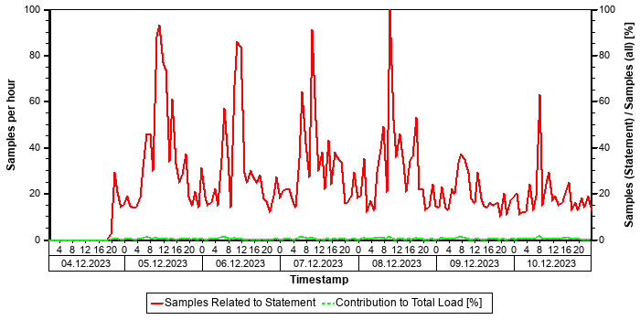

Correlation with Index Server Resource Consumption
The distribution of thread samples with the status "Running" correlates strongly with the overall CPU or memory consumption of the system. Such a correlation indicates that this statement might be responsible for peaks in the memory or CPU consumption.
Distiribution | Correlation Coefficient | Comment
CPU consumption index server(s) - Threads (running) from this SQL statement | 0,71 | strong correlation
Memory consumption index server(s) - Threads (running) from this SQL Statement | 0,42 | medium correlation

Tables
In the following, the tables involved in the SQL statement are listed (maximum of 20), sorted by the number of records.
Table Name | Schema Name | Table Type | Partition Type | Number of Records | Host
MATDOC | SAPPRD | COLUMN | Table not partitioned | 565.077.043 | tsls4proddbh

Origin of SQL Statement
The following table shows details of the applications responsible for the statement. This information is based on the information provided by SAP HANA in the "application source" connected to the statement in the "thread samples" or the list of "prepared" or "active" statements, and is not necessarily complete.
SID | Transaction / Jobaname | Report | Line | Last Changed on: | SAP Coding
PRD | /IRM/LAUNCHPAD | YMPCR_STOCK_REPORT_HANA_V2 | 7.344 | 25.10.2025
PRD | ANGUL_HR_STOCK | YMPCR_STOCK_REPORT_HANA_V2 | 7.344 | 25.10.2025
PRD | KHOPOLI_HR_STK | YMPCR_STOCK_REPORT_HANA_V2 | 7.344 | 25.10.2025
PRD | SBST_HR_STOCK | YMPCR_STOCK_REPORT_HANA_V2 | 7.344 | 25.10.2025
PRD | SO02 | YMPCR_STOCK_REPORT_HANA_V2 | 7.344 | 25.10.2025
PRD | YMPCR_STOCK_REPORT_HANA_V2 | YMPCR_STOCK_REPORT_HANA_V2 | 7.344 | 25.10.2025
PRD | YSTOCKN_V2 | YMPCR_STOCK_REPORT_HANA_V2 | 7.344 | 25.10.2025

SQL Statement a3591253752496fbb5b23fd934e0a799
SELECT
"MATNR"
FROM
/* Redirected table: MARD */ "NSDM_V_MARD" "MARD"
WHERE
"MANDT" = ? AND "MATNR" = ? AND "WERKS" = ? AND "LGORT" = ? AND "LABST" >= ? WITH RANGE_RESTRICTION('CURRENT')
Statement Impact
Indicator | Value
Contribution to Total CPU Load [%] | 0,56
Contribution to Total Execution Time [%] | 1,37
Maximal CPU Consumption per Hour [%] ( 10.10.2025 between 21:00 and 22:00 ) | 0,29

Analysis of Where Clause
Table | Field | Operator
? | LABST | >=
? | LGORT | =
? | MANDT | =
? | MATNR | =
? | WERKS | =

Time Consumption
The following table gives an overview of the time consumption of the analyzed SQL statement.
Activity | Total Time [s] | Average Time [us] | Minimal Time [us] | Maximal Time [us]
TOTAL EXECUTION | 121.763 | 141.538 | 701 | 1.688.226
PREPARATION | 1 | 1
LOCK DURATION | 0 | 0

Statement History (Thread Sample 'Running')
The following graph shows the number of observed thread samples (in state "running") related to this SQL statement together with the contribution of those samples to all thread samples (in state "running") active in the system.
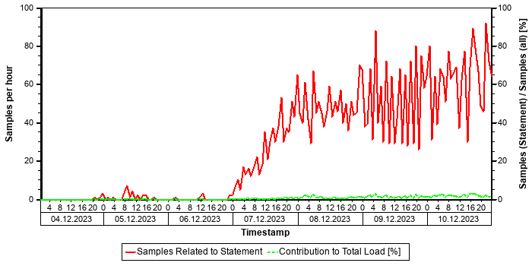

Tables
In the following, the tables involved in the SQL statement are listed (maximum of 20), sorted by the number of records.
Table Name | Schema Name | Table Type | Partition Type | Number of Records | Host
MATDOC_EXTRACT | SAPPRD | COLUMN | Table not partitioned | 313.982.684 | tsls4proddbh
MARD | SAPPRD | COLUMN | Table not partitioned | 18.428.794 | tsls4proddbh

Origin of SQL Statement
The following table shows details of the applications responsible for the statement. This information is based on the information provided by SAP HANA in the "application source" connected to the statement in the "thread samples" or the list of "prepared" or "active" statements, and is not necessarily complete.
SID | Transaction / Jobaname | Report | Line | Last Changed on: | SAP Coding
PRD | TSM_FPGI_POST | YMPCI_FPC_ACT_GI_POST | 871 | 22.09.2025

SQL Statement 8081d474ada325a2ff0b41aacc964b66
SELECT
"WERKS" , "MATNR" , "CHARG" , "BWART" , "MBLNR" , "BUDAT_MKPF"
FROM
/* Redirected table: MSEG */ "NSDM_V_MSEG" "MSEG"
WHERE
"MANDT" = ? AND "CHARG" = ? AND "BWART" IN ( N'101' , N'531' , N'561' ) AND "BUDAT_MKPF" >= ? WITH RANGE_RESTRICTION('CURRENT')
Statement Impact
Indicator | Value
Contribution to Total CPU Load [%] | 0,31
Contribution to Total Execution Time [%] | 0,92
Maximal CPU Consumption per Hour [%] ( 07.10.2025 between 06:00 and 07:00 ) | 0,51

Analysis of Where Clause
Table | Field | Operator | Supported by Single Column Index | Compression | Distinct Values | SCANNED RECORD COUNT | INDEX LOOKUP COUNT
MATDOC | BUDAT_MKPF | >=
MATDOC | BWART | IN |  |  |  | 6.018.692.923.567 | 3.376
MATDOC | CHARG | = |  |  |  | 1.143.214.930.736.203 | 46.005.376
MATDOC | MANDT | = |  |  |  | 548.707.335.241 | 0

Time Consumption
The following table gives an overview of the time consumption of the analyzed SQL statement.
Activity | Total Time [s] | Average Time [us] | Minimal Time [us] | Maximal Time [us]
TOTAL EXECUTION | 81.235 | 13.282 | 76 | 75.800.195
PREPARATION | 3 | 1
LOCK DURATION | 0 | 0

Statement History (Thread Sample 'Running')
The following graph shows the number of observed thread samples (in state "running") related to this SQL statement together with the contribution of those samples to all thread samples (in state "running") active in the system.
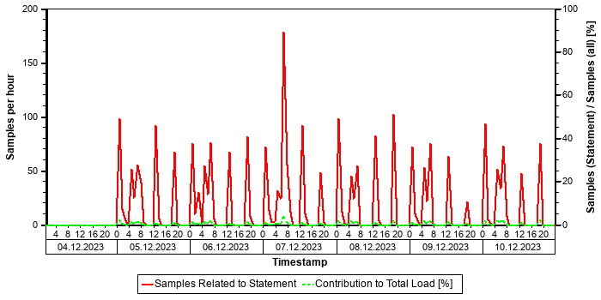

Tables
In the following, the tables involved in the SQL statement are listed (maximum of 20), sorted by the number of records.
Table Name | Schema Name | Table Type | Partition Type | Number of Records | Host
MATDOC | SAPPRD | COLUMN | Table not partitioned | 565.077.043 | tsls4proddbh

Origin of SQL Statement
The following table shows details of the applications responsible for the statement. This information is based on the information provided by SAP HANA in the "application source" connected to the statement in the "thread samples" or the list of "prepared" or "active" statements, and is not necessarily complete.
SID | Transaction / Jobaname | Report | Line | Last Changed on: | SAP Coding | Application Component | Description
PRD | STOCK_REP10 | ZCRMB_STOCK | 1.636 | 15.08.2025 |  | SD | Sales and Distribution
PRD | STOCK_REP11 | ZCRMB_STOCK | 1.636 | 15.08.2025 |  | SD | Sales and Distribution
PRD | STOCK_TUBES6 | ZCRMB_STOCK | 1.636 | 15.08.2025 |  | SD | Sales and Distribution
PRD | ZCRMB_STOCK3 | ZCRMB_STOCK | 1.636 | 15.08.2025 |  | SD | Sales and Distribution
PRD | ZCRMB_STOCK_TSM1 | ZCRMB_STOCK | 1.636 | 15.08.2025 |  | SD | Sales and Distribution

Statements on Top Scanned Table
This section shows the top non-internal statements according to "Total Elapsed Time". The "Total Elapsed Time" is the sum of the "Total Execution Time" and the "Total Preparation Time" from the SQL PLAN CACHE. It has a direct impact on the response time of the application calling the statement.
Only SQL Statement accessing the "top scanned table" are shown. The "top scanned table" is the table that contains the column with the highest number of "SCANNED_RECORDS" in M_CS_ALL_COLUMN_STATISTICS (see the following table). IN many cases, creating an index on that column might improve the accesses.
Schema | Table | Column
SAPPRD | VBFA | VBELN

See the following table for details of the selection:
Database Start | 15.10.2025 -- 08:03:55
Data Collection | 11.10.2025 -- 06:41:29
Analysis Type | Analysis of Plan Cache
Data Source | HOST_SQL_PLAN_CACHE
Begin of Time Interval | 03.10.2025 -- 23:48:58
End of Time Interval | 11.10.2025 -- 00:55:39

The selected statements - identified by their "Statement Hash" - are listed in the following table. Further details of these statements can be found in the subsections.
Statement Hash | Total Elapsed Time [s] | Number of Executions | Time / Execution [us] | Records / Execution | Time / Record [us]
ada23372ea59c0abd82cc2ffe5bbd714 | 31.577,3 | 3.121.252 | 10.116,9 | 0,9 | 11.710,0
c68c04a41b33a9f31691287ed2b77388 | 23.852,3 | 3.066.436 | 7.778,5 | 0,6 | 12.084,1
26c09a7ce6c5ef9e6cad9845f229670b | 8.622,2 | 117.981 | 73.081,4 | 49,3 | 1.482,8
3b29e9d402ccfdf9219483fdd8f7d91e | 3.789,5 | 38.255.677 | 99,1 | 1,0 | 99,1
6979b61a58e83eac89235d26ead77532 | 3.763,8 | 37.008.681 | 101,7 | 1,0 | 101,7

SQL Statement ada23372ea59c0abd82cc2ffe5bbd714
SELECT
"VBELV" , "POSNV"
FROM
"VBFA"
WHERE
"MANDT" = ? AND "VBELN" = ? AND "POSNN" = ? AND "VBTYP_N" = N'C' WITH RANGE_RESTRICTION('CURRENT')
Statement Impact
Indicator | Value
Contribution to Total CPU Load [%] | 1,71
Maximal CPU Consumption per Hour [%] ( 05.10.2025 between 03:00 and 04:00 ) | 2,61

Analysis of Where Clause
Table | Field | Operator | SCANNED RECORD COUNT | INDEX LOOKUP COUNT
VBFA | MANDT | = | 106.339.930 | 10
VBFA | POSNN | = | 1.219.830.944 | 0
VBFA | VBELN | = | 11.510.847.191.780.930 | 0
VBFA | VBTYP_N | = | 1.964.333.043 | 4

Explain Plan
OPERATOR_NAME | DETAILS | ENGINE | TABLE_NAME | OUTPUT_SIZE | SUBTREE_COST
PROJECT | VBFA.VBELV, VBFA.POS ... | HEX |  | 1 | 1,226
_COLUMN TABLE | FILTER CONDITION: VB ... | HEX | VBFA | 1 | 1,226

Time Consumption
The following table gives an overview of the time consumption of the analyzed SQL statement.
Activity | Total Time [s] | Average Time [us] | Minimal Time [us] | Maximal Time [us]
TOTAL EXECUTION | 31.577 | 10.117 | 53 | 2.019.367
PREPARATION | 0 | 0
LOCK DURATION | 0 | 0

Thread Distribution
Thread State | Area | Samples
Running | SQL | 14091
Job Exec Waiting | Idle | 577
Mutex Wait | Lock | 3

Thread Type (Thread Method) when THREAD_STATE = "Running" | Samples
JobWorker (HEX job running hex::cs::TableScanScheduleOp) | 13.780
SqlExecutor (ExecutePrepared) | 191
JobWorker | 120

The following table shows the "thread distribution" in terms of "thread detail" and for all thread samples.
Thread Type | Thread Method | Thread Detail | Samples
JobWorker | HEX job running hex::cs::TableScanScheduleOp | operatorId=5, pipeline=4 | 13783
SqlExecutor | ExecutePrepared | SELECT "VBELV" , "POSNV" FROM "VBFA" WHERE "MANDT" = ? AND "VBELN" = ? AND "POSNN" = ? AND "VBTYP_N" = N'C' WITH RANGE_RESTRICTION('CURRENT') | 768
JobWorker | ? | ? | 120

Note:
Table and column scan-related thread methods contribute significantly to the load caused by this SQL statement. It might be possible to accelerate the table scan (and by doing so, the execution time of this statement) either by changing the application in order to use existing indexes of this table or by changing the current index design (see SAP Note 2000002).
Recommendation: Consider creating a single column index for a column in the where clause not yet supported by an index.
If more than one column meets this condition, choose the most selective field. In many cases, this will be the field with the highest value for SCANNED_RECORD_COUNT (obtained from M_CS_ALL_COLUMN_STATISTICS), in particular when specified with "=".
See the following table with the fields specified with the where clause not yet supported by a single column index.
Table | Field | Operator | SCANNED_RECORD_COUNT
VBFA | VBELN | = | 11.510.847.191.780.930
VBFA | POSNN | = | 1.219.830.944

Statement History (Elapsed Time)
The following graph shows the number of executions and the average "Elapsed Time" of the statement within the considered time interval as obtained from the monitoring view HOST_SQL_PLAN_CACHE. Note that the absence of information at a given point in time does not necessarily mean that the statement was not executed, but only that no data was found in this monitoring view.
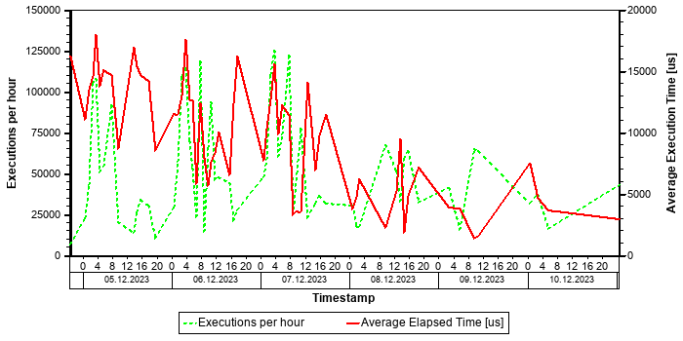
In the graph above, significant fluctuations in the average elapsed time can be observed. Besides reasons within the application, there might also be technical reasons for these fluctuations, for example, temporary CPU or memory bottlenecks.

Statement History (All Thread Samples)
The following graph shows the number of threads, both for state "Running" and for all other thread states. Threads in state "Running" are responsible for the CPU consumption due to the statements. Non-running threads could be "idle", but might also indicate network or I/O issues or locking situations.
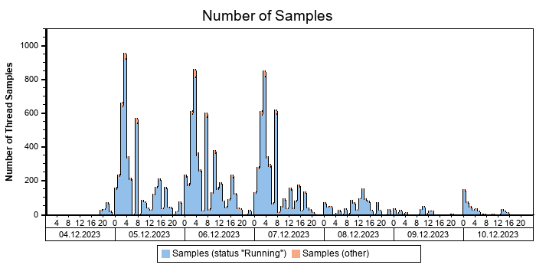

Statement History (Thread Sample 'Running')
The following graph shows the number of observed thread samples (in state "running") related to this SQL statement together with the contribution of those samples to all thread samples (in state "running") active in the system.
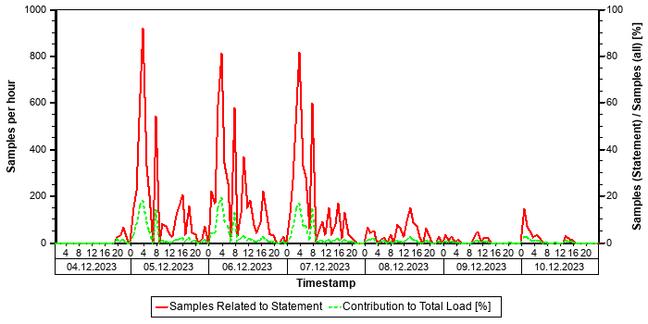

Tables
In the following, the tables involved in the SQL statement are listed (maximum of 20), sorted by the number of records.
Table Name | Schema Name | Table Type | Partition Type | Number of Records | Host
VBFA | SAPPRD | COLUMN | Table not partitioned | 613.470.583 | tsls4proddbh

Origin of SQL Statement
The following table shows details of the applications responsible for the statement. This information is based on the information provided by SAP HANA in the "application source" connected to the statement in the "thread samples" or the list of "prepared" or "active" statements, and is not necessarily complete.
SID | Transaction / Jobaname | Report | Line | Last Changed on: | SAP Coding
PRD | ZSSDOWNLOAD_TPL | ZVVR1800 | 4.691 | 10.10.2025

SQL Statement c68c04a41b33a9f31691287ed2b77388
SELECT
"VBELV" , "POSNV"
FROM
"VBFA"
WHERE
"MANDT" = ? AND "VBELN" = ? AND "POSNN" = ? AND "VBTYP_N" = N'C'
ORDER BY
"VBFA" . "MANDT" , "VBFA" . "RUUID" WITH RANGE_RESTRICTION('CURRENT')
Statement Impact
Indicator | Value
Contribution to Total CPU Load [%] | 1,53
Maximal CPU Consumption per Hour [%] ( 05.10.2025 between 03:00 and 04:00 ) | 3,00

Analysis of Where Clause
Table | Field | Operator | SCANNED RECORD COUNT | INDEX LOOKUP COUNT
VBFA | MANDT | = | 106.339.930 | 10
VBFA | POSNN | = | 1.219.830.944 | 0
VBFA | VBELN | = | 11.510.847.191.780.930 | 0
VBFA | VBTYP_N | = | 1.964.333.043 | 4

Explain Plan
OPERATOR_NAME | DETAILS | ENGINE | TABLE_NAME | OUTPUT_SIZE | SUBTREE_COST
PROJECT | VBFA.VBELV, VBFA.POS ... | HEX |  | 1 | 1,226
_ORDER BY | VBFA.RUUID ASC | HEX |  | 1 | 1,226
__COLUMN TABLE | FILTER CONDITION: VB ... | HEX | VBFA | 1 | 1,226

Time Consumption
The following table gives an overview of the time consumption of the analyzed SQL statement.
Activity | Total Time [s] | Average Time [us] | Minimal Time [us] | Maximal Time [us]
TOTAL EXECUTION | 23.852 | 7.779 | 73 | 1.015.696
PREPARATION | 0 | 0
LOCK DURATION | 0 | 0

Thread Distribution
Thread State | Area | Samples
Running | SQL | 12546
Job Exec Waiting | Idle | 505
Mutex Wait | Lock | 3
Speculative Lock Retry backoff | Lock | 1

Thread Type (Thread Method) when THREAD_STATE = "Running" | Samples
JobWorker (HEX job running hex::cs::TableScanScheduleOp) | 12.312
SqlExecutor (ExecutePrepared) | 158
JobWorker | 76

The following table shows the "thread distribution" in terms of "thread detail" and for all thread samples.
Thread Type | Thread Method | Thread Detail | Samples
JobWorker | HEX job running hex::cs::TableScanScheduleOp | operatorId=5, pipeline=4 | 12315
SqlExecutor | ExecutePrepared | SELECT "VBELV" , "POSNV" FROM "VBFA" WHERE "MANDT" = ? AND "VBELN" = ? AND "POSNN" = ? AND "VBTYP_N" = N'C' ORDER BY "VBFA" . "MANDT" , "VBFA" . "RUUID" WITH RANGE_RESTRICTION('CURRENT') | 663
JobWorker | ? | ? | 77

Note:
Table and column scan-related thread methods contribute significantly to the load caused by this SQL statement. It might be possible to accelerate the table scan (and by doing so, the execution time of this statement) either by changing the application in order to use existing indexes of this table or by changing the current index design (see SAP Note 2000002).
Recommendation: Consider creating a single column index for a column in the where clause not yet supported by an index.
If more than one column meets this condition, choose the most selective field. In many cases, this will be the field with the highest value for SCANNED_RECORD_COUNT (obtained from M_CS_ALL_COLUMN_STATISTICS), in particular when specified with "=".
See the following table with the fields specified with the where clause not yet supported by a single column index.
Table | Field | Operator | SCANNED_RECORD_COUNT
VBFA | VBELN | = | 11.510.847.191.780.930
VBFA | POSNN | = | 1.219.830.944

Statement History (Elapsed Time)
The following graph shows the number of executions and the average "Elapsed Time" of the statement within the considered time interval as obtained from the monitoring view HOST_SQL_PLAN_CACHE. Note that the absence of information at a given point in time does not necessarily mean that the statement was not executed, but only that no data was found in this monitoring view.
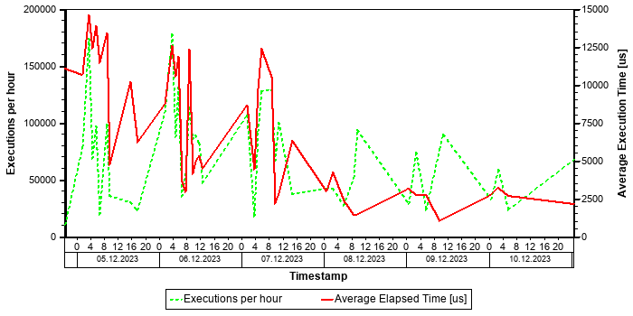
In the graph above, significant fluctuations in the average elapsed time can be observed. Besides reasons within the application, there might also be technical reasons for these fluctuations, for example, temporary CPU or memory bottlenecks.

Statement History (All Thread Samples)
The following graph shows the number of threads, both for state "Running" and for all other thread states. Threads in state "Running" are responsible for the CPU consumption due to the statements. Non-running threads could be "idle", but might also indicate network or I/O issues or locking situations.
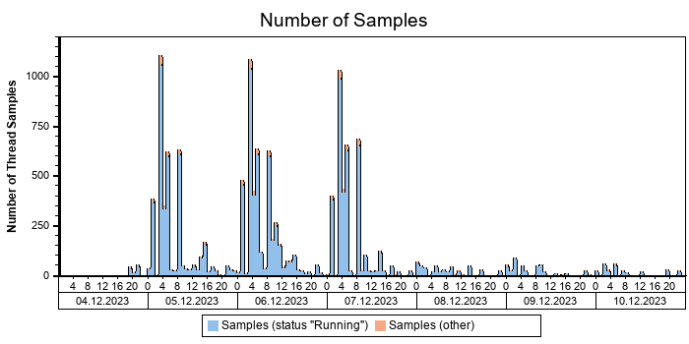

Statement History (Thread Sample 'Running')
The following graph shows the number of observed thread samples (in state "running") related to this SQL statement together with the contribution of those samples to all thread samples (in state "running") active in the system.
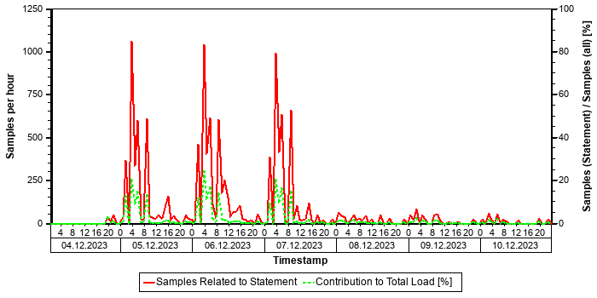

Tables
In the following, the tables involved in the SQL statement are listed (maximum of 20), sorted by the number of records.
Table Name | Schema Name | Table Type | Partition Type | Number of Records | Host
VBFA | SAPPRD | COLUMN | Table not partitioned | 613.470.583 | tsls4proddbh

Origin of SQL Statement
The following table shows details of the applications responsible for the statement. This information is based on the information provided by SAP HANA in the "application source" connected to the statement in the "thread samples" or the list of "prepared" or "active" statements, and is not necessarily complete.
SID | Transaction / Jobaname | Report | Line | Last Changed on: | SAP Coding
PRD | YMSDR_ZSSQ_DISPLAY | ZVVR1800 | 5.094 | 10.10.2025

SQL Statement 26c09a7ce6c5ef9e6cad9845f229670b
SELECT
"VBELV" , "POSNV" , "VBELN" , "POSNN"
FROM
"VBFA"
WHERE
"MANDT" = ? AND ( ( "VBELV" = ? AND "VBELN" = ? AND "POSNN" = ? ) OR ( "VBELV" = ? AND "VBELN" = ? AND "POSNN" = ? ) OR( "VBELV" = ? AND "VBELN" = ? AND "POSNN" = ? ) OR ( "VBELV" = ? AND "VBELN" = ? AND "POSNN" = ? ) OR ( "VBELV" = ? AND"VBELN" = ? AND "POSNN" = ? ) OR ( "VBELV" = ? AND "VBELN" = ? AND "POSNN" = ? ) OR ( "VBELV" = ? AND "VBELN" = ? AND "POSNN" = ? ) OR ( "VBELV" = ? AND "VBELN" = ? AND "POSNN" = ? ) OR ( "VBELV" = ? AND "VBELN" = ? AND "POSNN" = ? ) OR ( "VBELV" = ? AND "VBELN" = ? AND "POSNN" = ? ) OR ( "VBELV" = ? AND "VBELN" = ? AND "POSNN" = ? ) OR ( "VBELV" = ? AND "VBELN" = ? AND "POSNN" = ? ) OR ( "VBELV" = ? AND "VBELN" = ? AND "POSNN" = ? ) OR ( "VBELV" = ? AND "VBELN" = ? AND "POSNN" = ? ) OR ( "VBELV" = ? AND "VBELN" = ? AND "POSNN" = ? ) OR ( "VBELV" = ? AND "VBELN" = ? AND "POSNN" = ? ) OR ( "VBELV" = ? AND "VBELN" = ? AND "POSNN" = ? ) OR ( "VBELV" = ? AND "VBELN" = ? AND "POSNN" = ? ) OR ( "VBELV" = ? AND "VBELN" = ? AND "POSNN" = ? ) OR ( "VBELV" = ? AND "VBELN" = ? AND "POSNN" = ? ) OR ( "VBELV" = ? AND "VBELN" = ? AND "POSNN"= ? ) OR ( "VBELV" = ? AND "VBELN" = ? AND "POSNN" = ? ) OR ( "VBELV" = ? AND "VBELN" = ? AND "POSNN" = ? ) OR ( "VBELV" = ? AND "VBELN" = ? AND "POSNN" = ? ) OR ( "VBELV" = ? AND "VBELN" = ? AND "POSNN" = ? ) OR ( "VBELV" = ? AND "VBELN" = ? AND "POSNN" = ? ) OR ( "VBELV" = ? AND "VBELN" = ? AND "POSNN" = ? ) OR ( "VBELV" = ? AND "VBELN" = ? AND "POSNN" = ? ) OR ( "VBELV" = ? AND "VBELN" = ? AND "POSNN" = ? ) OR ( "VBELV" = ? AND "VBELN" = ? AND "POSNN" = ? ) OR ( "VBELV" =? AND "VBELN" = ? AND "POSNN" = ? ) OR ( "VBELV" = ? AND "VBELN" = ? AND "POSNN" = ? ) OR ( "VBELV" = ? AND "VBELN" = ?AND "POSNN" = ? ) OR ( "VBELV" = ? AND "VBELN" = ? AND "POSNN" = ? ) OR ( "VBELV" = ? AND "VBELN" = ? AND "POSNN" = ? )OR ( "VBELV" = ? AND "VBELN" = ? AND "POSNN" = ? ) OR ( "VBELV" = ? AND "VBELN" = ? AND "POSNN" = ? ) OR ( "VBELV" = ? AND "VBELN" = ? AND "POSNN" = ? ) OR ( "VBELV" = ? AND "VBELN" = ? AND "POSNN" = ? ) OR ( "VBELV" = ? AND "VBELN" = ? AND "POSNN" = ? ) OR ( "VBELV" = ? AND "VBELN" = ? AND "POSNN" = ? ) OR ( "VBELV" = ? AND "VBELN" = ? AND "POSNN" = ? ) OR( "VBELV" = ? AND "VBELN" = ? AND "POSNN" = ? ) OR ( "VBELV" = ? AND "VBELN" = ? AND "POSNN" = ? ) OR ( "VBELV" = ? AND"VBELN" = ? AND "POSNN" = ? ) OR ( "VBELV" = ? AND "VBELN" = ? AND "POSNN" = ? ) OR ( "VBELV" = ? AND "VBELN" = ? AND "POSNN" = ? ) OR ( "VBELV" = ? AND "VBELN" = ? AND "POSNN" = ? ) OR ( "VBELV" = ? AND "VBELN" = ? AND "POSNN" = ? ) OR ( "VBELV" = ? AND "VBELN" = ? AND "POSNN" = ? ) ) WITH RANGE_RESTRICTION('CURRENT')
Statement Impact
Indicator | Value
Contribution to Total CPU Load [%] | 0,75
Maximal CPU Consumption per Hour [%] ( 08.10.2025 between 00:00 and 01:00 ) | 0,84

Analysis of Where Clause
Table | Field | Operator | SCANNED RECORD COUNT | INDEX LOOKUP COUNT
VBFA | MANDT | = | 106.339.930 | 10
VBFA | POSNN | = | 1.219.830.944 | 0
VBFA | VBELN | = | 11.510.847.191.780.930 | 0
VBFA | VBELV | = | 463.249.971.146 | 161.104.466

Explain Plan
OPERATOR_NAME | DETAILS | ENGINE | TABLE_NAME | OUTPUT_SIZE | SUBTREE_COST
COLUMN SEARCH | VBFA.VBELV, VBFA.POS ... | COLUMN |  | 12 | 0,000
_COLUMN TABLE | FILTER CONDITION: (I ... | COLUMN | VBFA | 12 | 0,000

Time Consumption
The following table gives an overview of the time consumption of the analyzed SQL statement.
Activity | Total Time [s] | Average Time [us] | Minimal Time [us] | Maximal Time [us]
TOTAL EXECUTION | 8.616 | 73.028 | 583 | 1.766.602
PREPARATION | 6 | 53
LOCK DURATION | 0 | 0

Thread Distribution
Thread State | Area | Samples
Running | SQL | 6139
Job Exec Waiting | Idle | 268
Mutex Wait | Lock | 2

Thread Type (Thread Method) when THREAD_STATE = "Running" | Samples
JobWorker (IndirectPredScanVecOutJob<ScanVectorBinSearchPredicate>) | 5.948
JobWorker (IndirectPredScanVecOutJob<ScanVectorPredicate>) | 162
SqlExecutor (ExecutePrepared) | 22
JobWorker | 7

The following table shows the "thread distribution" in terms of "thread detail" and for all thread samples.
Thread Type | Thread Method | Thread Detail | Samples
JobWorker | IndirectPredScanVecOutJob<ScanVectorBinSearchPredicate> | SAPPRD:VBFA.VBELN | 5950
SqlExecutor | ExecutePrepared | SELECT "VBELV" , "POSNV" , "VBELN" , "POSNN" FROM "VBFA" WHERE "MANDT" = ? AND ( ( "VBELV" = ? AND "VBELN" = ? AND "POSNN" = ? ) OR ( "VBELV" = ? AND "VBELN" = ? AND "POSNN" = ? ) OR ( "VBELV" = ? AND "VBELN" = ? AND "POSNN" = ? ) OR ( "VBELV" = ? AN | 290
JobWorker | IndirectPredScanVecOutJob<ScanVectorPredicate> | SAPPRD:VBFA.VBELN | 162
JobWorker | ? | ? | 7

Note:
Table and column scan-related thread methods contribute significantly to the load caused by this SQL statement. It might be possible to accelerate the table scan (and by doing so, the execution time of this statement) either by changing the application in order to use existing indexes of this table or by changing the current index design (see SAP Note 2000002).
Recommendation: Consider creating a single column index for a column in the where clause not yet supported by an index.
If more than one column meets this condition, choose the most selective field. In many cases, this will be the field with the highest value for SCANNED_RECORD_COUNT (obtained from M_CS_ALL_COLUMN_STATISTICS), in particular when specified with "=".
See the following table with the fields specified with the where clause not yet supported by a single column index.
Table | Field | Operator | SCANNED_RECORD_COUNT
VBFA | VBELN | = | 11.510.847.191.780.930
VBFA | POSNN | = | 1.219.830.944

Statement History (Elapsed Time)
The following graph shows the number of executions and the average "Elapsed Time" of the statement within the considered time interval as obtained from the monitoring view HOST_SQL_PLAN_CACHE. Note that the absence of information at a given point in time does not necessarily mean that the statement was not executed, but only that no data was found in this monitoring view.
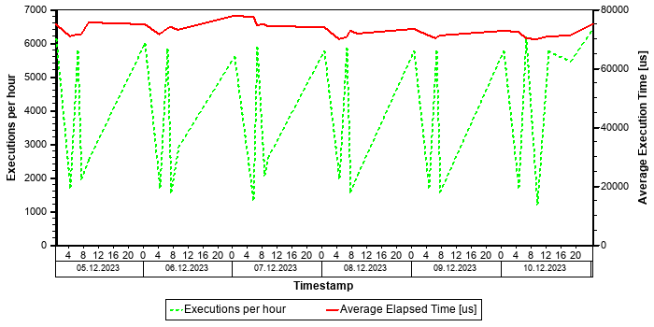

Statement History (All Thread Samples)
The following graph shows the number of threads, both for state "Running" and for all other thread states. Threads in state "Running" are responsible for the CPU consumption due to the statements. Non-running threads could be "idle", but might also indicate network or I/O issues or locking situations.
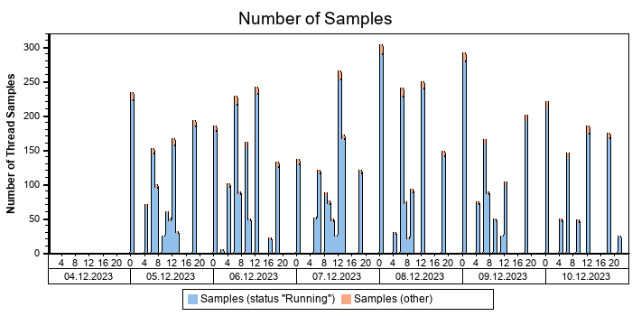

Statement History (Thread Sample 'Running')
The following graph shows the number of observed thread samples (in state "running") related to this SQL statement together with the contribution of those samples to all thread samples (in state "running") active in the system.
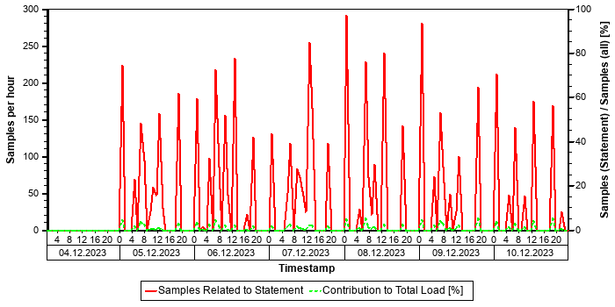

Tables
In the following, the tables involved in the SQL statement are listed (maximum of 20), sorted by the number of records.
Table Name | Schema Name | Table Type | Partition Type | Number of Records | Host
VBFA | SAPPRD | COLUMN | Table not partitioned | 613.470.583 | tsls4proddbh

Origin of SQL Statement
The following table shows details of the applications responsible for the statement. This information is based on the information provided by SAP HANA in the "application source" connected to the statement in the "thread samples" or the list of "prepared" or "active" statements, and is not necessarily complete.
SID | Transaction / Jobaname | Report | Line | Last Changed on: | SAP Coding
PRD | STOCK_REP13 | YMSDR_STOCK_JCP | 834 | 07.03.2022
PRD | YMSDR_STOCK_JCP | YMSDR_STOCK_JCP | 834 | 07.03.2022

SQL Statement 3b29e9d402ccfdf9219483fdd8f7d91e
SELECT
COUNT(*)
FROM
"VBFA"
WHERE
"MANDT" = ? AND "VBELV" = ? AND "POSNV" = ? AND "VBTYP_V" = N'J' AND ( "VBTYP_N" = N'i' OR "VBTYP_N" = N'R' ) AND "BWART" = N'101' WITH RANGE_RESTRICTION('CURRENT')
Statement Impact
Indicator | Value
Contribution to Total CPU Load [%] | 0,05
Maximal CPU Consumption per Hour [%] ( 08.10.2025 between 11:00 and 12:00 ) | 0,09

Analysis of Where Clause
Table | Field | Operator | SCANNED RECORD COUNT | INDEX LOOKUP COUNT
VBFA | BWART | = | 5.794.157 | 0
VBFA | MANDT | = | 106.339.930 | 10
VBFA | POSNV | = | 226.340.582.005 | 0
VBFA | VBELV | = | 463.249.971.146 | 161.104.466
VBFA | VBTYP_N | = | 1.964.333.043 | 4
VBFA | VBTYP_V | = | 48.666.348.745 | 0

Time Consumption
The following table gives an overview of the time consumption of the analyzed SQL statement.
Activity | Total Time [s] | Average Time [us] | Minimal Time [us] | Maximal Time [us]
TOTAL EXECUTION | 3.787 | 99 | 65 | 47.878
PREPARATION | 3 | 0
LOCK DURATION | 0 | 0

Statement History (Thread Sample 'Running')
The following graph shows the number of observed thread samples (in state "running") related to this SQL statement together with the contribution of those samples to all thread samples (in state "running") active in the system.
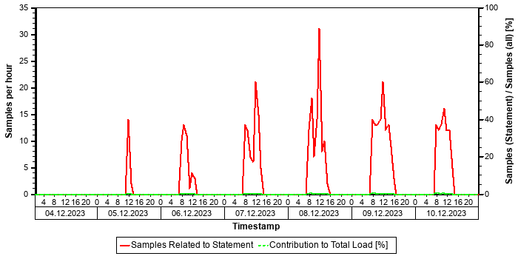

Tables
In the following, the tables involved in the SQL statement are listed (maximum of 20), sorted by the number of records.
Table Name | Schema Name | Table Type | Partition Type | Number of Records | Host
VBFA | SAPPRD | COLUMN | Table not partitioned | 613.470.583 | tsls4proddbh

Origin of SQL Statement
The following table shows details of the applications responsible for the statement. This information is based on the information provided by SAP HANA in the "application source" connected to the statement in the "thread samples" or the list of "prepared" or "active" statements, and is not necessarily complete.
SID | Transaction / Jobaname | Report | Line | Last Changed on: | SAP Coding
PRD | FRTCAL_FAMD | YMKUFRGCAL01_FAMD | 568 | 06.09.2025
PRD | ZFRC1_DD_FAMD | YMKUFRGCAL01_FAMD | 568 | 06.09.2025

SQL Statement 6979b61a58e83eac89235d26ead77532
SELECT
COUNT(*)
FROM
"VBFA"
WHERE
"MANDT" = ? AND "VBELV" = ? AND "POSNV" = ? AND "VBTYP_V" = N'J' AND ( "VBTYP_N" = N'i' OR "VBTYP_N" = N'R' ) AND "BWART" = N'102' WITH RANGE_RESTRICTION('CURRENT')
Statement Impact
Indicator | Value
Contribution to Total CPU Load [%] | 0,05
Maximal CPU Consumption per Hour [%] ( 10.10.2025 between 11:00 and 12:00 ) | 0,10

Analysis of Where Clause
Table | Field | Operator | SCANNED RECORD COUNT | INDEX LOOKUP COUNT
VBFA | BWART | = | 5.794.157 | 0
VBFA | MANDT | = | 106.339.930 | 10
VBFA | POSNV | = | 226.340.582.005 | 0
VBFA | VBELV | = | 463.249.971.146 | 161.104.466
VBFA | VBTYP_N | = | 1.964.333.043 | 4
VBFA | VBTYP_V | = | 48.666.348.745 | 0

Time Consumption
The following table gives an overview of the time consumption of the analyzed SQL statement.
Activity | Total Time [s] | Average Time [us] | Minimal Time [us] | Maximal Time [us]
TOTAL EXECUTION | 3.761 | 102 | 64 | 56.060
PREPARATION | 2 | 0
LOCK DURATION | 0 | 0

Statement History (Thread Sample 'Running')
The following graph shows the number of observed thread samples (in state "running") related to this SQL statement together with the contribution of those samples to all thread samples (in state "running") active in the system.
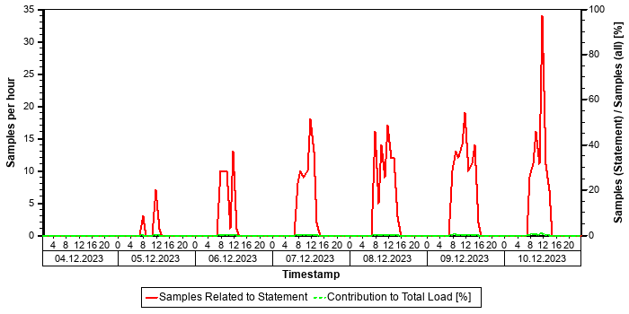

Tables
In the following, the tables involved in the SQL statement are listed (maximum of 20), sorted by the number of records.
Table Name | Schema Name | Table Type | Partition Type | Number of Records | Host
VBFA | SAPPRD | COLUMN | Table not partitioned | 613.470.583 | tsls4proddbh

Origin of SQL Statement
The following table shows details of the applications responsible for the statement. This information is based on the information provided by SAP HANA in the "application source" connected to the statement in the "thread samples" or the list of "prepared" or "active" statements, and is not necessarily complete.
SID | Transaction / Jobaname | Report | Line | Last Changed on: | SAP Coding
PRD | FRTCAL_FAMD | YMKUFRGCAL01_FAMD | 594 | 06.09.2025
PRD | ZFRC1_DD_FAMD | YMKUFRGCAL01_FAMD | 594 | 06.09.2025

Top Statements (Total Memory)
This section shows the top statements according to memory consumption as obtained from the SQL PLAN CACHE. It considers the product of the number of executions and the average memory consumption per execution.
See the following table for details of the selection:
Database Start | 15.10.2025 -- 08:03:55
Data Collection | 11.10.2025 -- 06:41:29
Analysis Type | Analysis of Plan Cache
Data Source | M_SQL_PLAN_CACHE

The selected statements - identified by their "Statement Hash" - are listed in the following table. Further details of these statements can be found in the subsections.
Statement Hash | Number of Executions | Time / Execution [us] | Records / Execution | Executions x Avg Mem x Avg Time[GB x s] | Memory / Execution [MB]
d6fd6678833f9a2e25e7b53239c50e9a | 28.312.725 | 253.851,1 | 0,0 | 18.405.803 | 2.622,4
54a9566c2195e1ab2540c7f5d0ac6ff4 | 4.217 | 131.708.738,5 | 392.782,8 | 15.191.710 | 28.008,4
938619e1d06635b2b252709b7ccd58af | 158.339 | 19.483.102,8 | 1,0 | 11.378.933 | 3.777,1
d0ada142d46046fe6eb866bc45bf8a3f | 603 | 196.827.412,6 | 35,3 | 9.981.205 | 86.115,2
77658c84db4c1afd41fa26aff7df5464 | 7.023 | 66.005.022,4 | 245.510,6 | 4.935.961 | 10.903,7

SQL Statement d6fd6678833f9a2e25e7b53239c50e9a
call _SYS_STATISTICS.STATISTICS_SCHEDULABLEWRAPPER('Timer', ?, ?, ?, ?)
Statement Impact
Indicator | Value
Contribution to Total CPU Load [%] | 0,01
Contribution to Total Execution Time [%] | 11,78
Maximal CPU Consumption per Hour [%] ( 08.10.2025 between 07:00 and 08:00 ) | 0,01

Known Issue
Information about this statement (as identified by its STATEMENT_HASH) can be found in the following SAP Note:
Recommendation: Check the mentioned SAP Note(s) for the recommendation concerning the statement and apply the recommendation if applicable.
STATEMENT_HASH | SAP Note | Type | Object
d6fd6678833f9a2e25e7b53239c50e9a | 2000002 | CALL | STATISTICS_SCHEDULABLEWRAPPER

Time Consumption
The following table gives an overview of the time consumption of the analyzed SQL statement.
Activity | Total Time [s] | Average Time [us] | Minimal Time [us] | Maximal Time [us]
TOTAL EXECUTION | 7.183.619 | 253.724 | 3.949 | 431.781.175
PREPARATION | 3.598 | 127
LOCK DURATION | 0 | 0

Memory Consumption
The following table provides an overview of the memory consumption of the analyzed SQL statement as obtained from the monitoring view M_SQL_PLAN_STATISTICS (or – if not yet available – M_SQL_PLAN_CACHE), that is, without taking a specific time interval into account.
Activity | Total Memory [GB] | Average Memory [MB] | Minimal Memory [MB] | Maximal Memory [MB]
EXECUTION_MEMORY_SIZE | 72.506.294 | 2.622,4 | 5,5 | 4.907,8

Statement History (Thread Sample 'Running')
The following graph shows the number of observed thread samples (in state "running") related to this SQL statement together with the contribution of those samples to all thread samples (in state "running") active in the system.
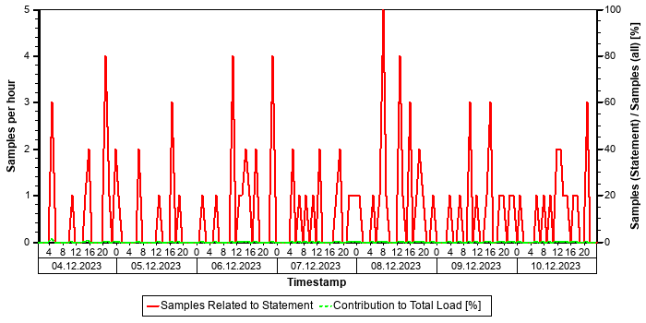

Origin of SQL Statement
APPLICATION_NAME | APPLICATION_SOURCE | PASSPORT_ACTION
Embedded Statistics Server | running ID (27, deletion: yes) for 08.10.2025 00:25:07 000 Fri
Embedded Statistics Server | running ID (38, deletion: yes) for 08.10.2025 00:10:07 000 Fri
Embedded Statistics Server | running ID (39, deletion: no) for 08.10.2025 00:10:07 000 Fri
Embedded Statistics Server | running ID (42, deletion: yes) for 08.10.2025 00:10:07 000 Fri
Embedded Statistics Server | running ID (65, deletion: no) for 08.10.2025 00:10:07 000 Fri
Embedded Statistics Server | running ID (65, deletion: no) for 09.10.2025 00:06:32 000 Sat
Embedded Statistics Server | running ID (65, deletion: no) for 09.10.2025 00:11:32 000 Sat
Embedded Statistics Server | running ID (65, deletion: no) for 10.10.2025 00:05:32 000 Sun
Embedded Statistics Server | running ID (65, deletion: no) for 10.10.2025 00:10:32 000 Sun
Embedded Statistics Server | running ID (69, deletion: yes) for 08.10.2025 00:10:07 000 Fri

Internal SQL Statement
This SQL statement was executed from an internal database connection.

SQL Statement 54a9566c2195e1ab2540c7f5d0ac6ff4
SELECT
/* Buffer Loading */ "MANDT" , "KAPPL" , "KSCHL" , "VKORG" , "KUNAG" , "KUNWE" , "WERKS" , "ZZTDCNO" , "KFRST" , "DATBI" , "DATAB" , "KBSTAT" , "KNUMH"
FROM
"A639"
WHERE
"MANDT" = ?
ORDER BY
"A639" . "MANDT" , "A639" . "KAPPL" , "A639" . "KSCHL" , "A639" . "VKORG" , "A639" . "KUNAG" , "A639" . "KUNWE" , "A639" . "WERKS" , "A639" . "ZZTDCNO" , "A639" . "KFRST" , "A639" . "DATBI" WITH RANGE_RESTRICTION('CURRENT')
Statement Impact
Indicator | Value
Contribution to Total CPU Load [%] | 3,45
Contribution to Total Execution Time [%] | 0,91
Maximal CPU Consumption per Hour [%] ( 05.10.2025 between 15:00 and 16:00 ) | 2,29
Maximal Memory Consumption [%] | 0,33

Note: The statement as identified by its statement hash can also be found in other sections of this report:
Other Sections Dealing with this Statement
SAP HANA SQL Statements in PRD -> Top Statements (CPU Peak Hour)
SAP HANA SQL Statements in PRD -> Top Statements (Thread Samples)

Analysis of Where Clause
Table | Field | Operator | Supported by Single Column Index | Compression | Distinct Values | SCANNED RECORD COUNT | INDEX LOOKUP COUNT
A639 | MANDT | = |  | RLE | 1 | 4.021 | 677

Calendar Week(s) of "Distinct Values" Collection
202549

Explain Plan
OPERATOR_NAME | DETAILS | ENGINE | TABLE_NAME | OUTPUT_SIZE | SUBTREE_COST
COLUMN SEARCH | A639.MANDT, A639.KAP ... | COLUMN |  | 190.556.391 | 2.471,740
_ORDER BY | A639.KAPPL ASC, A639 ... | COLUMN |  | 190.556.391 | 62,539
__COLUMN TABLE | FILTER CONDITION: A6 ... | COLUMN | A639 | 190.556.391 | 0,000

Time Consumption
The following table gives an overview of the time consumption of the analyzed SQL statement.
Activity | Total Time [s] | Average Time [us] | Minimal Time [us] | Maximal Time [us]
TOTAL EXECUTION | 555.414 | 131.708.250 | 93 | 902.990.363
PREPARATION | 2 | 488
LOCK DURATION | 0 | 0

Memory Consumption
The following table provides an overview of the memory consumption of the analyzed SQL statement as obtained from the monitoring view M_SQL_PLAN_STATISTICS (or – if not yet available – M_SQL_PLAN_CACHE), that is, without taking a specific time interval into account.
Activity | Total Memory [GB] | Average Memory [MB] | Minimal Memory [MB] | Maximal Memory [MB]
EXECUTION_MEMORY_SIZE | 115.343 | 28.008,4 | 0,1 | 30.654,8

Thread Distribution
The following table(s) shows both (if available) the "thread distribution" in terms of "thread state" and for thread samples in state "Running" (that is consuming CPU resources) the distribution of thread type and method. The information is obtained from the view HOST_SERVICE_THREAD_SAMPLES in the time interval analyzed. By this, some insight is given to the internal activities when the statement is processed, helping to understand which activities are responsible for the resource and/or time consumption.
For more information concerning threads and thread samples, see also SAP Note 2114710.
Thread State | Area | Samples
Running | SQL | 28325
Job Exec Waiting | Idle | 5462
Mutex Wait | Lock | 213
Semaphore Wait | Lock | 31

Thread Type (Thread Method) when THREAD_STATE = "Running" | Samples
JobWorker (RangeSortJob) | 11.117
JobWorker (MakeHeapJob) | 10.042
JobWorker (ParallelFor Job) | 4.379
SqlExecutor (ExecutePrepared) | 1.288
Others | 1.499

The following table shows the "thread distribution" in terms of "thread detail" and for all thread samples.
Thread Type | Thread Method | Thread Detail | Samples
JobWorker | MakeHeapJob | ? | 10042
SqlExecutor | ExecutePrepared | SELECT /* Buffer Loading */ "MANDT" , "KAPPL" , "KSCHL" , "VKORG" , "KUNAG" , "KUNWE" , "WERKS" , "ZZTDCNO" , "KFRST" , "DATBI" , "DATAB" , "KBSTAT" , "KNUMH" FROM "A639" WHERE "MANDT" = ? ORDER BY "A639" . "MANDT" , "A639" . "KAPPL" , "A639" . "KSCH | 3040
JobWorker | ZipResultJob | ? | 1150
JobWorker | ParallelFor Job | AE/getValues BlockJob on table PRD::SAPPRD:A639 (t 337) (parallelFor job 1/10) | 587
JobWorker | ParallelFor Job | AE/getValues BlockJob on table PRD::SAPPRD:A639 (t 337) (parallelFor job 2/10) | 466
JobWorker | ParallelFor Job | AE/getValues BlockJob on table PRD::SAPPRD:A639 (t 337) (parallelFor job 3/10) | 464
JobWorker | ParallelFor Job | AE/getValues BlockJob on table PRD::SAPPRD:A639 (t 337) (parallelFor job 5/10) | 463
JobWorker | ParallelFor Job | AE/getValues BlockJob on table PRD::SAPPRD:A639 (t 337) (parallelFor job 4/10) | 454
JobWorker | ParallelFor Job | AE/getValues BlockJob on table PRD::SAPPRD:A639 (t 337) (parallelFor job 6/10) | 445
JobWorker | ParallelFor Job | AE/getValues BlockJob on table PRD::SAPPRD:A639 (t 337) (parallelFor job 7/10) | 440
JobWorker | ParallelFor Job | AE/getValues BlockJob on table PRD::SAPPRD:A639 (t 337) (parallelFor job 8/10) | 407
JobWorker | ParallelFor Job | AE/getValues BlockJob on table PRD::SAPPRD:A639 (t 337) (parallelFor job 9/10) | 380
JobWorker | ParallelFor Job | AE/getValues BlockJob on table PRD::SAPPRD:A639 (t 337) (parallelFor job 10/10) | 296
JobWorker | RangeSortJob | RangeSort ranges from: 0 to: 190353789 | 61
JobWorker | RangeSortJob | RangeSort ranges from: 0 to: 190353765 | 54
SqlExecutor | FetchCursor | SELECT /* Buffer Loading */ "MANDT" , "KAPPL" , "KSCHL" , "VKORG" , "KUNAG" , "KUNWE" , "WERKS" , "ZZTDCNO" , "KFRST" , "DATBI" , "DATAB" , "KBSTAT" , "KNUMH" FROM "A639" WHERE "MANDT" = ? ORDER BY "A639" . "MANDT" , "A639" . "KAPPL" , "A639" . "KSCH | 24
JobWorker | RangeSortJob | RangeSort ranges from: 3612791 to: 4716227 | 21
JobWorker | RangeSortJob | RangeSort ranges from: 7910415 to: 8865183 | 19
JobWorker | RangeSortJob | RangeSort ranges from: 5691427 to: 6816623 | 18
JobWorker | RangeSortJob | RangeSort ranges from: 6816623 to: 7910415 | 18
OTHERS | OTHERS | OTHERS | 15182

Statement History (Elapsed Time)
The following graph shows the number of executions and the average "Elapsed Time" of the statement within the considered time interval as obtained from the monitoring view HOST_SQL_PLAN_CACHE. Note that the absence of information at a given point in time does not necessarily mean that the statement was not executed, but only that no data was found in this monitoring view.
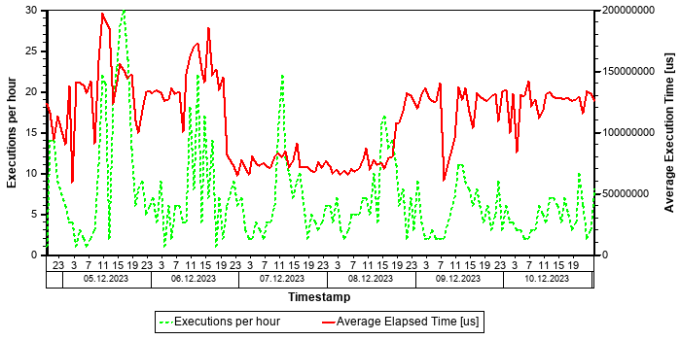

Statement History (All Thread Samples)
The following graph shows the number of threads, both for state "Running" and for all other thread states. Threads in state "Running" are responsible for the CPU consumption due to the statements. Non-running threads could be "idle", but might also indicate network or I/O issues or locking situations.
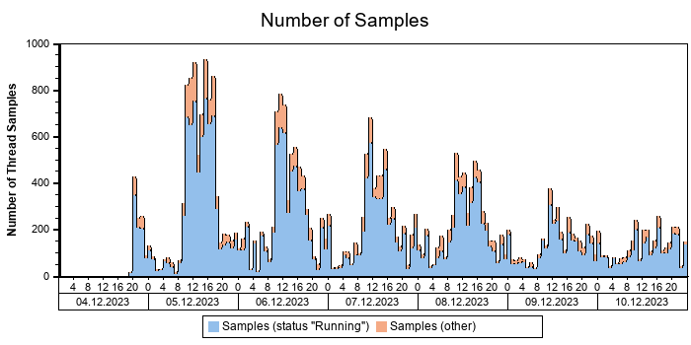

Statement History (Thread Sample 'Running')
The following graph shows the number of observed thread samples (in state "running") related to this SQL statement together with the contribution of those samples to all thread samples (in state "running") active in the system.
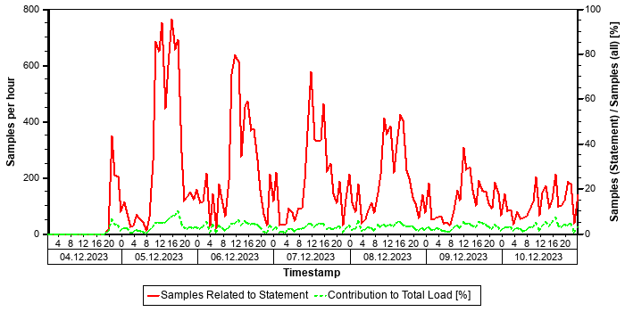

Correlation with Index Server Resource Consumption
The distribution of thread samples with the status "Running" correlates strongly with the overall CPU or memory consumption of the system. Such a correlation indicates that this statement might be responsible for peaks in the memory or CPU consumption.
Distiribution | Correlation Coefficient | Comment
CPU consumption index server(s) - Threads (running) from this SQL statement | 0,85 | strong correlation
Memory consumption index server(s) - Threads (running) from this SQL Statement | 0,61 | strong correlation

Tables
In the following, the tables involved in the SQL statement are listed (maximum of 20), sorted by the number of records.
Table Name | Schema Name | Table Type | Partition Type | Number of Records | Host
A639 | SAPPRD | COLUMN | Table not partitioned | 190.556.392 | tsls4proddbh

Statement used for Buffer Loading
Table
A639

The comment /* Buffer Loading */ in the statement text shows that this SQL statement was issued to copy information from the table listed above to the table buffer. A table should be loaded only rarely and the related SQL statement should not play an important role in a productive system. This statement might be executed frequently if the table is either invalidated very often or the table is displaced from the table buffer because the configuration of the table buffer is too small.
Recommendation: In order to check whether the buffering settings for this table are adequate, check the table statistics of this table in transaction ST10 (see SAP Note 1011158 and SAP Note 2457204). In order to check the setting for the table buffer, check the buffer statistics in ST02 for the different ABAP instances (see SAP Note 2442188).
If the buffer settings are not adequate, adjust the buffer settings, or un-buffer the table. If the configuration of the table buffer is too small and sufficient physical memory is available on the host, increase the size of the table buffer.

Origin of SQL Statement
The following table shows details of the applications responsible for the statement. This information is based on the information provided by SAP HANA in the "application source" connected to the statement in the "thread samples" or the list of "prepared" or "active" statements, and is not necessarily complete.
SID | Transaction / Jobaname | Report | Line | Last Changed on: | SAP Coding | Application Component | Description
PRD | /IRM/LAUNCHPAD | LV61ZU01 | 938 | 30.01.2017 |  | SD-BF-PR | Pricing and Conditions
PRD | Auto Delivery of 95172721270460 | LV61ZU01 | 938 | 30.01.2017 |  | SD-BF-PR | Pricing and Conditions
PRD | Auto Delivery of 95172882830938 | LV61ZU01 | 938 | 30.01.2017 |  | SD-BF-PR | Pricing and Conditions
PRD | Auto Delivery of 95172901390382 | LV61ZU01 | 938 | 30.01.2017 |  | SD-BF-PR | Pricing and Conditions
PRD | Auto Delivery of 95172901391221 | LV61ZU01 | 938 | 30.01.2017 |  | SD-BF-PR | Pricing and Conditions
PRD | Auto Delivery of 95172925000872 | LV61ZU01 | 938 | 30.01.2017 |  | SD-BF-PR | Pricing and Conditions
PRD | Auto Delivery of 95172929901592 | LV61ZU01 | 938 | 30.01.2017 |  | SD-BF-PR | Pricing and Conditions
PRD | Auto Delivery of 95172932099571 | LV61ZU01 | 938 | 30.01.2017 |  | SD-BF-PR | Pricing and Conditions
PRD | Auto Delivery of 95172933014931 | LV61ZU01 | 938 | 30.01.2017 |  | SD-BF-PR | Pricing and Conditions
PRD | Auto Delivery of 95172933015250 | LV61ZU01 | 938 | 30.01.2017 |  | SD-BF-PR | Pricing and Conditions
PRD | Auto Delivery of 95172945410184 | LV61ZU01 | 938 | 30.01.2017 |  | SD-BF-PR | Pricing and Conditions
PRD | Auto Delivery of 95172945410470 | LV61ZU01 | 938 | 30.01.2017 |  | SD-BF-PR | Pricing and Conditions
PRD | Auto Delivery of 95172945415482 | LV61ZU01 | 938 | 30.01.2017 |  | SD-BF-PR | Pricing and Conditions
PRD | Auto Delivery of 95172945415793 | LV61ZU01 | 938 | 30.01.2017 |  | SD-BF-PR | Pricing and Conditions

SQL Statement 938619e1d06635b2b252709b7ccd58af
SELECT DISTINCT
"A" . "REF_DOC" , "A" . "REF_DOC_YEAR" , "B" . "BUDAT_MKPF"
FROM
"/OPT/VIM_1ITEM" "A" INNER JOIN /* Redirected table: MSEG */ "NSDM_V_MSEG" "B" ON "A" . "MANDT" = "B" . "MANDT" AND "A"
. "REF_DOC" = "B" . "LFBNR" AND "A" . "REF_DOC_YEAR" = "B" . "MJAHR"
WHERE
"A" . "MANDT" = ? AND "A" . "DOCID" = ? WITH RANGE_RESTRICTION('CURRENT')
Statement Impact
Indicator | Value
Contribution to Total CPU Load [%] | 3,59
Contribution to Total Execution Time [%] | 5,06
Maximal CPU Consumption per Hour [%] ( 05.10.2025 between 12:00 and 13:00 ) | 4,49
Maximal Memory Consumption [%] | 0,11

Note: The statement as identified by its statement hash can also be found in other sections of this report:
Other Sections Dealing with this Statement
SAP HANA SQL Statements in PRD -> Top Statements (CPU Peak Hour)
SAP HANA SQL Statements in PRD -> Top Statements (Elapsed Time)
SAP HANA SQL Statements in PRD -> Top MATDOC Statements (Elapsed Time)
SAP HANA SQL Statements in PRD -> Top Statements (Thread Samples)

Analysis of Where Clause
Table | Field | Operator | Supported by Single Column Index | Compression | Distinct Values | SCANNED RECORD COUNT | INDEX LOOKUP COUNT
/OPT/VIM_1ITEM | DOCID | = |  | DEFAULT | 10.594.120 | 119.414.604 | 816.740
/OPT/VIM_1ITEM | MANDT | = |  | RLE | 1 | 3.879 | 2

Time Consumption
The following table gives an overview of the time consumption of the analyzed SQL statement.
Activity | Total Time [s] | Average Time [us] | Minimal Time [us] | Maximal Time [us]
TOTAL EXECUTION | 3.084.930 | 19.483.073 | 192 | 348.779.211
PREPARATION | 5 | 30
LOCK DURATION | 0 | 0

Memory Consumption
The following table provides an overview of the memory consumption of the analyzed SQL statement as obtained from the monitoring view M_SQL_PLAN_STATISTICS (or – if not yet available – M_SQL_PLAN_CACHE), that is, without taking a specific time interval into account.
Activity | Total Memory [GB] | Average Memory [MB] | Minimal Memory [MB] | Maximal Memory [MB]
EXECUTION_MEMORY_SIZE | 584.041 | 3.777,1 | 0,1 | 10.107,5

Statement History (Thread Sample 'Running')
The following graph shows the number of observed thread samples (in state "running") related to this SQL statement together with the contribution of those samples to all thread samples (in state "running") active in the system.


Correlation with Index Server Resource Consumption
The distribution of thread samples with the status "Running" correlates strongly with the overall CPU or memory consumption of the system. Such a correlation indicates that this statement might be responsible for peaks in the memory or CPU consumption.
Distiribution | Correlation Coefficient | Comment
CPU consumption index server(s) - Threads (running) from this SQL statement | 0,81 | strong correlation
Memory consumption index server(s) - Threads (running) from this SQL Statement | 0,62 | strong correlation

Tables
In the following, the tables involved in the SQL statement are listed (maximum of 20), sorted by the number of records.
Table Name | Schema Name | Table Type | Partition Type | Number of Records | Host
MATDOC | SAPPRD | COLUMN | Table not partitioned | 565.077.043 | tsls4proddbh
/OPT/VIM_1ITEM | SAPPRD | COLUMN | Table not partitioned | 30.153.698 | tsls4proddbh

Compatibility View Access
SAP S/4HANA Supply Chain (MM - Inventory Management) offers a simplified data model. Several tables have become obsolete and are removed. To allow existing coding to continue to work, these tables are replaced by views with the same name, known as "Compatibility Views". As a result, read access to these objects is still possible; however, performance is affected since it is now an access to a view instead of a simple table. For some general background information, see https://launchpad.support.sap.com/#/notes/2206980 [SAP Note 2206980].
For performance-critical coding parts, we strongly recommend the code adjustments suggested in Section 2 of the SAP Note. For non-critical parts, these adjustments are optional in the short term but recommended in the long term.

Origin of SQL Statement
The following table shows details of the applications responsible for the statement. This information is based on the information provided by SAP HANA in the "application source" connected to the statement in the "thread samples" or the list of "prepared" or "active" statements, and is not necessarily complete.
SID | Transaction / Jobaname | Report | Line | Last Changed on: | SAP Coding
PRD | /OPT/DR_BR_WAIT | LZOPT_VIM_1U07 | 29 | 25.09.2019
PRD | /OPT/VIM_ANALYTICS | LZOPT_VIM_1U07 | 29 | 25.09.2019
PRD | /OPT/VIM_ANALYTICS_750 | LZOPT_VIM_1U07 | 29 | 25.09.2019
PRD | /OPT/VIM_RULERUN | LZOPT_VIM_1U07 | 29 | 25.09.2019
PRD | /OPT/VIM_VA2 | LZOPT_VIM_1U07 | 29 | 25.09.2019
PRD | /OPT/VIM_WP | LZOPT_VIM_1U07 | 29 | 25.09.2019
PRD | RSWIWILS | LZOPT_VIM_1U07 | 29 | 25.09.2019
PRD | SBWP | LZOPT_VIM_1U07 | 29 | 25.09.2019
PRD | SWIA | LZOPT_VIM_1U07 | 29 | 25.09.2019
PRD | VIM_BC_INBOUND_PROCESSING | LZOPT_VIM_1U07 | 29 | 25.09.2019
PRD | YP2P_DASH | LZOPT_VIM_1U07 | 29 | 25.09.2019

SQL Statement d0ada142d46046fe6eb866bc45bf8a3f
SELECT
"LFGJA" , "LFMON" , "VERPR" , "MATNR" , "BWTAR"
FROM
/* Redirected table: MBEWH */ "MBVMBEWH" "MBEWH"
WHERE
"MANDT" = ? AND ( ( "MATNR" = ? AND "LFMON" = ? AND "LFGJA" = ? AND "BWTAR" = ? AND "BWKEY" = ? ) OR ( "MATNR" = ? AND "LFMON" = ? AND "LFGJA" = ? AND "BWTAR" = ? AND "BWKEY" = ? ) OR ( "MATNR" = ? AND "LFMON" = ? AND "LFGJA" = ? AND "BWTAR" = ? AND "BWKEY" = ? ) OR ( "MATNR" = ? AND "LFMON" = ? AND "LFGJA" = ? AND "BWTAR" = ? AND "BWKEY" = ? ) OR ( "MATNR"= ? AND "LFMON" = ? AND "LFGJA" = ? AND "BWTAR" = ? AND "BWKEY" = ? ) OR ( "MATNR" = ? AND "LFMON" = ? AND "LFGJA" = ? AND "BWTAR" = ? AND "BWKEY" = ? ) OR ( "MATNR" = ? AND "LFMON" = ? AND "LFGJA" = ? AND "BWTAR" = ? AND "BWKEY" = ? ) OR ( "MATNR" = ? AND "LFMON" = ? AND "LFGJA" = ? AND "BWTAR" = ? AND "BWKEY" = ? ) OR ( "MATNR" = ? AND "LFMON" = ? AND "LFGJA" = ? AND "BWTAR" = ? AND "BWKEY" = ? ) OR ( "MATNR" = ? AND "LFMON" = ? AND "LFGJA" = ? AND "BWTAR" = ? AND "BWKEY" = ? ) OR ( "MATNR" = ? AND "LFMON" = ? AND "LFGJA" = ? AND "BWTAR" = ? AND "BWKEY" = ? ) OR ( "MATNR" = ? AND "LFMON" = ? AND "LFGJA" = ? AND "BWTAR" = ? AND "BWKEY" = ? ) OR ( "MATNR" = ? AND "LFMON" = ? AND "LFGJA" = ? AND "BWTAR" = ? AND"BWKEY" = ? ) OR ( "MATNR" = ? AND "LFMON" = ? AND "LFGJA" = ? AND "BWTAR" = ? AND "BWKEY" = ? ) OR ( "MATNR" = ? AND "LFMON" = ? AND "LFGJA" = ? AND "BWTAR" = ? AND "BWKEY" = ? ) OR ( "MATNR" = ? AND "LFMON" = ? AND "LFGJA" = ? AND "BWTAR" = ? AND "BWKEY" = ? ) OR ( "MATNR" = ? AND "LFMON" = ? AND "LFGJA" = ? AND "BWTAR" = ? AND "BWKEY" = ? ) OR ( "MATNR" = ? AND "LFMON" = ? AND "LFGJA" = ? AND "BWTAR" = ? AND "BWKEY" = ? ) OR ( "MATNR" = ? AND "LFMON" = ? AND "LFGJA" = ? AND "BWTAR" = ? AND "BWKEY" = ? ) OR ( "MATNR" = ? AND "LFMON" = ? AND "LFGJA" = ? AND "BWTAR" = ? AND "BWKEY" = ? ) OR ("MATNR" = ? AND "LFMON" = ? AND "LFGJA" = ? AND "BWTAR" = ? AND "BWKEY" = ? ) OR ( "MATNR" = ? AND "LFMON" = ? AND "LFGJA" = ? AND "BWTAR" = ? AND "BWKEY" = ? ) OR ( "MATNR" = ? AND "LFMON" = ? AND "LFGJA" = ? AND "BWTAR" = ? AND "BWKEY" =? ) OR ( "MATNR" = ? AND "LFMON" = ? AND "LFGJA" = ? AND "BWTAR" = ? AND "BWKEY" = ? ) OR ( "MATNR" = ? AND "LFMON" = ?AND "LFGJA" = ? AND "BWTAR" = ? AND "BWKEY" = ? ) OR ( "MATNR" = ? AND "LFMON" = ? AND "LFGJA" = ? AND "BWTAR" = ? AND "BWKEY" = ? ) OR ( "MATNR" = ? AND "LFMON" = ? AND "LFGJA" = ? AND "BWTAR" = ? AND "BWKEY" = ? ) OR ( "MATNR" = ? AND "LFMON" = ? AND "LFGJA" = ? AND "BWTAR" = ? AND "BWKEY" = ? ) OR ( "MATNR" = ? AND "LFMON" = ? AND "LFGJA" = ? AND "BWTAR"= ? AND "BWKEY" = ? ) OR ( "MATNR" = ? AND "LFMON" = ? AND "LFGJA" = ? AND "BWTAR" = ? AND "BWKEY" = ? ) OR ( "MATNR" =? AND "LFMON" = ? AND "LFGJA" = ? AND "BWTAR" = ? AND "BWKEY" = ? ) OR ( "MATNR" = ? AND "LFMON" = ? AND "LFGJA" = ? AND "BWTAR" = ? AND "BWKEY" = ? ) OR ( "MATNR" = ? AND "LFMON" = ? AND "LFGJA" = ? AND "BWTAR" = ? AND "BWKEY" = ? ) OR ( "MATNR" = ? AND "LFMON" = ? AND "LFGJA" = ? AND "BWTAR" = ? AND "BWKEY" = ? ) OR ( "MATNR" = ? AND "LFMON" = ? AND "LFGJA" = ? AND "BWTAR" = ? AND "BWKEY" = ? ) OR ( "MATNR" = ? AND "LFMON" = ? AND "LFGJA" = ? AND "BWTAR" = ? AND "BWKEY" = ? ) OR ( "MATNR" = ? AND "LFMON" = ? AND "LFGJA" = ? AND "BWTAR" = ? AND "BWKEY" = ? ) OR ( "MATNR" = ? AND "LFMON" = ? AND "LFGJA" = ? AND "BWTAR" = ? AND "BWKEY" = ? ) OR ( "MATNR" = ? AND "LFMON" = ? AND "LFGJA" = ? AND "BWTAR" = ? AND "BWKEY" = ? ) OR ( "MATNR" = ? AND "LFMON" = ? AND "LFGJA" = ? AND "BWTAR" = ? AND "BWKEY" = ? ) OR ( "MATNR" = ? AND "LFMON" = ? AND "LFGJA" = ? AND "BWTAR" = ? AND "BWKEY" = ? ) OR ( "MATNR" = ? AND "LFMON" = ? AND "LFGJA" = ? AND "BWTAR" = ? AND "BWKEY" = ? ) OR ( "MATNR" = ? AND "LFMON" = ? AND "LFGJA" = ? AND "BWTAR" = ? AND "BWKEY" = ? ) OR ( "MATNR" = ? AND "LFMON" = ? AND "LFGJA" = ? AND "BWTAR" = ? AND "BWKEY" = ? ) OR ( "MATNR" = ? AND "LFMON" = ? AND "LFGJA" = ? AND"BWTAR" = ? AND "BWKEY" = ? ) OR ( "MATNR" = ? AND "LFMON" = ? AND "LFGJA" = ? AND "BWTAR" = ? AND "BWKEY" = ? ) OR ( "MATNR" = ? AND "LFMON" = ? AND "LFGJA" = ? AND "BWTAR" = ? AND "BWKEY" = ? ) OR ( "MATNR" = ? AND "LFMON" = ? AND "LFGJA" = ? AND "BWTAR" = ? AND "BWKEY" = ? ) OR ( "MATNR" = ? AND "LFMON" = ? AND "LFGJA" = ? AND "BWTAR" = ? AND "BWKEY" = ?) OR ( "MATNR" = ? AND "LFMON" = ? AND "LFGJA" = ? AND "BWTAR" = ? AND "BWKEY" = ? ) ) WITH RANGE_RESTRICTION('CURRENT')
Statement Impact
Indicator | Value
Contribution to Total CPU Load [%] | 0,71
Maximal CPU Consumption per Hour [%] ( 07.10.2025 between 15:00 and 16:00 ) | 2,55
Maximal Memory Consumption [%] | 0,95

Note: The statement as identified by its statement hash can also be found in other sections of this report:
Other Sections Dealing with this Statement
SAP HANA SQL Statements in PRD -> Top ACDOCA Statements (Elapsed Time)

Analysis of Where Clause
Table | Field | Operator
? | BWKEY | =
? | BWTAR | =
? | LFGJA | =
? | LFMON | =
? | MANDT | =
? | MATNR | =

Time Consumption
The following table gives an overview of the time consumption of the analyzed SQL statement.
Activity | Total Time [s] | Average Time [us] | Minimal Time [us] | Maximal Time [us]
TOTAL EXECUTION | 118.685 | 196.824.565 | 94.954.681 | 473.312.112
PREPARATION | 2 | 2.847
LOCK DURATION | 0 | 0

Memory Consumption
The following table provides an overview of the memory consumption of the analyzed SQL statement as obtained from the monitoring view M_SQL_PLAN_STATISTICS (or – if not yet available – M_SQL_PLAN_CACHE), that is, without taking a specific time interval into account.
Activity | Total Memory [GB] | Average Memory [MB] | Minimal Memory [MB] | Maximal Memory [MB]
EXECUTION_MEMORY_SIZE | 50.710 | 86.115,2 | 25.666,7 | 86.991,1

Statement History (Thread Sample 'Running')
The following graph shows the number of observed thread samples (in state "running") related to this SQL statement together with the contribution of those samples to all thread samples (in state "running") active in the system.


Correlation with Index Server Resource Consumption
The distribution of thread samples with the status "Running" correlates strongly with the overall CPU or memory consumption of the system. Such a correlation indicates that this statement might be responsible for peaks in the memory or CPU consumption.
Distiribution | Correlation Coefficient | Comment
CPU consumption index server(s) - Threads (running) from this SQL statement | 0,36 | medium correlation
Memory consumption index server(s) - Threads (running) from this SQL Statement | 0,67 | strong correlation

Tables
In the following, the tables involved in the SQL statement are listed (maximum of 20), sorted by the number of records.
Table Name | Schema Name | Table Type | Partition Type | Number of Records | Host
CKMLCR | SAPPRD | COLUMN | Table not partitioned | 796.619.304 | tsls4proddbh
MBEWH | SAPPRD | COLUMN | Table not partitioned | 145.755.805 | tsls4proddbh
MBEW | SAPPRD | COLUMN | Table not partitioned | 21.021.143 | tsls4proddbh
ACDOCA_M_EXTRACT | SAPPRD | COLUMN | Table not partitioned | 16.159.656 | tsls4proddbh
FMLT_CURTP_ML | SAPPRD | COLUMN | Table not partitioned | 22 | tsls4proddbh
DUMMY | SYS | ROW | Table not partitioned | 1 | tsls4proddbh
FMLT_PRICE | SAPPRD | COLUMN | Table not partitioned | 0 | tsls4proddbh

Origin of SQL Statement
The following table shows details of the applications responsible for the statement. This information is based on the information provided by SAP HANA in the "application source" connected to the statement in the "thread samples" or the list of "prepared" or "active" statements, and is not necessarily complete.
SID | Transaction / Jobaname | Report | Line | Last Changed on: | SAP Coding
PRD | YMPCR_STOCK_REPORT_SUM | YMPCR_STOCK_REPORT_SUM | 4.670 | 16.10.2025
PRD | YSTOCKDTLS | YMPCR_STOCK_REPORT_SUM | 4.670 | 16.10.2025

SQL Statement 77658c84db4c1afd41fa26aff7df5464
SELECT
/* Buffer Loading */ "MANDT" , "KAPPL" , "KSCHL" , "WERKS" , "MATNR" , "KUNNR" , "DATBI" , "DATAB" , "KNUMH"
FROM
"A915"
WHERE
"MANDT" = ?
ORDER BY
"A915" . "MANDT" , "A915" . "KAPPL" , "A915" . "KSCHL" , "A915" . "WERKS" , "A915" . "MATNR" , "A915" . "KUNNR" , "A915" . "DATBI" WITH RANGE_RESTRICTION('CURRENT')
Statement Impact
Indicator | Value
Contribution to Total CPU Load [%] | 1,89
Contribution to Total Execution Time [%] | 0,76
Maximal CPU Consumption per Hour [%] ( 05.10.2025 between 12:00 and 13:00 ) | 0,97
Maximal Memory Consumption [%] | 0,14

Note: The statement as identified by its statement hash can also be found in other sections of this report:
Other Sections Dealing with this Statement
SAP HANA SQL Statements in PRD -> Top Statements (Thread Samples)

Analysis of Where Clause
Table | Field | Operator | Supported by Single Column Index | Compression | Distinct Values | SCANNED RECORD COUNT | INDEX LOOKUP COUNT
A915 | MANDT | = |  | RLE | 3 | 1.150.589 | 876

Calendar Week(s) of "Distinct Values" Collection
202549

Explain Plan
OPERATOR_NAME | DETAILS | ENGINE | TABLE_NAME | OUTPUT_SIZE | SUBTREE_COST
COLUMN SEARCH | A915.MANDT, A915.KAP ... | COLUMN |  | 31.165.134 | 282,040
_ORDER BY | A915.KAPPL ASC, A915 ... | COLUMN |  | 31.165.134 | 9,257
__COLUMN TABLE | FILTER CONDITION: A9 ... | COLUMN | A915 | 31.165.134 | 0,000

Time Consumption
The following table gives an overview of the time consumption of the analyzed SQL statement.
Activity | Total Time [s] | Average Time [us] | Minimal Time [us] | Maximal Time [us]
TOTAL EXECUTION | 463.552 | 66.004.868 | 218 | 378.326.540
PREPARATION | 1 | 155
LOCK DURATION | 0 | 0

Memory Consumption
The following table provides an overview of the memory consumption of the analyzed SQL statement as obtained from the monitoring view M_SQL_PLAN_STATISTICS (or – if not yet available – M_SQL_PLAN_CACHE), that is, without taking a specific time interval into account.
Activity | Total Memory [GB] | Average Memory [MB] | Minimal Memory [MB] | Maximal Memory [MB]
EXECUTION_MEMORY_SIZE | 74.782 | 10.903,7 | 0,1 | 12.720,3

Thread Distribution
The following table(s) shows both (if available) the "thread distribution" in terms of "thread state" and for thread samples in state "Running" (that is consuming CPU resources) the distribution of thread type and method. The information is obtained from the view HOST_SERVICE_THREAD_SAMPLES in the time interval analyzed. By this, some insight is given to the internal activities when the statement is processed, helping to understand which activities are responsible for the resource and/or time consumption.
For more information concerning threads and thread samples, see also SAP Note 2114710.
Thread State | Area | Samples
Running | SQL | 15510
Job Exec Waiting | Idle | 2992
Mutex Wait | Lock | 367
Semaphore Wait | Lock | 20

Thread Type (Thread Method) when THREAD_STATE = "Running" | Samples
JobWorker (RangeSortJob) | 5.891
JobWorker (ParallelFor Job) | 3.847
JobWorker (MakeHeapJob) | 3.106
SqlExecutor (ExecutePrepared) | 1.209
Others | 1.457

The following table shows the "thread distribution" in terms of "thread detail" and for all thread samples.
Thread Type | Thread Method | Thread Detail | Samples
JobWorker | MakeHeapJob | ? | 3106
SqlExecutor | ExecutePrepared | SELECT /* Buffer Loading */ "MANDT" , "KAPPL" , "KSCHL" , "WERKS" , "MATNR" , "KUNNR" , "DATBI" , "DATAB" , "KNUMH" FROM "A915" WHERE "MANDT" = ? ORDER BY "A915" . "MANDT" , "A915" . "KAPPL" , "A915" . "KSCHL" , "A915" . "WERKS" , "A915" . "MATNR" , | 3097
JobWorker | ZipResultJob | ? | 1047
JobWorker | ParallelFor Job | AE/getValues BlockJob on table PRD::SAPPRD:A915 (t 434) (parallelFor job 1/7) | 967
JobWorker | ParallelFor Job | AE/getValues BlockJob on table PRD::SAPPRD:A915 (t 434) (parallelFor job 2/7) | 685
JobWorker | ParallelFor Job | AE/getValues BlockJob on table PRD::SAPPRD:A915 (t 434) (parallelFor job 3/7) | 561
JobWorker | ParallelFor Job | AE/getValues BlockJob on table PRD::SAPPRD:A915 (t 434) (parallelFor job 4/7) | 494
JobWorker | ParallelFor Job | AE/getValues BlockJob on table PRD::SAPPRD:A915 (t 434) (parallelFor job 5/7) | 419
JobWorker | ParallelFor Job | AE/getValues BlockJob on table PRD::SAPPRD:A915 (t 434) (parallelFor job 6/7) | 383
JobWorker | ParallelFor Job | AE/getValues BlockJob on table PRD::SAPPRD:A915 (t 434) (parallelFor job 7/7) | 352
JobWorker | RangeSortJob | RangeSort ranges from: 0 to: 3521388 | 23
JobWorker | RangeSortJob | RangeSort ranges from: 0 to: 3519272 | 20
SqlExecutor | FetchCursor | SELECT /* Buffer Loading */ "MANDT" , "KAPPL" , "KSCHL" , "WERKS" , "MATNR" , "KUNNR" , "DATBI" , "DATAB" , "KNUMH" FROM "A915" WHERE "MANDT" = ? ORDER BY "A915" . "MANDT" , "A915" . "KAPPL" , "A915" . "KSCHL" , "A915" . "WERKS" , "A915" . "MATNR" , | 20
JobWorker | RangeSortJob | RangeSort ranges from: 2334857 to: 2952066 | 20
JobWorker | RangeSortJob | RangeSort ranges from: 3519272 to: 93470265 | 19
JobWorker | RangeSortJob | RangeSort ranges from: 1860490 to: 2334857 | 19
JobWorker | RangeSortJob | RangeSort ranges from: 0 to: 617141 | 16
JobWorker | RangeSortJob | RangeSort ranges from: 4676812 to: 37287904 | 15
JobWorker | RangeSortJob | RangeSort ranges from: 37287904 to: 38103530 | 15
JobWorker | RangeSortJob | RangeSort ranges from: 3942303 to: 4676812 | 15
OTHERS | OTHERS | OTHERS | 7596

Statement History (Elapsed Time)
The following graph shows the number of executions and the average "Elapsed Time" of the statement within the considered time interval as obtained from the monitoring view HOST_SQL_PLAN_CACHE. Note that the absence of information at a given point in time does not necessarily mean that the statement was not executed, but only that no data was found in this monitoring view.
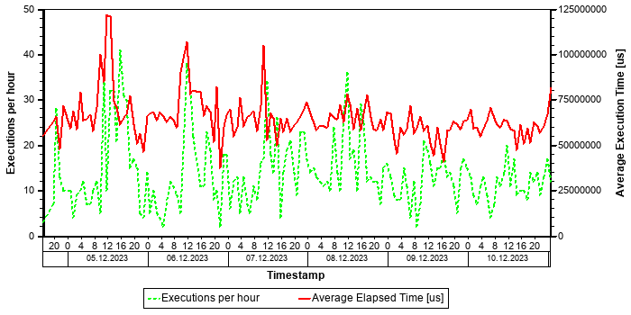

Statement History (All Thread Samples)
The following graph shows the number of threads, both for state "Running" and for all other thread states. Threads in state "Running" are responsible for the CPU consumption due to the statements. Non-running threads could be "idle", but might also indicate network or I/O issues or locking situations.
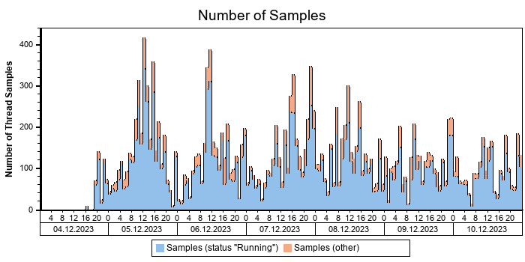

Statement History (Thread Sample 'Running')
The following graph shows the number of observed thread samples (in state "running") related to this SQL statement together with the contribution of those samples to all thread samples (in state "running") active in the system.
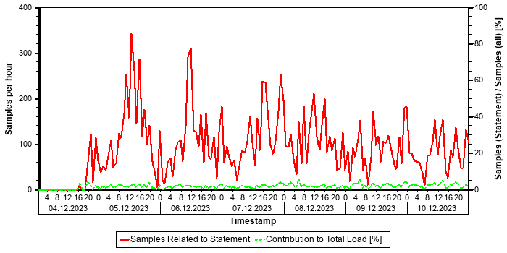

Correlation with Index Server Resource Consumption
The distribution of thread samples with the status "Running" correlates strongly with the overall CPU or memory consumption of the system. Such a correlation indicates that this statement might be responsible for peaks in the memory or CPU consumption.
Distiribution | Correlation Coefficient | Comment
CPU consumption index server(s) - Threads (running) from this SQL statement | 0,73 | strong correlation
Memory consumption index server(s) - Threads (running) from this SQL Statement | 0,56 | strong correlation

Tables
In the following, the tables involved in the SQL statement are listed (maximum of 20), sorted by the number of records.
Table Name | Schema Name | Table Type | Partition Type | Number of Records | Host
A915 | SAPPRD | COLUMN | Table not partitioned | 93.498.956 | tsls4proddbh

Statement used for Buffer Loading
Table
A915

The comment /* Buffer Loading */ in the statement text shows that this SQL statement was issued to copy information from the table listed above to the table buffer. A table should be loaded only rarely and the related SQL statement should not play an important role in a productive system. This statement might be executed frequently if the table is either invalidated very often or the table is displaced from the table buffer because the configuration of the table buffer is too small.
Recommendation: In order to check whether the buffering settings for this table are adequate, check the table statistics of this table in transaction ST10 (see SAP Note 1011158 and SAP Note 2457204). In order to check the setting for the table buffer, check the buffer statistics in ST02 for the different ABAP instances (see SAP Note 2442188).
If the buffer settings are not adequate, adjust the buffer settings, or un-buffer the table. If the configuration of the table buffer is too small and sufficient physical memory is available on the host, increase the size of the table buffer.

Origin of SQL Statement
The following table shows details of the applications responsible for the statement. This information is based on the information provided by SAP HANA in the "application source" connected to the statement in the "thread samples" or the list of "prepared" or "active" statements, and is not necessarily complete.
SID | Transaction / Jobaname | Report | Line | Last Changed on: | SAP Coding | Application Component | Description
PRD | /IRM/LAUNCHPAD | LV61ZU01 | 938 | 30.01.2017 |  | SD-BF-PR | Pricing and Conditions
PRD | Auto Delivery of 00000015562624 | LV61ZU01 | 938 | 30.01.2017 |  | SD-BF-PR | Pricing and Conditions
PRD | Auto Delivery of 00000015562754 | LV61ZU01 | 938 | 30.01.2017 |  | SD-BF-PR | Pricing and Conditions
PRD | Auto Delivery of 00000015563097 | LV61ZU01 | 938 | 30.01.2017 |  | SD-BF-PR | Pricing and Conditions
PRD | Auto Delivery of 00000015563367 | LV61ZU01 | 938 | 30.01.2017 |  | SD-BF-PR | Pricing and Conditions
PRD | Auto Delivery of 00000015563375 | LV61ZU01 | 938 | 30.01.2017 |  | SD-BF-PR | Pricing and Conditions
PRD | Auto Delivery of 00000015563460 | LV61ZU01 | 938 | 30.01.2017 |  | SD-BF-PR | Pricing and Conditions
PRD | Auto Delivery of 00000015563919 | LV61ZU01 | 938 | 30.01.2017 |  | SD-BF-PR | Pricing and Conditions
PRD | Auto Delivery of 00000015564299 | LV61ZU01 | 938 | 30.01.2017 |  | SD-BF-PR | Pricing and Conditions
PRD | Auto Delivery of 00000015564353 | LV61ZU01 | 938 | 30.01.2017 |  | SD-BF-PR | Pricing and Conditions
PRD | Auto Delivery of 00000015564397 | LV61ZU01 | 938 | 30.01.2017 |  | SD-BF-PR | Pricing and Conditions

Top Statements (Maximal Memory)
This section shows the top statements according to maximal memory consumption of a single execution. The data is obtained from the SQL PLAN CACHE.
See the following table for details of the selection:
Database Start | 15.10.2025 -- 08:03:55
Data Collection | 11.10.2025 -- 06:41:29
Analysis Type | Analysis of Plan Cache
Data Source | M_SQL_PLAN_CACHE

The selected statements - identified by their "Statement Hash" - are listed in the following table. Further details of these statements can be found in the subsections.
Statement Hash | Number of Executions | Time / Execution [us] | Records / Execution | Memory / Execution [MB] | Maximum Memory [MB]
3ea62d41801822a39de258aaffcaecad | 13 | 110.023.805,5 | 5.119,8 | 78.758,1 | 512.000,0
ea81f47ec13795eef6bb0c792e6437ee | 348 | 58.500.724,7 | 7.847,4 | 21.128,5 | 511.999,8
723069d1b8560a3760f739c79d41c9a5 | 32 | 12.497.620,9 | 5.508,6 | 16.251,0 | 511.947,6
fa17a80f91c9a9b0481bca7fbaae941d | 1 | 1.136.498.956,0 | 56.155.067,0 | 344.903,5 | 344.903,5
323cae7ebf5dc71bce8ba1bf0eba2025 | 26 | 67.744.388,5 | 159,4 | 58.485,1 | 342.490,8

SQL Statement 3ea62d41801822a39de258aaffcaecad
SELECT
"MSPR" . "MATNR" , "MSPR" . "WERKS" , "MSPR" . "LGORT" , "MSPR" . "CHARG" , "MSPR" . "SOBKZ" , "MSPR" . "PSPNR" , "MSSQ" . "KZBWS" , SUM( "MSPR" . "PRLAB" ) "LABST" , SUM( "MSPR" . "PRINS" ) "INSME" , SUM( "MSPR" . "PRSPE" ) "SPEME" , SUM("MSPR" . "PREIN" ) "EINME" , SUM( "MSPR" . "/CWM/PRLAB" ) "/CWM/LABST" , SUM( "MSPR" . "/CWM/PRINS" ) "/CWM/INSME" , SUM( "MSPR" . "/CWM/PRSPE" ) "/CWM/SPEME" , SUM( "MSPR" . "/CWM/PREIN" ) "/CWM/EINME" , "MARA" . "/CWM/VALUM" "/CWM/VALUM", "MARA" . "/CWM/XCWMAT" "/CWM/XCWMAT" , "MCHA" . "BWTAR"
FROM
/* Entity name: NSDM_E_MSPR */ "NSDM_V_MSPR" "MSPR" INNER JOIN /* Entity name: NSDM_E_MSSQ_DIFF */ "NSDM_V_MSSQ_DIFF" "MSSQ" ON "MSPR" . "MANDT" = "MSSQ" . "MANDT" AND "MSPR" . "MATNR" = "MSSQ" . "MATNR" AND "MSPR" . "WERKS" = "MSSQ" . "WERKS" AND "MSPR" . "SOBKZ" = "MSSQ" . "SOBKZ" AND "MSPR" . "PSPNR" = "MSSQ" . "PSPNR" INNER JOIN "V_MARC_MD" "MARC" ON "MSPR" . "MANDT" = "MARC" . "MANDT" AND "MARC" . "MATNR" = "MSSQ" . "MATNR" AND "MARC" . "WERKS" = "MSSQ" . "WERKS" INNER JOIN "MARA" ON "MSPR" . "MANDT" = "MARA" . "MANDT" AND "MARA" . "MATNR" = "MSSQ" . "MATNR" LEFT OUTER JOIN "MCHA" ON "MSPR" . "MANDT" = "MCHA" . "MANDT" AND "MCHA" . "MATNR" = "MSPR" . "MATNR" AND "MCHA" . "WERKS" = "MSPR" . "WERKS" AND "MCH
A" . "CHARG" = "MSPR" . "CHARG"
WHERE
"MSPR" . "MANDT" = ? AND "MSPR" . "WERKS" = ? AND ( 1 = 1 OR 1 = 1 OR 1 = 1 OR 1 = 1 OR 1 = 1 OR 1 = 1 OR 1 = 1 OR 1 = 1
)
GROUP BY
"MSPR" . "MATNR" , "MSPR" . "WERKS" , "MSPR" . "LGORT" , "MSPR" . "CHARG" , "MSPR" . "SOBKZ" , "MSPR" . "PSPNR" , "MSSQ" . "KZBWS" , "MCHA" . "BWTAR" , "MARA" . "/CWM/VALUM" , "MARA" . "/CWM/XCWMAT" WITH RANGE_RESTRICTION('CURRENT')
Statement Impact
Indicator | Value
Contribution to Total CPU Load [%] | 0,00
Maximal CPU Consumption per Hour [%] ( 06.10.2025 between 13:00 and 14:00 ) | 0,00
Maximal Memory Consumption [%] | 5,59

Analysis of Where Clause
Table | Field | Operator | SCANNED RECORD COUNT | INDEX LOOKUP COUNT
? | 1 | =
MSPR | MANDT | = | 291.068 | 149
MSPR | WERKS | = | 301.390.987 | 2.727

Time Consumption
The following table gives an overview of the time consumption of the analyzed SQL statement.
Activity | Total Time [s] | Average Time [us] | Minimal Time [us] | Maximal Time [us]
TOTAL EXECUTION | 1.428 | 109.879.057 | 8.132 | 736.419.413
PREPARATION | 2 | 144.749
LOCK DURATION | 0 | 0

Memory Consumption
The following table provides an overview of the memory consumption of the analyzed SQL statement as obtained from the monitoring view M_SQL_PLAN_STATISTICS (or – if not yet available – M_SQL_PLAN_CACHE), that is, without taking a specific time interval into account.
Activity | Average Memory [MB] | Minimal Memory [MB] | Maximal Memory [MB]
EXECUTION_MEMORY_SIZE | 78.758,1 | 5,1 | 512.000,0

High Memory Consumption
The memory consumption of this statement is relatively high when compared with the minimum "effective allocation limit" of the index server(s) as obtained from M_SERVICE_MEMORY. See the following table for details. Note that the excessive memory consumption of a single statement might impact the stability of the whole SAP HANA system. See SAP Note 1999997 for details and for an option to restrict the maximum memory allocated by a single statement.
(Minimal) Effective Allocation Limit [GB] | 8.937,3
Maximal Statement Size / Effective Allocation Limit [%] | 5,6
Average Statement Size / Effective Allocation Limit [%] | 0,9

Statement History (Thread Sample 'Running')
The following graph shows the number of observed thread samples (in state "running") related to this SQL statement together with the contribution of those samples to all thread samples (in state "running") active in the system.
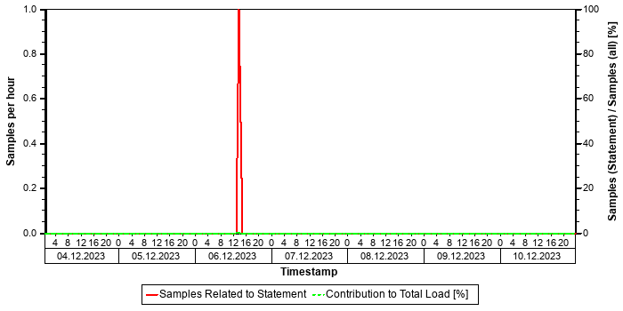

Tables
In the following, the tables involved in the SQL statement are listed (maximum of 20), sorted by the number of records.
Table Name | Schema Name | Table Type | Partition Type | Number of Records | Host
MATDOC_EXTRACT | SAPPRD | COLUMN | Table not partitioned | 313.982.684 | tsls4proddbh
MCHA | SAPPRD | COLUMN | Table not partitioned | 89.451.778 | tsls4proddbh
MARC | SAPPRD | COLUMN | Table not partitioned | 9.458.859 | tsls4proddbh
MARA | SAPPRD | COLUMN | Table not partitioned | 4.170.642 | tsls4proddbh
MSPR | SAPPRD | COLUMN | Table not partitioned | 1.389.441 | tsls4proddbh

Origin of SQL Statement
The following table shows details of the applications responsible for the statement. This information is based on the information provided by SAP HANA in the "application source" connected to the statement in the "thread samples" or the list of "prepared" or "active" statements, and is not necessarily complete.
SID | Transaction / Jobaname | Report | Line | Last Changed on: | SAP Coding | Application Component | Description
PRD | MB52 | RM07MLBS | 4.232 | 08.08.2025 |  | MM-IM | Inventory Management
PRD | RM07MLBS | RM07MLBS | 4.232 | 08.08.2025 |  | MM-IM | Inventory Management

SQL Statement ea81f47ec13795eef6bb0c792e6437ee
SELECT
"MSPR" . "MATNR" , "MSPR" . "WERKS" , "MSPR" . "LGORT" , "MSPR" . "CHARG" , "MSPR" . "SOBKZ" , "MSPR" . "PSPNR" , "MSSQ" . "KZBWS" , SUM( "MSPR" . "PRLAB" ) "LABST" , SUM( "MSPR" . "PRINS" ) "INSME" , SUM( "MSPR" . "PRSPE" ) "SPEME" , SUM("MSPR" . "PREIN" ) "EINME" , SUM( "MSPR" . "/CWM/PRLAB" ) "/CWM/LABST" , SUM( "MSPR" . "/CWM/PRINS" ) "/CWM/INSME" , SUM( "MSPR" . "/CWM/PRSPE" ) "/CWM/SPEME" , SUM( "MSPR" . "/CWM/PREIN" ) "/CWM/EINME" , "MARA" . "/CWM/VALUM" "/CWM/VALUM", "MARA" . "/CWM/XCWMAT" "/CWM/XCWMAT" , "MCHA" . "BWTAR"
FROM
/* Entity name: NSDM_E_MSPR */ "NSDM_V_MSPR" "MSPR" INNER JOIN /* Entity name: NSDM_E_MSSQ_DIFF */ "NSDM_V_MSSQ_DIFF" "MSSQ" ON "MSPR" . "MANDT" = "MSSQ" . "MANDT" AND "MSPR" . "MATNR" = "MSSQ" . "MATNR" AND "MSPR" . "WERKS" = "MSSQ" . "WERKS" AND "MSPR" . "SOBKZ" = "MSSQ" . "SOBKZ" AND "MSPR" . "PSPNR" = "MSSQ" . "PSPNR" INNER JOIN "V_MARC_MD" "MARC" ON "MSPR" . "MANDT" = "MARC" . "MANDT" AND "MARC" . "MATNR" = "MSSQ" . "MATNR" AND "MARC" . "WERKS" = "MSSQ" . "WERKS" INNER JOIN "MARA" ON "MSPR" . "MANDT" = "MARA" . "MANDT" AND "MARA" . "MATNR" = "MSSQ" . "MATNR" LEFT OUTER JOIN "MCHA" ON "MSPR" . "MANDT" = "MCHA" . "MANDT" AND "MCHA" . "MATNR" = "MSPR" . "MATNR" AND "MCHA" . "WERKS" = "MSPR" . "WERKS" AND "MCH
A" . "CHARG" = "MSPR" . "CHARG"
WHERE
"MSPR" . "MANDT" = ? AND "MSPR" . "WERKS" = ? AND ( ( "MSPR" . "PRLAB" > ? OR "MSPR" . "PRLAB" < ? ) OR ( "MSPR" . "PRINS" > ? OR "MSPR" . "PRINS" < ? ) OR ( "MSPR" . "PRSPE" > ? OR "MSPR" . "PRSPE" < ? ) OR ( "MSPR" . "PREIN" > ? OR "MSPR" . "PREIN" < ? ) OR ( "MSPR" . "/CWM/PRLAB" > ? OR "MSPR" . "/CWM/PRLAB" < ? ) OR ( "MSPR" . "/CWM/PRINS" > ? OR "MSPR". "/CWM/PRINS" < ? ) OR ( "MSPR" . "/CWM/PRSPE" > ? OR "MSPR" . "/CWM/PRSPE" < ? ) OR ( "MSPR" . "/CWM/PREIN" > ? OR "MS
PR" . "/CWM/PREIN" < ? ) )
GROUP BY
"MSPR" . "MATNR" , "MSPR" . "WERKS" , "MSPR" . "LGORT" , "MSPR" . "CHARG" , "MSPR" . "SOBKZ" , "MSPR" . "PSPNR" , "MSSQ" . "KZBWS" , "MCHA" . "BWTAR" , "MARA" . "/CWM/VALUM" , "MARA" . "/CWM/XCWMAT" WITH RANGE_RESTRICTION('CURRENT')
Statement Impact
Indicator | Value
Contribution to Total CPU Load [%] | 0,03
Maximal CPU Consumption per Hour [%] ( 08.10.2025 between 08:00 and 09:00 ) | 0,13
Maximal Memory Consumption [%] | 5,59

Analysis of Where Clause
Table | Field | Operator | SCANNED RECORD COUNT | INDEX LOOKUP COUNT
MSPR | /CWM/PREIN | < | 0 | 0
MSPR | /CWM/PREIN | > | 0 | 0
MSPR | /CWM/PRINS | < | 0 | 0
MSPR | /CWM/PRINS | > | 0 | 0
MSPR | /CWM/PRLAB | < | 0 | 0
MSPR | /CWM/PRLAB | > | 0 | 0
MSPR | /CWM/PRSPE | < | 0 | 0
MSPR | /CWM/PRSPE | > | 0 | 0
MSPR | MANDT | = | 291.068 | 149
MSPR | PREIN | < | 0 | 0
MSPR | PREIN | > | 0 | 0
MSPR | PRINS | < | 0 | 0
MSPR | PRINS | > | 0 | 0
MSPR | PRLAB | < | 0 | 0
MSPR | PRLAB | > | 0 | 0
MSPR | PRSPE | < | 0 | 0
MSPR | PRSPE | > | 0 | 0
MSPR | WERKS | = | 301.390.987 | 2.727

Time Consumption
The following table gives an overview of the time consumption of the analyzed SQL statement.
Activity | Total Time [s] | Average Time [us] | Minimal Time [us] | Maximal Time [us]
TOTAL EXECUTION | 20.301 | 58.337.118 | 6.364 | 962.433.920
PREPARATION | 57 | 163.607
LOCK DURATION | 0 | 0

Memory Consumption
The following table provides an overview of the memory consumption of the analyzed SQL statement as obtained from the monitoring view M_SQL_PLAN_STATISTICS (or – if not yet available – M_SQL_PLAN_CACHE), that is, without taking a specific time interval into account.
Activity | Average Memory [MB] | Minimal Memory [MB] | Maximal Memory [MB]
EXECUTION_MEMORY_SIZE | 21.128,5 | 0,2 | 511.999,8

High Memory Consumption
The memory consumption of this statement is relatively high when compared with the minimum "effective allocation limit" of the index server(s) as obtained from M_SERVICE_MEMORY. See the following table for details. Note that the excessive memory consumption of a single statement might impact the stability of the whole SAP HANA system. See SAP Note 1999997 for details and for an option to restrict the maximum memory allocated by a single statement.
(Minimal) Effective Allocation Limit [GB] | 8.937,3
Maximal Statement Size / Effective Allocation Limit [%] | 5,6
Average Statement Size / Effective Allocation Limit [%] | 0,2

Statement History (Thread Sample 'Running')
The following graph shows the number of observed thread samples (in state "running") related to this SQL statement together with the contribution of those samples to all thread samples (in state "running") active in the system.
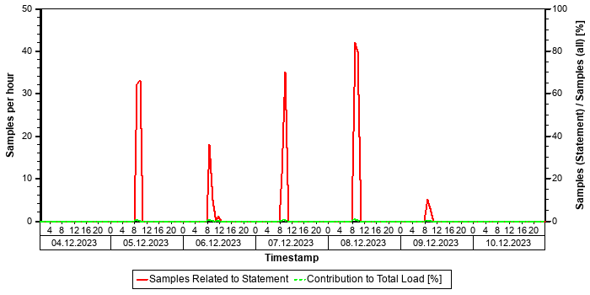

Tables
In the following, the tables involved in the SQL statement are listed (maximum of 20), sorted by the number of records.
Table Name | Schema Name | Table Type | Partition Type | Number of Records | Host
MATDOC_EXTRACT | SAPPRD | COLUMN | Table not partitioned | 313.982.684 | tsls4proddbh
MCHA | SAPPRD | COLUMN | Table not partitioned | 89.451.778 | tsls4proddbh
MARC | SAPPRD | COLUMN | Table not partitioned | 9.458.859 | tsls4proddbh
MARA | SAPPRD | COLUMN | Table not partitioned | 4.170.642 | tsls4proddbh
MSPR | SAPPRD | COLUMN | Table not partitioned | 1.389.441 | tsls4proddbh

Origin of SQL Statement
The following table shows details of the applications responsible for the statement. This information is based on the information provided by SAP HANA in the "application source" connected to the statement in the "thread samples" or the list of "prepared" or "active" statements, and is not necessarily complete.
SID | Transaction / Jobaname | Report | Line | Last Changed on: | SAP Coding | Application Component | Description
PRD | MB52 | RM07MLBS | 4.232 | 08.08.2025 |  | MM-IM | Inventory Management
PRD | RM07MLBS | RM07MLBS | 4.232 | 08.08.2025 |  | MM-IM | Inventory Management

SQL Statement 723069d1b8560a3760f739c79d41c9a5
SELECT
"A" . "BUKRS" , "A" . "HKONT" , "A" . "WAERS" , "A" . "XBLNR" , "A" . "MONAT" , "A" . "SHKZG" , "A" . "GSBER" , "A" . "DMBTR" , "A" . "WRBTR" , "A" . "KOSTL" , "A" . "ZFBDT" , "A" . "BDIFF" , "A" . "BDIF2" , "A" . "VBUND" , "A" . "PSWSL" ,"A" . "WVERW" , "A" . "DMBE2" , "A" . "DMBE3" , "A" . "BDIF3" , "A" . "XRAGL" , "A" . "PROJK" , "A" . "XARCH" , "A" . "PSWBT" , "A" . "XNEGP" , "A" . "RFZEI" , "A" . "CCBTC" , "A" . "XREF3" , "A" . "BUPLA" , "A" . "BEWAR" , "A" . "IMKEY" ,"A" . "GRANT_NBR" , "A" . "FKBER" , "A" . "GEBER" , "A" . "PPRCT" , "A" . "BUZID" , "A" . "UZAWE" , "A" . "PGEBER" , "A" . "PGRANT_NBR" , "A" . "RE_ACCOUNT" , "A" . "KIDNO" , "A" . "GKART" , "A" . "LOGSYSTEM_SENDER" , "A" . "BELNR_SENDER" , "A" . "GJAHR_SENDER" , "A" . "BUZEI_SENDER" , "B" . "RCLNT" , "LD_REP" . "RLDNR" , "B" . "RBUKRS" , "B" . "GJAHR" , "B" . "BELNR" , "B" . "DOCLN" , "B" . "RYEAR" , "B" . "RRCTY" , "B" . "RMVCT" , "B" . "BTTYPE" , "B" . "AWTYP" , "B" . "AWSYS" , "B" . "AWORG" , "B" . "AWREF" , "B" . "AWITEM" , "B" . "AWITGRP" , "B" . "XREVERSING" , "B" . "XREVERSED" , "B" ."XTRUEREV" , "B" . "AWTYP_REV" , "B" . "AWORG_REV" , "B" . "AWREF_REV" , "B" . "XSETTLING" , "B" . "XSETTLED" , "B" . "PREC_AWTYP" , "B" . "PREC_AWSYS" , "B" . "PREC_AWORG" , "B" . "PREC_AWREF" , "B" . "PREC_AWITEM" , "B" . "PREC_SUBTA" , "B" . "PREC_AWMULT" , "B" . "PREC_BUKRS" , "B" . "PREC_GJAHR" , "B" . "PREC_BELNR" , "B" . "PREC_DOCLN" , "B" . "SRC_AWTYP" , "B" . "SRC_AWSYS" , "B" . "SRC_AWORG" , "B" . "SRC_AWREF" , "B" . "SRC_AWITEM" , "B" . "SRC_AWSUBIT" , "B" . "XCOMMITMENT" , "B" . "RTCUR" , "B" . "RWCUR" , "B" . "RHCUR" , "B" . "RKCUR" , "B" . "RFCCUR" , "B" . "ROCUR" , "B" . "RVCUR" , "B" . "RBCUR" , "B" . "RCCUR" , "B" . "RDCUR" , "B" . "RECUR" , "B" . "RFCUR" , "B" . "RGCUR" , "B" . "RCO_OCUR" , "B" . "RUNIT" , "B" . "RVUNIT" , "B" . "QUNIT1" , "B" . "QUNIT2" , "B" . "QUNIT3" , "B" . "RACCT" , "B" . "RCNTR" , "B" ."PRCTR" , "B" . "RFAREA" , "B" . "RBUSA" , "B" . "KOKRS" , "B" . "SEGMENT" , "B" . "SCNTR" , "B" . "PPRCTR" , "B" . "SFAREA" , "B" . "SBUSA" , "B" . "RASSC" , "B" . "PSEGMENT" , "B" . "TSL" , "B" . "WSL" , "B" . "HSL" , "B" . "KSL" , "B" ."FCSL" , "B" . "OSL" , "B" . "VSL" , "B" . "BSL" , "B" . "CSL" , "B" . "DSL" , "B" . "ESL" , "B" . "FSL" , "B" . "GSL" , "B" . "KFSL" , "B" . "PSL" , "B" . "PFSL" , "B" . "CO_OSL" , "B" . "MSL" , "B" . "MFSL" , "B" . "VMSL" , "B" . "VMFSL", "B" . "QUANT1" , "B" . "QUANT2" , "B" . "QUANT3" , "B" . "DRCRK" , "B" . "POPER" , "B" . "PERIV" , "B" . "FISCYEARPER" , "B" . "BUDAT" , "B" . "BLDAT" , "B" . "BLART" , "B" . "BUZEI" , "B" . "ZUONR" , "B" . "BSCHL" , "B" . "BSTAT" , "B" . "LINETYPE" , "B" . "KTOSL" , "B" . "SLALITTYPE" , "B" . "XSPLITMOD" , "B" . "USNAM" , "B" . "TIMESTAMP" , "B" . "EPRCTR" , "B" . "RHOART" , "B" . "GLACCOUNT_TYPE" , "B" . "KTOPL" , "B" . "LOKKT" , "B" . "KTOP2" , "B" . "REBZG" , "B" . "REBZJ" , "B" . "REBZZ" , "B" . "REBZT" , "B" . "RBEST" , "B" . "EBELN" , "B" . "EBELP" , "B" . "ZEKKN" , "B" . "SGTXT" , "B" . "KDAUF" , "B" . "KDPOS" , "B" . "MATNR" , "B" . "WERKS" , "B" . "KUNNR" , "B" . "FBUDA" , "B" . "PEROP_BEG" , "B" ."PEROP_END" , "B" . "COCO_NUM" , "B" . "KOART" , "B" . "UMSKZ" , "B" . "MWSKZ" , "B" . "HBKID" , "B" . "HKTID" , "B" . "VALUT" , "B" . "XOPVW" , "B" . "AUGDT" , "B" . "AUGBL" , "B" . "AUGGJ" , "B" . "AFABE" , "B" . "ANLN1" , "B" . "ANLN2" , "B" . "BZDAT" , "B" . "ANBWA" , "B" . "MOVCAT" , "B" . "DEPR_PERIOD" , "B" . "ANLGR" , "B" . "ANLGR2" , "B" . "KALNR" , "B" . "KZBWS" , "B" . "XOBEW" , "B" . "SOBKZ" , "B" . "MAT_KDAUF" , "B" . "MAT_KDPOS" , "B" . "MAT_PS_POSID" , "B" . "MAT_LIFNR" , "B" . "BWTAR" , "B" . "BWKEY" , "B" . "BUKRS_SENDER" , "B" . "RACCT_SENDER" , "B" . "ACCAS_SENDER" , "B" . "ACCASTY_SENDER" , "B" . "HKGRP" , "B" . "CO_BELKZ" , "B" . "BELTP" , "B" . "MUVFLG" , "B" . "GKONT" , "B" . "GKOAR" , "B" . "ERLKZ" , "B" . "PERNR" , "B" . "SCOPE" , "B" . "PBUKRS" , "B" . "PSCOPE" , "B" . "AUFNR_ORG" , "B" . "UKOSTL" , "B" . "ULSTAR" , "B" . "UPRZNR" , "B" . "UPRCTR" , "B" . "ACCAS" , "B" . "ACCASTY" , "B" . "LSTAR" , "B" . "AUFNR" , "B" ."AUTYP" , "B" . "PS_POSID" , "B" . "PS_PSPID" , "B" . "NPLNR" , "B" . "NPLNR_VORGN" , "B" . "PRZNR" , "B" . "KSTRG" , "B" . "BEMOT" , "B" . "RSRCE" , "B" . "QMNUM" , "B" . "SERVICE_DOC_TYPE" , "B" . "SERVICE_DOC_ID" , "B" . "SERVICE_DOC_ITEM_ID" , "B" . "SERVICE_CONTRACT_TYPE" , "B" . "SERVICE_CONTRACT_ID" , "B" . "SERVICE_CONTRACT_ITEM_ID" , "B" . "ERKRS" , "B" . "PACCAS" , "B" . "PACCASTY" , "B" . "PLSTAR" , "B" . "PAUFNR" , "B" . "PAUTYP" , "B" . "PPS_PSP_PNR" , "B" . "PPS_POSID" , "B" . "PPS_PRJ_PNR" , "B" . "PPS_PSPID" , "B" . "PKDAUF" , "B" . "PKDPOS" , "B" . "PNPLNR" , "B" . "PNPLNR_VORGN" , "B" . "PPRZNR" , "B" . "PKSTRG" , "B" . "PSERVICE_DOC_TYPE" , "B" . "PSERVICE_DOC_ID" , "B" . "PSERVICE_DOC_ITEM_ID" , "B" . "OVERTIMECAT" , "B" . "WORK_ITEM_ID" , "B" . "ARBID" , "B" . "VORNR" , "B" . "AUFPS" , "B" . "UVORN" , "B" ."EQUNR" , "B" . "TPLNR" , "B" . "ISTRU" , "B" . "ILART" , "B" . "PLKNZ" ,
...
Statement Impact
Indicator | Value
Contribution to Total CPU Load [%] | 0,00
Maximal CPU Consumption per Hour [%] ( 06.10.2025 between 19:00 and 20:00 ) | 0,04
Maximal Memory Consumption [%] | 5,59

Time Consumption
The following table gives an overview of the time consumption of the analyzed SQL statement.
Activity | Total Time [s] | Average Time [us] | Minimal Time [us] | Maximal Time [us]
TOTAL EXECUTION | 339 | 10.592.095 | 17.545 | 304.843.375
PREPARATION | 61 | 1.905.526
LOCK DURATION | 0 | 0

Memory Consumption
The following table provides an overview of the memory consumption of the analyzed SQL statement as obtained from the monitoring view M_SQL_PLAN_STATISTICS (or – if not yet available – M_SQL_PLAN_CACHE), that is, without taking a specific time interval into account.
Activity | Average Memory [MB] | Minimal Memory [MB] | Maximal Memory [MB]
EXECUTION_MEMORY_SIZE | 16.251,0 | 1,7 | 511.947,6

High Memory Consumption
The memory consumption of this statement is relatively high when compared with the minimum "effective allocation limit" of the index server(s) as obtained from M_SERVICE_MEMORY. See the following table for details. Note that the excessive memory consumption of a single statement might impact the stability of the whole SAP HANA system. See SAP Note 1999997 for details and for an option to restrict the maximum memory allocated by a single statement.
(Minimal) Effective Allocation Limit [GB] | 8.937,3
Maximal Statement Size / Effective Allocation Limit [%] | 5,6
Average Statement Size / Effective Allocation Limit [%] | 0,2

Statement History (Thread Sample 'Running')
The following graph shows the number of observed thread samples (in state "running") related to this SQL statement together with the contribution of those samples to all thread samples (in state "running") active in the system.
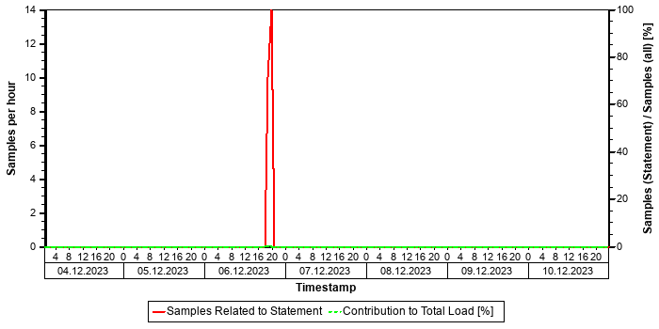

Tables
In the following, the tables involved in the SQL statement are listed (maximum of 20), sorted by the number of records.
Table Name | Schema Name | Table Type | Partition Type | Number of Records | Host
ACDOCA | SAPPRD | COLUMN | HASH | 3.570.094.832 | tsls4proddbh
BSEG | SAPPRD | COLUMN | Table not partitioned | 1.548.827.352 | tsls4proddbh
BKPF | SAPPRD | COLUMN | Table not partitioned | 452.194.147 | tsls4proddbh
BSAS_BCK | SAPPRD | COLUMN | Table not partitioned | 194.087.107 | tsls4proddbh
FINSC_LEDGER_REP | SAPPRD | COLUMN | Table not partitioned | 26 | tsls4proddbh

Origin of SQL Statement
The following table shows details of the applications responsible for the statement. This information is based on the information provided by SAP HANA in the "application source" connected to the statement in the "thread samples" or the list of "prepared" or "active" statements, and is not necessarily complete.
SID | Transaction / Jobaname | Report | Line | Last Changed on: | SAP Coding | Application Component | Description
PRD | FAGLB03 | LFAGL_ITEMS_SELECTU07 | 402 | 15.01.2020 |  | FI-GL-IS | Information System
PRD | FAGL_ACCOUNT_BALANCE | LFAGL_ITEMS_SELECTU07 | 402 | 15.01.2020 |  | FI-GL-IS | Information System

SQL Statement fa17a80f91c9a9b0481bca7fbaae941d
SELECT
"HEAD" . "BUKRS" , "ACDOCA" . "BELNR" , "ACDOCA" . "BSTAT" , "ACDOCA" . "UMSKZ" , "HEAD" . "XBLNR" , "ACDOCA" . "BLART", "ACDOCA" . "RBUSA" "GSBER" , "ACDOCA" . "ZUONR" , "ACDOCA" . "GJAHR" , "HEAD" . "MONAT" , "ACDOCA" . "BLDAT" , "ACDOCA" . "BUDAT" , "ACDOCA" . "DRCRK" "SHKZG" , "ACDOCA" . "HSL" "BWWRT" , "ACDOCA" . "RHCUR" "HWAER" , "ACDOCA" . "WSL" "WRBTR" , "ACDOCA" . "RWCUR" "WAERS" , "ACDOCA" . "LIFNR" , "ACDOCA" . "KUNNR" , "ACDOCA" . "RASSC" "VBUND" , "ACDOCA" . "SGTXT" , "HEAD" . "BKTXT" , "ACDOCA" . "KTOSL" , "ACDOCA" . "REBZG" , "ACDOCA" . "RACCT" "HKONT" , "ACDOCA" . "GKONT" , "ACDOCA" . "BSCHL" , "HEAD" . "STBLG" , "ACDOCA" . "AUGBL" , "ACDOCA" . "AUGDT" , "HEAD" . "CPUDT" , "HEAD" . "CPUTM" , "ACDOCA" . "BUZEI" , "ACDOCA" . "DOCLN" "CUSTOM_1" , "ACDOCA" . "KOART" , "ACDOCA" . "MWSKZ" , "ACDOCA" . "PS_PSP_PNR" "PROJK" , "ACDOCA" . "NPLNR" "NPLNR" , "ACDOCA" . "MATNR" , "ACDOCA" . "AWREF" , "ACDOCA" . "AWORG" , "ACDOCA" . "EBELN" ,"ACDOCA" . "EBELP" , "ACDOCA" . "GKOAR"
FROM
"ACDOCA" LEFT OUTER JOIN "BKPF" "HEAD" ON "ACDOCA" . "RCLNT" = "HEAD" . "MANDT" AND "ACDOCA" . "RBUKRS" = "HEAD" . "BUKR
S" AND "ACDOCA" . "BELNR" = "HEAD" . "BELNR" AND "ACDOCA" . "GJAHR" = "HEAD" . "GJAHR"
WHERE
"ACDOCA" . "RCLNT" = ? AND "ACDOCA" . "RLDNR" = N'0L' AND NOT ( "ACDOCA" . "BLART" = ? ) AND ( "ACDOCA" . "AUGDT" > ? OR "ACDOCA" . "AUGDT" = ? ) WITH RANGE_RESTRICTION('CURRENT')
Statement Impact
Indicator | Value
Contribution to Total CPU Load [%] | 0,01
Maximal CPU Consumption per Hour [%] ( 07.10.2025 between 13:00 and 14:00 ) | 0,28
Maximal Memory Consumption [%] | 3,77

Analysis of Where Clause
Table | Field | Operator | SCANNED RECORD COUNT | INDEX LOOKUP COUNT
ACDOCA | AUGDT | = | 12.553.799.417.252 | 0
ACDOCA | AUGDT | > | 12.553.799.417.252 | 0
ACDOCA | BLART | = | 167.273.767.653 | 0
ACDOCA | RCLNT | = | 19.225.649.307 | 0
ACDOCA | RLDNR | = | 5.322.555.019.223 | 4.763

Time Consumption
The following table gives an overview of the time consumption of the analyzed SQL statement.
Activity | Total Time [s] | Average Time [us] | Minimal Time [us] | Maximal Time [us]
TOTAL EXECUTION | 1.135 | 1.135.459.704 | 1.135.459.704 | 1.135.459.704
PREPARATION | 1 | 1.039.252
LOCK DURATION | 0 | 0

Memory Consumption
The following table provides an overview of the memory consumption of the analyzed SQL statement as obtained from the monitoring view M_SQL_PLAN_STATISTICS (or – if not yet available – M_SQL_PLAN_CACHE), that is, without taking a specific time interval into account.
Activity | Average Memory [MB] | Minimal Memory [MB] | Maximal Memory [MB]
EXECUTION_MEMORY_SIZE | 344.903,5 | 344.903,5 | 344.903,5

High Memory Consumption
The memory consumption of this statement is relatively high when compared with the minimum "effective allocation limit" of the index server(s) as obtained from M_SERVICE_MEMORY. See the following table for details. Note that the excessive memory consumption of a single statement might impact the stability of the whole SAP HANA system. See SAP Note 1999997 for details and for an option to restrict the maximum memory allocated by a single statement.
(Minimal) Effective Allocation Limit [GB] | 8.937,3
Maximal Statement Size / Effective Allocation Limit [%] | 3,8
Average Statement Size / Effective Allocation Limit [%] | 3,8

Statement History (Thread Sample 'Running')
The following graph shows the number of observed thread samples (in state "running") related to this SQL statement together with the contribution of those samples to all thread samples (in state "running") active in the system.
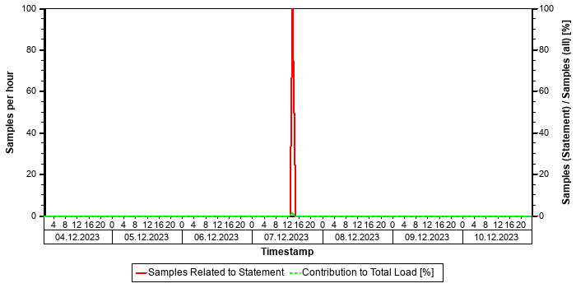

Tables
In the following, the tables involved in the SQL statement are listed (maximum of 20), sorted by the number of records.
Table Name | Schema Name | Table Type | Partition Type | Number of Records | Host
ACDOCA | SAPPRD | COLUMN | HASH | 3.570.094.832 | tsls4proddbh
BKPF | SAPPRD | COLUMN | Table not partitioned | 452.194.147 | tsls4proddbh

Origin of SQL Statement
The following table shows details of the applications responsible for the statement. This information is based on the information provided by SAP HANA in the "application source" connected to the statement in the "thread samples" or the list of "prepared" or "active" statements, and is not necessarily complete.
SID | Transaction / Jobaname | Report | Line | Last Changed on: | SAP Coding
PRD | ZFBL3N_BL_RP | ZMFAR_FBL3N_GRIR_SUB_TEST | 1.675 | 24.11.2025

SQL Statement 323cae7ebf5dc71bce8ba1bf0eba2025
SELECT
"MCHB" . "WERKS" "WERKS" , "MCHB" . "MATNR" "MATNR" , "VBAP" . "VGBEL" "SONO" , "VBAP" . "VGPOS" "SOITEM" , "EBAN" . "BANFN" "STRNO" , "EBAN" . "BNFPO" "STRITEM" , SUM( "MCHB" . "CLABS" ) "STK" , "MAKT" . "MAKTX" "MAKTX" , "MVKE" . "MVGR2""MVGR2" , "TVM2T" . "BEZEI" "BEZEI" , "VBAK" . "AUART" "AUART" , "EKPO" . "EBELN" "STONO" , "EKPO" . "EBELP" "STOITEM" , "EKPO" . "MENGE" "MENGE" , "VBAP" . "VBELN" "DONO" , "VBAP" . "POSNR" "DOITEM" , "VBAP" . "KWMENG" "KWMENG" , "VBAK" ."KUNNR" "KUNNR" , "KNA1" . "NAME1" "NAME1" , "EBAN" . "WERKS" "RCVPLNT" , "T001W" . "NAME1" "RCVDESC" , "KNA1" . "ORT01" "ORT01" , "VBAK" . "VKBUR" "VKBUR" , "ISDDOCPARTNERWAD" . "PERSONEXTERNALID" "EMPLOYEE" , "ISDDOCPARTNERWAD" . "PERSONFULLNAME" "EMPLOYEEFULLNAME"
FROM
/* Redirected table: MCHB */ "NSDM_V_MCHB" "MCHB" INNER JOIN "MAKT" ON "MCHB" . "MANDT" = "MAKT" . "MANDT" AND "MAKT" ."MATNR" = "MCHB" . "MATNR" INNER JOIN "MVKE" ON "MCHB" . "MANDT" = "MVKE" . "MANDT" AND "MVKE" . "MATNR" = "MAKT" . "MATNR" INNER JOIN "TVM2T" ON "MCHB" . "MANDT" = "TVM2T" . "MANDT" AND "TVM2T" . "MVGR2" = "MVKE" . "MVGR2" AND "TVM2T" . "SPRAS" = ? INNER JOIN "MARA" ON "MCHB" . "MANDT" = "MARA" . "MANDT" AND "MARA" . "MATNR" = "MCHB" . "MATNR" AND "MARA" ."MATKL" BETWEEN N'A' AND N'X' AND "MARA" . "MATNR" BETWEEN N'000000000000242533' AND N'000000000009999999' INNER JOIN /* Redirected table: MBEW */ "MBVMBEW" "MBEW" ON "MCHB" . "MANDT" = "MBEW" . "MANDT" AND "MBEW" . "MATNR" = "MCHB" . "MATNR" AND "MBEW" . "BWKEY" = "MCHB" . "WERKS" AND "MBEW" . "BKLAS" IN ( N'7021' , N'7061' , N'7093' ) LEFT OUTER JOIN "VEPVG" ON "MCHB" . "MANDT" = "VEPVG" . "MANDT" AND "VEPVG" . "VSTEL" = "MCHB" . "WERKS" AND "VEPVG" . "AUART" = N'ZDO' LEFTOUTER JOIN "VBAP" ON "MCHB" . "MANDT" = "VBAP" . "MANDT" AND "VBAP" . "VBELN" = "VEPVG" . "VBELN" AND "VBAP" . "MATNR" = "MCHB" . "MATNR" AND "VBAP" . "WERKS" = "MCHB" . "WERKS" LEFT OUTER JOIN "VBAK" ON "MCHB" . "MANDT" = "VBAK" . "MANDT"AND "VBAK" . "VBELN" = "VBAP" . "VGBEL" AND "VBAK" . "AUART" IN ( N'ZSO' , N'ZVCD' ) LEFT OUTER JOIN "KNA1" ON "MCHB" ."MANDT" = "KNA1" . "MANDT" AND "KNA1" . "KUNNR" = "VBAK" . "KUNNR" LEFT OUTER JOIN "ISDDOCPARTNERWAD" ON "MCHB" . "MANDT" = "ISDDOCPARTNERWAD" . "MANDT" AND "ISDDOCPARTNERWAD" . "SDDOCUMENT" = "VBAK" . "VBELN" AND "ISDDOCPARTNERWAD" . "PARTNERFUNCTION" = N'VE' LEFT OUTER JOIN "VETVG" ON "MCHB" . "MANDT" = "VETVG" . "MANDT" AND "VETVG" . "VSTEL" = "MCHB" . "WERKS" AND "VETVG" . "AUART" = N'ZWLL' LEFT OUTER JOIN "EBAN" ON "MCHB" . "MANDT" = "EBAN" . "MANDT" AND "EBAN" . "RESWK" = "MCHB" . "WERKS" AND "EBAN" . "MATNR" = "MCHB" . "MATNR" AND "EBAN" . "EBELN" = "VETVG" . "VBELN" AND "EBAN" . "BSART" = N'ZBTS' LEFT OUTER JOIN "EKPO" ON "MCHB" . "MANDT" = "EKPO" . "MANDT" AND "EKPO" . "EBELN" = "EBAN" . "EBELN" AND "EKPO" . "EBELP" = "EBAN" . "EBELP" LEFT OUTER JOIN "T001W" ON "MCHB" . "MANDT" = "T001W" . "MANDT" AND "T001W" . "WERKS"
= "EBAN" . "WERKS"
WHERE
"MCHB" . "MANDT" = ? AND "MCHB" . "WERKS" IN ( ? , ? ) AND "MVKE" . "MVGR2" IN ( ? , ? , ? , ? , ? , ? ) AND "MCHB" . "C
LABS" > CAST( 0 AS DECIMAL(13,3) )
GROUP BY
"MCHB" . "WERKS" , "MCHB" . "MATNR" , "VBAP" . "VGBEL" , "VBAP" . "VGPOS" , "EBAN" . "BANFN" , "EBAN" . "BNFPO" , "MAKT" . "MAKTX" , "MVKE" . "MVGR2" , "TVM2T" . "BEZEI" , "VBAK" . "AUART" , "EKPO" . "EBELN" , "EKPO" . "EBELP" , "EKPO" . "MENGE" , "VBAP" . "VBELN" , "VBAP" . "POSNR" , "VBAP" . "KWMENG" , "VBAK" . "KUNNR" , "KNA1" . "NAME1" , "EBAN" . "WERKS" , "T001W" . "NAME1" , "KNA1" . "ORT01" , "VBAK" . "VKBUR" , "ISDDOCPARTNERWAD" . "PERSONEXTERNALID" , "ISDDOCPARTNERWAD" . "PERSONFULLNAME" WITH RANGE_RESTRICTION('CURRENT')
Statement Impact
Indicator | Value
Contribution to Total CPU Load [%] | 0,03
Maximal CPU Consumption per Hour [%] ( 06.10.2025 between 16:00 and 17:00 ) | 0,28
Maximal Memory Consumption [%] | 3,74

Analysis of Where Clause
Table | Field | Operator
? | CLABS | >
? | MANDT | =
? | MVGR2 | IN
? | WERKS | IN

Time Consumption
The following table gives an overview of the time consumption of the analyzed SQL statement.
Activity | Total Time [s] | Average Time [us] | Minimal Time [us] | Maximal Time [us]
TOTAL EXECUTION | 1.725 | 66.336.094 | 2.760.730 | 336.023.401
PREPARATION | 37 | 1.408.294
LOCK DURATION | 0 | 0

Memory Consumption
The following table provides an overview of the memory consumption of the analyzed SQL statement as obtained from the monitoring view M_SQL_PLAN_STATISTICS (or – if not yet available – M_SQL_PLAN_CACHE), that is, without taking a specific time interval into account.
Activity | Average Memory [MB] | Minimal Memory [MB] | Maximal Memory [MB]
EXECUTION_MEMORY_SIZE | 58.485,1 | 480,9 | 342.490,8

High Memory Consumption
The memory consumption of this statement is relatively high when compared with the minimum "effective allocation limit" of the index server(s) as obtained from M_SERVICE_MEMORY. See the following table for details. Note that the excessive memory consumption of a single statement might impact the stability of the whole SAP HANA system. See SAP Note 1999997 for details and for an option to restrict the maximum memory allocated by a single statement.
(Minimal) Effective Allocation Limit [GB] | 8.937,3
Maximal Statement Size / Effective Allocation Limit [%] | 3,7
Average Statement Size / Effective Allocation Limit [%] | 0,6

Statement History (Thread Sample 'Running')
The following graph shows the number of observed thread samples (in state "running") related to this SQL statement together with the contribution of those samples to all thread samples (in state "running") active in the system.
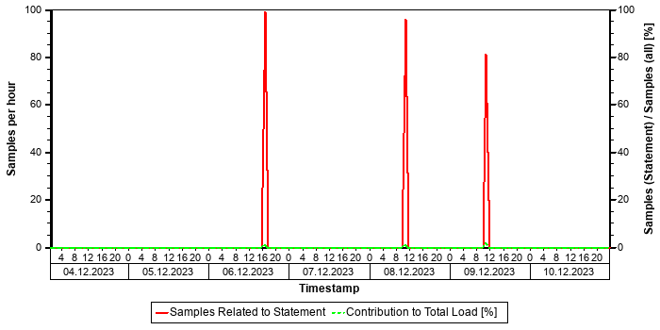

Tables
In the following, the tables involved in the SQL statement are listed (maximum of 20), sorted by the number of records.
Table Name | Schema Name | Table Type | Partition Type | Number of Records | Host
CKMLCR | SAPPRD | COLUMN | Table not partitioned | 796.619.304 | tsls4proddbh
VBPA | SAPPRD | COLUMN | Table not partitioned | 358.526.695 | tsls4proddbh
MATDOC_EXTRACT | SAPPRD | COLUMN | Table not partitioned | 313.982.684 | tsls4proddbh
MCHB | SAPPRD | COLUMN | Table not partitioned | 85.401.854 | tsls4proddbh
EKPO | SAPPRD | COLUMN | Table not partitioned | 38.758.670 | tsls4proddbh
VBAP | SAPPRD | COLUMN | Table not partitioned | 27.322.065 | tsls4proddbh
MBEW | SAPPRD | COLUMN | Table not partitioned | 21.021.143 | tsls4proddbh
ACDOCA_M_EXTRACT | SAPPRD | COLUMN | Table not partitioned | 16.159.656 | tsls4proddbh
VBAK | SAPPRD | COLUMN | Table not partitioned | 10.357.120 | tsls4proddbh
EBAN | SAPPRD | COLUMN | Table not partitioned | 9.366.281 | tsls4proddbh
... (further 25 tables)... | ... | ... | ... |  | ...

Origin of SQL Statement
The following table shows details of the applications responsible for the statement. This information is based on the information provided by SAP HANA in the "application source" connected to the statement in the "thread samples" or the list of "prepared" or "active" statements, and is not necessarily complete.
SID | Transaction / Jobaname | Report | Line | Last Changed on: | SAP Coding
PRD | YWSTK | YGWP_STK_FG | 2.631 | 14.08.2025

Top Statements (Thread Samples)
This section shows the top statements according to the number of observed "threads" ("Number of Samples") in the SERVICE THREAD SAMPLES. A statement might occupy a high number of threads if (a) it has a long execution time, (b) it is executed very often, or (c) it has a highly parallelized execution. In any case, it shows statements with a high resource consumption on the SAP HANA database.
See the following table for details of the selection:
Database Start | 15.10.2025 -- 08:03:55
Data Collection | 11.10.2025 -- 06:41:29
Analysis Type | Analysis of Thread Samples
Data Source | HOST_SERVICE_THREAD_SAMPLES
First Day | 04.10.2025
Last Day | 10.10.2025

The selected statements - identified by their "Statement Hash" - are listed in the following table. Further details of these statements can be found in the subsections.
Statement Hash | Time / Execution [us] | Records / Execution | Time / Record [us] | Number of Samples
938619e1d06635b2b252709b7ccd58af | 20.507.332,4 | 1,0 | 20.424.557,6 | 29.504
54a9566c2195e1ab2540c7f5d0ac6ff4 | 118.147.256,7 | 490.873,4 | 240,7 | 28.325
a8eb789ee40468a3bc31c19f4e3c2733 | 4.651.401,0 | 79,2 | 58.732,8 | 25.985
0afe14bc6bea35eee9d86b117185c277 | 314.977,3 | 16,6 | 18.925,9 | 18.408
77658c84db4c1afd41fa26aff7df5464 | 66.188.156,0 | 335.199,0 | 197,5 | 15.510

SQL Statement 938619e1d06635b2b252709b7ccd58af
SELECT DISTINCT
"A" . "REF_DOC" , "A" . "REF_DOC_YEAR" , "B" . "BUDAT_MKPF"
FROM
"/OPT/VIM_1ITEM" "A" INNER JOIN /* Redirected table: MSEG */ "NSDM_V_MSEG" "B" ON "A" . "MANDT" = "B" . "MANDT" AND "A"
. "REF_DOC" = "B" . "LFBNR" AND "A" . "REF_DOC_YEAR" = "B" . "MJAHR"
WHERE
"A" . "MANDT" = ? AND "A" . "DOCID" = ? WITH RANGE_RESTRICTION('CURRENT')
Statement Impact
Indicator | Value
Contribution to Total CPU Load [%] | 3,59
Contribution to Total Execution Time [%] | 9,76
Maximal CPU Consumption per Hour [%] ( 05.10.2025 between 12:00 and 13:00 ) | 4,49
Maximal Memory Consumption [%] | 0,11

Note: The statement as identified by its statement hash can also be found in other sections of this report:
Other Sections Dealing with this Statement
SAP HANA SQL Statements in PRD -> Top Statements (CPU Peak Hour)
SAP HANA SQL Statements in PRD -> Top Statements (Elapsed Time)
SAP HANA SQL Statements in PRD -> Top MATDOC Statements (Elapsed Time)
SAP HANA SQL Statements in PRD -> Top Statements (Total Memory)

Analysis of Where Clause
Table | Field | Operator | Supported by Single Column Index | Compression | Distinct Values | SCANNED RECORD COUNT | INDEX LOOKUP COUNT
/OPT/VIM_1ITEM | DOCID | = |  | DEFAULT | 10.594.120 | 119.414.604 | 816.740
/OPT/VIM_1ITEM | MANDT | = |  | RLE | 1 | 3.879 | 2

Time Consumption
The following table gives an overview of the time consumption of the analyzed SQL statement.
Activity | Average Time [us] | Minimal Time [us] | Maximal Time [us]
TOTAL EXECUTION | 20.507.309 | 198 | 316.055.039
PREPARATION | 23
LOCK DURATION | 0

Memory Consumption
The following table provides an overview of the memory consumption of the analyzed SQL statement as obtained from the monitoring view M_SQL_PLAN_STATISTICS (or – if not yet available – M_SQL_PLAN_CACHE), that is, without taking a specific time interval into account.
Activity | Average Memory [MB] | Minimal Memory [MB] | Maximal Memory [MB]
EXECUTION_MEMORY_SIZE | 3.777,1 | 0,1 | 10.107,5

Statement History (Thread Sample 'Running')
The following graph shows the number of observed thread samples (in state "running") related to this SQL statement together with the contribution of those samples to all thread samples (in state "running") active in the system.


Correlation with Index Server Resource Consumption
The distribution of thread samples with the status "Running" correlates strongly with the overall CPU or memory consumption of the system. Such a correlation indicates that this statement might be responsible for peaks in the memory or CPU consumption.
Distiribution | Correlation Coefficient | Comment
CPU consumption index server(s) - Threads (running) from this SQL statement | 0,81 | strong correlation
Memory consumption index server(s) - Threads (running) from this SQL Statement | 0,62 | strong correlation

Tables
In the following, the tables involved in the SQL statement are listed (maximum of 20), sorted by the number of records.
Table Name | Schema Name | Table Type | Partition Type | Number of Records | Host
MATDOC | SAPPRD | COLUMN | Table not partitioned | 565.077.043 | tsls4proddbh
/OPT/VIM_1ITEM | SAPPRD | COLUMN | Table not partitioned | 30.153.698 | tsls4proddbh

Compatibility View Access
SAP S/4HANA Supply Chain (MM - Inventory Management) offers a simplified data model. Several tables have become obsolete and are removed. To allow existing coding to continue to work, these tables are replaced by views with the same name, known as "Compatibility Views". As a result, read access to these objects is still possible; however, performance is affected since it is now an access to a view instead of a simple table. For some general background information, see https://launchpad.support.sap.com/#/notes/2206980 [SAP Note 2206980].
For performance-critical coding parts, we strongly recommend the code adjustments suggested in Section 2 of the SAP Note. For non-critical parts, these adjustments are optional in the short term but recommended in the long term.

Origin of SQL Statement
The following table shows details of the applications responsible for the statement. This information is based on the information provided by SAP HANA in the "application source" connected to the statement in the "thread samples" or the list of "prepared" or "active" statements, and is not necessarily complete.
SID | Transaction / Jobaname | Report | Line | Last Changed on: | SAP Coding
PRD | /OPT/DR_BR_WAIT | LZOPT_VIM_1U07 | 29 | 25.09.2019
PRD | /OPT/VIM_ANALYTICS | LZOPT_VIM_1U07 | 29 | 25.09.2019
PRD | /OPT/VIM_ANALYTICS_750 | LZOPT_VIM_1U07 | 29 | 25.09.2019
PRD | /OPT/VIM_RULERUN | LZOPT_VIM_1U07 | 29 | 25.09.2019
PRD | /OPT/VIM_VA2 | LZOPT_VIM_1U07 | 29 | 25.09.2019
PRD | /OPT/VIM_WP | LZOPT_VIM_1U07 | 29 | 25.09.2019
PRD | RSWIWILS | LZOPT_VIM_1U07 | 29 | 25.09.2019
PRD | SBWP | LZOPT_VIM_1U07 | 29 | 25.09.2019
PRD | SWIA | LZOPT_VIM_1U07 | 29 | 25.09.2019
PRD | VIM_BC_INBOUND_PROCESSING | LZOPT_VIM_1U07 | 29 | 25.09.2019
PRD | YP2P_DASH | LZOPT_VIM_1U07 | 29 | 25.09.2019

SQL Statement 54a9566c2195e1ab2540c7f5d0ac6ff4
SELECT
/* Buffer Loading */ "MANDT" , "KAPPL" , "KSCHL" , "VKORG" , "KUNAG" , "KUNWE" , "WERKS" , "ZZTDCNO" , "KFRST" , "DATBI" , "DATAB" , "KBSTAT" , "KNUMH"
FROM
"A639"
WHERE
"MANDT" = ?
ORDER BY
"A639" . "MANDT" , "A639" . "KAPPL" , "A639" . "KSCHL" , "A639" . "VKORG" , "A639" . "KUNAG" , "A639" . "KUNWE" , "A639" . "WERKS" , "A639" . "ZZTDCNO" , "A639" . "KFRST" , "A639" . "DATBI" WITH RANGE_RESTRICTION('CURRENT')
Statement Impact
Indicator | Value
Contribution to Total CPU Load [%] | 3,45
Contribution to Total Execution Time [%] | 1,36
Maximal CPU Consumption per Hour [%] ( 05.10.2025 between 15:00 and 16:00 ) | 2,29
Contribution to Total Memory Consumption [%] | 0,09
Maximal Memory Consumption [%] | 0,33

Note: The statement as identified by its statement hash can also be found in other sections of this report:
Other Sections Dealing with this Statement
SAP HANA SQL Statements in PRD -> Top Statements (Total Memory)
SAP HANA SQL Statements in PRD -> Top Statements (CPU Peak Hour)

Analysis of Where Clause
Table | Field | Operator | Supported by Single Column Index | Compression | Distinct Values | SCANNED RECORD COUNT | INDEX LOOKUP COUNT
A639 | MANDT | = |  | RLE | 1 | 4.021 | 677

Calendar Week(s) of "Distinct Values" Collection
202549

Explain Plan
OPERATOR_NAME | DETAILS | ENGINE | TABLE_NAME | OUTPUT_SIZE | SUBTREE_COST
COLUMN SEARCH | A639.MANDT, A639.KAP ... | COLUMN |  | 190.556.391 | 2.471,740
_ORDER BY | A639.KAPPL ASC, A639 ... | COLUMN |  | 190.556.391 | 62,539
__COLUMN TABLE | FILTER CONDITION: A6 ... | COLUMN | A639 | 190.556.391 | 0,000

Time Consumption
The following table gives an overview of the time consumption of the analyzed SQL statement.
Activity | Average Time [us] | Minimal Time [us] | Maximal Time [us]
TOTAL EXECUTION | 118.146.871 | 100 | 347.709.520
PREPARATION | 385
LOCK DURATION | 0

Memory Consumption
The following table provides an overview of the memory consumption of the analyzed SQL statement as obtained from the monitoring view M_SQL_PLAN_STATISTICS (or – if not yet available – M_SQL_PLAN_CACHE), that is, without taking a specific time interval into account.
Activity | Average Memory [MB] | Minimal Memory [MB] | Maximal Memory [MB]
EXECUTION_MEMORY_SIZE | 30.650,9 | 30.650,9 | 30.650,9

Thread Distribution
The following table(s) shows both (if available) the "thread distribution" in terms of "thread state" and for thread samples in state "Running" (that is consuming CPU resources) the distribution of thread type and method. The information is obtained from the view HOST_SERVICE_THREAD_SAMPLES in the time interval analyzed. By this, some insight is given to the internal activities when the statement is processed, helping to understand which activities are responsible for the resource and/or time consumption.
For more information concerning threads and thread samples, see also SAP Note 2114710.
Thread State | Area | Samples
Running | SQL | 28325
Job Exec Waiting | Idle | 5462
Mutex Wait | Lock | 213
Semaphore Wait | Lock | 31

Thread Type (Thread Method) when THREAD_STATE = "Running" | Samples
JobWorker (RangeSortJob) | 11.117
JobWorker (MakeHeapJob) | 10.042
JobWorker (ParallelFor Job) | 4.379
SqlExecutor (ExecutePrepared) | 1.288
Others | 1.499

The following table shows the "thread distribution" in terms of "thread detail" and for all thread samples.
Thread Type | Thread Method | Thread Detail | Samples
JobWorker | MakeHeapJob | ? | 10042
SqlExecutor | ExecutePrepared | SELECT /* Buffer Loading */ "MANDT" , "KAPPL" , "KSCHL" , "VKORG" , "KUNAG" , "KUNWE" , "WERKS" , "ZZTDCNO" , "KFRST" , "DATBI" , "DATAB" , "KBSTAT" , "KNUMH" FROM "A639" WHERE "MANDT" = ? ORDER BY "A639" . "MANDT" , "A639" . "KAPPL" , "A639" . "KSCH | 3040
JobWorker | ZipResultJob | ? | 1150
JobWorker | ParallelFor Job | AE/getValues BlockJob on table PRD::SAPPRD:A639 (t 337) (parallelFor job 1/10) | 587
JobWorker | ParallelFor Job | AE/getValues BlockJob on table PRD::SAPPRD:A639 (t 337) (parallelFor job 2/10) | 466
JobWorker | ParallelFor Job | AE/getValues BlockJob on table PRD::SAPPRD:A639 (t 337) (parallelFor job 3/10) | 464
JobWorker | ParallelFor Job | AE/getValues BlockJob on table PRD::SAPPRD:A639 (t 337) (parallelFor job 5/10) | 463
JobWorker | ParallelFor Job | AE/getValues BlockJob on table PRD::SAPPRD:A639 (t 337) (parallelFor job 4/10) | 454
JobWorker | ParallelFor Job | AE/getValues BlockJob on table PRD::SAPPRD:A639 (t 337) (parallelFor job 6/10) | 445
JobWorker | ParallelFor Job | AE/getValues BlockJob on table PRD::SAPPRD:A639 (t 337) (parallelFor job 7/10) | 440
JobWorker | ParallelFor Job | AE/getValues BlockJob on table PRD::SAPPRD:A639 (t 337) (parallelFor job 8/10) | 407
JobWorker | ParallelFor Job | AE/getValues BlockJob on table PRD::SAPPRD:A639 (t 337) (parallelFor job 9/10) | 380
JobWorker | ParallelFor Job | AE/getValues BlockJob on table PRD::SAPPRD:A639 (t 337) (parallelFor job 10/10) | 296
JobWorker | RangeSortJob | RangeSort ranges from: 0 to: 190353789 | 61
JobWorker | RangeSortJob | RangeSort ranges from: 0 to: 190353765 | 54
SqlExecutor | FetchCursor | SELECT /* Buffer Loading */ "MANDT" , "KAPPL" , "KSCHL" , "VKORG" , "KUNAG" , "KUNWE" , "WERKS" , "ZZTDCNO" , "KFRST" , "DATBI" , "DATAB" , "KBSTAT" , "KNUMH" FROM "A639" WHERE "MANDT" = ? ORDER BY "A639" . "MANDT" , "A639" . "KAPPL" , "A639" . "KSCH | 24
JobWorker | RangeSortJob | RangeSort ranges from: 3612791 to: 4716227 | 21
JobWorker | RangeSortJob | RangeSort ranges from: 7910415 to: 8865183 | 19
JobWorker | RangeSortJob | RangeSort ranges from: 5691427 to: 6816623 | 18
JobWorker | RangeSortJob | RangeSort ranges from: 6816623 to: 7910415 | 18
OTHERS | OTHERS | OTHERS | 15182

Statement History (Elapsed Time)
The following graph shows the number of executions and the average "Elapsed Time" of the statement within the considered time interval as obtained from the monitoring view HOST_SQL_PLAN_CACHE. Note that the absence of information at a given point in time does not necessarily mean that the statement was not executed, but only that no data was found in this monitoring view.


Statement History (All Thread Samples)
The following graph shows the number of threads, both for state "Running" and for all other thread states. Threads in state "Running" are responsible for the CPU consumption due to the statements. Non-running threads could be "idle", but might also indicate network or I/O issues or locking situations.


Statement History (Thread Sample 'Running')
The following graph shows the number of observed thread samples (in state "running") related to this SQL statement together with the contribution of those samples to all thread samples (in state "running") active in the system.


Correlation with Index Server Resource Consumption
The distribution of thread samples with the status "Running" correlates strongly with the overall CPU or memory consumption of the system. Such a correlation indicates that this statement might be responsible for peaks in the memory or CPU consumption.
Distiribution | Correlation Coefficient | Comment
CPU consumption index server(s) - Threads (running) from this SQL statement | 0,85 | strong correlation
Memory consumption index server(s) - Threads (running) from this SQL Statement | 0,61 | strong correlation

Tables
In the following, the tables involved in the SQL statement are listed (maximum of 20), sorted by the number of records.
Table Name | Schema Name | Table Type | Partition Type | Number of Records | Host
A639 | SAPPRD | COLUMN | Table not partitioned | 190.556.392 | tsls4proddbh

Statement used for Buffer Loading
Table
A639

The comment /* Buffer Loading */ in the statement text shows that this SQL statement was issued to copy information from the table listed above to the table buffer. A table should be loaded only rarely and the related SQL statement should not play an important role in a productive system. This statement might be executed frequently if the table is either invalidated very often or the table is displaced from the table buffer because the configuration of the table buffer is too small.
Recommendation: In order to check whether the buffering settings for this table are adequate, check the table statistics of this table in transaction ST10 (see SAP Note 1011158 and SAP Note 2457204). In order to check the setting for the table buffer, check the buffer statistics in ST02 for the different ABAP instances (see SAP Note 2442188).
If the buffer settings are not adequate, adjust the buffer settings, or un-buffer the table. If the configuration of the table buffer is too small and sufficient physical memory is available on the host, increase the size of the table buffer.

Origin of SQL Statement
The following table shows details of the applications responsible for the statement. This information is based on the information provided by SAP HANA in the "application source" connected to the statement in the "thread samples" or the list of "prepared" or "active" statements, and is not necessarily complete.
SID | Transaction / Jobaname | Report | Line | Last Changed on: | SAP Coding | Application Component | Description
PRD | /IRM/LAUNCHPAD | LV61ZU01 | 938 | 30.01.2017 |  | SD-BF-PR | Pricing and Conditions
PRD | Auto Delivery of 95172721270460 | LV61ZU01 | 938 | 30.01.2017 |  | SD-BF-PR | Pricing and Conditions
PRD | Auto Delivery of 95172882830938 | LV61ZU01 | 938 | 30.01.2017 |  | SD-BF-PR | Pricing and Conditions
PRD | Auto Delivery of 95172901390382 | LV61ZU01 | 938 | 30.01.2017 |  | SD-BF-PR | Pricing and Conditions
PRD | Auto Delivery of 95172901391221 | LV61ZU01 | 938 | 30.01.2017 |  | SD-BF-PR | Pricing and Conditions
PRD | Auto Delivery of 95172925000872 | LV61ZU01 | 938 | 30.01.2017 |  | SD-BF-PR | Pricing and Conditions
PRD | Auto Delivery of 95172929901592 | LV61ZU01 | 938 | 30.01.2017 |  | SD-BF-PR | Pricing and Conditions
PRD | Auto Delivery of 95172932099571 | LV61ZU01 | 938 | 30.01.2017 |  | SD-BF-PR | Pricing and Conditions
PRD | Auto Delivery of 95172933014931 | LV61ZU01 | 938 | 30.01.2017 |  | SD-BF-PR | Pricing and Conditions
PRD | Auto Delivery of 95172933015250 | LV61ZU01 | 938 | 30.01.2017 |  | SD-BF-PR | Pricing and Conditions
PRD | Auto Delivery of 95172945410184 | LV61ZU01 | 938 | 30.01.2017 |  | SD-BF-PR | Pricing and Conditions
PRD | Auto Delivery of 95172945410470 | LV61ZU01 | 938 | 30.01.2017 |  | SD-BF-PR | Pricing and Conditions
PRD | Auto Delivery of 95172945415482 | LV61ZU01 | 938 | 30.01.2017 |  | SD-BF-PR | Pricing and Conditions
PRD | Auto Delivery of 95172945415793 | LV61ZU01 | 938 | 30.01.2017 |  | SD-BF-PR | Pricing and Conditions

SQL Statement a8eb789ee40468a3bc31c19f4e3c2733
SELECT
"EKPO" . "EBELN" , "EKPO" . "BEDNR" , "EKKO" . "BSTYP" , "EKKO" . "SUBMI"
FROM
"EKPO" INNER JOIN "EKKO" ON "EKPO" . "MANDT" = "EKKO" . "MANDT" AND "EKKO" . "EBELN" = "EKPO" . "EBELN"
WHERE
"EKPO" . "MANDT" = ? AND ( "EKKO" . "SUBMI" = ? OR "EKKO" . "SUBMI" BETWEEN ? AND ? OR "EKPO" . "BEDNR" = ? ) WITH RANGE_RESTRICTION('CURRENT')
Statement Impact
Indicator | Value
Contribution to Total CPU Load [%] | 3,16
Contribution to Total Execution Time [%] | 1,30
Maximal CPU Consumption per Hour [%] ( 05.10.2025 between 23:00 and 24:00 ) | 3,05

Analysis of Where Clause
Table | Field | Operator | SCANNED RECORD COUNT | INDEX LOOKUP COUNT
EKKO | SUBMI | = | 42.494.402 | 304.054
EKKO | SUBMI | BETWEEN | 42.494.402 | 304.054
EKPO | BEDNR | = | 462.433.387 | 74.213
EKPO | MANDT | = | 7.488.593.045 | 55.331

Time Consumption
The following table gives an overview of the time consumption of the analyzed SQL statement.
Activity | Average Time [us] | Minimal Time [us] | Maximal Time [us]
TOTAL EXECUTION | 4.651.384 | 2.401.013 | 13.091.010
PREPARATION | 17
LOCK DURATION | 0

Memory Consumption
The following table provides an overview of the memory consumption of the analyzed SQL statement as obtained from the monitoring view M_SQL_PLAN_STATISTICS (or – if not yet available – M_SQL_PLAN_CACHE), that is, without taking a specific time interval into account.
Activity | Average Memory [MB] | Minimal Memory [MB] | Maximal Memory [MB]
EXECUTION_MEMORY_SIZE | 970,9 | 967,3 | 1.106,7

Statement History (Thread Sample 'Running')
The following graph shows the number of observed thread samples (in state "running") related to this SQL statement together with the contribution of those samples to all thread samples (in state "running") active in the system.
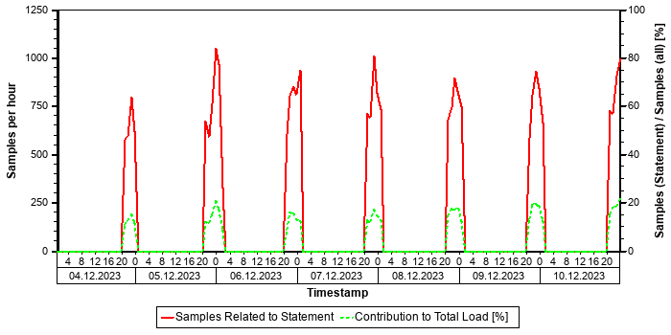

Tables
In the following, the tables involved in the SQL statement are listed (maximum of 20), sorted by the number of records.
Table Name | Schema Name | Table Type | Partition Type | Number of Records | Host
EKPO | SAPPRD | COLUMN | Table not partitioned | 38.758.670 | tsls4proddbh
EKKO | SAPPRD | COLUMN | Table not partitioned | 14.321.805 | tsls4proddbh

Origin of SQL Statement
The following table shows details of the applications responsible for the statement. This information is based on the information provided by SAP HANA in the "application source" connected to the statement in the "thread samples" or the list of "prepared" or "active" statements, and is not necessarily complete.
SID | Transaction / Jobaname | Report | Line | Last Changed on: | SAP Coding
PRD | YMPIR_MRO_ORDER_UPDATE | YMPIR_MRO_ORDER_UPDATE | 201 | 06.11.2020

SQL Statement 0afe14bc6bea35eee9d86b117185c277
SELECT
"MANDANT" , "OBJECTCLAS" , "OBJECTID" , "CHANGENR" , "TABNAME" , "TABKEY" , "FNAME" , "CHNGIND" , "TEXT_CASE" , "UNIT_OLD" , "UNIT_NEW" , "CUKY_OLD" , "CUKY_NEW" , "VALUE_NEW" , "VALUE_OLD" , "_DATAAGING"
FROM
"CDPOS"
WHERE
"MANDANT" = ? AND "OBJECTCLAS" = N'IDENTITY' AND "OBJECTID" BETWEEN ? AND ? AND "TABNAME" = N'USR04' AND "FNAME" = N'KEY' AND "CHNGIND" = N'D' WITH RANGE_RESTRICTION('CURRENT')
Statement Impact
Indicator | Value
Contribution to Total CPU Load [%] | 2,24
Contribution to Total Execution Time [%] | 1,90
Maximal CPU Consumption per Hour [%] ( 05.10.2025 between 12:00 and 13:00 ) | 0,57

Analysis of Where Clause
Table | Field | Operator | SCANNED RECORD COUNT | INDEX LOOKUP COUNT
CDPOS | CHNGIND | = | 579 | 0
CDPOS | FNAME | = | 64.805.619.468 | 2.978.098
CDPOS | MANDANT | = | 61.527.983 | 30
CDPOS | OBJECTCLAS | = | 8.997.435 | 71
CDPOS | OBJECTID | BETWEEN | 1.277.616.497.678.994 | 3.297.086
CDPOS | TABNAME | = | 58.493.754.973 | 269.413

Time Consumption
The following table gives an overview of the time consumption of the analyzed SQL statement.
Activity | Average Time [us] | Minimal Time [us] | Maximal Time [us]
TOTAL EXECUTION | 314.970 | 768 | 42.019.897
PREPARATION | 7
LOCK DURATION | 0

Memory Consumption
The following table provides an overview of the memory consumption of the analyzed SQL statement as obtained from the monitoring view M_SQL_PLAN_STATISTICS (or – if not yet available – M_SQL_PLAN_CACHE), that is, without taking a specific time interval into account.
Activity | Average Memory [MB] | Minimal Memory [MB] | Maximal Memory [MB]
EXECUTION_MEMORY_SIZE | 32,7 | 0,2 | 3.869,5

Statement History (Thread Sample 'Running')
The following graph shows the number of observed thread samples (in state "running") related to this SQL statement together with the contribution of those samples to all thread samples (in state "running") active in the system.
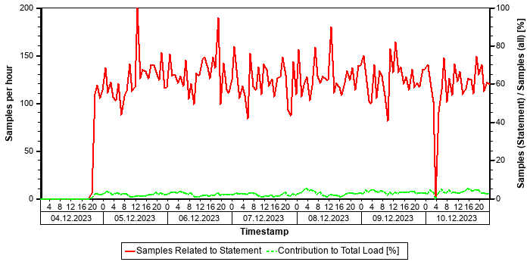

Correlation with Index Server Resource Consumption
The distribution of thread samples with the status "Running" correlates strongly with the overall CPU or memory consumption of the system. Such a correlation indicates that this statement might be responsible for peaks in the memory or CPU consumption.
Distiribution | Correlation Coefficient | Comment
CPU consumption index server(s) - Threads (running) from this SQL statement | 0,63 | strong correlation
Memory consumption index server(s) - Threads (running) from this SQL Statement | 0,50 | medium correlation

Tables
In the following, the tables involved in the SQL statement are listed (maximum of 20), sorted by the number of records.
Table Name | Schema Name | Table Type | Partition Type | Number of Records | Host
CDPOS | SAPPRD | COLUMN | HASH | 7.150.225.343 | tsls4proddbh

Origin of SQL Statement
The following table shows details of the applications responsible for the statement. This information is based on the information provided by SAP HANA in the "application source" connected to the statement in the "thread samples" or the list of "prepared" or "active" statements, and is not necessarily complete.
SID | Transaction / Jobaname | Report | Line | Last Changed on: | SAP Coding | Application Component | Description
PRD | GRAC_REPOSITORY_OBJECT_SYNC | /GRCPI/CL_GRIA_USR============CM001 | 757 | 08.08.2025 |  | GRC-ACP | GRC Access Control Plug-In
PRD | GRAC_REP_OBJ_SYNC_ECC | /GRCPI/CL_GRIA_USR============CM001 | 757 | 08.08.2025 |  | GRC-ACP | GRC Access Control Plug-In
PRD | GRAC_REP_OBJ_SYNC_LOGSYS500 | /GRCPI/CL_GRIA_USR============CM001 | 757 | 08.08.2025 |  | GRC-ACP | GRC Access Control Plug-In

SQL Statement 77658c84db4c1afd41fa26aff7df5464
SELECT
/* Buffer Loading */ "MANDT" , "KAPPL" , "KSCHL" , "WERKS" , "MATNR" , "KUNNR" , "DATBI" , "DATAB" , "KNUMH"
FROM
"A915"
WHERE
"MANDT" = ?
ORDER BY
"A915" . "MANDT" , "A915" . "KAPPL" , "A915" . "KSCHL" , "A915" . "WERKS" , "A915" . "MATNR" , "A915" . "KUNNR" , "A915" . "DATBI" WITH RANGE_RESTRICTION('CURRENT')
Statement Impact
Indicator | Value
Contribution to Total CPU Load [%] | 1,89
Contribution to Total Execution Time [%] | 1,54
Maximal CPU Consumption per Hour [%] ( 05.10.2025 between 12:00 and 13:00 ) | 0,97
Maximal Memory Consumption [%] | 0,14

Note: The statement as identified by its statement hash can also be found in other sections of this report:
Other Sections Dealing with this Statement
SAP HANA SQL Statements in PRD -> Top Statements (Total Memory)

Analysis of Where Clause
Table | Field | Operator | Supported by Single Column Index | Compression | Distinct Values | SCANNED RECORD COUNT | INDEX LOOKUP COUNT
A915 | MANDT | = |  | RLE | 3 | 1.150.589 | 876

Calendar Week(s) of "Distinct Values" Collection
202549

Explain Plan
OPERATOR_NAME | DETAILS | ENGINE | TABLE_NAME | OUTPUT_SIZE | SUBTREE_COST
COLUMN SEARCH | A915.MANDT, A915.KAP ... | COLUMN |  | 31.165.134 | 282,040
_ORDER BY | A915.KAPPL ASC, A915 ... | COLUMN |  | 31.165.134 | 9,257
__COLUMN TABLE | FILTER CONDITION: A9 ... | COLUMN | A915 | 31.165.134 | 0,000

Time Consumption
The following table gives an overview of the time consumption of the analyzed SQL statement.
Activity | Average Time [us] | Minimal Time [us] | Maximal Time [us]
TOTAL EXECUTION | 66.188.069 | 218 | 261.527.158
PREPARATION | 87
LOCK DURATION | 0

Memory Consumption
The following table provides an overview of the memory consumption of the analyzed SQL statement as obtained from the monitoring view M_SQL_PLAN_STATISTICS (or – if not yet available – M_SQL_PLAN_CACHE), that is, without taking a specific time interval into account.
Activity | Average Memory [MB] | Minimal Memory [MB] | Maximal Memory [MB]
EXECUTION_MEMORY_SIZE | 11.852,2 | 0,1 | 12.720,3

Thread Distribution
The following table(s) shows both (if available) the "thread distribution" in terms of "thread state" and for thread samples in state "Running" (that is consuming CPU resources) the distribution of thread type and method. The information is obtained from the view HOST_SERVICE_THREAD_SAMPLES in the time interval analyzed. By this, some insight is given to the internal activities when the statement is processed, helping to understand which activities are responsible for the resource and/or time consumption.
For more information concerning threads and thread samples, see also SAP Note 2114710.
Thread State | Area | Samples
Running | SQL | 15510
Job Exec Waiting | Idle | 2992
Mutex Wait | Lock | 367
Semaphore Wait | Lock | 20

Thread Type (Thread Method) when THREAD_STATE = "Running" | Samples
JobWorker (RangeSortJob) | 5.891
JobWorker (ParallelFor Job) | 3.847
JobWorker (MakeHeapJob) | 3.106
SqlExecutor (ExecutePrepared) | 1.209
Others | 1.457

The following table shows the "thread distribution" in terms of "thread detail" and for all thread samples.
Thread Type | Thread Method | Thread Detail | Samples
JobWorker | MakeHeapJob | ? | 3106
SqlExecutor | ExecutePrepared | SELECT /* Buffer Loading */ "MANDT" , "KAPPL" , "KSCHL" , "WERKS" , "MATNR" , "KUNNR" , "DATBI" , "DATAB" , "KNUMH" FROM "A915" WHERE "MANDT" = ? ORDER BY "A915" . "MANDT" , "A915" . "KAPPL" , "A915" . "KSCHL" , "A915" . "WERKS" , "A915" . "MATNR" , | 3097
JobWorker | ZipResultJob | ? | 1047
JobWorker | ParallelFor Job | AE/getValues BlockJob on table PRD::SAPPRD:A915 (t 434) (parallelFor job 1/7) | 967
JobWorker | ParallelFor Job | AE/getValues BlockJob on table PRD::SAPPRD:A915 (t 434) (parallelFor job 2/7) | 685
JobWorker | ParallelFor Job | AE/getValues BlockJob on table PRD::SAPPRD:A915 (t 434) (parallelFor job 3/7) | 561
JobWorker | ParallelFor Job | AE/getValues BlockJob on table PRD::SAPPRD:A915 (t 434) (parallelFor job 4/7) | 494
JobWorker | ParallelFor Job | AE/getValues BlockJob on table PRD::SAPPRD:A915 (t 434) (parallelFor job 5/7) | 419
JobWorker | ParallelFor Job | AE/getValues BlockJob on table PRD::SAPPRD:A915 (t 434) (parallelFor job 6/7) | 383
JobWorker | ParallelFor Job | AE/getValues BlockJob on table PRD::SAPPRD:A915 (t 434) (parallelFor job 7/7) | 352
JobWorker | RangeSortJob | RangeSort ranges from: 0 to: 3521388 | 23
JobWorker | RangeSortJob | RangeSort ranges from: 0 to: 3519272 | 20
SqlExecutor | FetchCursor | SELECT /* Buffer Loading */ "MANDT" , "KAPPL" , "KSCHL" , "WERKS" , "MATNR" , "KUNNR" , "DATBI" , "DATAB" , "KNUMH" FROM "A915" WHERE "MANDT" = ? ORDER BY "A915" . "MANDT" , "A915" . "KAPPL" , "A915" . "KSCHL" , "A915" . "WERKS" , "A915" . "MATNR" , | 20
JobWorker | RangeSortJob | RangeSort ranges from: 2334857 to: 2952066 | 20
JobWorker | RangeSortJob | RangeSort ranges from: 3519272 to: 93470265 | 19
JobWorker | RangeSortJob | RangeSort ranges from: 1860490 to: 2334857 | 19
JobWorker | RangeSortJob | RangeSort ranges from: 0 to: 617141 | 16
JobWorker | RangeSortJob | RangeSort ranges from: 4676812 to: 37287904 | 15
JobWorker | RangeSortJob | RangeSort ranges from: 37287904 to: 38103530 | 15
JobWorker | RangeSortJob | RangeSort ranges from: 3942303 to: 4676812 | 15
OTHERS | OTHERS | OTHERS | 7596

Statement History (Elapsed Time)
The following graph shows the number of executions and the average "Elapsed Time" of the statement within the considered time interval as obtained from the monitoring view HOST_SQL_PLAN_CACHE. Note that the absence of information at a given point in time does not necessarily mean that the statement was not executed, but only that no data was found in this monitoring view.


Statement History (All Thread Samples)
The following graph shows the number of threads, both for state "Running" and for all other thread states. Threads in state "Running" are responsible for the CPU consumption due to the statements. Non-running threads could be "idle", but might also indicate network or I/O issues or locking situations.


Statement History (Thread Sample 'Running')
The following graph shows the number of observed thread samples (in state "running") related to this SQL statement together with the contribution of those samples to all thread samples (in state "running") active in the system.


Correlation with Index Server Resource Consumption
The distribution of thread samples with the status "Running" correlates strongly with the overall CPU or memory consumption of the system. Such a correlation indicates that this statement might be responsible for peaks in the memory or CPU consumption.
Distiribution | Correlation Coefficient | Comment
CPU consumption index server(s) - Threads (running) from this SQL statement | 0,73 | strong correlation
Memory consumption index server(s) - Threads (running) from this SQL Statement | 0,56 | strong correlation

Tables
In the following, the tables involved in the SQL statement are listed (maximum of 20), sorted by the number of records.
Table Name | Schema Name | Table Type | Partition Type | Number of Records | Host
A915 | SAPPRD | COLUMN | Table not partitioned | 93.498.956 | tsls4proddbh

Statement used for Buffer Loading
Table
A915

The comment /* Buffer Loading */ in the statement text shows that this SQL statement was issued to copy information from the table listed above to the table buffer. A table should be loaded only rarely and the related SQL statement should not play an important role in a productive system. This statement might be executed frequently if the table is either invalidated very often or the table is displaced from the table buffer because the configuration of the table buffer is too small.
Recommendation: In order to check whether the buffering settings for this table are adequate, check the table statistics of this table in transaction ST10 (see SAP Note 1011158 and SAP Note 2457204). In order to check the setting for the table buffer, check the buffer statistics in ST02 for the different ABAP instances (see SAP Note 2442188).
If the buffer settings are not adequate, adjust the buffer settings, or un-buffer the table. If the configuration of the table buffer is too small and sufficient physical memory is available on the host, increase the size of the table buffer.

Origin of SQL Statement
The following table shows details of the applications responsible for the statement. This information is based on the information provided by SAP HANA in the "application source" connected to the statement in the "thread samples" or the list of "prepared" or "active" statements, and is not necessarily complete.
SID | Transaction / Jobaname | Report | Line | Last Changed on: | SAP Coding | Application Component | Description
PRD | /IRM/LAUNCHPAD | LV61ZU01 | 938 | 30.01.2017 |  | SD-BF-PR | Pricing and Conditions
PRD | Auto Delivery of 00000015562624 | LV61ZU01 | 938 | 30.01.2017 |  | SD-BF-PR | Pricing and Conditions
PRD | Auto Delivery of 00000015562754 | LV61ZU01 | 938 | 30.01.2017 |  | SD-BF-PR | Pricing and Conditions
PRD | Auto Delivery of 00000015563097 | LV61ZU01 | 938 | 30.01.2017 |  | SD-BF-PR | Pricing and Conditions
PRD | Auto Delivery of 00000015563367 | LV61ZU01 | 938 | 30.01.2017 |  | SD-BF-PR | Pricing and Conditions
PRD | Auto Delivery of 00000015563375 | LV61ZU01 | 938 | 30.01.2017 |  | SD-BF-PR | Pricing and Conditions
PRD | Auto Delivery of 00000015563460 | LV61ZU01 | 938 | 30.01.2017 |  | SD-BF-PR | Pricing and Conditions
PRD | Auto Delivery of 00000015563919 | LV61ZU01 | 938 | 30.01.2017 |  | SD-BF-PR | Pricing and Conditions
PRD | Auto Delivery of 00000015564299 | LV61ZU01 | 938 | 30.01.2017 |  | SD-BF-PR | Pricing and Conditions
PRD | Auto Delivery of 00000015564353 | LV61ZU01 | 938 | 30.01.2017 |  | SD-BF-PR | Pricing and Conditions
PRD | Auto Delivery of 00000015564397 | LV61ZU01 | 938 | 30.01.2017 |  | SD-BF-PR | Pricing and Conditions

Top Statements (CPU Peak Hour)
This section shows the top statements according to the number of observed "threads" ("Number of Samples") in the SERVICE THREAD SAMPLES. A statement might occupy a high number of threads if (a) it has a long execution time, (b) it is executed very often, or (c) it has a highly parallelized execution. In any case, it shows statements with a high resource consumption on the SAP HANA database.
For this section, the hour with the highest number of thread samples in thread state" "Running" is determined, that is, the "CPU peak hour". The top statements observed in this hour are listed and analyzed.
Hour of Maximal CPU Consumptiion
From | To
05.10.2025 -- 12:00:00 | 05.10.2025 -- 13:00:00

See the following table for details of the selection:
Database Start | 15.10.2025 -- 08:03:55
Data Collection | 11.10.2025 -- 06:41:29
Analysis Type | Analysis of Thread Samples
Data Source | HOST_SERVICE_THREAD_SAMPLES
First Day | 04.10.2025
Last Day | 10.10.2025

The selected statements - identified by their "Statement Hash" - are listed in the following table. Further details of these statements can be found in the subsections.
Statement Hash | Time / Execution [us] | Records / Execution | Time / Record [us] | Number if Samples in CPU Peak Hour
938619e1d06635b2b252709b7ccd58af | 20.507.332,4 | 1,0 | 20.424.557,6 | 1.581
da0cae818c8fca6b540d1d5f8357432a | 686.082,5 | 56,2 | 12.202,4 | 869
54a9566c2195e1ab2540c7f5d0ac6ff4 | 118.147.256,7 | 490.873,4 | 240,7 | 752
3876e9bc48476246934e1f701b04af96 | 12.620.061,5 | 0,3 | 36.882.414,0 | 503
f26860d87aea91b859d94199ce6b5dff | 505.244,6 | 0,0 | 59.789.994,2 | 464

SQL Statement 938619e1d06635b2b252709b7ccd58af
SELECT DISTINCT
"A" . "REF_DOC" , "A" . "REF_DOC_YEAR" , "B" . "BUDAT_MKPF"
FROM
"/OPT/VIM_1ITEM" "A" INNER JOIN /* Redirected table: MSEG */ "NSDM_V_MSEG" "B" ON "A" . "MANDT" = "B" . "MANDT" AND "A"
. "REF_DOC" = "B" . "LFBNR" AND "A" . "REF_DOC_YEAR" = "B" . "MJAHR"
WHERE
"A" . "MANDT" = ? AND "A" . "DOCID" = ? WITH RANGE_RESTRICTION('CURRENT')
Statement Impact
Indicator | Value
Contribution to Total CPU Load [%] | 3,59
Contribution to Total Execution Time [%] | 9,76
Maximal CPU Consumption per Hour [%] ( 05.10.2025 between 12:00 and 13:00 ) | 4,49
Maximal Memory Consumption [%] | 0,11

Note: The statement as identified by its statement hash can also be found in other sections of this report:
Other Sections Dealing with this Statement
SAP HANA SQL Statements in PRD -> Top Statements (Elapsed Time)
SAP HANA SQL Statements in PRD -> Top MATDOC Statements (Elapsed Time)
SAP HANA SQL Statements in PRD -> Top Statements (Thread Samples)
SAP HANA SQL Statements in PRD -> Top Statements (Total Memory)

Analysis of Where Clause
Table | Field | Operator | Supported by Single Column Index | Compression | Distinct Values | SCANNED RECORD COUNT | INDEX LOOKUP COUNT
/OPT/VIM_1ITEM | DOCID | = |  | DEFAULT | 10.594.120 | 119.414.604 | 816.740
/OPT/VIM_1ITEM | MANDT | = |  | RLE | 1 | 3.879 | 2

Time Consumption
The following table gives an overview of the time consumption of the analyzed SQL statement.
Activity | Total Time [s] | Average Time [us] | Minimal Time [us] | Maximal Time [us]
TOTAL EXECUTION | 865.285 | 20.507.309 | 198 | 316.055.039
PREPARATION | 1 | 23
LOCK DURATION | 0 | 0

Memory Consumption
The following table provides an overview of the memory consumption of the analyzed SQL statement as obtained from the monitoring view M_SQL_PLAN_STATISTICS (or – if not yet available – M_SQL_PLAN_CACHE), that is, without taking a specific time interval into account.
Activity | Average Memory [MB] | Minimal Memory [MB] | Maximal Memory [MB]

Statement History (Thread Sample 'Running')
The following graph shows the number of observed thread samples (in state "running") related to this SQL statement together with the contribution of those samples to all thread samples (in state "running") active in the system.


Correlation with Index Server Resource Consumption
The distribution of thread samples with the status "Running" correlates strongly with the overall CPU or memory consumption of the system. Such a correlation indicates that this statement might be responsible for peaks in the memory or CPU consumption.
Distiribution | Correlation Coefficient | Comment
CPU consumption index server(s) - Threads (running) from this SQL statement | 0,81 | strong correlation
Memory consumption index server(s) - Threads (running) from this SQL Statement | 0,62 | strong correlation

Tables
In the following, the tables involved in the SQL statement are listed (maximum of 20), sorted by the number of records.
Table Name | Schema Name | Table Type | Partition Type | Number of Records | Host
MATDOC | SAPPRD | COLUMN | Table not partitioned | 565.077.043 | tsls4proddbh
/OPT/VIM_1ITEM | SAPPRD | COLUMN | Table not partitioned | 30.153.698 | tsls4proddbh

Compatibility View Access
SAP S/4HANA Supply Chain (MM - Inventory Management) offers a simplified data model. Several tables have become obsolete and are removed. To allow existing coding to continue to work, these tables are replaced by views with the same name, known as "Compatibility Views". As a result, read access to these objects is still possible; however, performance is affected since it is now an access to a view instead of a simple table. For some general background information, see https://launchpad.support.sap.com/#/notes/2206980 [SAP Note 2206980].
For performance-critical coding parts, we strongly recommend the code adjustments suggested in Section 2 of the SAP Note. For non-critical parts, these adjustments are optional in the short term but recommended in the long term.

Origin of SQL Statement
The following table shows details of the applications responsible for the statement. This information is based on the information provided by SAP HANA in the "application source" connected to the statement in the "thread samples" or the list of "prepared" or "active" statements, and is not necessarily complete.
SID | Transaction / Jobaname | Report | Line | Last Changed on: | SAP Coding
PRD | /OPT/DR_BR_WAIT | LZOPT_VIM_1U07 | 29 | 25.09.2019
PRD | /OPT/VIM_ANALYTICS | LZOPT_VIM_1U07 | 29 | 25.09.2019
PRD | /OPT/VIM_ANALYTICS_750 | LZOPT_VIM_1U07 | 29 | 25.09.2019
PRD | /OPT/VIM_RULERUN | LZOPT_VIM_1U07 | 29 | 25.09.2019
PRD | /OPT/VIM_VA2 | LZOPT_VIM_1U07 | 29 | 25.09.2019
PRD | /OPT/VIM_WP | LZOPT_VIM_1U07 | 29 | 25.09.2019
PRD | RSWIWILS | LZOPT_VIM_1U07 | 29 | 25.09.2019
PRD | SBWP | LZOPT_VIM_1U07 | 29 | 25.09.2019
PRD | SWIA | LZOPT_VIM_1U07 | 29 | 25.09.2019
PRD | VIM_BC_INBOUND_PROCESSING | LZOPT_VIM_1U07 | 29 | 25.09.2019
PRD | YP2P_DASH | LZOPT_VIM_1U07 | 29 | 25.09.2019

SQL Statement da0cae818c8fca6b540d1d5f8357432a
SELECT
"VBELV" , "VBELN" , "VBTYP_V" , "POSNN"
FROM
"VBFA"
WHERE
"MANDT" = ? AND ( ( "VBELN" = ? AND "ERDAT" >= ? AND "VBTYP_V" = N'J' ) OR ( "VBELN" = ? AND "ERDAT" >= ? AND "VBTYP_V"= N'J' ) OR ( "VBELN" = ? AND "ERDAT" >= ? AND "VBTYP_V" = N'J' ) OR ( "VBELN" = ? AND "ERDAT" >= ? AND "VBTYP_V" = N'J' ) OR ( "VBELN" = ? AND "ERDAT" >= ? AND "VBTYP_V" = N'J' ) OR ( "VBELN" = ? AND "ERDAT" >= ? AND "VBTYP_V" = N'J' ) OR( "VBELN" = ? AND "ERDAT" >= ? AND "VBTYP_V" = N'J' ) OR ( "VBELN" = ? AND "ERDAT" >= ? AND "VBTYP_V" = N'J' ) OR ( "VBELN" = ? AND "ERDAT" >= ? AND "VBTYP_V" = N'J' ) OR ( "VBELN" = ? AND "ERDAT" >= ? AND "VBTYP_V" = N'J' ) OR ( "VBELN" =? AND "ERDAT" >= ? AND "VBTYP_V" = N'J' ) OR ( "VBELN" = ? AND "ERDAT" >= ? AND "VBTYP_V" = N'J' ) OR ( "VBELN" = ? AND"ERDAT" >= ? AND "VBTYP_V" = N'J' ) OR ( "VBELN" = ? AND "ERDAT" >= ? AND "VBTYP_V" = N'J' ) OR ( "VBELN" = ? AND "ERDAT" >= ? AND "VBTYP_V" = N'J' ) OR ( "VBELN" = ? AND "ERDAT" >= ? AND "VBTYP_V" = N'J' ) OR ( "VBELN" = ? AND "ERDAT" >= ? AND "VBTYP_V" = N'J' ) OR ( "VBELN" = ? AND "ERDAT" >= ? AND "VBTYP_V" = N'J' ) OR ( "VBELN" = ? AND "ERDAT" >= ? AND "VBTYP_V" = N'J' ) OR ( "VBELN" = ? AND "ERDAT" >= ? AND "VBTYP_V" = N'J' ) OR ( "VBELN" = ? AND "ERDAT" >= ? AND "VBTYP_V" = N'J' ) OR ( "VBELN" = ? AND "ERDAT" >= ? AND "VBTYP_V" = N'J' ) OR ( "VBELN" = ? AND "ERDAT" >= ? AND "VBTYP_V" = N'J' ) OR ( "VBELN" = ? AND "ERDAT" >= ? AND "VBTYP_V" = N'J' ) OR ( "VBELN" = ? AND "ERDAT" >= ? AND "VBTYP_V" = N'J' )OR ( "VBELN" = ? AND "ERDAT" >= ? AND "VBTYP_V" = N'J' ) OR ( "VBELN" = ? AND "ERDAT" >= ? AND "VBTYP_V" = N'J' ) OR ( "VBELN" = ? AND "ERDAT" >= ? AND "VBTYP_V" = N'J' ) OR ( "VBELN" = ? AND "ERDAT" >= ? AND "VBTYP_V" = N'J' ) OR ( "VBELN" = ? AND "ERDAT" >= ? AND "VBTYP_V" = N'J' ) OR ( "VBELN" = ? AND "ERDAT" >= ? AND "VBTYP_V" = N'J' ) OR ( "VBELN" = ? AND "ERDAT" >= ? AND "VBTYP_V" = N'J' ) OR ( "VBELN" = ? AND "ERDAT" >= ? AND "VBTYP_V" = N'J' ) OR ( "VBELN" = ? AND "ERDAT" >= ? AND "VBTYP_V" = N'J' ) OR ( "VBELN" = ? AND "ERDAT" >= ? AND "VBTYP_V" = N'J' ) OR ( "VBELN" = ? AND "ERDAT" >= ? AND "VBTYP_V" = N'J' ) OR ( "VBELN" = ? AND "ERDAT" >= ? AND "VBTYP_V" = N'J' ) OR ( "VBELN" = ? AND "ERDAT" >= ? AND "VBTYP_V" = N'J' ) OR ( "VBELN" = ? AND "ERDAT" >= ? AND "VBTYP_V" = N'J' ) OR ( "VBELN" = ? AND "ERDAT" >= ? AND "VBTYP_V" = N'J' ) OR ( "VBELN" = ? AND "ERDAT" >= ? AND "VBTYP_V" = N'J' ) OR ( "VBELN" = ? AND "ERDAT" >= ? AND "VBTYP_V"= N'J' ) OR ( "VBELN" = ? AND "ERDAT" >= ? AND "VBTYP_V" = N'J' ) OR ( "VBELN" = ? AND "ERDAT" >= ? AND "VBTYP_V" = N'J' ) OR ( "VBELN" = ? AND "ERDAT" >= ? AND "VBTYP_V" = N'J' ) OR ( "VBELN" = ? AND "ERDAT" >= ? AND "VBTYP_V" = N'J' ) OR( "VBELN" = ? AND "ERDAT" >= ? AND "VBTYP_V" = N'J' ) OR ( "VBELN" = ? AND "ERDAT" >= ? AND "VBTYP_V" = N'J' ) OR ( "VBELN" = ? AND "ERDAT" >= ? AND "VBTYP_V" = N'J' ) OR ( "VBELN" = ? AND "ERDAT" >= ? AND "VBTYP_V" = N'J' ) ) WITH RANGE_RESTRICTION('CURRENT')
Statement Impact
Indicator | Value
Contribution to Total CPU Load [%] | 0,45
Maximal CPU Consumption per Hour [%] ( 06.10.2025 between 11:00 and 12:00 ) | 2,90

Analysis of Where Clause
Table | Field | Operator | SCANNED RECORD COUNT | INDEX LOOKUP COUNT
VBFA | ERDAT | >= | 874.829.585.184 | 0
VBFA | MANDT | = | 106.339.930 | 10
VBFA | VBELN | = | 11.510.847.191.780.930 | 0
VBFA | VBTYP_V | = | 48.666.348.745 | 0

Time Consumption
The following table gives an overview of the time consumption of the analyzed SQL statement.
Activity | Total Time [s] | Average Time [us] | Minimal Time [us] | Maximal Time [us]
TOTAL EXECUTION | 3.146 | 685.809 | 777 | 4.458.554
PREPARATION | 1 | 273
LOCK DURATION | 0 | 0

Memory Consumption
The following table provides an overview of the memory consumption of the analyzed SQL statement as obtained from the monitoring view M_SQL_PLAN_STATISTICS (or – if not yet available – M_SQL_PLAN_CACHE), that is, without taking a specific time interval into account.
Activity | Average Memory [MB] | Minimal Memory [MB] | Maximal Memory [MB]
EXECUTION_MEMORY_SIZE | 5,6 | 0,1 | 21,5

Thread Distribution
Thread State | Area | Samples
Running | SQL | 3700
Job Exec Waiting | Idle | 195
Mutex Wait | Lock | 14

Thread Type (Thread Method) when THREAD_STATE = "Running" | Samples
JobWorker (IndirectScanVecOutJob<range>) | 3.621
SqlExecutor (ExecutePrepared) | 32
JobWorker (IndirectPredScanVecOutJob<ScanVectorBinSearchPredicate>) | 25
JobWorker | 21
Others | 1

The following table shows the "thread distribution" in terms of "thread detail" and for all thread samples.
Thread Type | Thread Method | Thread Detail | Samples
JobWorker | IndirectScanVecOutJob<range> | SAPPRD:VBFA.VBELN | 3634
SqlExecutor | ExecutePrepared | SELECT "VBELV" , "VBELN" , "VBTYP_V" , "POSNN" FROM "VBFA" WHERE "MANDT" = ? AND ( ( "VBELN" = ? AND "ERDAT" >= ? AND "VBTYP_V" = N'J' ) OR ( "VBELN" = ? AND "ERDAT" >= ? AND "VBTYP_V" = N'J' ) OR ( "VBELN" = ? AND "ERDAT" >= ? AND "VBTYP_V" = N'J' ) | 228
JobWorker | IndirectPredScanVecOutJob<ScanVectorBinSearchPredicate> | SAPPRD:VBFA.VBELN | 25
JobWorker | ? | ? | 21
JobWorker | IndirectPredScanVecOutJob<ScanVectorPredicate> | SAPPRD:VBFA.VBELN | 1

Note:
Table and column scan-related thread methods contribute significantly to the load caused by this SQL statement. It might be possible to accelerate the table scan (and by doing so, the execution time of this statement) either by changing the application in order to use existing indexes of this table or by changing the current index design (see SAP Note 2000002).
Recommendation: Consider creating a single column index for a column in the where clause not yet supported by an index.
If more than one column meets this condition, choose the most selective field. In many cases, this will be the field with the highest value for SCANNED_RECORD_COUNT (obtained from M_CS_ALL_COLUMN_STATISTICS), in particular when specified with "=".
See the following table with the fields specified with the where clause not yet supported by a single column index.
Table | Field | Operator | SCANNED_RECORD_COUNT
VBFA | VBELN | = | 11.510.847.191.780.930
VBFA | ERDAT | >= | 874.829.585.184
VBFA | VBTYP_V | = | 48.666.348.745

Statement History (Elapsed Time)
The following graph shows the number of executions and the average "Elapsed Time" of the statement within the considered time interval as obtained from the monitoring view HOST_SQL_PLAN_CACHE. Note that the absence of information at a given point in time does not necessarily mean that the statement was not executed, but only that no data was found in this monitoring view.
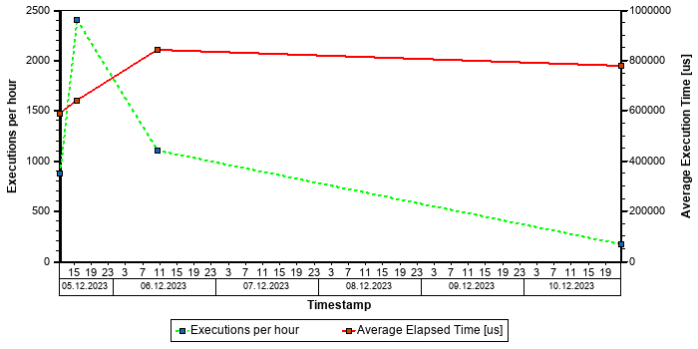

Statement History (All Thread Samples)
The following graph shows the number of threads, both for state "Running" and for all other thread states. Threads in state "Running" are responsible for the CPU consumption due to the statements. Non-running threads could be "idle", but might also indicate network or I/O issues or locking situations.
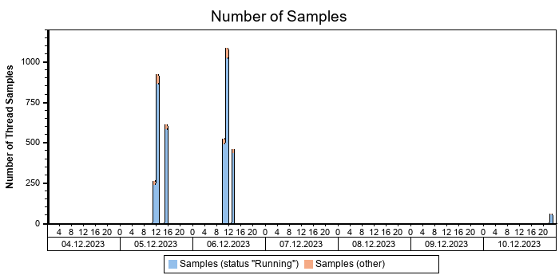

Statement History (Thread Sample 'Running')
The following graph shows the number of observed thread samples (in state "running") related to this SQL statement together with the contribution of those samples to all thread samples (in state "running") active in the system.
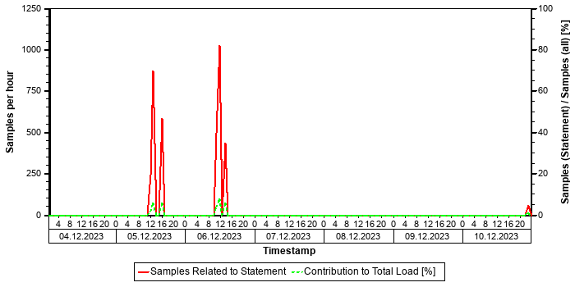

Correlation with Index Server Resource Consumption
The distribution of thread samples with the status "Running" correlates with the overall CPU or memory consumption of the system. Such a correlation indicates that this statement might be responsible for peaks in the memory or CPU consumption.
Distiribution | Correlation Coefficient | Comment
CPU consumption index server(s) - Threads (running) from this SQL statement | 0,43 | medium correlation
Memory consumption index server(s) - Threads (running) from this SQL Statement | 0,19 | weak correlation

Tables
In the following, the tables involved in the SQL statement are listed (maximum of 20), sorted by the number of records.
Table Name | Schema Name | Table Type | Partition Type | Number of Records | Host
VBFA | SAPPRD | COLUMN | Table not partitioned | 613.470.583 | tsls4proddbh

Origin of SQL Statement
The following table shows details of the applications responsible for the statement. This information is based on the information provided by SAP HANA in the "application source" connected to the statement in the "thread samples" or the list of "prepared" or "active" statements, and is not necessarily complete.
SID | Transaction / Jobaname | Report | Line | Last Changed on: | SAP Coding
PRD | YGSTNR | YMSDR_GSTIN | 291 | 06.03.2025
PRD | YMSDR_GSTIN | YMSDR_GSTIN | 291 | 06.03.2025

SQL Statement 54a9566c2195e1ab2540c7f5d0ac6ff4
SELECT
/* Buffer Loading */ "MANDT" , "KAPPL" , "KSCHL" , "VKORG" , "KUNAG" , "KUNWE" , "WERKS" , "ZZTDCNO" , "KFRST" , "DATBI" , "DATAB" , "KBSTAT" , "KNUMH"
FROM
"A639"
WHERE
"MANDT" = ?
ORDER BY
"A639" . "MANDT" , "A639" . "KAPPL" , "A639" . "KSCHL" , "A639" . "VKORG" , "A639" . "KUNAG" , "A639" . "KUNWE" , "A639" . "WERKS" , "A639" . "ZZTDCNO" , "A639" . "KFRST" , "A639" . "DATBI" WITH RANGE_RESTRICTION('CURRENT')
Statement Impact
Indicator | Value
Contribution to Total CPU Load [%] | 3,45
Contribution to Total Execution Time [%] | 1,36
Maximal CPU Consumption per Hour [%] ( 05.10.2025 between 15:00 and 16:00 ) | 2,29
Contribution to Total Memory Consumption [%] | 0,09
Maximal Memory Consumption [%] | 0,33

Note: The statement as identified by its statement hash can also be found in other sections of this report:
Other Sections Dealing with this Statement
SAP HANA SQL Statements in PRD -> Top Statements (Total Memory)
SAP HANA SQL Statements in PRD -> Top Statements (Thread Samples)

Analysis of Where Clause
Table | Field | Operator | Supported by Single Column Index | Compression | Distinct Values | SCANNED RECORD COUNT | INDEX LOOKUP COUNT
A639 | MANDT | = |  | RLE | 1 | 4.021 | 677

Calendar Week(s) of "Distinct Values" Collection
202549

Explain Plan
OPERATOR_NAME | DETAILS | ENGINE | TABLE_NAME | OUTPUT_SIZE | SUBTREE_COST
COLUMN SEARCH | A639.MANDT, A639.KAP ... | COLUMN |  | 190.556.391 | 2.471,740
_ORDER BY | A639.KAPPL ASC, A639 ... | COLUMN |  | 190.556.391 | 62,539
__COLUMN TABLE | FILTER CONDITION: A6 ... | COLUMN | A639 | 190.556.391 | 0,000

Time Consumption
The following table gives an overview of the time consumption of the analyzed SQL statement.
Activity | Total Time [s] | Average Time [us] | Minimal Time [us] | Maximal Time [us]
TOTAL EXECUTION | 120.746 | 118.146.871 | 100 | 347.709.520
PREPARATION | 0 | 385
LOCK DURATION | 0 | 0

Memory Consumption
The following table provides an overview of the memory consumption of the analyzed SQL statement as obtained from the monitoring view M_SQL_PLAN_STATISTICS (or – if not yet available – M_SQL_PLAN_CACHE), that is, without taking a specific time interval into account.
Activity | Average Memory [MB] | Minimal Memory [MB] | Maximal Memory [MB]
EXECUTION_MEMORY_SIZE | 30,0 | 30.650,9 | 30.650,9

Thread Distribution
The following table(s) shows both (if available) the "thread distribution" in terms of "thread state" and for thread samples in state "Running" (that is consuming CPU resources) the distribution of thread type and method. The information is obtained from the view HOST_SERVICE_THREAD_SAMPLES in the time interval analyzed. By this, some insight is given to the internal activities when the statement is processed, helping to understand which activities are responsible for the resource and/or time consumption.
For more information concerning threads and thread samples, see also SAP Note 2114710.
Thread State | Area | Samples
Running | SQL | 28325
Job Exec Waiting | Idle | 5462
Mutex Wait | Lock | 213
Semaphore Wait | Lock | 31

Thread Type (Thread Method) when THREAD_STATE = "Running" | Samples
JobWorker (RangeSortJob) | 11.117
JobWorker (MakeHeapJob) | 10.042
JobWorker (ParallelFor Job) | 4.379
SqlExecutor (ExecutePrepared) | 1.288
Others | 1.499

The following table shows the "thread distribution" in terms of "thread detail" and for all thread samples.
Thread Type | Thread Method | Thread Detail | Samples
JobWorker | MakeHeapJob | ? | 10042
SqlExecutor | ExecutePrepared | SELECT /* Buffer Loading */ "MANDT" , "KAPPL" , "KSCHL" , "VKORG" , "KUNAG" , "KUNWE" , "WERKS" , "ZZTDCNO" , "KFRST" , "DATBI" , "DATAB" , "KBSTAT" , "KNUMH" FROM "A639" WHERE "MANDT" = ? ORDER BY "A639" . "MANDT" , "A639" . "KAPPL" , "A639" . "KSCH | 3040
JobWorker | ZipResultJob | ? | 1150
JobWorker | ParallelFor Job | AE/getValues BlockJob on table PRD::SAPPRD:A639 (t 337) (parallelFor job 1/10) | 587
JobWorker | ParallelFor Job | AE/getValues BlockJob on table PRD::SAPPRD:A639 (t 337) (parallelFor job 2/10) | 466
JobWorker | ParallelFor Job | AE/getValues BlockJob on table PRD::SAPPRD:A639 (t 337) (parallelFor job 3/10) | 464
JobWorker | ParallelFor Job | AE/getValues BlockJob on table PRD::SAPPRD:A639 (t 337) (parallelFor job 5/10) | 463
JobWorker | ParallelFor Job | AE/getValues BlockJob on table PRD::SAPPRD:A639 (t 337) (parallelFor job 4/10) | 454
JobWorker | ParallelFor Job | AE/getValues BlockJob on table PRD::SAPPRD:A639 (t 337) (parallelFor job 6/10) | 445
JobWorker | ParallelFor Job | AE/getValues BlockJob on table PRD::SAPPRD:A639 (t 337) (parallelFor job 7/10) | 440
JobWorker | ParallelFor Job | AE/getValues BlockJob on table PRD::SAPPRD:A639 (t 337) (parallelFor job 8/10) | 407
JobWorker | ParallelFor Job | AE/getValues BlockJob on table PRD::SAPPRD:A639 (t 337) (parallelFor job 9/10) | 380
JobWorker | ParallelFor Job | AE/getValues BlockJob on table PRD::SAPPRD:A639 (t 337) (parallelFor job 10/10) | 296
JobWorker | RangeSortJob | RangeSort ranges from: 0 to: 190353789 | 61
JobWorker | RangeSortJob | RangeSort ranges from: 0 to: 190353765 | 54
SqlExecutor | FetchCursor | SELECT /* Buffer Loading */ "MANDT" , "KAPPL" , "KSCHL" , "VKORG" , "KUNAG" , "KUNWE" , "WERKS" , "ZZTDCNO" , "KFRST" , "DATBI" , "DATAB" , "KBSTAT" , "KNUMH" FROM "A639" WHERE "MANDT" = ? ORDER BY "A639" . "MANDT" , "A639" . "KAPPL" , "A639" . "KSCH | 24
JobWorker | RangeSortJob | RangeSort ranges from: 3612791 to: 4716227 | 21
JobWorker | RangeSortJob | RangeSort ranges from: 7910415 to: 8865183 | 19
JobWorker | RangeSortJob | RangeSort ranges from: 5691427 to: 6816623 | 18
JobWorker | RangeSortJob | RangeSort ranges from: 6816623 to: 7910415 | 18
OTHERS | OTHERS | OTHERS | 15182

Statement History (Elapsed Time)
The following graph shows the number of executions and the average "Elapsed Time" of the statement within the considered time interval as obtained from the monitoring view HOST_SQL_PLAN_CACHE. Note that the absence of information at a given point in time does not necessarily mean that the statement was not executed, but only that no data was found in this monitoring view.


Statement History (All Thread Samples)
The following graph shows the number of threads, both for state "Running" and for all other thread states. Threads in state "Running" are responsible for the CPU consumption due to the statements. Non-running threads could be "idle", but might also indicate network or I/O issues or locking situations.


Statement History (Thread Sample 'Running')
The following graph shows the number of observed thread samples (in state "running") related to this SQL statement together with the contribution of those samples to all thread samples (in state "running") active in the system.


Correlation with Index Server Resource Consumption
The distribution of thread samples with the status "Running" correlates strongly with the overall CPU or memory consumption of the system. Such a correlation indicates that this statement might be responsible for peaks in the memory or CPU consumption.
Distiribution | Correlation Coefficient | Comment
CPU consumption index server(s) - Threads (running) from this SQL statement | 0,85 | strong correlation
Memory consumption index server(s) - Threads (running) from this SQL Statement | 0,61 | strong correlation

Tables
In the following, the tables involved in the SQL statement are listed (maximum of 20), sorted by the number of records.
Table Name | Schema Name | Table Type | Partition Type | Number of Records | Host
A639 | SAPPRD | COLUMN | Table not partitioned | 190.556.392 | tsls4proddbh

Statement used for Buffer Loading
Table
A639

The comment /* Buffer Loading */ in the statement text shows that this SQL statement was issued to copy information from the table listed above to the table buffer. A table should be loaded only rarely and the related SQL statement should not play an important role in a productive system. This statement might be executed frequently if the table is either invalidated very often or the table is displaced from the table buffer because the configuration of the table buffer is too small.
Recommendation: In order to check whether the buffering settings for this table are adequate, check the table statistics of this table in transaction ST10 (see SAP Note 1011158 and SAP Note 2457204). In order to check the setting for the table buffer, check the buffer statistics in ST02 for the different ABAP instances (see SAP Note 2442188).
If the buffer settings are not adequate, adjust the buffer settings, or un-buffer the table. If the configuration of the table buffer is too small and sufficient physical memory is available on the host, increase the size of the table buffer.

Origin of SQL Statement
The following table shows details of the applications responsible for the statement. This information is based on the information provided by SAP HANA in the "application source" connected to the statement in the "thread samples" or the list of "prepared" or "active" statements, and is not necessarily complete.
SID | Transaction / Jobaname | Report | Line | Last Changed on: | SAP Coding | Application Component | Description
PRD | /IRM/LAUNCHPAD | LV61ZU01 | 938 | 30.01.2017 |  | SD-BF-PR | Pricing and Conditions
PRD | Auto Delivery of 95172721270460 | LV61ZU01 | 938 | 30.01.2017 |  | SD-BF-PR | Pricing and Conditions
PRD | Auto Delivery of 95172882830938 | LV61ZU01 | 938 | 30.01.2017 |  | SD-BF-PR | Pricing and Conditions
PRD | Auto Delivery of 95172901390382 | LV61ZU01 | 938 | 30.01.2017 |  | SD-BF-PR | Pricing and Conditions
PRD | Auto Delivery of 95172901391221 | LV61ZU01 | 938 | 30.01.2017 |  | SD-BF-PR | Pricing and Conditions
PRD | Auto Delivery of 95172925000872 | LV61ZU01 | 938 | 30.01.2017 |  | SD-BF-PR | Pricing and Conditions
PRD | Auto Delivery of 95172929901592 | LV61ZU01 | 938 | 30.01.2017 |  | SD-BF-PR | Pricing and Conditions
PRD | Auto Delivery of 95172932099571 | LV61ZU01 | 938 | 30.01.2017 |  | SD-BF-PR | Pricing and Conditions
PRD | Auto Delivery of 95172933014931 | LV61ZU01 | 938 | 30.01.2017 |  | SD-BF-PR | Pricing and Conditions
PRD | Auto Delivery of 95172933015250 | LV61ZU01 | 938 | 30.01.2017 |  | SD-BF-PR | Pricing and Conditions
PRD | Auto Delivery of 95172945410184 | LV61ZU01 | 938 | 30.01.2017 |  | SD-BF-PR | Pricing and Conditions
PRD | Auto Delivery of 95172945410470 | LV61ZU01 | 938 | 30.01.2017 |  | SD-BF-PR | Pricing and Conditions
PRD | Auto Delivery of 95172945415482 | LV61ZU01 | 938 | 30.01.2017 |  | SD-BF-PR | Pricing and Conditions
PRD | Auto Delivery of 95172945415793 | LV61ZU01 | 938 | 30.01.2017 |  | SD-BF-PR | Pricing and Conditions

SQL Statement 3876e9bc48476246934e1f701b04af96
SELECT
"MATNR" , "WERKS" , "LGORT" , "CHARG" , "ERSDA" , "SOBKZ" , "VBELN" , "POSNR" , "KALAB" , "KAINS" , "KASPE"
FROM
"NSDM_V_MSKA"
WHERE
"MANDT" = ? AND ( ( "MATNR" = ? AND "WERKS" = ? AND "CHARG" LIKE ? AND "SOBKZ" = N'E' ) OR ( "MATNR" = ? AND "WERKS" = ? AND "CHARG" LIKE ? AND "SOBKZ" = N'E' ) OR ( "MATNR" = ? AND "WERKS" = ? AND "CHARG" LIKE ? AND "SOBKZ" = N'E' ) OR ( "MATNR" = ? AND "WERKS" = ? AND "CHARG" LIKE ? AND "SOBKZ" = N'E' ) OR ( "MATNR" = ? AND "WERKS" = ? AND "CHARG" LIKE ? AND "SOBKZ" = N'E' ) OR ( "MATNR" = ? AND "WERKS" = ? AND "CHARG" LIKE ? AND "SOBKZ" = N'E' ) OR ( "MATNR" = ? AND "WERKS" = ? AND "CHARG" LIKE ? AND "SOBKZ" = N'E' ) OR ( "MATNR" = ? AND "WERKS" = ? AND "CHARG" LIKE ? AND "SOBKZ" = N'E' ) OR ( "MATNR" = ? AND "WERKS" = ? AND "CHARG" LIKE ? AND "SOBKZ" = N'E' ) OR ( "MATNR" = ? AND "WERKS" = ? AND "CHARG" LIKE ? AND "SOBKZ" = N'E' ) OR ( "MATNR" = ? AND "WERKS" = ? AND "CHARG" LIKE ? AND "SOBKZ" = N'E' ) OR ( "MATNR" = ? AND "WERKS" = ? AND "CHARG" LIKE ? AND "SOBKZ" = N'E' ) OR ( "MATNR" = ? AND "WERKS" = ? AND "CHARG" LIKE ? AND "SOBKZ" = N'E' ) OR ( "MATNR" = ? AND "WERKS" = ? AND "CHARG" LIKE ? AND "SOBKZ" = N'E' ) OR ( "MATNR" = ? AND "WERKS" = ? AND "CHARG" LIKE ? AND "SOBKZ" = N'E' ) OR ( "MATNR" = ? AND "WERKS" = ? AND "CHARG" LIKE ? AND "SOBKZ" = N'E' ) OR ( "MATNR" = ?AND "WERKS" = ? AND "CHARG" LIKE ? AND "SOBKZ" = N'E' ) OR ( "MATNR" = ? AND "WERKS" = ? AND "CHARG" LIKE ? AND "SOBKZ"= N'E' ) OR ( "MATNR" = ? AND "WERKS" = ? AND "CHARG" LIKE ? AND "SOBKZ" = N'E' ) OR ( "MATNR" = ? AND "WERKS" = ? AND "CHARG" LIKE ? AND "SOBKZ" = N'E' ) OR ( "MATNR" = ? AND "WERKS" = ? AND "CHARG" LIKE ? AND "SOBKZ" = N'E' ) OR ( "MATNR" = ? AND "WERKS" = ? AND "CHARG" LIKE ? AND "SOBKZ" = N'E' ) OR ( "MATNR" = ? AND "WERKS" = ? AND "CHARG" LIKE ? AND "SOBKZ" = N'E' ) OR ( "MATNR" = ? AND "WERKS" = ? AND "CHARG" LIKE ? AND "SOBKZ" = N'E' ) OR ( "MATNR" = ? AND "WERKS" = ?AND "CHARG" LIKE ? AND "SOBKZ" = N'E' ) OR ( "MATNR" = ? AND "WERKS" = ? AND "CHARG" LIKE ? AND "SOBKZ" = N'E' ) OR ( "MATNR" = ? AND "WERKS" = ? AND "CHARG" LIKE ? AND "SOBKZ" = N'E' ) OR ( "MATNR" = ? AND "WERKS" = ? AND "CHARG" LIKE ? AND "SOBKZ" = N'E' ) OR ( "MATNR" = ? AND "WERKS" = ? AND "CHARG" LIKE ? AND "SOBKZ" = N'E' ) OR ( "MATNR" = ? AND "WERKS" = ? AND "CHARG" LIKE ? AND "SOBKZ" = N'E' ) OR ( "MATNR" = ? AND "WERKS" = ? AND "CHARG" LIKE ? AND "SOBKZ" = N'E' ) OR ( "MATNR" = ? AND "WERKS" = ? AND "CHARG" LIKE ? AND "SOBKZ" = N'E' ) OR ( "MATNR" = ? AND "WERKS" = ? AND "CHARG" LIKE ? AND "SOBKZ" = N'E' ) OR ( "MATNR" = ? AND "WERKS" = ? AND "CHARG" LIKE ? AND "SOBKZ" = N'E' ) OR ( "MATNR" = ? AND "WERKS" = ? AND "CHARG" LIKE ? AND "SOBKZ" = N'E' ) OR ( "MATNR" = ? AND "WERKS" = ? AND "CHARG" LIKE ? AND "SOBKZ" = N'E' ) OR ( "MATNR" = ? AND "WERKS" = ? AND "CHARG" LIKE ? AND "SOBKZ" = N'E' ) OR ( "MATNR" = ? AND "WERKS" = ? AND "CHARG" LIKE ? AND "SOBKZ" = N'E' ) OR ( "MATNR" = ? AND "WERKS" = ? AND "CHARG" LIKE ? AND "SOBKZ" = N'E' ) OR ( "MATNR" = ? AND "WERKS" = ? AND "CHARG" LIKE ? AND "SOBKZ" = N'E' ) OR ( "MATNR" = ? AND "WERKS" = ? AND "CHARG" LIKE ? AND "SOBKZ" = N'E' ) OR ( "MATNR" = ? AND "WERKS" = ? AND "CHARG" LIKE ? AND "SOBKZ" = N'E' ) OR ( "MATNR" = ? AND "WERKS" = ? AND "CHARG" LIKE ? AND "SOBKZ" = N'E' ) OR ( "MATNR" = ? AND "WERKS" = ? AND "CHARG" LIKE ? AND "SOBKZ" = N'E' ) OR ( "MATNR"= ? AND "WERKS" = ? AND "CHARG" LIKE ? AND "SOBKZ" = N'E' ) OR ( "MATNR" = ? AND "WERKS" = ? AND "CHARG" LIKE ? AND "SOBKZ" = N'E' ) OR ( "MATNR" = ? AND "WERKS" = ? AND "CHARG" LIKE ? AND "SOBKZ" = N'E' ) OR ( "MATNR" = ? AND "WERKS" = ? AND "CHARG" LIKE ? AND "SOBKZ" = N'E' ) OR ( "MATNR" = ? AND "WERKS" = ? AND "CHARG" LIKE ? AND "SOBKZ" = N'E' ) OR ( "MATNR" = ? AND "WERKS" = ? AND "CHARG" LIKE ? AND "SOBKZ" = N'E' ) ) WITH RANGE_RESTRICTION('CURRENT')
Statement Impact
Indicator | Value
Contribution to Total CPU Load [%] | 1,24
Contribution to Total Execution Time [%] | 0,69
Maximal CPU Consumption per Hour [%] ( 05.10.2025 between 11:00 and 12:00 ) | 2,15

Analysis of Where Clause
Table | Field | Operator
? | CHARG | LIKE
? | MANDT | =
? | MATNR | =
? | SOBKZ | =
? | WERKS | =

Time Consumption
The following table gives an overview of the time consumption of the analyzed SQL statement.
Activity | Total Time [s] | Average Time [us] | Minimal Time [us] | Maximal Time [us]
TOTAL EXECUTION | 61.403 | 12.618.812 | 487.922 | 78.714.690
PREPARATION | 6 | 1.249
LOCK DURATION | 0 | 0

Memory Consumption
The following table provides an overview of the memory consumption of the analyzed SQL statement as obtained from the monitoring view M_SQL_PLAN_STATISTICS (or – if not yet available – M_SQL_PLAN_CACHE), that is, without taking a specific time interval into account.
Activity | Average Memory [MB] | Minimal Memory [MB] | Maximal Memory [MB]

Statement History (Thread Sample 'Running')
The following graph shows the number of observed thread samples (in state "running") related to this SQL statement together with the contribution of those samples to all thread samples (in state "running") active in the system.
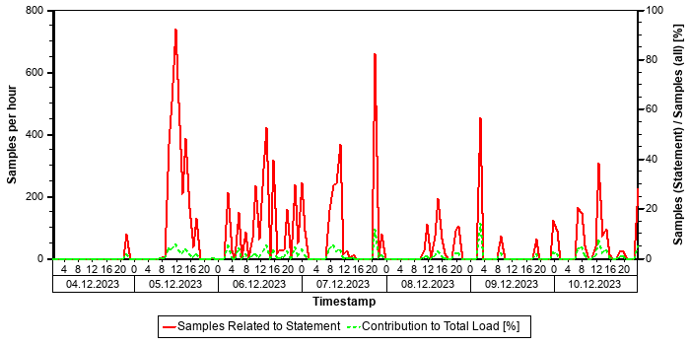

Correlation with Index Server Resource Consumption
The distribution of thread samples with the status "Running" correlates with the overall CPU or memory consumption of the system. Such a correlation indicates that this statement might be responsible for peaks in the memory or CPU consumption.
Distiribution | Correlation Coefficient | Comment
CPU consumption index server(s) - Threads (running) from this SQL statement | 0,47 | medium correlation
Memory consumption index server(s) - Threads (running) from this SQL Statement | 0,17 | weak correlation

Tables
In the following, the tables involved in the SQL statement are listed (maximum of 20), sorted by the number of records.
Table Name | Schema Name | Table Type | Partition Type | Number of Records | Host
MATDOC_EXTRACT | SAPPRD | COLUMN | Table not partitioned | 313.982.684 | tsls4proddbh
MSKA | SAPPRD | COLUMN | Table not partitioned | 10.252.159 | tsls4proddbh

Origin of SQL Statement
The following table shows details of the applications responsible for the statement. This information is based on the information provided by SAP HANA in the "application source" connected to the statement in the "thread samples" or the list of "prepared" or "active" statements, and is not necessarily complete.
SID | Transaction / Jobaname | Report | Line | Last Changed on: | SAP Coding
PRD | ZPP005 | ZRPP_STOCK_REPORT_TSL | 486 | 29.10.2025
PRD | ZRPP_STOCK_REPORT_TSL | ZRPP_STOCK_REPORT_TSL | 486 | 29.10.2025

SQL Statement f26860d87aea91b859d94199ce6b5dff
SELECT
"MANDANT" , "OBJECTCLAS" , "OBJECTID" , "CHANGENR" , "USERNAME" , "UDATE" , "UTIME" , "TCODE" , "PLANCHNGNR" , "ACT_CHNGNO" , "WAS_PLANND" , "CHANGE_IND" , "LANGU" , "VERSION" , "_DATAAGING"
FROM
"CDHDR"
WHERE
"MANDANT" = ? AND "OBJECTCLAS" = ? AND ( "OBJECTID" LIKE ? OR "OBJECTID" LIKE ? AND ( N'_' <> ? OR "OBJECTID" <> N'' ) )
Statement Impact
Indicator | Value
Contribution to Total CPU Load [%] | 0,63
Maximal CPU Consumption per Hour [%] ( 07.10.2025 between 11:00 and 12:00 ) | 1,81

Analysis of Where Clause
Table | Field | Operator | Supported by Single Column Index | Compression | Distinct Values | SCANNED RECORD COUNT | INDEX LOOKUP COUNT
CDHDR | MANDANT | = |  |  |  | 17.957.888.310 | 4.588
CDHDR | N'_' | <>
CDHDR | OBJECTCLAS | = |  |  |  | 2.076.686.009.642 | 228.080
CDHDR | OBJECTID | <> |  |  |  | 819.406.919.288.633 | 12.809.846
CDHDR | OBJECTID | LIKE |  |  |  | 819.406.919.288.633 | 12.809.846

Time Consumption
The following table gives an overview of the time consumption of the analyzed SQL statement.
Activity | Total Time [s] | Average Time [us] | Minimal Time [us] | Maximal Time [us]
TOTAL EXECUTION | 3.707 | 505.228 | 297 | 2.200.788
PREPARATION | 0 | 17
LOCK DURATION | 0 | 0

Memory Consumption
The following table provides an overview of the memory consumption of the analyzed SQL statement as obtained from the monitoring view M_SQL_PLAN_STATISTICS (or – if not yet available – M_SQL_PLAN_CACHE), that is, without taking a specific time interval into account.
Activity | Average Memory [MB] | Minimal Memory [MB] | Maximal Memory [MB]
EXECUTION_MEMORY_SIZE | 2,8 | 0,1 | 32,0

Statement History (Thread Sample 'Running')
The following graph shows the number of observed thread samples (in state "running") related to this SQL statement together with the contribution of those samples to all thread samples (in state "running") active in the system.
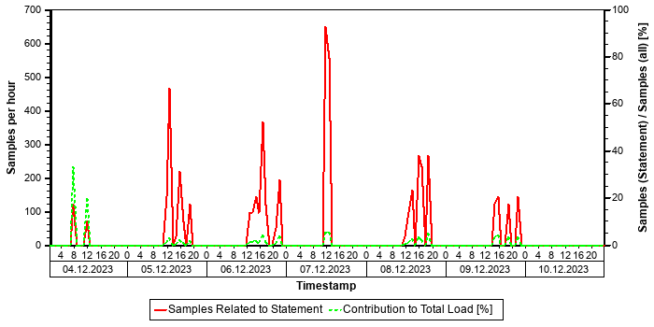

Correlation with Index Server Resource Consumption
The distribution of thread samples with the status "Running" correlates with the overall CPU or memory consumption of the system. Such a correlation indicates that this statement might be responsible for peaks in the memory or CPU consumption.
Distiribution | Correlation Coefficient | Comment
CPU consumption index server(s) - Threads (running) from this SQL statement | 0,43 | medium correlation
Memory consumption index server(s) - Threads (running) from this SQL Statement | 0,37 | medium correlation

Tables
In the following, the tables involved in the SQL statement are listed (maximum of 20), sorted by the number of records.
Table Name | Schema Name | Table Type | Partition Type | Number of Records | Host
CDHDR | SAPPRD | COLUMN | Table not partitioned | 720.603.854 | tsls4proddbh

Origin of SQL Statement
The following table shows details of the applications responsible for the statement. This information is based on the information provided by SAP HANA in the "application source" connected to the statement in the "thread samples" or the list of "prepared" or "active" statements, and is not necessarily complete.
SID | Transaction / Jobaname | Report | Line | Last Changed on: | SAP Coding | Application Component | Description
PRD | /OPT/VIM_ANALYTICS_750 | LCD_READF01 | 3.057 | 08.08.2025 |  | BC-SRV-ASF-CHD | Change Documents
PRD | /OPT/VIM_VA2 | LCD_READF01 | 3.057 | 08.08.2025 |  | BC-SRV-ASF-CHD | Change Documents
PRD | /OPT/VIM_WP | LCD_READF01 | 3.057 | 08.08.2025 |  | BC-SRV-ASF-CHD | Change Documents
PRD | BP | LCD_READF01 | 3.057 | 08.08.2025 |  | BC-SRV-ASF-CHD | Change Documents
PRD | FB03 | LCD_READF01 | 3.057 | 08.08.2025 |  | BC-SRV-ASF-CHD | Change Documents
PRD | FK02 | LCD_READF01 | 3.057 | 08.08.2025 |  | BC-SRV-ASF-CHD | Change Documents
PRD | FK03 | LCD_READF01 | 3.057 | 08.08.2025 |  | BC-SRV-ASF-CHD | Change Documents
PRD | RFITEMAP | LCD_READF01 | 3.057 | 08.08.2025 |  | BC-SRV-ASF-CHD | Change Documents
PRD | SBWP | LCD_READF01 | 3.057 | 08.08.2025 |  | BC-SRV-ASF-CHD | Change Documents
PRD | UKM_BP | LCD_READF01 | 3.057 | 08.08.2025 |  | BC-SRV-ASF-CHD | Change Documents
PRD | UKM_BP_DISPLAY | LCD_READF01 | 3.057 | 08.08.2025 |  | BC-SRV-ASF-CHD | Change Documents
PRD | VA03 | LCD_READF01 | 3.057 | 08.08.2025 |  | BC-SRV-ASF-CHD | Change Documents
PRD | VF03 | LCD_READF01 | 3.057 | 08.08.2025 |  | BC-SRV-ASF-CHD | Change Documents
PRD | VL03 | LCD_READF01 | 3.057 | 08.08.2025 |  | BC-SRV-ASF-CHD | Change Documents
PRD | XD03 | LCD_READF01 | 3.057 | 08.08.2025 |  | BC-SRV-ASF-CHD | Change Documents
PRD | XK03 | LCD_READF01 | 3.057 | 08.08.2025 |  | BC-SRV-ASF-CHD | Change Documents

SAP NetWeaver Gateway
 | The gateway configuration and administration of your SAP S/4HANA system PRD have been analyzed and areas that require your attention have been highlighted. To ensure system stability, you should implement the recommendations in the following section.

Rating | Check
 | MetaData Cache Activation
 | Logging Configuration
 | Gateway Error Logs
 | Important Periodic Jobs

Gateway Configuration

MetaData Cache Activation
Cache | Activated
Metadata Cache | Yes

The metadata cache is activated in your system as recommended.

Logging Configuration
Logging Use Case | Log Level | Recommended Log Level
Regular processing | Error, Security, Warning | Error, Security, Warning

The gateway logging configuration is set correctly on your system.

Gateway Administration

Important Periodic Jobs
The jobs based on the reports listed in the table below are important for the smooth operation of your system.
Report Name | Scheduled Periodically? | Scheduled Frequency | Recommended Frequency | Rating | Further Information
/UI5/UPD_ODATA_METADATA_CACHE |  | - | 48 Hours* |  | LINK
/UI5/APP_INDEX_CALCULATE |  | - | Daily* |  | LINK
/IWFND/R_SM_CLEANUP | X | 1 per day | Daily |  | LINK
/IWBEP/R_CLEAN_UP_QRL | X | 1 per day | Daily |  | LINK
/IWBEP/SUTIL_CLEANUP | X | 1 per day | Daily |  | LINK
/UI2/PERS_EXPIRED_DELETE |  | - | Weekly |  | LINK
/IWFND/R_METERING_DELETE |  | - | Daily |  | LINK
/IWFND/R_METERING_AGGREGATE |  | - | Daily |  | LINK

*Schedule these jobs as indicated, or more often in periods of frequent imports, depending on your use case. Take observed job duration for your system into account when tuning the schedule.
Recommendation: See the recommended schedule for the important periodic jobs listed in the table above. One or more periodic jobs important for the smooth operation of your system are not scheduled to run regularly as recommended.

UI Technologies Checks
 | No major problems were found with the UI technology configuration or administration of your SAP S/4HANA system PRD.

Fiori Checks for PRD
Rating | Check
 | Maintenance and Update Strategy for SAP Fiori Front-End Server
 | SAPUI5 Version
 | SAP Fiori Cache Buster Activation
 | HTTP/2 Support
 | Activated but unused ICF services in UI5 apps

No major problems were found with the SAP Fiori configuration or administration of your SAP S/4HANA system PRD.

Maintenance and Update Strategy for SAP Fiori Front-End Server
Software Product | SAP_UI Release | End of Maintenance | Rating
SAP Fiori FES 2021 for S/4HANA | 756 | 31.12.2024

Your version of the SAP Fiori Front-End Server (SAP_UI) is still in maintenance by SAP. For further information on the SAP Fiori Front-End Server maintenance and upgrade strategy, refer to SAP Note 2217489.

SAPUI5 Version
Current SAPUI5 Version Installed
1.96.8

Your SAPUI5 Library version is up to date as recommended. The planned end of maintenance for your SAPUI5 Library version is 31.12.2024.
SAP recommends to plan updates and upgrades with SAP Maintenance Planner.
It is strongly recommended that you test all of your SAPUI5 applications before upgrading the SAPUI5 version in the productive system.

SAP Fiori Cache Buster Activation
You have activated the cache buster mechanism for system PRD because the ICF service /sap/bc/ui2/flp is activated in SICF.
Please note that to use the cache buster mechanism, you need to call the SAP Fiori launchpad with one of the following URLs:
https://<server>:<port>/sap/bc/ui2/flp/
https://<server>:<port>/sap/bc/ui2/flp/index.html
https://<server>:<port>/sap/bc/ui2/flp/FioriLaunchpad.html
You can also maintain a custom URL via an SICF external alias as described here: Customize the Launchpad URL
Background:
Web browsers store static resources like JavaScript files, stylesheets, and images in the browser cache. When these resources are changed on the server in a software upgrade, you want the browser to load the new resources from the server rather than from the cache, without having to manually clear the browser cache.
Cache buster techniques cause Web browsers to load content from the server rather than from the browser cache when new resources are available on the server.
You can find the latest information about the cache buster for SAP Fiori components in 2043432.

HTTP/2 Support
HTTP/2 support is currently active as recommended.
The HTTP protocol is one of the most frequently used protocols on the Internet. However, HTTP/1.0 and HTTP/1.1 have some disadvantages for modern applications, in particular with respect to performance in wide-area networks. To improve these problems, their successor RFC 7540 HTTP/2 has been implemented.
For more information on HTTP/2 Support, see here
Host | Parameter Name | Current Value | Rating
sapapp18 | icm/HTTP/support_http2 | TRUE
sapapp27 | icm/HTTP/support_http2 | TRUE
sapapp38 | icm/HTTP/support_http2 | TRUE
sapapp20 | icm/HTTP/support_http2 | TRUE
sapapp40 | icm/HTTP/support_http2 | TRUE
sapapp37 | icm/HTTP/support_http2 | TRUE
sapapp23 | icm/HTTP/support_http2 | TRUE
sapapp41 | icm/HTTP/support_http2 | TRUE
sapapp19 | icm/HTTP/support_http2 | TRUE
sapapp33 | icm/HTTP/support_http2 | TRUE
sapapp21 | icm/HTTP/support_http2 | TRUE
sapapp35 | icm/HTTP/support_http2 | TRUE
sapapp32 | icm/HTTP/support_http2 | TRUE
sapapp31 | icm/HTTP/support_http2 | TRUE
sapapp30 | icm/HTTP/support_http2 | TRUE
sapapp36 | icm/HTTP/support_http2 | TRUE
sapapp28 | icm/HTTP/support_http2 | TRUE
sapapp31-ha | icm/HTTP/support_http2 | TRUE
sapapp29 | icm/HTTP/support_http2 | TRUE
sapapp39 | icm/HTTP/support_http2 | TRUE
sapapp34 | icm/HTTP/support_http2 | TRUE
sapapp15 | icm/HTTP/support_http2 | TRUE
sapapp26 | icm/HTTP/support_http2 | TRUE
sapapp42 | icm/HTTP/support_http2 | TRUE
sapapp43 | icm/HTTP/support_http2 | TRUE

Trend Analysis
This section contains the trend analysis for key performance indicators (KPIs).
Diagrams are built weekly once the EarlyWatch Alert service is activated.
In this section, a "week" is from Monday to Sunday. The date displayed is the Sunday of the week.

System Activity
The following diagrams show the system activity over time.
The "Transaction Activity" diagram below depicts transaction activity in the system over time.
- Total Activity: Transaction steps performed each week (in thousands)
- Dialog Activity: Transaction steps performed in dialog task each week (in thousands)
- Peak Activity: Transaction steps (in thousands) during the peak hour; this peak hour is calculated as the hour with the maximum dialog activity in the ST03 time profile divided by 5 working days per week.
(Peak Activity is absent if "Activity Data" is taken from ST03 data directly).
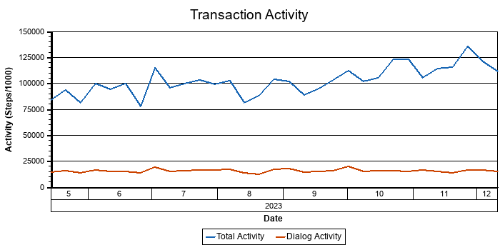
The "User Activity" diagram below shows the user activity on the system over time.
- Total Users: Total users that logged on in one week.
- Active Users: Users who performed more than 400 transaction steps in one week.
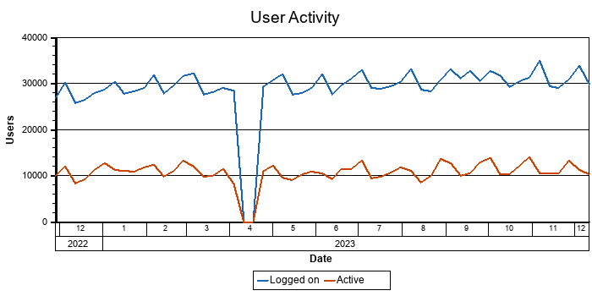

Response Times
The following diagrams show how the response time varies over time.
The "System Performance" diagram below shows the average response time in dialog tasks for the previous week.
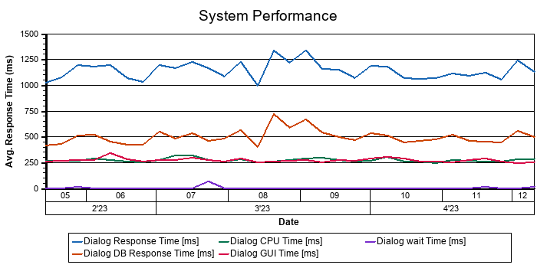
The "Database Performance" diagram below shows the average DB response time in dialog tasks.
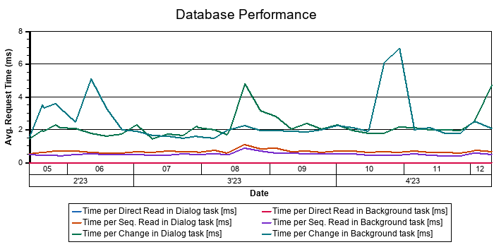
The "Top 5 transactions" diagram below shows the average response time in dialog tasks for the top 5 transactions.
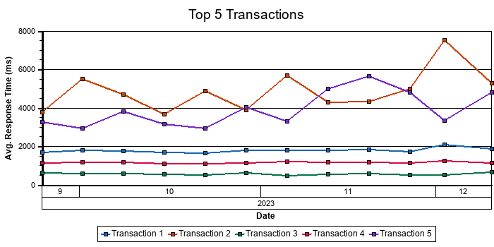
The "Transaction Code" table below shows the load percentage caused by the top 5 transactions.
No | Transaction Code | Load (%)
Transaction 1 | /OPT/VIM_WP | 9,5
Transaction 2 | ZSSNEW | 5,1
Transaction 3 | SESSION_MANAGER | 2,6
Transaction 4 | VA02 | 2,4
Transaction 5 | FBL3N | 1,8

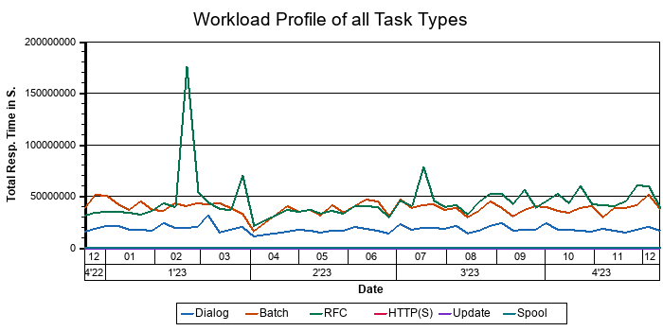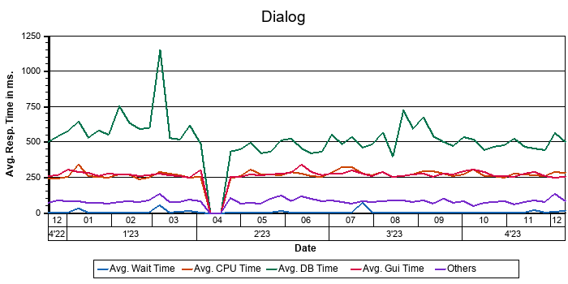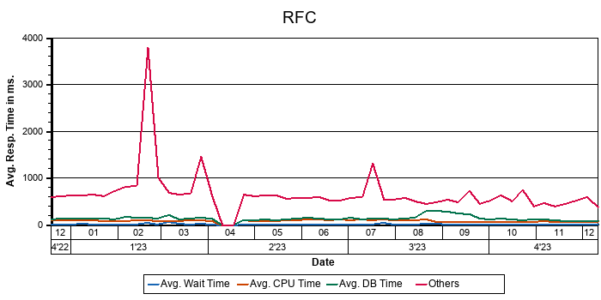

System Operation
The following diagram or table shows important KPIs for system operation.
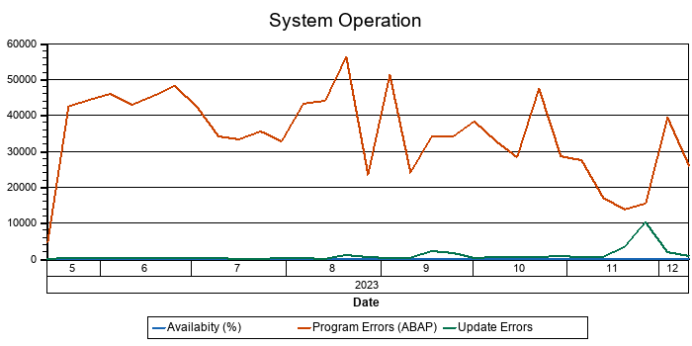

Hardware Capacity
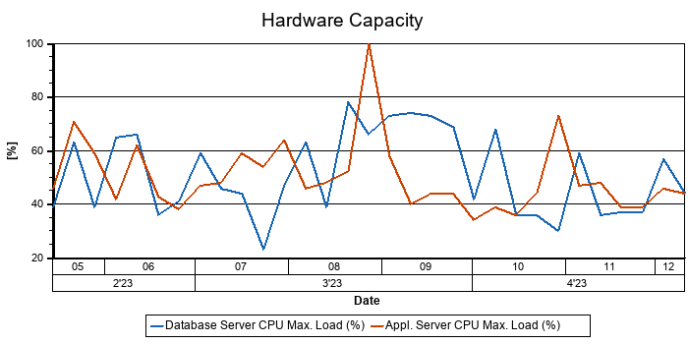
Report time frame: Service data was collected starting at 11.10.2025 04:21:19. This took 157 minutes.
You can see sample SAP EarlyWatch Alert reports on SAP Support Portal at SAP EarlyWatch Alert -> Sample Reports.
For general information about SAP EarlyWatch Alert, see SAP Note 1257308.
About System And Solution Manager
System No. Of Target System | 850372985

